**Abortion**

**Introduction**

The topic of abortion is quite extensive and also addressed all over the world. I chose it because I am interested in this topic and wanted more information.

In this thesis, I will focus on abortion itself and its definition, and I will also discuss the difference between a miscarriage and elective abortion. Furthermore, I will explain the possible methods of abortion and the period in which it can be performed. A big topic is women's rights to abortion, which vary from country to country and affect more things than one would think.

A miscarriage brings with it several complications, which are mainly medical and can threaten the life of the mother herself. This topic is closely related to the laws, so I will summarize in it what are the connections between regulations and health.

Finally, I will present how society views abortion, the arguments they use to defend their view, and how much of the decision is up to men.

**Text of the essay**

The view of ethical problems and issues is quite different at different stages of life. It is, therefore, apparent that society perceives these issues differently at the birth of life and the end of life. In reality, however, these issues are quite similar. The unconscious trigger for making this distinction is often that youth tends to be associated with a particular joy and longing for new opportunities that we can fulfill. On the other hand, the end of life, old age, is already associated with despair and a certain sadness for the memory of events. The big problem with these symbols, as certain metaphors for youth and old age, is the loss of rational thought caused by this very unconscious trigger. A perfect example is comparing the fatal illness of the old and the young. Although the disease is precisely the same, manifests the same way, and ends the same way, it is generally much worse to accept the fact that a young person dies simply because he is associated with a certain hope, energy, and undiscovered opportunities that are taken away by the disease. For these reasons, abortion is a complicated and often misperceived topic (Loewy, 2004, p.217).

# Characteristics of abortion

Abortion is generally defined as the termination of pregnancy that occurs before the embryo or fetus is delivered (Potts et al, 1977, p. 1). Abortion can occur in two ways, either spontaneously or artificially. Spontaneous abortion occurs when the fetus cannot survive in the mother's body and either spontaneously absorbs or has to be expelled. Spontaneous abortion cannot be judged as ethical or unethical because it comes unexpectedly and usually brings great sadness and disappointment for the mother, who has to cope with it afterward. Artificial or unnatural abortions are already a major ethical problem. There are ethical implications to be reckoned with in elective abortions (Phalen, 2017).

Abortion itself is considered a routine medical intervention. An experienced doctor carries it out; if all the correct methods are followed, it is also safe for the woman. An abortion can be done surgically or with the help of medication. Sometimes, a woman doesn’t have to be in the hospital with drugs. Still, she can easily take it at home, but after thorough consultation with a specialist (WHO, 2021).

**Miscarriage**

Miscarriage is considered one of the most common complications that can occur during pregnancy. Several definitions of miscarriage can be found on the internet. Still, the most accurate one is from 1977, published by the WHO, which reads: '*miscarriage is the expulsion or extraction from its mother of an embryo or fetus weighing 500 g or less'.*

The percentage of miscarriages was around 12%-14%, but this did not include those that occurred very early in pregnancy or that may have been mistaken for menstruation. A more realistic figure is around 17%-22%.

Malformations of the mother's uterus and (the presence of balanced chromosomal rearrangements in parents) are the leading causes of spontaneous abortion.

A number of risk factors can negatively affect the pregnancy and contribute to the miscarriage itself. The first factor is tobacco, for example, where many components are toxic to the body and may contribute to miscarriage. Another known factor is alcohol. Alcohol itself has very adverse effects on the developing fetus; therefore, there is no safe dose of alcohol for pregnant women.

Also, as for non-pregnant women, it is not good to use drugs during pregnancy, specifically, for example, cocaine. It is known that more spontaneous abortions have been observed in women using cocaine than in normal women.

A spontaneous abortion may occur not only once but more than once in a woman's lifetime. Previous miscarriages can adversely affect the chance of another pregnancy and cause a higher risk of another possible miscarriage.

Another risk is the risk of having already had an abortion. The risk increases, especially if a woman has had more than one abortion. With more, the risk increases.

The age of the pregnant woman is also a very controversial topic. This age has varied a lot over the years, but several studies show that the risk of miscarriage increases with age. For example, for women between ages 30 and 32, the percentage risk is 2.1%. While for women over 33, it is already 2.8%.

There are many more, but these risks are among the most basic and well-known. They may also be more likely to be not visible at first sight and often not even known to the woman until pregnancy, such as various genetic anomalies (Garcia - Enguidanos et al., 2002, pp. 111-119).

**Elective abortion**

Elective abortion is related to unwanted (unintended) pregnancy. This phenomenon will not and cannot be eliminated. Therefore, a great effort is made to prevent unintended pregnancy and thus to prevent abortion itself. Not only in the US, but all over the world, education about contraceptive methods is ongoing. The aim is to improve the general view of these methods so that couples who do not want children use them to prevent unwanted pregnancies (Rigterink et al., 2013, pp.235-250).

Terminating pregnancy as an elective abortion is one of the most frequently performed gynecological procedures. Going back in history, it has been found through anthropological research that abortion has been performed in every known culture. In the times of today and in times past, abortion has been seen as a very controversial topic. Related to this is the religious or social perspective and, most importantly, the laws, which vary greatly worldwide (Rigterink et al., 213, p. 235).

**Methods**

There are two basic types of abortion.

The first type is medical abortion. This option is perceived better by women and feels more natural to them. It is performed in the form of pills, which the woman takes after consultation with an erudite specialist who decides whether this option is suitable for her. The course is such that it is necessary that two medications are taken, each having a different effect. The first medication is for the termination of the pregnancy itself. It works by blocking the hormone progesterone, thus gradually causing the uterine lining to break down and the fetus to die. Most women will experience pain in the lower abdomen, and vaginal bleeding will also occur, as with menstruation. This is caused by a second drug that causes uterine contractions and subsequent expulsion of the fetus. Sometimes the pain can be so severe that it requires analgesics. Mild bleeding may last until the next menstrual period, and the abortion should be completed 4 hours after taking the tablet. Side effects may include nausea, vomiting, diarrhea, and headache (Medical abortion, 2015).

The second method is surgical abortion. It is a small and quick operation that can be performed in two ways.

Vacuum aspiration is a surgical procedure in which a doctor inserts a tube into the patient to suction the inside of the uterus gently. The woman may experience mild cramps that are similar to menstrual cramps. This procedure may involve local anesthesia, conscious sedation, or complete anesthesia. After the procedure, the patient is checked, and once the doctor feels everything is fine, she can leave (Vacuum aspiration, 2015).

Dilatation and evacuation are more commonly used surgical methods. This method takes a little longer than an aspiration, but it is still relatively quick. Again, the patient is sedated with local anesthesia or under general anesthesia. The main difference is that the fetus is not sucked out of the uterus with a tube but is taken out with special forceps. As with aspiration, the patient is monitored after the procedure; once all is well, she can leave (Dilation and evacuation, 2015).

**Timing of the abortion**

Abortion is most often performed in the first or early second trimester. The first trimester is counted as a period of up to 12 weeks. The second trimester is from 13 to 28. For example, in the US in 2015, over 90% of abortions were performed by week 13 and two-thirds by week 8.

In the first trimester, drug abortion or vacuum aspiration is most often used. Patients take medications 7 to 9 weeks after the last menstrual period. Vacuum aspiration is more likely to be used between 6 and 14 weeks of pregnancy.

In the second trimester, dilation and evacuation occur most often between 12 and 24 weeks.

Miscarriages in the third trimester are rare (Satmary and Burgess, 2022).

**Laws**

The legalization of abortion is a big issue on which everyone has an opinion. But the most important is the country’s leaders' opinion because we must act accordingly. Every country has a different set of rules, and that is why there are countries where abortion is entirely legal and also countries where it is completely inaccessible. Since 2000, however, at least 38 countries have either legalized abortion or at least relaxed the limits they had set for it. All of these restrictions lead women, when they seek an abortion, to go to another country and have it legally performed there. Black women, particularly those most affected by the abortion ban, struggle with this (Satmary and Burgess, 2022).

The World Abortion Law map shows how the rights of women and girls to abortion have evolved worldwide. The map is gradually updated so that it is possible to see how the situation is evolving globally and in what direction it is moving. The map has been produced since 1998 by the Center for Reproductive Rights with the main aim of protecting the abortion rights of all girls and women around the world. The images below show the 2021 situation in each country (Abortion laws, online).

Obrázek 1 – The World Abortion Law map

(dostupné z: <https://reproductiverights.org/wp-content/uploads/2019/05/WALM_2021update_V1-1.pdf>)

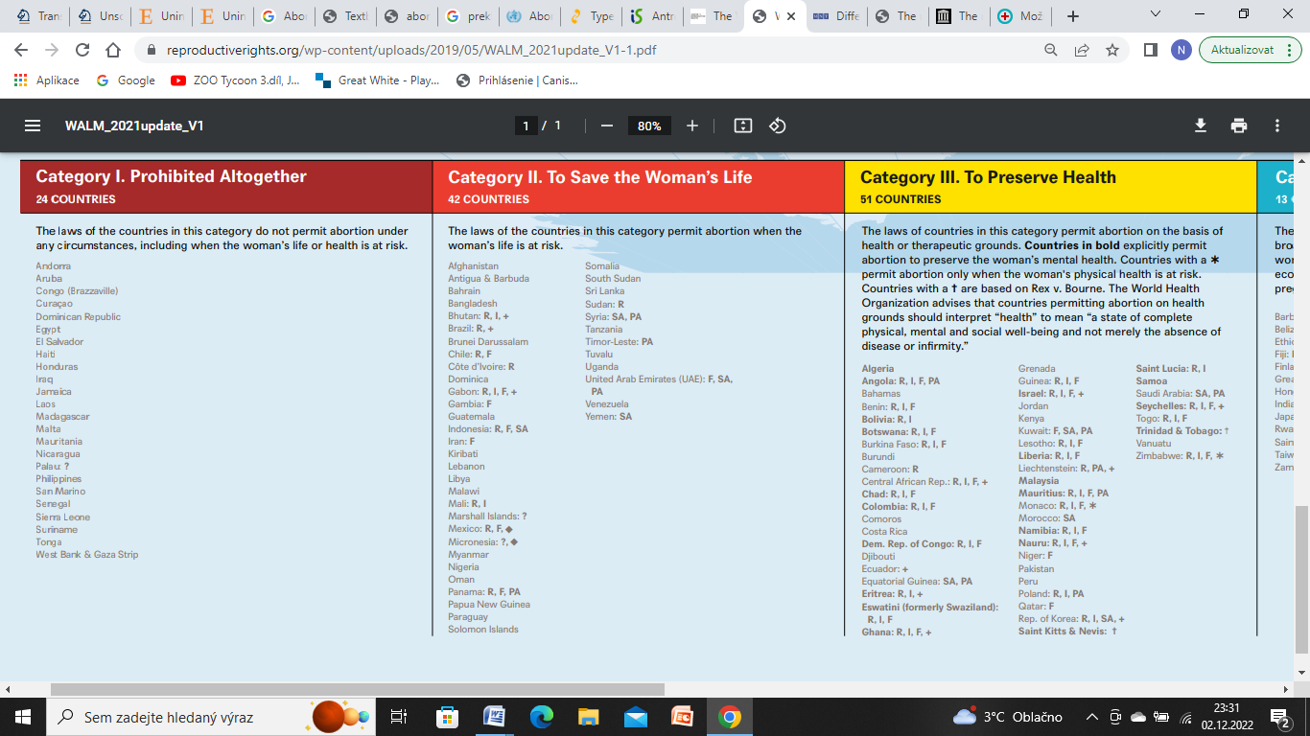

Obrázek 2 – The World Abortion Law map (dostupné z: https://reproductiverights.org/wp-content/uploads/2019/05/WALM_2021update_V1-1.pdf)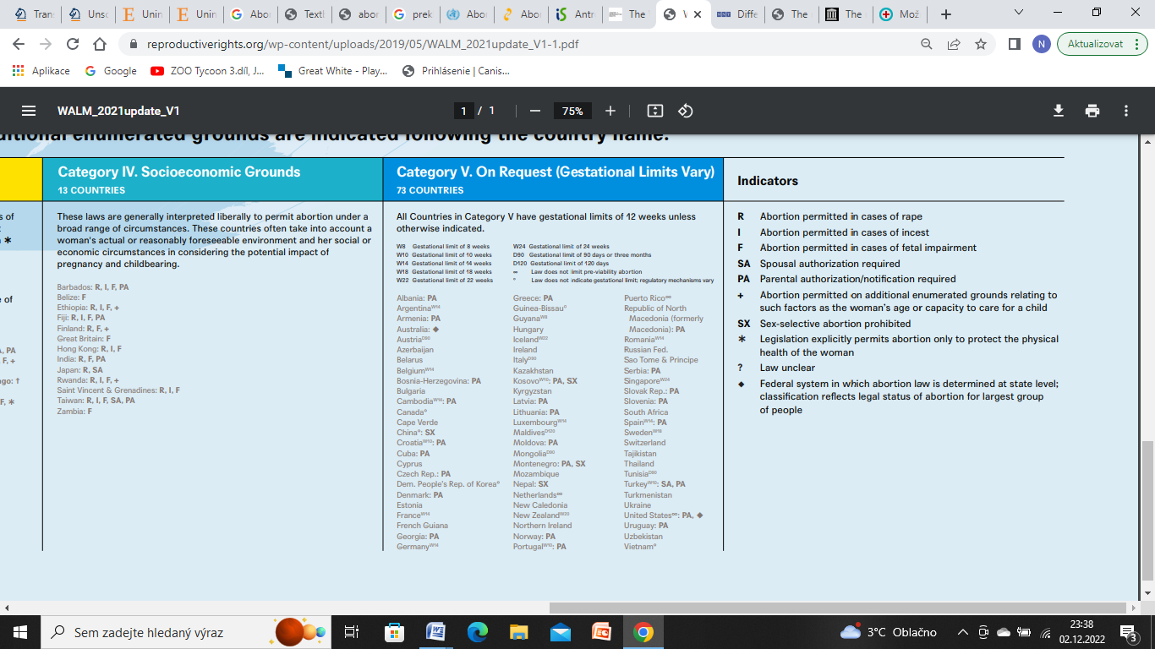

The right to abortion is a fundamental human right protected by several laws and treaties worldwide. The right to abortion is closely related to other fundamental human rights, such as the right to life, liberty, and non-discrimination. Restrictive laws regarding abortion have been widely condemned and considered incompatible with fundamental human rights on several occasions.

More than half of women of reproductive age live in countries with abortion rights. However, around 41% of women live in countries that deny them the right to abortion. This affects approximately 700 million women of reproductive age who are denied a free choice and forced to seek illegal alternatives in these situations, which can cost them their lives. According to the WHO, an abortion performed in this unprofessional manner can cost the lives of up to 23 000 women a year and several thousand more the enormous digestive health complications associated with it.

Thanks to indicators such as the map above, we can not only see where the country stands on abortion laws but also how they relate to women in general, what rights they have, their prospects for the future, and whether they are taken seriously at all (Abortion laws, online).

**Abortion and health – problems?**

As mentioned above, abortion itself is uncomplicated and usually wholly uncomplicated. However, it can only be so in countries where it is permitted; therefore, women receive all the care they need. In countries where it is not allowed, women have to resort to various procedures, most of which are carried out by people who are uneducated in the field and still use completely inappropriate methods.

Up to nearly half of the world's abortions are unsafe, according to statistics. Developing countries deserve most of the credit for this figure, with up to ¾ of abortions in Africa, for example, considered unsafe. Asia is close behind.

The stigma associated with abortion and the lack of access to care and understanding put much pressure on women worldwide. Up to 13.2% of maternal deaths, each year can be attributed to unsafe abortion. Examples of the risks associated with unprofessional abortion are incomplete fetal removal, bleeding, infection, and genital tract damage.

These complications come with money, and all the needed post-abortion care costs the health system or families much. This money could be used much more effectively to help with contraceptive methods and prevent more unwanted pregnancies (WHO, 2021).

**Abortion – yes or no?**

In Europe and North America, most states are pro-choice, and it is perfectly legal here. However, there are still groups of people who condemn the procedure and are totally against it. These opponents are called "pro-life," and their main idea is pro-abortion. The second group, who is pro-choice, is called "pro-choice," whose main idea is that every woman has her own choice and has the right to it.

The Catholic Church is the most opposed to abortion because human life is seen as a gift from God and must not be rejected (the same argument applies to suicide). They have gone so far with their rejection that they do not even accept contraception and are unable to allow abortion even when the life of the mother is in danger.

Women who are not affiliated with the Church in any way but who recognize a special relationship between the unborn embryo and the mother are also against abortion. According to them, this relationship is formed from the very beginning of pregnancy, so a woman can’t have the embryo/fetus killed.

On the other hand, the second group, pro-abortion, believes that a woman is not just a machine for making babies but has the right to make her own decisions. A woman experiences enormous changes in pregnancy and knows that life and the whole future will change for her with the child, so she has every right to refuse the pregnancy.

Another significant difference between these groups is when a person becomes a person or an entire subject. The "pro-choice" group holds that this change occurs when a person acquires fundamental characteristics (but it is not given precisely when it happens). In contrast, according to the "pro-life" group, a person is a person after the gametes have fused.

In general, there is no clear consensus on this issue. One can say that abortion is not the ideal solution, but in situations such as rape or a complicated life situation, this act is much more understandable and permissible.

An important point that often leads or does not lead a woman to abortion is whether or not the woman can take responsibility for the child. If she is not, then abortion is the possible and most used solution. But it is only the woman's decision, no one else's (not in countries without legalized abortion).

What about the men? Although he participates in the creation of the fetus, the man is more of a bystander for the rest of the process, who can watch the pregnancy unfold. However, the woman will do the whole pregnancy and experience all the mental and physical changes that can significantly impact her, so the decision is mainly up to the woman, and she can invite the man to help her make the decision. However, this is a topic that can never be agreed upon (Šimek, 2015, p.166).

**Conclusion**

It is important not to confuse the terms miscarriage and abortion. Miscarriage is spontaneous and cannot be influenced in any way, so it is not as controversial as abortion, which depends on the pregnant woman’s decision.

Abortion is a much-discussed and complicated topic worldwide. However, there is a great effort to fight for their legalisation.

Abortion is already legal in most countries, but many countries still strictly prohibit it. In these countries, women are forced to undergo dangerous illegal procedures or travel to a foreign country. These countries are mainly the less developed and very religious ones because the Catholic Church does not recognise this type of procedure.

The best solution is to make abortion legal. This solution would reduce the number of deaths and health complications for women, who would then be able to function normally and thus contribute more to the development of the state, which would not have to put so much money into their subsequent health care. As the pro-choice group points out, this is the woman's decision, and the man has no right to interfere.

**References**

*Abortion laws* [online]. Center for reproductive rights [cit. 2022-12-02]. Dostupné z: <https://reproductiverights.org/maps/worlds-abortion-laws/>

*Dilatation and evacuation* [online]. British Pregnancy Advisory service, 2015 [cit. 2022-12-02]. Dostupné z: <https://www.bpas.org/abortion-care/abortion-treatments/surgical-abortion/dilatation-and-evacuation/>

GARCÍA-ENGUÍDANOS, A., M.E. CALLE, J. VALERO, S. LUNA a V. DOMÍNGUEZ-ROJAS. Miscarriage. *European Journal of Obstetrics & Gynecology and Reproductive Biology* [online]. 2002, **102**(2), 111-119 [cit. 2022-12-02]. ISSN 0301-2115. Dostupné z: <https://doi.org/10.1016/S0301-2115(01)00613-3>.

LOEWY, Erich H. a Roberta SPRINGER LOEWY. *Textbook of Healthcare Ethics* [online]. 2nd. Kluwer Academic Publishers, 2004 [cit. 2022-11-30]. ISBN 1-4020-2252-2.

*Medical abortion* [online]. British Pregnancy Advisory service, 2015 [cit. 2022-12-02]. Dostupné z: <https://www.bpas.org/abortion-care/abortion-treatments/the-abortion-pill/remote-treatment/>

Phalen, R.F. (2017). Unsolved Problems: Our Brave New World. In: Core Ethics for Health Professionals. Springer, Cham. <https://doi-org.proxy.k.utb.cz/10.1007/978-3-319-56090-8_10>

POTTS, Malcolm, Peter DIGGORY a John PEEL. *Abortion*. Cambridge: Cambridge University Presss, 1977, 450 s. ISBN 978-0521214421. Dostupné také z: <https://books.google.cz/books?id=T205AAAAIAAJ&lpg=PP13&ots=nUOHNyHKYB&dq=abortion&lr&hl=cs&pg=PP7#v=onepage&q=abortion&f=false>

RIGTERINK, Ellen S., Audrey F. SAFTLAS a Hani K. ATRASH. Induced Abortion. In: GOLDMAN, Marlene B., Kathryn M. REXRODE a Rebecca TROISI. *Women and Health* [online]. 2nd. Academic Press, 2013, s. 235-250 [cit. 2022-12-02]. ISBN 9780123849786. Dostupné z: <https://doi.org/10.1016/B978-0-12-384978-6.00016-9>.

SATMARY, Wendy A. a Lana BURGESS. *What are the different types of abortions?* [online]. 2022 [cit. 2022-12-02]. Dostupné z: <https://www.medicalnewstoday.com/articles/325582>

ŠIMEK, Jiří. *Lékařská etika*. Grada, 2015, 1 online zdroj (224 stran). ISBN 978-80-247-9884-4. Dostupné také z: <https://www.bookport.cz/AccountSaml/SignIn/?idp=https://shibboleth.utb.cz/idp/shibboleth&returnUrl=/kniha/lekarska-etika-1213/>

*The World Abortion Law map* [online]. 2021 [cit. 2022-12-02]. Dostupné z: <https://reproductiverights.org/wp-content/uploads/2019/05/WALM_2021update_V1-1.pdf>

*Vacuum aspiration* [online]. British Pregnancy Advisory service, 2015 [cit. 2022-12-02]. Dostupné z: <https://www.bpas.org/abortion-care/abortion-treatments/surgical-abortion/vacuum-aspiration/>

WHO abortion. *World Health Organization* [online]. 2021 [cit. 2022-11-30]. Dostupné z: <https://www.who.int/news-room/fact-sheets/detail/abortion>

Začátek formuláře

Konec formuláře

Bc. Zuzana Tesárková, M210207