|  |  |
| --- | --- |
|  | |
| **Ethical Aspects of Surrogacy** | |
|  | |
| Bc. Zuzana Tomášová | |
|  | |
|  |  |
| Essey  2022 |  |
|  |  |
|  | |

**OBSAH**

1. 1 introduction 3
2. 2 surrogacy 4

2.1 Surrogacy in Czech Republic 4

2.2 Requirements for surrogate mother 5

1. 3 Ethical aspect of surrogacy 6
2. 4 závěr 8
3. 5 SEZNAM POUŽITÉ LITERATURY 9

introduction

Nowadays there is a great scientific progress in reproductive medicine. For most infertile couples it brings another option of reproduction. One of them is surrogacy. Unfortunately this progress contains new ethical problems.

In this essey we will describe what surrogacy means. Part of this chapter will be description of surrogacy in Czech Republic. Another part of this chapter will be what the requirements for surrogate mother are.

In the last chapter will described if there are any ethical problems of surrogacy. This topic will be analyzed from view of law. Then it will be analyzed from point of view of the child a surrogate mother. Another part of this chapter will be opinion of religion. In this chapter there will be described opinions of Roman Catholic Church, Islam, Hinduism, Judaism and Budhism.

Problematics of surrogacy is very difficult but it gives hope to some infertile couples that longs for a child. I chose this topic because it is very close to me. I work at Reproduction Clinic in Zlín.

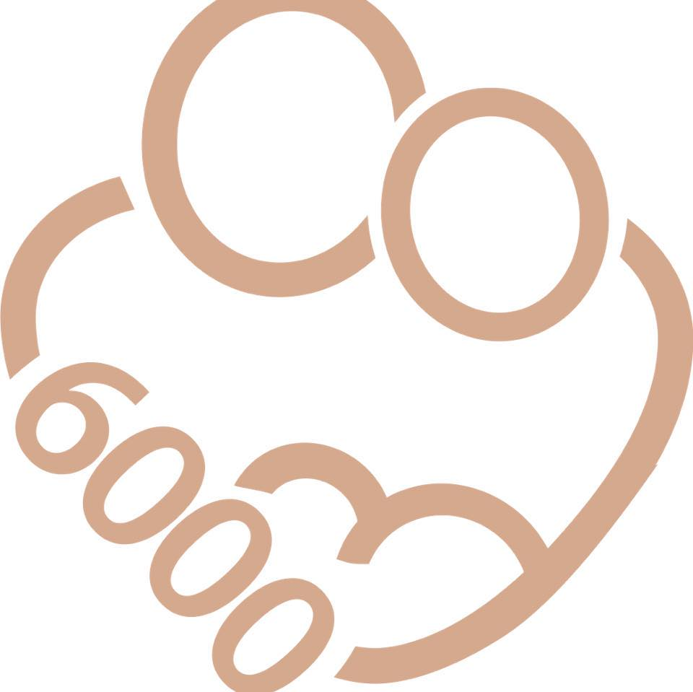

Obrázek č. 1 Klinika reprodukční medicíny Zlín - logo

surrogacy

The term of surrogacy comes from latin word „surrogātus“ witch means „to choose alternative candidate”. If the biological mother is not capable to bear a child she chooses “substitute mother”. This woman is willing to conceives, gestates and delivers a baby on behalf of biological mother mostly for a financial reward. After birth she abnegates a right on motherhood. The gametes can be from parents or from donors – then we are talking about third-party reproduction.

We can divide surrogacy in two types – total surrogacy and partial surrogacy. (Burešová, 2016) In case of total surrogacy is surrogate mother accepting gametes that are not hers biological material (biological mother´s egg or egg of anonymous donor). (Dostál, 2007)

In case of partial surrogacy surrogate mother gets pregnant after in vitro fertilization or insemination – in both cases is used hers egg. (Dostál, 2007)

We can also divide surrogacy into altruistic and commercial. Altruistic surrogacy is when surrogate mother is bearing a child only because she wants to help to the infertile couple. The commissioning couple only pays for cost related with pregnancy care. On the other hand the commercial surrogacy is a trade. Surrogate mother is delivering a baby for a financial reward.

Surrogacy in Czech Republic

In Czech Republic is topic of surrogacy controversial. Surrogacy is not precisely defined by laws. It is neither forbidden nor allowed. According to the law § 169 odst. 1 zák. č. 40/2009 Sb. is in Czech Republic commercial surrogacy forbidden – delivering baby for a financial reward. States that allow commercial surrogacy are Georgia, India, Russia, California and Thailand. (Torres, 2019)

By Czech law is mother the woman that delivered the baby. If surrogate mother is married her husband is considered to be father of the baby. There is no law that acknowledges commissioning couple as mother and father of delivered baby. (Sněmonvní tisk 362, 2012) The most problematic is adoption of a child because there is needed agreement of surrogate mother or both parents. The adoption can be provided six months after birth.

In Czech republic is surrogacy accepted only because of medicine reasons. Surrogacy because of social reasons is forbidden. First health organization that placed surrogacy to its healthcare was Reproductive clinic in Zlín. (Rumpík, 2018) Reproductive Clinic in Zlín is accredited medical facility that specializes on human infertility. World Health Organizations says that infertile couple it the couple that can not conceive a child after one year of trying. Clinic is working since 2000 and has on his account more than 6000 children.

Because surrogacy in Czech Republic is not regulated by law the responsibility is on reproduction clinic. Between indications of surrogacy belongs for example uterus pathology or abnormalities, hysterectomy or some serious illness (Ashermann syndrome, Mayers syndrome and others). Other indications are repeated abortions or contraindications after complicated birth. (Mezulániková, 2021)

Requirements for surrogate mother

Commissioning couple is looking for surrogate mother on their own – mostly on the internet (Rumpík, 2018). Surrogate mother supposed to be physically and mentally healthy. Her age should be between twenty one to thirty five. By the law age of surrogate mother should not overcome forty nine.

Another recommendation is that surrogate mother should be multipara and there is no pathology in hers obstetric history. Commissioning couple should be looking for surrogate mother that had birth without any complications.

Except for gynecologist examination surrogate mother should be examined by psychologist. Psychologist should give his opinion weather surrogate mother is able to understand consequences of surrogacy. Also if she is able to bear emotional burden that could be related to surrogacy. (Mezulániková, 2021)

Surrogate mother should have not used drugs or alcohol. These recommendations come from Czech Gynecological and Maternity Society. Surrogate mother should be inform about risks of surrogacy and examined by a gynecologist. Every surrogate mother should have her documentation at reproduction clinic. After accomplishing all the conditions than she will be suggested as appropriate. (Rumpík, 2018)

Ethical aspect of surrogacy

There are many opinions about surrogacy. The whole theme of reproductive medicine is the most difficult in medical ethics. Now the whole process of creating new life is in hands of the doctors. (Šimek, 2015) But for most people it could be another option to „gain“ their dream child. In this chapter there will be analyzed ethical problems of surrogacy. This topic will be analyzed from view of law. Then it will be analyzed from point of view of the child a surrogate mother. Another part of this chapter will be opinion of religion.

First ethical dilemma is that the baby is a subject of contract. And his life is something that can be count in money. From another point of view some author says that parenthood is something that “depends on fate” and some people are not supposed to have children. (Šimek, 2015) Some resources indicate that surrogate mother approaches delivering baby as a job and they did not created with it any emotional bond. (The Iona Institude, 2013)

There is a question what happens with the child if both of parties do not want him or her. Like when the baby is born with some pathology. Then to whom does the baby belong to? (Šimek, 2015) We also have to think about feelings of the baby. There are opinions saying the baby could feel abandoned and didn´t wanted. (The Iona Institute, 2013) Should the baby know that there was another women that delivered him? Who is his or hers mother? The one that gave biological matherial or the one that delivered him/her?

Another ethical dilemma is reproductive travel a cross border surrogacy. Traveling for a cross border surrogacy is more financially available and is mostly used by same sex pairs or “single” parents. Also it is used by couples from countries where surrogacy is forbidden (Kirby, 2020) This type of surrogacy is allowed in developing countries and brings a serious question about child trafficking. States that allow commercial surrogacy are Georgia, India, Russia, California and Thailand. (Torres, 2019)

Many religious have a different opinion. Roman Catholic church is maybe the greatest opponent of reproductive medicine. They take its techniques very amoral. They accept only one method – insemination. (Mezulániková, 2021) They takes that only god can judge who can have or have not children. If the couple is for same reason infertile that it is “a God´s plan”.

Judaism is more open to modern medicine. The religion urges its followers to reproduct. It allows any methods of reproductive medicine but insemination with donor sperm. They take insemination with donor sperm as adultery. In this religion they also allow surrogacy. (Mezulániková, 2021)

Islam allows methods of reproductive medicine with using biological material of future parents. For them is very important to know who is the first born child. There is a question about age of embryo and then baby if it was created long time before using. Surrogacy in this religion is very discussed. Some sects are for surrogacy some of them are not. (Mezulániková, 2021)

Hinduism has very positive point of view in case of reproductive medicine. They take infertility as a curse and any effort to “break this curse” is welcome. They also allow surrogacy. Before was India center of a cross border surrogacy and commercial surrogacy. But today both of two are forbidden because of child trafficking. Today is allowed only altruistic surrogacy. (Rumpík, 2018)

The most dilemmatic opinion about reproductive medicine and surrogacy has Buddhism. There are different opinions in different sects. Monastic ethics practice celibacy but economic ethics sees benefits from reproduction. Some of them sees benefits for oncological patients because they have option to reproduce after chemotherapy. But they are asking question what is life? Is embryo life? Then does it mean if you disposal unused embryo you kill a human being? There is also unclear opinion about surrogacy. (Mezulániková, 2021)

závěr

This essay was about ethical aspects of surrogacy. In first chapter was described what surrogacy means. Also there was described what surrogacy requirements are. After reading this essey we know that surrogacy is very discussed theme with many different opinions. Some of us sees it as miracle of todays medicine and some are worried about what it can brings. Some of these ethical dilemmas will be written in separated chapter.

In second chapter there are described ethical aspects of surrogacy. This topic will be analyzed from view of law. Then it will be analyzed from point of view of the child a surrogate mother. Another part of this chapter will be opinion of religion. In this chapter there will be written opinions of religions – Roman Catholic Church, Islam, Hinduism, Judaism. Also there will described ethical dilemma traveling for a cross boarding surrogacy.

SEZNAM POUŽITÉ LITERATURY

BUREŠOVÁ, Kateřina. Surogátní mateřství a jeho (nejen) právní aspekty. Právní rozhledy. 2016, roč. 24, č. 6, s. 193-201. ISSN 1210-6410.

DOSTÁL, Jiří. Etické a právní aspekty asistované reprodukce. Olomouc: Univerzita Palackého, 2007. 170 s. ISBN 978-80-244-1700-4.

KIRBY, Jordan. Cross Border Surrogacy. AMSA Journal of Global Health [online]. June 2020, vol. 14, no. 1, p. 22-28 [cit.2021-02-18]. Dostupné z: <http://ajgh.amsa.org.au/index.php/ajgh/article/view/84/74>

MEZULÁNIKOVÁ, Karolína, 2021. Etické aspekty náhradního mateřství. Zlín. Bakalářská práce. Univerzita Tomáše Bati.

RUMPÍK, David. Etické a právní aspekty náhradního mateřství [online]. Brno: Masarykova Univerzita, Lékařská fakulta, Gynekologicko-porodnická klinika, 2018 [cit. 2021-02-02]. Vedoucí disertační práce Pavel Ventruba. Dostupné z: <https://is.muni.cz/th/u8ler>

Sněmovní tisk 362 [online]. Poslanecká sněmovna Parlamentu České republiky, 2012 [cit. 2013-01-21]. s. 1144. Dostupné z: <https://www.psp.cz/sqw/sntisk.sqw?o=6&>

ŠIMEK, Jiří. Lékařská etika. Praha: Grada Publishing, a. s.,2015. s. 224. ISBN 978-80- 247-5306-5.

THE IONA INSTITUTE. The ethical case against surrogate motherhood: What we can learn from the law of other European countries [online]. Dublin: © 2014 Iona, p. 23 [cit. 2021-02-07]. Dostupné z: <https://ionainstitute.ie/the-case-against-surrogatemotherhood/>

TORRES, Giorgia et al. A review of surrogate motherhood regulation in south American countries: pointing to a need for an international legal framework. BMC Pregnancy Childbirth [online]. January 2019, vol. 19, no. 46, p.46 [cit. 2021-02-17]. ISSN 1471- 2393 Dostupné z: https://bmcpregnancychildbirth.biomedcentral.com/articles/10.1186/s12884-019-2182- 1#citeas