**Euthanasia and Assisted Suicide in the world**

**Introduction**

For many years, humanity has struggled with the ethical issue of assisted suicide and its legalization. In 2019, the legalization of euthanasia was widely discussed in the Czech Republic. In the Netherlands, where hospice care is not developed, euthanasia has been legal since 2002. Six months later, Belgium also legalized euthanasia.

The word euthanasia comes from the Greek word “*eu*” - good and “*thanatos*” - death. It could be translated as painless death. The reasons for euthanasia can be various, such as compassion for the sufferer, poor quality of life, reduction of treatment and hospitalization costs. Euthanasia is one of today's bioethical issues that needs to be addressed.

**The right to life, the right to die**

There is a need to develop guidelines and assessments to specify the criteria for recommending euthanasia for each type of patient. Of course, there is "informed consent," without which we cannot deal with majority of medical procedures. Each case should be a subject of legal supervision and investigated by a medical committee. (1)

By creating such a protocol, the disabled person's family would not be placed in a difficult position. The performance of euthanasia involves some administrative and legal measures that need to be addressed before legalizing euthanasia. The trained staff which will perform the euthanasia will inject the victim with a lethal substance in a dose that will be lethal to the victim. (1)

**The right to life and Czech legislation**

The right to life is protected in the Czech legal system in Article 6 of the Charter of Fundamental Rights:

1. Everyone has the right to life. Human life is worthy of protection even before birth. No one must be deprived of life.

2. The death penalty is not allowed.

3. There shall be no violation of the rights according to this article if someone has been deprived of his life in association with a conduct that is not a criminal offense under the law. (2)

People who are proponents of euthanasia advocate the right to decide freely about their lives and also that a patient suffering from an incurable disease or at the terminal stage is in a state of extreme need. (2)

**Netherlands**

Legal assisted suicide or euthanasia in the Netherlands is strictly regulated. In the Netherlands, commissions are set up to assess a doctor's progress in a patients treatment. The doctor must report a case of euthanasia or assisted suicide to one of the five regional euthanasia evaluation commissions. Unless the doctor does it, he gets prosecuted. That means facing up to 12 years in prison for euthanasia and up to 3 years for assisted suicide. (3)

In the Netherlands, adolescents can apply for euthanasia from the age of 12 with the need of consent of a parent or guardian, otherwise from the age of 16. From the age of 16 to 18, teenagers do not need the permission of a parent or guardian, but parents must be involved. From the age of eighteen, consent to perform euthanasia from parents or guardians is no longer required. (3)

Euthanasia cannot be performed at the request of family or relatives, only at the request of the patient himself. The difference between assisted suicide and euthanasia is that in assisted suicide, the doctor does not administer the deadly substance, but the patient self-administers it. In euthanasia, only a doctor will supply and administer the fatal substance. The doctor is not obliged to perform euthanasia, so he can send the patient to another doctor. (4)

Physician-assisted suicide is legal in some countries, under certain circumstances, including Austria, Belgium, Canada, Luxembourg, the Netherlands, New Zealand, Spain, Switzerland and parts of the United States (California, Colorado, Hawaii, Maine, Montana, New Jersey, New Mexico, Oregon, Vermont and Washington). (5)

**Belgium**

In Belgium, the applicant for death at the hands of a doctor must be of legal age, entirely sane and informed. He/she has to apply for euthanasia twice in writing, and must be aware of the consequences as the procedure is ireversible. In Belgium and the Netherlands, special commissions are set up to examine whether euthanasia of a doctor has been carried out in accordance with the law. (6)

**The Division of Euthanasia**

Euthanasia can be divided into active and passive. Active euthanasia involves active intervention, for example, by administering a lethal dose of lethal injection (CLC) into a vein. Passive euthanasia is defined as allowing a patient to die, whether it is to disconnect him from devices without which he cannot survive, or to give him medicine, or to stop providing him with water and food. The active form of euthanasia is considered a more significant moral dilemma than the passive form of euthanasia. (7)

Countries that have legalized active forms of euthanasia include the Netherlands, Belgium, Switzerland, and Luxembourg. (7)

There are countries where the passive form of euthanasia is legalized: Denmark, France, Italy, and Germany. (7)

We can also distinguish between active euthanasia and assisted suicide. In active euthanasia, the doctor provides and administers the drug, while in assisted suicide, the doctor provides the means to end the life, but the patient self-administers it. (7)

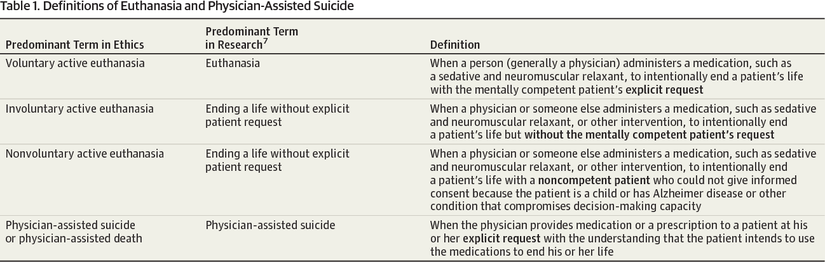

picture one: (8)

Most physicians condemn the active form of euthanasia, even if the patient requires it, except for physicians in those countries where some form of euthanasia or assisted suicide is legal. Some also consider the term passive euthanasia to be misguided. In former Nazi Germany, for example, doctors were abused to carry out extermination programs under the term euthanasia, which were targeted at people identified as undesirable. (7)

**Palliative care versus euthanasia**

We refer to palliative care as all treatments that do not lead to a permanent cure. It is the care of the dying patient, and this care is intended to provide him with a certain comfort when dying. Palliative care includes, above all, a sufficient amount of painkillers - so-called analgesics, as well as anti-anxiety drugs - so-called anxiolytics and anti-depressant drugs, so-called anti-depressants, and, of course, nursing care. (9)

The [World Health Organization](https://en.wikipedia.org/wiki/World_Health_Organization" \o "World Health Organization) (WHO) describes palliative care as "an approach that improves the quality of life of patients and their families facing the problems associated with life-threatening illness, through the prevention and relief of suffering by means of early identification and impeccable assessment and treatment of pain and other problems, physical, psychosocial, and spiritual." (10)

Palliative care is part of the human right to health, so doctors also have the opportunity to certify in the palliative medicine program. This type of care is necessary for a wide range of diseases. Most sufferers who need this type of care suffer from chronic diseases such as cardiovascular disease, cancer, chronic respiratory disease, Acquired Immune Deficiency Syndrome, and diabetes. (9)

**Arguments for euthanasia**

- The human being should have the right to decide when and how he wants to die (right to live, right to die,

- Euthanasia allows a person to die with dignity and is subject to their own control,

- Death is a private matter for every individual, and the state should not have the right to invade her/his privacy,

- It is financially costly to keep alive patients who does not have a chance to recover or have no chance of improved quality of life,

- Relieving the pain and suffering of family and acquaintances who witness their relative suffering,

- Animal euthanasia is acceptable in society, so why should it be different in humans. (11)

**Arguments against euthanasia**

(does not include religious arguments)

- Belittling of society's values and respect for human life,

- Existence of palliative care,

- Immense power and responsibility for doctors,

- Infringement of trust between patient and doctor,

- Halting research to develop new treatment methods and procedures,

- Insufficient motivation to invent new drugs. (11)

**Sarco suicide capsule**

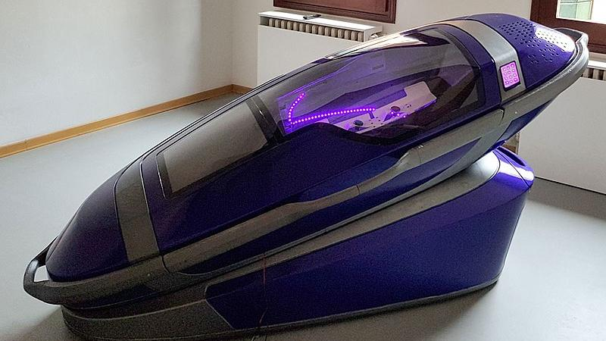

Picture two: (12)

In December this year, Switzerland approved a prototype of a new capsule, which is intended to facilitate the course of assisted suicides. According to the inventor of this facility, patients who choose this variant of assisted suicide will have the opportunity to die dignified, calm, and painless. In Switzerland, liquid sodium pentobarbital has been used for assisted suicide. Australian Philip Nitschke created the capsule (resembling a coffin) called Sarco. The capsule should come into operation in 2022. (12)

A person who wishes to die enters a capsule, and it is activated from the inside. The capsule space is filled with nitrogen, and the oxygen content is reduced. This phenomenon causes a person to lose consciousness in two to five minutes and eventually die without suffocating or panicking. The capsule is fully movable. (12)

Before losing consciousness, one may feel disoriented and have a mild euphoric state. The coffin is made by a 3D printer and is also equipped with a safety button that one can press if one changes one's mind to go to the afterlife. (12)

**Conclusion**

It is up to each individual to decide whether to accept the arguments legalizing euthanasia or take a negative stance. In some cases, where there is a clear prognosis of impending death in suffering, the sufferer should make this choice. This unfortunate situation of analgesics is currently being addressed, which can also be considered euthanasia. Thanks to this analgesia, we can avoid pain, but the psychological suffering persists, and one is aware that he is terminally ill and is exposed to much stress when expecting to die every day. Even if one has a dull perception of reality, there is still a feeling of fear and uncertainty about which day will be the last in this suffering. The introduction of euthanasia and its legalization in an advanced society is a political, medical, ethical, religious, and legal issue that needs to be addressed. If I was in such situation, where I had to decide on the life of a family member, I am not sure which choice I would go for. Each coin has two sides.

Some people who choose to undergo euthanasia, whether its active or passive form or assisted suicide, have to travel abroad. This year, a 37-year-old man from the Czech Republic flew to Switzerland to undergo assisted suicide because he suffered from incurable amyotrophic lateral sclerosis and did not want his children to see him gradually lose control of his body and bother his wife. The mental abilities of these patients remain unchanged, and therefore they become prisoners in a dysfunctional body.

If they do not have the financial means (like this man), they can resort to suicide.

Some, whether for religious, moral, or other reasons, are unable to commit suicide on their own. He asks for the help of a doctor or other family members. These people near them find themselves in an awkward situation and solve a moral dilemma. Is it really necessary for these people to have to choose some extreme methods when in today's modern world there are means by which to die with dignity and in the circle of loved ones?

In my opinion, after my detailed examination of the methods when elaborating this essay, I have come to the conclusion that a person who is mentally well should have the right to decide when, where, and how to say farewell to life. There should be an independent comitted that examines the patient's condition, both physical and mental. In detail, make psychological and psychiatric examinations, and approve either assisted suicide or euthanasia.

# References

1. **Mishra, Vivek R. Minocha and Arima.** Euthanasia: Ethical Challenges of Shift from “Right to Die” to “Objective Decision”. *https://www.researchgate.net/.* [Online] April 2019.

2. **Parlament České republiky, Poslanecká sněmovna.** *https://www.psp.cz/docs/laws/listina.html#.* [Online] 1992.

3. **Netherlands, Government of the.** *https://www.government.nl/topics/euthanasia/is-euthanasia-allowed.* [Online]

4. **Government of the Netherlands.** https://www.government.nl/topics/euthanasia/euthanasia-assisted-suicide-and-non-resuscitation-on-request. [Online]

5. **Wikipedia.** https://en.wikipedia.org/wiki/Assisted_suicide. [Online] 19. December 2021.

6. **Sterckx, Kasper Raus and Bert Vanderhaegen and Sigrid.** https://academic.oup.com/jmp/article-abstract/46/1/80/6118631?redirectedFrom=fulltext. *Euthanasia in Belgium: Shortcomings of the Law and Its Application and of the Monitoring of Practice.* [Online] Pages 80–107, 25. January 2021.

7. **Hope, Tony.** Mediccal Ethics: A Very Short Introduction. *Oxford: Oxford University Press.* [Online] str.11, 2004.

8. **E. Emanuel, B. Onwuteaka-Philipsen, John W. Urwin, Joachim Cohen.** Attitudes and Practices of Euthanasia and Physician-Assisted Suicide in the United States, Canada, and Europe. *https://www.semanticscholar.org/paper/Attitudes-and-Practices-of-Euthanasia-and-Suicide-Emanuel-Onwuteaka-Philipsen/6648f6dd0130507ebc3e120e13da5ba820a7bb2d/figure/0.* [Online] JAMA, 2016.

9. **WHO.** https://www.who.int/news-room/fact-sheets/detail/palliative-care. [Online]

10. **Wikipedia.** https://en.wikipedia.org/wiki/Palliative_care. [Online] 13. December 2021.

11. **BBC,** Copyright © 2021. Euthanasia. *https://www.bbc.co.uk/bitesize/guides/zynv87h/revision/3.* [Online] 2011.

12. **swissinfo.ch.** *https://www.swissinfo.ch/eng/sarco-suicide-capsule--passes-legal-review--in-switzerland/46966510.* [Online] December 2021.

**Aneta Moudrá, Student: M20856 - FAM**