|  |  |
| --- | --- |
|  | |
| **Women in Management Leadership Positions**  **of Company** | |
|  | |
| Bc. Lucie Smolková, DiS. | |
|  | |
|  |  |
| Seminar work – Essay (2MAEE)  2021 |  |
|  |  |
|  | |

CONTENTS

Introduction 3

1 Management and the business environment 4

1.1 Leadership and Ethics 4

2 ethics in management 5

2.1 How Companies Deal with Ethical Issues 5

3 woman in top positions – yes, no? 6

3.1 Hypotheses 6

3.2 Trends in Management Methods, Business Ethics and Women 7

4 women in management, why and how? 8

4.1 Women – Carries of Positive Changes in Companies 8

5 woman and their added value in management 9

5.1 What Makes Men and Women Different 9

5.2 How do Men and Women Differ in their Management 9

5.3 Survey of the Role of Men and Women in Management in the Czech Republic 10

5.4 The Hidden Potential of Women 11

Conclusion 12

Bibliography 13

Introduction

I chose the area of ​​Women in Top Management positions as a topic for the elaboration of this seminar paper – essay in the subject of Business Ethics. I conceived the work mainly from a theoretical point of view, where in the chapters I will rely on book sources. This is a very broad area, so I tried to focus and highlight the most important findings. In the introductory chapter, I will first focus on a general description of the functioning of management and then also mention the basic functioning of ethics in management. The next chapters will then focus on a specific topic of work, namely women in top positions, hypotheses and trends. Part of the work will be the justification of the selection of women for leadership positions and the positive changes they can bring to society.

I chose this ethical area mainly because I had the opportunity to work under the leadership of both men and women, and I can make a personal comparison. Nowadays, this is certainly a much-discussed issue that is still overlooked by some people. Historically, it has always been the case that a man is the one who leads and supports the family, while a woman takes care of other matters concerning the provision of family life. However, this "trend" is now a thing of the past and I would like to prove this fact with this work.

Management and the business environment

The relationship between superior and subordinate, between manager and owner of the company and employees has developed over a long period of time. The development of the relationship between the employee and the employer has always been influenced mainly by differences between the social strata, which, as a result of existential dependence, have also turned into hatred and later into hostility. However, negative relationships in the workplace are manifested and, in most cases, even reflected in the company's management itself, which fixes mutual mistrust between the subject and the object of management, thus complicating the management process and at the same time reducing its level. (Dytrt, 2006, p. 31)

Due to fundamental political changes, such as the development and understanding of ownership relations, social, humanitarian or ethical development of society, we are currently at a crossroads with the past relationship of a differentiated society according to belonging to a particular social class. In some cases, the manager is no longer the owner of the land or company, but is an employee of the owners. As a result, the manager is somewhat closer to other employees. (Dytrt, 2006, p. 32)

Leadership and Ethics

In addition to a thorough elaborate internal directive, the basic goals of quality management should also include the factor of the company's external contact with the surrounding environment, especially in relation to the fulfillment of the customer's wishes and requirements. The visibility of society in the context of transparency is a crucial aspect in the social environment with regard to the perception of the added value achieved by the company. Today, it brings with it rapidly changing and complex societies, for which it is increasingly difficult to accept and take responsibility, along with the requirement to share it somewhat with others. The social rules that have been experienced have essentially disappeared, along with the functioning framework of "general competences". In commercial companies, it is no longer a tradition for an employee to automatically follow a superior or carry out orders from above without further questions. Relativism and cynicism very often appear in the forefront of today's modern social attitudes. However, this fact should not be taken as a disadvantage, but rather as an opportunity. (Dytrt, 2006, p. 41)

ethics in management

The term ethics in management has begun to be used in cases where it is necessary to emphasize or even refine some statements, or to explain the not very popular measures that we face in the management of companies or the state economy. Many events are organized about the importance and role of ethics in management, but interest in them has never been great, but at present it seems to be declining. Most managers do not admit that ethics does not apply in their organization, but opinions on the content of ethics and its meaning are often simplified and overlooked. (Dytrt, 2006, p. 55)

The basic causes of the state of disregard for ethics in society:

1.) Insufficient awareness of the content of ethics and its benefits.

2.) Managers are often afraid to apply managerial ethics and are afraid that ethical behavior would complicate their lifestyle.

3.) Managers are sure that everything has to be enough for everything.

4.) Managers are considering whether ethics will pay off. (Dytrt, 2006, pp. 55-56)

How Companies Deal with Ethical Issues

Knowledge of ethics is very much needed in a rapidly changing world. It is important that the manager receives support at all times to enable them to successfully face moral dilemmas. It is also necessary for companies to put in place appropriate structures to make it easier to deal with moral problems. Many organizations are increasingly aware of the importance of moral qualities and their subsequent impact on the long-term effectiveness of the organization. All activities that the company carries out necessarily affect the interests, values ​​and feelings of people both inside and outside the organization. In today's world, employees make decisions in ethically unclear situations, which increases the level of uncertainty and stress, so ethical decisions must be explained and defended not only in public, but also in private life in relation to family and friends. The moral pressure that can occur in the workplace automatically reduces labor productivity, and bad decisions can have serious consequences for those affected, both in terms of financial losses and for the organization. In this regard, it is important to apply the principles of morality to professional life, through groups, organizations or societies that can provide certain solid structures and help gain sufficient knowledge of moral principles. (Dytrt, 2006, p. 57)

woman in top positions – yes, no?

Current articles talk about how Europe is looking for ways to overcome the crisis, increase employment and restart economic growth. European finances are aimed at implementing the objectives of the EU vision and the strategies derived from it, such as the Innovation Union and the related Horizon program, which formulates objectives, measures in the field of science, research and innovation. Part of all European strategies is always to mobilize the full potential of society. One of the innovative measures proposed by the European Commission to balance gender equality is the setting of quotas for the representation of women on company boards. This proposal is based on pre-conducted analyzes of the behavior and success of companies, where there is an adequate representation of women compared to those run only by men. (Dytrt, 2014, p. 9)

Hypotheses

The following hypotheses are based on the consideration of the President of the Norwegian Association of International Professionals and Entrepreneurs, Caroline Sutton. All her thoughts on women in management are based on experience, professional knowledge and thinking about social movement. According to her, the statement of hypotheses could help both women themselves, who are striving for their place in the limelight, but also men who can start thinking differently, innovatively and use the talents and abilities of their partners, not only subordinates or housewives. (Dytrt, 2014, p. 10)

Hypothesis 1: The trend towards participating in management methods is closer to women

Trends in successful management are in most cases in the direction of participatory management methods. In the western culture of society, this way of leading people is closer to women than to men. This corresponds to the need for greater representation of women in management positions and decision-making processes. (Dytrt, 2014, p. 10)

Hypothesis 2: Women become natural carriers of changes in the management paradigm

It is common knowledge that a woman has to do much more for her career in our society than a man, and at the same time she has to manage other expected female duties, such as caring for the household, family and children. Therefore, women should have much stronger motives than earnings when participating in public office. Therefore, women in managerial positions are mostly oriented towards visions and ideals and, as a result, they are the natural bearers of the concept of shared values. (Dytrt, 2014, p. 11)

Hypothesis 3: A glass ceiling may be a position for a woman with benefits

Under the influence of the Declaration on Equal Opportunities, society often pushes women into positions that are without significant benefits, such as status, share of power or financial reward. Women find it difficult to assert themselves in these positions and exceptionally overcome these glass ceilings, which means an inadequate and insufficient number of women in top positions. (Dytrt, 2014, p. 11)

Hypothesis 4: Gradual demographic aging and at the same time higher qualification of women creates the need for their significant involvement in decision-making processes

Here, two factors meet that support the demand for greater involvement of women in public administration and the economy. The first is demographic aging, which suggests that there will be a shortage of highly skilled workers in the future. The second factor is the fact that 60% of university students are already women today. (Dytrt, 2014, pp. 11-12)

Trends in Management Methods, Business Ethics and Women

The trends of the management method are gradually evolving with the needs of the company, respectively with the needs of the global market. In the literature we can read about the division of management styles into three groups, namely autocratic, participatory and liberal. The modern trend of management is evolving from autocratic management to participatory. Where a woman is in a leadership position, she must behave differently. He can't run men's teams by commanding them. He can only be successful in the long run if he chooses a partnership with his subordinate and gives room for their self-realization. This is exactly what modern management methods correspond to - management by objectives, systemic coaching and project or matrix management. (Dytrt, 2014, p. 14)

However, the topic of ethics is not foreign to women either. Under the term business ethics, they primarily include the decent behavior of the company and management towards business partners, but also towards the competition and especially towards the customers themselves. However, Tomáš Baťa became the legend of business success and the implementer of responsible business in the 1930s. (Dytrt, 2014, p. 14)

women in management, why and how?

First of all, it should be noted that from a historical point of view or from other scientific disciplines, we can gradually find communities with various relationships between men and women, and not always women necessarily belonged to discriminated or oppressed groups. Relationships between the sexes were influenced more than by biological factors in the environment in which the company found itself, i.e., specific economic conditions, natural conditions, and the relationship with the external environment. (Dytrt, 2014, p. 19-20)

Despite the fact that the position of women in our civilization has changed radically in the mid-100 years, it is not possible to state that equal opportunities and discrimination are really being promoted at the moment. The following table interprets some basic facts that relate to the average situation in the EU and the Czech Republic. (Dytrt, 2014, p. 20)

|  |  |  |
| --- | --- | --- |
|  | **EU** | **CZ** |
| Number of female students at university per 100 men (year 2010) | 124,3 | 131,6 |
| Gender Pay Gap | 16,4 | 25,5 |
| Representation of Women in Governments (August 2012) | 24,2 % | 12,5 % |
| Representation of Women in Parliament | 25,2 % | 21 % |

Source: Český statistický úřad

*Table 1 The status of women*

Women – Carries of Positive Changes in Companies

An increasing number of managers are realizing that the quality of human resources must always be worked on and that education also has its rules. The professional career of most employees begins after completing the relevant school education and continues with personal education, in which he develops his personality and his ability to learn. The third pillar is strategic education, which develops skills in financial literacy, legal awareness, human resources, processes, quality of work, etc. When entering the career path of a manager, women are primarily prevented by their innate impenetrability. Unlike women, women do not have the ability to assert themselves, plan a career and fulfill everything in the long run and systematically. All this can also be learned, trained and improved by subsequent practice. Just as men can offer logic, rationality and toughness to a company, women, on the other hand, come with intuition, emotion and courage for shifts and the necessary diplomacy. (Dytrt, 2014, p. 79-83)

woman and their added value in management

In November 2012, the European Commission proposed a new directive concerning quotas for the representation of men and women on the supervisory boards of publicly traded companies. The aim of this directive is to reach 40% of the under-represented sex by 2018 in companies that have a dominant influence on the public sector and by 2020 by other companies. This directive is relatively ground-breaking in terms of the view of so-called gender quotas. In the Czech Republic, such regulation is lacking both in the form of external / legal regulation and in the form of culturally based internal regulatory mechanisms. (Dytrt, 2014, p. 127)

What Makes Men and Women Different

It is clearly proven that men and women differ from each other, especially in the field of physiology, biochemistry, neurology or anthropology, which has significant effects on their historical position in society and their work in the field of company management. However, it is essential for management that men and women have different abilities in terms of their cognitive functions, they have different general intelligence (IQ) distributions and they also have different behaviours. Given the diversity of each gender, we can say that the strength of men is the ability to use their brains, in terms of creating new concepts, innovations that have no basis in the past, assertiveness and the ability and willingness to fight. On the contrary, women have their strengths in the ability to connect, communicate with the other party or look for a better solution in a seemingly negative end. Women are generally better equipped for the problem of how to survive in the current situation. Men are more programmed to make decisions that affect life in the long run. (Dytrt, 2014, p. 128-131)

How do Men and Women Differ in their Management

As shown in the previous chapter, men and women differ from each other not only in the above areas, but are also differently oriented. Men prefer working with things, while women prefer working with people. Communication is an effective way for women to build and maintain relationships. Thus, women constantly work to maintain the conversation, are receptive and support and appreciate equal status in the conversation. In the case of men, the discussion is more focused on problem solving, maintaining dominance and assertiveness. Men are also less receptive and their discussion is more abstract and less personal. The most commonly used test to identify and identify a candidate's potential is MBTI - it distinguishes 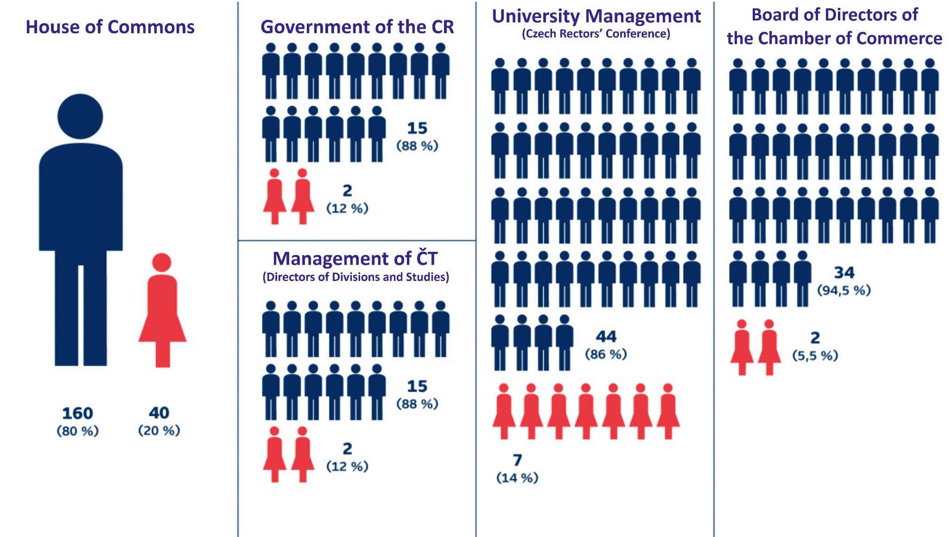between type T (thinking) and type F (feeling). (Dytrt, 2014, p. 131)

Source: ČT24

*Picture 1 Women in management positions*

Survey of the Role of Men and Women in Management in the Czech Republic

In 2013, research was conducted in the Czech Republic that mapped the roles of men and women in management. A total of 182 of the respondents answered using an electronic questionnaire. The whole survey is very extensive and it is not possible to completely interpret it in this seminar paper. The following points reflect the most important questions from the questionnaires:

The leadership style that is typical of women / men

According to the survey, the typical leadership style for women is perceived as collaborative and motivating, job security and career advancement. On the contrary, the leadership style for men is perceived as penetrating, aggressive, determined.

Perception of women and men who have achieved a high managerial position

The women here were mostly characterized as penetrating, but at the same time cooperating, understanding and helpful. Men who achieved high management positions were perceived primarily as penetrating, predatory and motivating.

Ethical behaviour of women and men

Almost more than 60% of respondents consider women to be more ethical. Given that women predominated among the respondents in the same proportion as men, men can also be self-projected. (Dytrt, 2014, pp. 136-143)

The Hidden Potential of Women

Today, women represent a potential for the economy and society that needs to be exploited. In some cases, young women are becoming more educated worldwide than men. In the case of the Czech Republic, girls outnumber boys at all levels of education. Women also recorded a higher proportion of university graduates under the age of 34 than men. However, women still have a weaker position compared to men in the position of company management and in politics. Less penetration and ambition may play a role, in some cases stereotype or prejudice. According to the author of the book, Mr. Dytrt, today's global society and economy need to absorb more feminine values ​​in order to survive. (Dytrt, 2014, p. 145-148)

Conclusion

In several of the above chapters, I have tried to briefly summarize the issue of women in top management. As I mentioned in the introduction, the whole topic is very extensive and I was able to write a lot of pages of texts and research about it. With the help of this seminar - essay work, I mainly wanted to highlight women who will take up the position of top management, because it is definitely not an easy task. Women can bring a certain oversight, humanity and individuality to the company's management.

As I wrote in the introduction to this work, I chose this topic mainly because I can make a personal comparison of management of men and women. For more than 3 years I had the opportunity to work under a director - male. As my first employer, I held him in high esteem and respect. But over time, I have come to realize that his approach to work or to people is absolutely unprofessional and, in most cases, unethical. I really liked working in the company, but the reason for my subsequent departure was the man in charge, who did not provide me with the necessary motivation or desire to create new visions or projects.

I currently work as a project manager and I am also an assistant to the company's executive and director. The director of the company is a man, on the contrary, the executive of the company is a woman, so I have the opportunity to ideally compare their approach to work or to any problems that need to be addressed at present. Everyone's approach is different, but in most cases, it leads to the same (or similar) conclusion. I really liked this job and the opportunity to be in communication in the leadership of both men and women. Of course, everyone has their pros and cons, but their very friendly and open approach always gives me the opportunity to implement their ideas and suggestions to the management.

In conclusion, I cannot fully assess and say which gender is best for management and top management, but it is certainly good to use both women and men in management. Each of them brings something different and at the same time they can enrich society with new areas of knowledge. However, it always depends on the very approach of the manager. If the person is motivated to work, they can pass on their enthusiasm to their employees and thus create a truly friendly and pleasant environment for them to perform their tasks, and thus at the same time realize the predetermined goals of the entire organization.

Bibliography

[1] ČT24: *V řídicích pozicích a politice je žen stále poskrovnu* [online]. Česká televize, © 1996–2021 [cit. 2021-12-15]. Dostupné z: https://ct24.ceskatelevize.cz/domaci/1508268-v-ridicich-pozicich-a-politice-je-zen-stale-poskrovnu

[2] DYTRT, Zdeněk. Etika v podnikatelském prostředí. Praha: Grada, 2006. ISBN 80-247-1589-9.

[3] DYTRT, Zdeněk. Ženy a management: kreativita, inovace, etika, kvalitativní management. Brno: Biz Books, 2014. ISBN 978-80-265-0150-3.