Revealing financial preferences in case of landscape amenity - Contingent valuation method

Eva Cudlinova, Miloslav Lapka

Institute of Landscape Ecology, Na sadkach 7, C.Budejovice, Czech Republic evacu@uek.cas.cz

Abstract

Evaluation of landscape amenity is not very common and relatively difficult from economic point of view. Appearance of new evaluation methods and their practical use has relatively short history. An explosion of these methods occurred in the 1960s and 1970s. In our case study focused on comparison of aesthetic preferences of Czech and Japan respondents to rural landscape we used contingent valuation method. We wanted to reveal respondents` preferences also in financial form. These preferences served us as quantitative indicators for attestation of respondents` qualitative aesthetical preferences. This study was a part of international grant “Perception of Landscape from evaluation to landscape planning” (Ministry of Education of the Czech Republic, ME 530). According preliminary results it seemed that strong correlation between aesthetical and financial evaluation probably exist in two extreme cases – respondents are not interested or are strongly involved in landscape amenity. The substantial difference between Czech and Japan respondents occurred in case of open or close access to landscape. We are aware of limited validity of our results. The interpretation of changes in the order of preferences must take into account the real change of money amount or index rank that are on the background. The high importance has also the probable relation between preferences and characteristic of respondents. In other words we come again to the common questions of evaluations – the importance who, what and how evaluates.

Key words : contingent valuation, landscape, aesthetical valuation

Introduction

Problem of landscape perception is connected with the beginning of the modern approach to landscape ecology from 1980s (IALE International Associations for Landscape Ecology was formed in 1982, Naveh, Liberman, 1983, book of general theory of landscape ecology).We can find even “schools” concentrated on methodology and approaches (Kaplan and Kaplan, 1989, Zube et al., 1982, Palmer, 1997).

The general problem of landscape perception could be labeled as “validity” and “stability” of the obtained social and aesthetic data. The problem of data “validity” is broadly discussed in aesthetics and sociology as well as landscape ecology (Aoki, 1999). Despite the fact that these data are subjective in nature, they show great social similarities across the many groups of a certain society. We can speak about the “aesthetic ideal” of landscape in a specific culture.

Our study tries to test the reliability of sociological method based on revealing aesthetical preferences supported by comparison with financial valuation. Application of contingent valuation method in this frame gives us also some information about validity of this method. Possible correlation between aesthetc and economic preferences could support the credibility of results gained by both methods.

Description of study area

The Novohradské Hory (Nové Hrady Mountains) lies along the Czech-Austrian border between the towns of Nové Hrady and Dolní Dvořiště. The mountains cover an area of 162 km² on the Czech side and approximately 120 km² in Austria. The highest peaks of the mountains are over 1,000 m high. Three of them are in the Czech part - Kamenec (1,072 m), Myslivna (1,040 m) and Vysoká (High - 1,034 m); and the rest of the eleven lie in Austria.
The Novohradské Hory (the Czech part) is a valuable untouched nature area with a lot of natural forests, which cover about 75% of the whole region, and with a large concentration of nature interests: the nature park Terčino Údolí (Theresa's Valley), the nature reserves Žofínský Prales (Žofín Forest) and Hojná Voda, etc. Due to its importance the Nature Park Novohradské Hory was established in 2000. This area was not open to the public for a long time after the Second World War, during the communist era. It was declassified and new tourist trails and infrastructure were founded here after 1989.
The south and south – east hillsides of the Novohradske Mts. Are in Austria. The line between the towns of Freistadt and Weitra makes roughly its south – east boundary. The landscape character is different than that on the Czech side: more cultivated, with a mosaic of small patches of farmland. Of course, the history after 1945 in this area was also completely different; there was no collectivization, no abandoned areas, and no „iron curtain“along all of the boundary.
Description of our sample
There was 18 Czech respondents, none professionally working in the Novohradske Mts, but involved in protection of the environment or similar activities. Because of the high number of students, we called the group „future experts“. Their average age was 28, with ten women and eight men. Three-fourths of the respondents had a university education or were university students, the remaining 25% graduated from secondary schools. The respondents came from small and middle-sized towns from all over the Czech Republic, as well as from Prague and Ceske Budejovice (44% and 31%).
The group of Japan respondents was slightly smaller that Czech one. There were about 12 students, with 8 men and 4 women with average about 23 years. All of them were university students of landscape architecture, so they were familiar with topic of landscape evaluation. The respondents came also from medium sized town.
Methods
Sociological as same as contingent valuation method (CVM) are often critisized because of a high level of subjectivity of gained results. The combination of these methods was used as to gain more precise results dealing with respondents` preferences related to the different type of landscape. The cultural difference between our two groups of respondents was choosen as to reveal the importance of the cultural background in respondents decision-making. In other words to reveal to which extent could be such a kind of results interpreted as an objective and valid for different cultural environment. From the point of view of CVM it could be important to know the role that cultural aspects could play in financial preferences.
a) Sociologic method of valuation aesthetic amenity of landscape
We used a modification of methods described in research concerning visual landscape perception (Hunziker, Kienast, 1999, Zube, et al. 1982). In the Novohradske Mts., it seemed useful to apply the methods used by Hutzinger (1999), who worked with the changing amount of woody patches in a landscape. But the Novohradske Mts. required other modification, because it is still a cultural rural landscape. So, we decided to evaluate the landscape in several stages of natural succession. Both Czech and Japan respondents were showen six areas in the natural succession gradient, from uncultivated former rural landscape to smaller shopping and industrial areas located in the suburb of a former rural town in Austria. (Fig. 1)
b) Economic valuation method of landscape amenity - CVM

Studies dedicated to contingent valuation do not label landscape preferences like aesthetic values, but no doubt they are working with these integrated values. (Willis,1994). CVM is the generic name given to a broad class of methods in which citizen respondents, confronted with choice problems defined by the researcher, reveal their willingness to pay (WTP) either directly or implicitly via decisions to buy or not at a given price (contingent purchase decision) a hypothetical proposition (Randall, 1987) . The most common form of application of CVM is the survey method. This method for revealing social preferences is deeply rooted in psychology and sociology. CVM method is most frequently used in the case of landscape amenity evaluation or changing landscape scenery. It was the main reason why we applied it in our case.
Our respondents were told that they were in a hypothetical situation where their annual salary was about 100 000 Crowns (which is about the average salary in Czech). They were then asked the following tasks:
1) Sort the landscape from the most to the least beautiful according to their personal feeling in the different types of landscapes.
2) Decide which amount of money from their hypothetical annual salary they are willing to pay for preserving the specific type of landscape in case that its future existence is threatened by change in management:
a) under the condition of free access to landscape scenery
b) under the condition of closed public access to landscape scenery

Japan respondents were asked the same questions with hypothetical annual salary of 300 000 Yen.

Results:

a) Results gained from sample of the Czech respondents

Table 1 shows in summary form our first results gained from the Czech sapmle.

Table 1. Valuation of the Czech landscape by the Czech respondents

Areas | Order of aesthetic preferences | Open for public  (thousands of CZK) | Public open -  Order | Public exclusive (thousands of CZK) | Public exclusive – Order
1  Industrial and shopping areas | 6. | 2, 0 | 6. | 1, 0 | 6.
2  Sub – urban rural landscape | 5. | 15, 0 | 5. | 11, 0 | 5.
3  Park landscape | 3. | 34, 0 | 4. | 16, 0 | 2.
4  Traditional conservation of rural landscape | 2. | 50, 0 | 3. | 15, 0 | 3 - 4.
5  Renewal of rural landscape | 1. | 55, 0 | 1-2. | 25, 0 | 1.
6  Fallow rural landscape | 4. | 55, 0 | 1-2. | 15, 0 | 3 - 4.

Note : Number 1 belongs to the most preferred landscape and number 6 to the least
preferred one.
On the base of revealed facts it seemed that strong correlation exists in two extreme cases – respondents are not interested or are strongly involved in landscape amenity.
Appraisal of industrial and urban landscape is relatively stable. It is very low and practically the same in both cases of aesthetic and financial evaluation The condition of open and closed access for public was just formal in these types of landscape it was used just to apply the same method for all landscapes. It seems that in case when respondents are not interested in landscape correlation between qualitative and quantitative classification is very close. Similarly the first place on the aesthetical chart for renewal rural landscape corresponds with the highest amount of money given to this type of landscape. More difficult is situation when aesthetical preferences are not such unique. As could be seen in the following two examples of park and fallow landscape.
Value of park area in case when it serves for public leisure is lower in comparison with situation when access is closed. It could seem a little bit creasy from the first point of view. But we must take into account the amount of financial sum that lies in the background of this situation. It is just one thousand of crowns difference between type of traditional conservation landscape and park one for closed access. This relatively small difference could result in the significant change in total order and interpretation. This situation could serve as a good example how fragile is such kind of sorting.
The other surprising fact is a shift in position of fallow landscape - from the forth place according qualitative valuation (amenity appraisal) to the nearly first place according financial valuation. The reason could be in educational backround of our respondentsand and their environmental orientation. They want to preserve landscape not for its amenity but due to its ecological value.

b) Results gained from sample of Japan respondents
CVM method was used also in case of Japan respondents – see Table 2 .
Table 2. Valuation of the Czech landscape by Japan respondents
Areas | Order of Aesthetic preferences | Public open -  Order | Open for public  (thousands of Yen) | Public exclusive – Order | Public exclusive (thousands of Yen)
1  Industrial and shopping areas | 6 | 6 | 2,5. | 4-5 | 6.3
2  Sub – urban rural landscape | 1 | 3 | 11,6. | 1 | 12,8
3  Park landscape | 4 | 2 | 11,9. | 2 | 7,3
4  Traditional conservation of rural landscape | 2 | 1 | 17,2. | 3 | 6.4
5  Renewal of rural landscape | 3 | 4 | 11,0 | 6 | 5,4
6  Fallow rural landscape | 5 | 5 | 9,7 | 4-5 | 6.2

Gained results from Japan respondents differed a little bit from the results of the Czech sample in tendency of close relation between aesthetic and finacial values. In spite of similarities in both types of valuation the correlation in Japan case is not so strong. In other words the high aesthetical preference is not always followed by the expression of the high willingnes to pay for certain kind of landscape. The different situation is also in the evaluation of landscape with excluded access of public. Japan respondents often gave higher financial preferences to landscape without access as to the public open one. In our opinion this apparent difference in valuation between Czech and Japan respondents simply reflects the cultural differences.

There is also significant difference in feeling of landscape beauty. In Czech sample it was renewed landscape that appeared at the top of aethetical scale in Japan case the same position gained the sub-urban type of landscape. Japan preferences for sub-urban landscape could be caused by prevailing typical character of Japan landscape. It is not characterised by sharp lines and borders its more landscape with disperse settlement. Renewing rural landscape so highly evaluated by Czech respondents is not so important in Japan case. Their renewing landscape has different character than Czech one and has no so symbolic importance as in Czech where it represents new beginning after socialist period.

The main influence in valuation plays especially the different concept of landscape and perception of its amenity. Landcsape according Japan concept is something like a picture, nice scenery of shapes and colours, picture often created in Japan gardens as a symbol of ideal world or Universum. In this relation landscape architects often speak about collor-scape, water - scape etc. Garden wall often separated this ideal landscape world from the surrounding area. Ideal Japan landscape is static something like a final art without natural motion and development. European conncept of landscape and its perception is more dynamic. People are living and creating landscape at the same time.

All these similarity and differences between Japan and Czech valuation described above are more visible showen in the following two graphs:
c) Comparison of Czech and Japan aesthetical and economic preferences
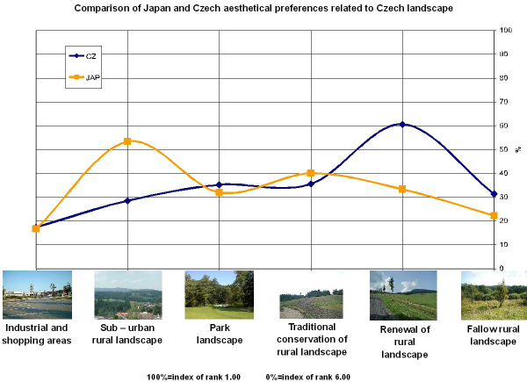
Graph describing aesthetic preferences transparently shows the different perception of landscape amenity in case of Czech and Japan culture as it was explained in the text above. It is the high value of sub-urban landscape for Japan on one side and renewal landscape for the Czech respondents.

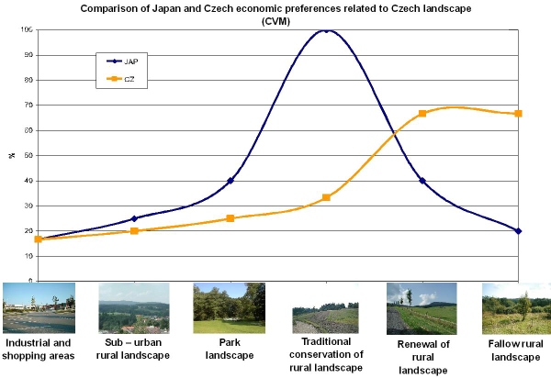
Graph comparing economic preferences of the Czech and Japan sample shows that the highest financial value was given also to the different types of landscape. In case of Czech it si renewed landscape but in Japan sample the highest financial value obtained the type of traditional conservation of rural landscape. These results arised out that Czech aesthetic preferences are relatively closed to financial ones in case of the aesthetic sensitive type of landscape. In Japan case it is a greater discrepance between aesthetic and economic valuation even in the case of landscape with the high aesthetical sensitivity. We could see a slight shift from suburban landscape favoured for its amenity and finacial preferences for traditional conserved landscape. The interpretation of this difference is not so easy as to be more sure we have to repeat our test with more groups of Japan respondents.
Conclusions
The results show relatively large changes in landscape perception in natural - rural areas. Traditional conservation land-use is somtimes considered too cultivated, being similar to parks or gardens. On the contrary, some stage of natural succession is often appreciated as the possibility of a new beginning as wellas the renewal, of the rural landscape. The willingness to spend money for area protection shows a dramatic difference in the case of visitor exclusion, especially in the Czech case.
In spite of these facts it seems that aesthetic values can play the role of a relatively stable cultural and social values for landscape planning. Thanks to this stability, we can use long-term vision about the future landscape without any natural or cultural discontinuity. Of course, the crucial questions for a data sampling procedure like this are the methods used and samples of respondents.
We recommend a combination of the method of landscape perception with contingent valuation methods. This practice could give us some kind of feedback and enable the more precise interpretation.
Anyway the interpretation of changes in the order of preferences must take into account the real change of money amount or index rank that are on the background. The high importance has also the probable relation between preferences and characteristic of respondents . In other words we come again to the basic questions - importance who, what and how evaluates.
Acknowledgement

This research is a part of ILE Research Intention No. AV0Z 6087904. This study was funded also by the Program Contact ME 530. Many thanks to Josef Maxa for preparing the database of all pictures from the Nové Hrady workshop.

Fig. 1
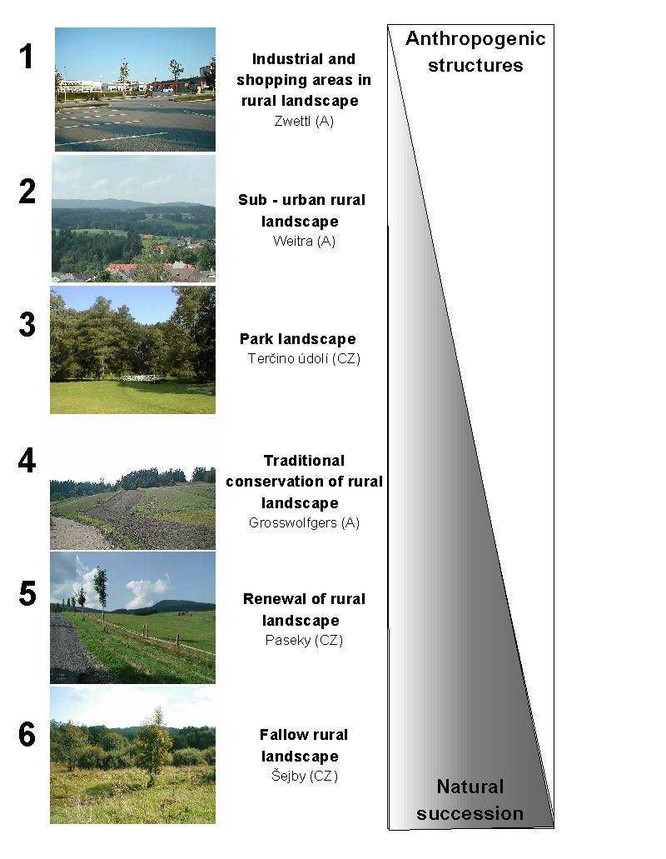
References
Hunziker, M., Kienast, F., 1999: Potential impacts of ganging agricultural activities on scenic beauty - a prototypical technique for automated rapid assessment. Landscape Ecology. Vol. 14, No. 2, p.161-185.

Kaplan, R. and Kaplan, S., 1989: The experience of Nature: A Psychological Perspective. Cambridge University Press, New York.

Naveh, Z, Lieberman, A., S., 1983: Landscape ecology, theory and application. Springer Verlag. New York, Berlin, Heidelberg, Tokyo.

Randall, A., 1987: Resource economics 2nd ed. New York, Wiley.
Willis, K., 1994: Contingent valuation in a policy context. Landscape Research, Vol. 19., No. 1., p.17-20.
Zube, E., H., Sell, J., L., and Taylor, J., G., 1982: Landscape perception: reserarch, application and theory. Landscape and Urban Planning, Vol. 9 No.1., p.1-33.

