Lecture notes - Lecture 2

Environment
= institutions and forces that potentially affect an organization’s performance

- external environment - general
- specific
- internal environment - organizational culture

External environment
- globalization = the worldwide process, which makes the world and its economic systems more uniform, more integrated, and more interdependent.
- ⇒ this influences management, too!!!
  - company location decisions – more possibilities around the world (qualified workforce, infrastructure, etc);
  - utilization of economic advantages
    - cost savings – lower costs in the host country;
    - economies of scale and scope;
    - common purchase of inputs
    - corporate tax optimization
  - better capital availability
  - minimization of risks
  - know-how spillovers
  - tougher competition
  - more uncertainty = the degree of change and complexity
    - dynamic
    - complex
      - complexity = the number of components and the degree of their interdependencies

Methods of environmental analysis
- general environment
  - SLEPT analysis
    - Social segment
      - attitudes about quality of work life
      - workforce diversity
      - women in the work force
      - work and career preferences
      - preferences regarding product and service characteristics
    - Legal segment
      - antitrust laws
      - taxation laws
      - labor training laws
    - Economic segment
      - inflation
      - interest rates
      - budget discipline
      - GDP
      - trade deficit / surplus
    - Political segment
      - economic policies
      - deregulation policies
      - educational policies
      - industry-specific policies
    - Technological segment
      - innovations
      - research and development
      - IS / IT
      - application of knowledge
  - general environmental analysis techniques
    - scanning = studying of all segments in the general environments in order to identify early signals of potential changes and to detect changes already under way.
    - monitoring = analysts observe environmental changes to see if an important trend is emerging.
    - forecasting = analysts develop feasible projections of what might happen and how quickly, as a result of changes and trends detected through scanning and monitoring.
    - assessing = determines the timing and significance of the effects of environmental changes and trends on the firm and its management.

- specific environment
  - stakeholder theory
    - the individuals and groups who can affect and are affected by the firm and who have enforceable claims on a firm’s performance.
  - Porter’s analysis – The Five Force Model of Competition
    - threat of new entrants
      - barriers to entry
        - economies of scale
        - capital requirements
        - access to distribution channels
      - expected retaliation against entry
    - bargaining power of suppliers
      - level of concentration of suppliers (a few large companies exist)
      - availability of substitutes
      - how significant customers buyers are for suppliers
      - how critical suppliers’ goods are for buyers’ success
    - bargaining power of buyers
    - threat of substitute products
      - level of switching costs to a substitute product
      - level of substitute product’s price (also depends on quality)
      - level of differentiation
    - rivalry among competing firms
      - level of concentration ⇒ many competitors = more intense competition
      - industry growth
      - level of fixed or storage costs
      - level of differentiation
      - level of switching costs
      - level of exit barriers

Internal environment
- organizational culture
SLEPT analysis
    - Social segment
      - attitudes about quality of work life
      - workforce diversity
      - women in the work force
      - work and career preferences
      - preferences regarding product and service characteristics
    - Legal segment
      - antitrust laws
      - taxation laws
      - labor training laws
    - Economic segment
      - inflation
      - interest rates
      - budget discipline
      - GDP
      - trade deficit / surplus
    - Political segment
      - economic policies
      - deregulation policies
      - educational policies
      - industry-specific policies
    - Technological segment
      - innovations
      - research and development
      - IS / IT
      - application of knowledge

Techniques used
Scanning = studying of all segments in the general environments in order to identify early signals of potential changes and to detect changes already under way.
Monitoring = analysts observe environmental changes to see if an important trend is emerging.
Forecasting = analysts develop feasible projections of what might happen and how quickly, as a result of changes and trends detected through scanning and monitoring.
Assessing = determines the timing and significance of the effects of environmental changes and trends on the firm and its management.
Porter’s analysis – The Five Force Model of Competition

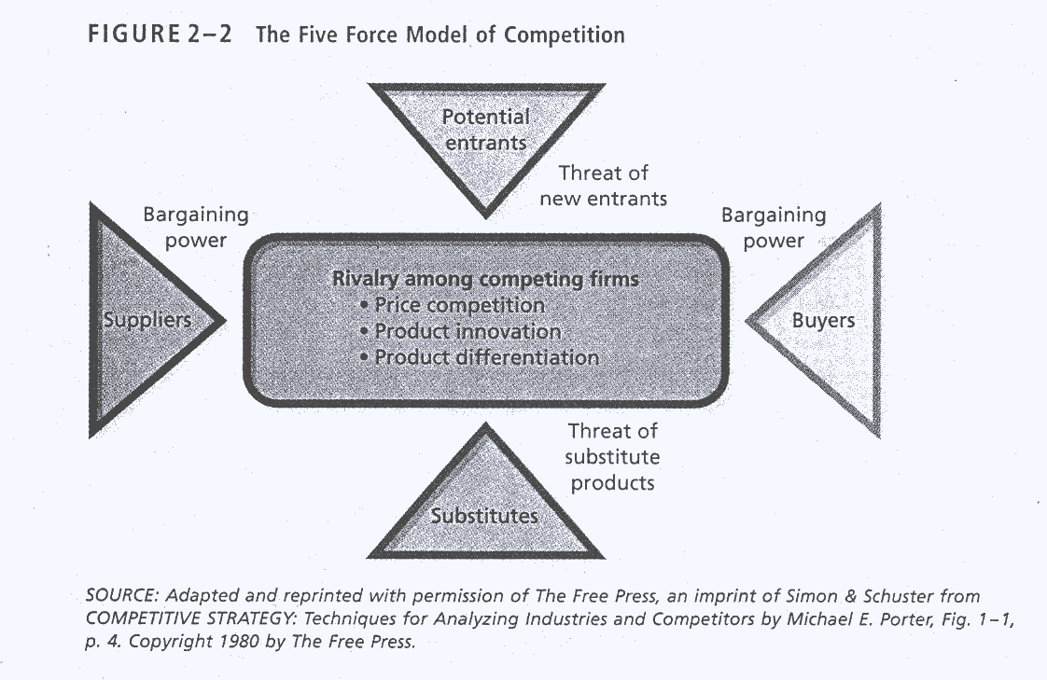

  - threat of new entrants
    - barriers to entry
      - economies of scale
      - capital requirements
      - access to distribution channels
    - expected retaliation against entry

  - bargaining power of suppliers
    - level of concentration of suppliers (a few large companies exist)
    - availability of substitutes
    - how significant customers buyers are for suppliers
    - how critical suppliers’ goods are for buyers’ success
  - bargaining power of buyers

  - threat of substitute products
    - level of switching costs to a substitute product
    - level of substitute product’s price (also depends on quality)
    - level of differentiation

  - rivalry among competing firms
    - level of concentration ⇒ many competitors = more intense competition
    - industry growth
    - level of fixed or storage costs
    - level of differentiation
    - level of switching costs
    - level of exit barriers
Organizational culture

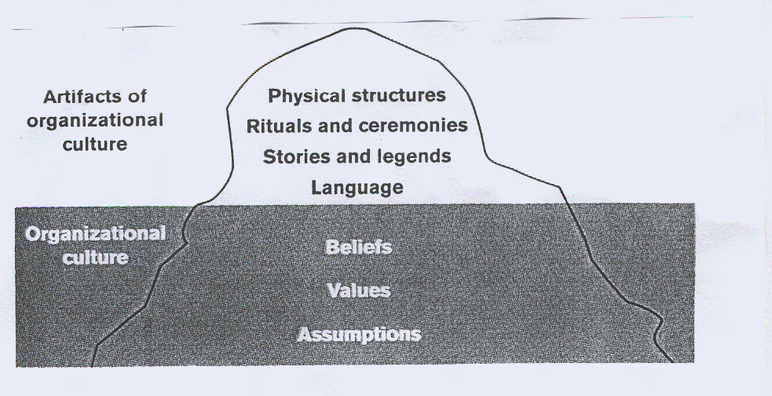

Assumptions = unconscious shared mental models, the broad worldviews or theories-in-use that people rely on to guide their perceptions and behaviors.
Example: 2 organizations, in both firms, assumptions about taking sick leave are taken for granted, but they are different:
Firm 1: employees assume that sick leave is their right to use whether or not they are sick
Firm 2: sick leave is reserved for real illness; employees would not imagine taking paid time off unless they are really sick.

Beliefs = an individuals perceptions of reality.

Values = more stable, long lasting beliefs about what is important. They help us define what is right of wrong, good or bad in the world.

Physical structures and symbols
- the way the buildings look like (size, shape, location)
- the way the furniture and the inside of buildings look like (desks, chairs, etc.)
- items that might convey cultural meaning.

Rituals = programmed routines of daily organizational life
- how visitors are greeted,
- how people communicate with each other,
- how much time employees take for lunch, etc.
Ceremonies = planned activities conducted specifically for the benefit of an audience
- publicly rewarding (punishing) employees,
- celebrating the launch of a new product,

Stories and legends – used for communicating cultural values by describing real people and real situations within the organization.

“Many years ago, a security guard stopped IBM CEO Thomas Watson, Jr. as he was about to enter an area without his identification badge. Watson explained who he was, but the guard insisted that a badge must be worn in secured areas of the building. Rather than discipline the guard, Watson praised him and used this experience to tell others about performing their job well.”

Language – is used to communicate the values. It highlights the values of the dominant culture as well as subcultures.
Reading for Lesson 2:
ROBBINS, S. P. Management. 4th ed. New Jersey : Prentice Hall, 1994. (ORG 126)
- Chapter 3, pp. 67 – 86
- Chapter 5, pp 117 – 173

Review questions for Lesson 2
  - Contrast strong and weak cultures. Which has the greatest impact on managers and why?
  - Select a socially responsible activity such as corporate philanthropy, environmental control, of advancement for minorities and women and expand upon how a corporation can specifically pursue its responsibility.
  - Why do managers try to minimize environmental uncertainty? How can they do that?

