http://ww2.nscc.edu/gerth_d/MKT2220000/Lecture_Notes/unit13.htm
Unit 13: Channels of Distribution, Logistics, and Wholesaling
The Importance of Distribution:
Most producers use intermediaries to bring their products to market. They try to develop a distribution channel (marketing channel) to do this. A distribution channel is a set of interdependent organizations that help make a product available for use or consumption by the consumer or business user. Channel intermediaries are firms or individuals such as wholesalers, agents, brokers, or retailers who help move a product from the producer to the consumer or business user.
A company’s channel decisions directly affect every other marketing decision. Place decisions, for example, affect pricing. Marketers that distribute products through mass merchandisers such as Wal-Mart will have different pricing objectives and strategies than will those that sell to specialty stores. Distribution decisions can sometimes give a product a distinct position in the market. The choice of retailers and other intermediaries is strongly tied to the product itself. Manufacturers select mass merchandisers to sell mid-price-range products while they distribute top-of-the-line products through high-end department and specialty stores. The firm’s sales force and communications decisions depend on how much persuasion, training, motivation, and support its channel partners need. Whether a company develops or acquires certain new products may depend on how well those products fit the capabilities of its channel members.
Some companies pay too little attention to their distribution channels. Others, such as FedEx, Dell Computer, and Charles Schwab have used imaginative distribution systems to gain a competitive advantage.
Functions of Distribution Channels
Distribution channels perform a number of functions that make possible the flow of goods from the producer to the customer. These functions must be handled by someone in the channel. Though the type of organization that performs the different functions can vary from channel to channel, the functions themselves cannot be eliminated. Channels provide time, place, and ownership utility. They make products available when, where, and in the sizes and quantities that customers want. Distribution channels provide a number of logistics or physical distribution functions that increase the efficiency of the flow of goods from producer to customer. Distribution channels create efficiencies by reducing the number of transactions necessary for goods to flow from many different manufacturers to large numbers of customers. This occurs in two ways. The first is called breaking bulk. Wholesalers and retailers purchase large quantities of goods from manufacturers but sell only one or a few at a time to many different customers. Second, channel intermediaries reduce the number of transactions by creating assortments—providing a variety of products in one location—so that customers can conveniently buy many different items from one seller at one time. Channels are efficient. The transportation and storage of goods is another type of physical distribution function. Retailers and other channel members move the goods from the production site to other locations where they are held until they are wanted by customers. Channel intermediaries also perform a number of facilitating functions, functions that make the purchase process easier for customers and manufacturers. Intermediaries often provide customer services such as offering credit to buyers and accepting customer returns. Customer services are oftentimes more important in B2B markets in which customers purchase larger quantities of higher-priced products.
Some wholesalers and retailers assist the manufacturer by providing repair and maintenance service for products they handle. Channel members also perform a risk-taking function. If a retailer buys a product from a manufacturer and it doesn’t sell, it is “stuck” with the item and will lose money. Last, channel members perform a variety of communication and transaction functions. Wholesalers buy products to make them available for retailers and sell products to other channel members. Retailers handle transactions with final consumers. Channel members can provide two-way communication for manufacturers. They may supply the sales force, advertising, and other marketing communications necessary to inform consumers and persuade them to buy. And the channel members can be invaluable sources of information on consumer complaints, changing tastes, and new competitors in the market.

The Internet in the Distribution Channel
By using the Internet, even small firms with limited resources can enjoy some of the same competitive advantages as their largest competitors in making their products available to customers internationally at low cost. E-commerce can result in radical changes in distribution strategies. Today most goods are mass-produced, and in most cases end users do not obtain products directly from manufacturers. With the Internet, however, the need for intermediaries and much of what has been assumed about the need and benefits of channels will change. In the future, channel intermediaries that physically handle the product may become largely obsolete. Many traditional intermediaries are already being eliminated as companies question the value added by layers in the distribution channel. This removal of intermediaries is termed disintermediation, the elimination of some layers of the distribution channel in order to cut costs and improve the efficiency of the channel.
Wholesaling:
Wholesaling is all activities involved in selling products to those buying for resale or business use. Wholesaling intermediaries are firms that handle the flow of products from the manufacturer to the retailer or business user.
Wholesaling intermediaries add value by performing one or more of the following channel functions:
- Selling and Promoting
- Buying and Assortment Building
- Bulk-Breaking
- Warehousing
- Transportation
- Financing
- Risk Bearing
- Market Information – giving information to suppliers and customers about competitors, new products, and price developments
- Management Services and Advice – helping retailers train their sales clerks, improving store layouts and displays, and setting up accounting and inventory control systems.
Independent Intermediaries
Independent intermediaries do business with many different manufacturers and many different customers. Because they are not owned or controlled by any manufacturer, they make it possible for many manufacturers to serve customers throughout the world while keeping prices low.
Merchant Wholesalers
Merchant wholesalers are independent intermediaries that buy goods from manufacturers and sell to retailers and other B2B customers. Because merchant wholesalers take title to the goods, they assume certain risks and can suffer losses if products get damaged, become out-of-date or obsolete, are stolen, or just don’t sell. At the same time, because they own the products, they are free to develop their own marketing strategies including setting prices. Merchant wholesalers include full-service merchant wholesalers and limited-service wholesalers. Limited-service wholesalers are comprised of cash-and-carry wholesalers, truck jobbers, drop shippers, mail-order wholesalers, and rack jobbers.
Merchandise Agents or Brokers
Merchandise agents or brokers are a second major type of independent intermediary. Agents and brokers provide services in exchange for commissions. They may or may not take possession of the product, but they never take title; that is, they do not accept legal ownership of the product. Agents normally represent buyers or sellers on an ongoing basis, whereas brokers are employed by clients for a short period of time. Merchandise agents or brokers include manufacturers’ agents (manufacturers’ reps), selling agents, commission merchants, and merchandise brokers.
Manufacturer-Owned Intermediaries
Manufacturer-owned intermediaries are set up by manufacturers in order to have separate business units that perform all of the functions of independent intermediaries, while at the same time maintaining complete control over the channel. Manufacturer-owned intermediaries include sales branches, sales offices, and manufacturers’ showrooms. Sales branches carry inventory and provide sales and service to customers in a specific geographic area. Sales offices do not carry inventory but provide selling functions for the manufacturer in a specific geographic area. Because they allow members of the sales force to be located close to customers, they reduce selling costs and provide better customer service. Manufacturers’ showrooms permanently display products for customers to visit. They are often located in or near large merchandise marts, such as the furniture market in High Point, North Carolina.
Types of Distribution Channels:
The first step in selecting a marketing channel is determining which type of channel will best meet both the seller’s objectives and the distribution needs of customers.
Channel Length
Distribution channels can be described as being either short or long. A short channel involves few intermediaries. A long channel, on the other hand, involves many intermediaries working in succession to move goods from producers to consumers. In general, business products tend to move through shorter channels than consumer products due to geographical concentrations and comparatively few business purchases. Service firms market primarily through short channels because they sell intangible products and need to maintain personal relationships within their channels. Not-for-profit institutions also tend to work with short, simple, and direct channels. Please note Table 15.1 below that highlights the characteristics of short and long marketing channels.
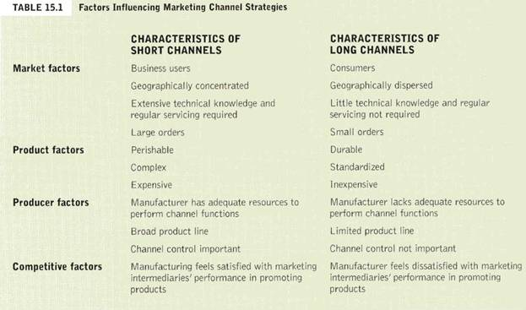
Consumer Channels
The simplest and shortest distribution channel is a direct channel. A direct channel carries goods directly from a producer to the business purchaser or consumer. One of the newest means of selling in a direct channel is the Internet. A direct channel may allow the producer to serve its customers better and at a lower price than is possible using a retailer. Sometimes a direct channel is the only way to sell the product because using channel intermediaries may increase the price above what consumers are willing to pay. Another reason to use a direct channel is control.
Many producers, however, choose to use indirect channels to reach consumers. Customers are familiar with certain retailers or other intermediaries and habitually turn to them when looking for what they need. Intermediaries also help producers fulfill the channel functions previously cited. By creating utility and transaction efficiencies, channel members make producers’ lives easier and enhance their ability to reach customers.
The producer-retailer-consumer channel is the shortest indirect channel. GE uses this channel when it sells small appliances through large retailers such as Wal-Mart or Sears. The producer-wholesaler-retailer-consumer channel is another common distribution channel in consumer marketing.
Business-to-Business Channels
B2B distribution channels facilitate the flow of goods from a producer to an organizational customer. Generally, B2B channels parallel consumer channels in that they may be direct or indirect. The simplest indirect channel in industrial markets occurs when the single intermediary—a merchant wholesaler referred to as an industrial distributor rather than a retailer—buys products from a manufacturer and sells them to business customers. Direct channels are more common to business-to-business markets because B2B marketing often means selling high-dollar, high-profit items to a market made up of only a few customers. In such markets, it pays for a company to develop its own sales force and sell directly to customers at a lower cost than if it used intermediaries.
Channels for Services
Because services are intangible, there is no need to worry about storage, transportation, and the other functions of physical distribution. In most cases, the service travels directly from the producer to the customer. Some services, however, do need an intermediary, often called an agent, who helps the parties complete the transaction. Examples include insurance agents, stockbrokers, and travel agents.
Note the alternative distribution channels for consumer goods, business goods, and services illustrated in Figure 15.2 below:
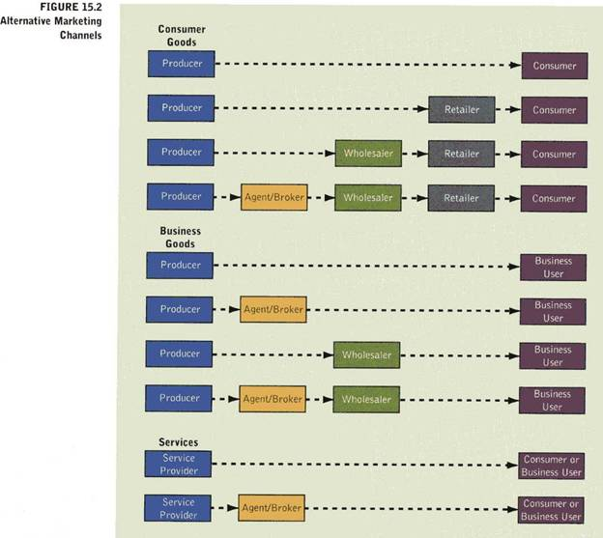
Horizontal Marketing Systems
A horizontal marketing system is a channel arrangement in which two or more companies at one level join together to follow a new marketing opportunity. By working together, companies can combine their financial, production, or marketing resources to accomplish more than any one company could alone. Companies can join forces with competitors or noncompetitors. McDonald’s places “express” versions of its restaurants in Wal-Mart stores. McDonald’s benefits from Wal-Mart’s considerable store traffic, while Wal-Mart keeps hungry shoppers from having to go elsewhere to eat.
Multichannel Distribution Systems
A multichannel distribution system is a distribution system in which a single firm sets up two or more marketing channels to reach one or more customer segments. This is also called a hybrid marketing channel. Multichannel distribution systems offer many advantages to companies facing large and complex markets. With each new channel, the company expands its sales and market coverage and gains opportunities to tailor its products to the specific needs of diverse customers. Multichannel distribution systems, however, are harder to control, and they generate conflict as more channels compete for customers and sales.
Channel Strategy:
Marketers face several strategic decisions in choosing channels and marketing intermediaries for their products. Selecting a specific channel is the most basic of these decisions. Marketers must also resolve questions about the level of distribution intensity, the desirability of vertical marketing systems, and the performance of current intermediaries.
Marketing Channel Selection
Marketing channel selection can be facilitated by analyzing market, product, producer, and competitive factors. A marketer could refer to Table 15.1 above for insights into whether the distribution channel should be short or long for the product in question. Then, he or she could refer to Figure 15.2 above and consider the alternative long or short channels for consumer goods, business goods, or services.
Distribution Intensity
Distribution intensity refers to the number of intermediaries through which a manufacturer distributes its goods. The decision about distribution intensity should ensure adequate market coverage for a product. In general, distribution intensity varies along a continuum with three general categories: intensive distribution, selective distribution, and exclusive distribution.
Intensive Distribution
An intensive distribution strategy seeks to distribute a product through all available channels in an area. Usually, an intensive distribution strategy suits items with wide appeal across broad groups of consumers, such as convenience goods.
Selective Distribution
Selective distribution is distribution of a product through only a limited number of channels. This arrangement helps to control price cutting. By limiting the number of retailers, marketers can reduce total marketing costs while establishing strong working relationships within the channel. Moreover, selected retailers often agree to comply with the company’s rules for advertising, pricing, and displaying its products. Where service is important, the manufacturer usually provides training and assistance to dealers it chooses. Cooperative advertising can also be utilized for mutual benefit. Selective distribution strategies are suitable for shopping products such as clothing, furniture, household appliances, computers, and electronic equipment for which consumers are willing to spend time visiting different retail outlets to compare product alternatives. Producers can choose only those wholesalers and retailers that have a good credit rating, provide good market coverage, serve customers well, and cooperate effectively. Wholesalers and retailers like selective distribution because it results in higher sales and profits than are possible with intensive distribution where sellers have to compete on price.
Exclusive Distribution
Exclusive distribution is distribution of a product through one wholesaler or retailer in a specific geographical area. The automobile industry provides a good example of exclusive distribution. Though marketers may sacrifice some market coverage with exclusive distribution, they often develop and maintain an image of quality and prestige for the product. In addition, exclusive distribution limits marketing costs since the firm deals with a smaller number of accounts. In exclusive distribution, producers and retailers cooperate closely in decisions concerning advertising and promotion, inventory carried by the retailers, and prices. Exclusive distribution is typically used with products that are high priced, that have considerable service requirements, and when there are a limited number of buyers in any single geographic area. Exclusive distribution allows wholesalers and retailers to recoup the costs associated with long selling processes for each customer and, in some cases, extensive after-sale service. Specialty goods are usually good candidates for this kind of distribution intensity.
Channel Conflict
The channel captain or leader, the dominant and controlling member of a distribution channel, must work to resolve conflicts between channel members. Conflicts can be horizontal and vertical.
Horizontal & Vertical Conflict
Horizontal conflict occurs among firms at the same level of the channel (i.e. between two retailers). Vertical conflict is conflict between different levels of the same channel (i.e. between a wholesaler and a retailer). Some conflict in the channel takes the form of healthy competition. Severe or prolonged conflict, however, can disrupt channel effectiveness and cause lasting harm to channel relationships.
Vertical Marketing Systems
A vertical marketing system (VMS) is a distribution channel structure in which producers, wholesalers, and retailers act as a unified system. One channel member owns the others, has contracts with them, or has so much power that they all cooperate. A conventional distribution channel consists of one or more independent producers, wholesalers, and retailers. A vertical marketing system, on the other hand, provides a way to resolve the channel conflict that can occur in a conventional distribution channel where channel members are separate businesses seeking to maximize their own profits—even at the expense sometimes of the system as a whole. The VMS can be dominated by the producer, wholesaler, or retailer. There are three major types of vertical marketing systems: corporate, contractual, and administered.
A corporate VMS is a vertical marketing system that combines successive stages of production and distribution under single ownership—channel leadership is established through common ownership. A little-known Italian eyewear maker, Luxottica, sells its many famous eyewear brands—including Giorgio, Armani, Yves Saint Laurent, and Ray-Ban—through the world’s largest optical chain, LensCrafters, which it also owns.
A contractual VMS is a vertical marketing system in which independent firms at different levels of production and distribution join together through contracts to obtain more economies or sales impact than they could achieve alone. Coordination and conflict management are attained through contractual agreements among channel members. The franchise organization is the most common type of contractual relationship. There are three types of franchises: manufacturer-sponsored retailer franchise system (Ford Motor Co.), manufacturer-sponsored wholesaler franchise system (Coca-Cola bottlers), and service-firm-sponsored retailer franchise system (McDonald’s). The fact that most consumers cannot tell the difference between contractual and corporate VMSs shows how successfully the contractual organizations compete with corporate chains.
An administered VMS is a vertical marketing system that coordinates successive stages of production and distribution, not through common ownership or contractual ties, but through the size and power of one of the parties. Manufacturers of a top brand can obtain strong trade cooperation and support from resellers (P&G). Large retailers such as Wal-Mart can exert strong influence on the manufacturers that supply the products they sell.
Logistics:
Logistics is the process of designing, managing, and improving the movement of products through the supply chain. The supply chain is all the firms that engage in activities necessary to turn raw materials into a product and put it in the hands of the consumer or business customer. The difference between a supply chain and a distribution channel is the number of members and their function. A supply chain consists of those firms that supply the raw materials, component parts, and supplies necessary for a firm to produce a product plus the firms that facilitate the movement of that product from the producer to the ultimate users of the product—the channel members.
Physical Distribution
Logistics has the objective of delivering exactly what the customer wants—at the right time, in the right place, and at the right price. In planning for the delivery of goods to customers, marketers have usually looked at a process termed physical distribution, which refers to the activities used to move finished goods from manufacturers to final customers. Physical distribution activities include order processing, warehousing, materials handling, transportation, and inventory control. This process impacts how marketers physically get products where they need to be, when they need to be there, and at the lowest possible cost.
In logistics, the focus is on the customer. When planning for the logistics function, firms consider the needs of the customer first. The customer’s goals become the logistics provider’s goals. With most logistics decisions, firms must compromise between low costs and high customer service.
Note: The above lecture notes were compiled by David Gerth. These materials are a composite of quotations, paraphrases, and ideas from Marketing: Real People, Real Choices, Solomon & Stuart, 2003, Prentice Hall; Contemporary Marketing, Boone & Kurtz, 2004, Thomson; Principles of Marketing, Kotler & Armstrong, 2004, Prentice Hall; and David Gerth. They are only intended for the noncommercial use of students in David Gerth’s marketing classes for educational purposes.

