Product design
The purpose of any organization is to provide products or services to its customers. An organization can gain a competitive edge through designs that bring new ideas to the market quickly, do a better job of satisfying customer needs, or are easier to manufacture, use, and repair than existing products and services.
Product design specifies which materials are to be used, determines dimensions and tolerances, defines the appearance of the product, and sets standards for performance.
Service design specifies what physical items, sensual benefits, and psychological benefits the customer is to receive from the service.
Design has a tremendous impact on the quality of a product or service. For example: What if the design does not meet customer needs or the design is difficult or costly to make? What if the design process takes so much time that a competitor is able to introduce new products, services, or features before we can? What if, in rushing to be first to the market, our design is flawed? An effective design process:
- Matches product or service characteristics with customer requirements,
- Ensures that customer requirements are met in the simplest and least costly manner,
- Reduces the time required to design a new product or service, and
- Minimizes the revisions necessary to make a design workable.

Strategy and Design
Design is a critical process for a firm. Strategically, it defines a firm's customers, as well as its competitors. It capitalizes on a firm's core competencies and determines what new competencies need to be developed. It is also the most obvious driver of change--new products and services often define new markets and require new processes.
New products can rejuvenate an organization, even an industry. Ford's Taurus, GM's Saturn, and Chrysler's minivan saved the American automobile industry. Motorola's Bandit pager, HP's DeskJet printer, and Kodak's FunSaver camera turned their corporations around. But the benefits from a newly designed product or service are more than increased revenues and market share. The design process itself is beneficial because it encourages companies to look outside their boundaries, bring in new ideas, challenge conventional thinking, and experiment. Product and service design provide a natural venue for learning, breaking down barriers, working in teams, and integrating across functions.
In this chapter we examine the design process with an eye toward ensuring quality in products and services, and enhancing strategic capabilities. The impact of technology on design and the differences between product and service design are also discussed.

*5-1. Donald Norman has published several books on design - The Design of Everyday Things, Turn Signals are the Facial Expressions of Automobiles, and Things that Make Us Smart. Locate one of his books at your local library, bookstore, or Internet site and read about his "spin" on design. Choose an example to discuss.
5-2. Look around your classroom and make a list of items that impede your ability to learn. Classify them as problems in quality of design or quality of conformance.
*5-3. Some designs of products and services are inherently bad. Read about them at the bad designs web site. Make a list of the factors that make a design unworkable. Which one of the designs on the website is your favorite? What are your candidates for bad design?
*These exercises require a direct link to a specific Web site. Click Internet Exercises for the list of internet links for these exercises.

The Design Process
The design process cuts across functional departments, requiring input, coordination, and action from marketing, engineering, and production. The process begins with ideas. Ideas for new products or improvements to existing products can be generated from many sources, including a company's own R&D department, customer complaints or suggestions, marketing research, suppliers, salespersons in the field, factory workers, actions by competitors, and new technological developments. Figure 5.1(a) shows customers generating ideas for a product concept that is sent to the marketing department. If the proposed product meets market and economic expectations, performance specifications for the product are developed and sent to the company's design engineers to be developed into preliminary technical specifications and then detailed design specifications. The design specifications are sent to the manufacturing engineers, who develop specific requirements for equipment, tooling, and fixtures. These manufacturing specifications are passed on to production personnel on the factory floor, where production of the new product can be scheduled.
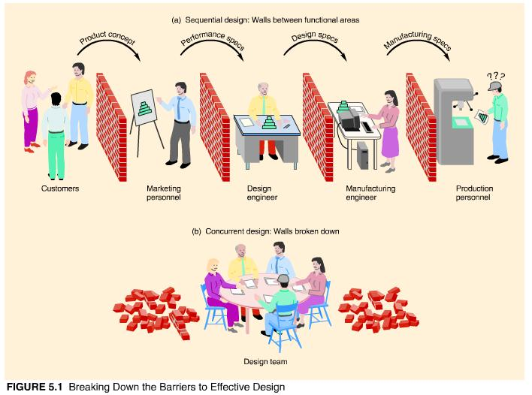
When the steps of the design process are performed sequentially, physical and mental "walls" tend to build up between functional areas and departments. When this happens, the output from one design stage is "thrown over the wall" to the next stage, with little discussion or feedback. A more enlightened view of product and service design brings representatives from the various functions and departments together to work on the design concurrently, as shown in Figure 5.1(b).
Figure 5.2 outlines the design process from idea generation to manufacture. Let us examine each step in more detail.
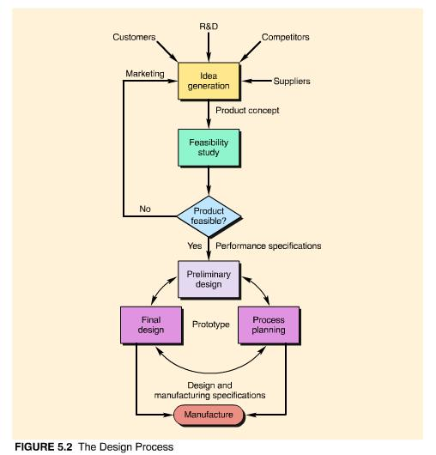

Idea Generation
Product innovation comes from understanding the customer and actively identifying customer needs. There are a variety of ways to garner customer input. Would-be customers as well as existing customers should be surveyed. The toughest and more exacting customers provide the most useful information. Customer surveys can be followed up with smaller focus groups or individual customer interviews. Field testing is imperative and should be done as soon as possible.
Anyone who comes in contact with a company's product or customers is a potential source of new product ideas. A formal channel for inputting ideas from suppliers, distributors, salespersons, and workers should be established--and used. Companies also need to use the information that is readily available to them through trade journals, government reports, and the news media, as well as a careful analysis of their own successes and failures.
Competitors are also a source of ideas for new products or services. Perceptual maps, benchmarking, and reverse engineering can help companies learn from their competitors.
Perceptual maps compare customer perceptions of a company's products with competitor products. Consider the perceptual map of breakfast cereals in terms of taste and nutrition shown in Figure 5.3. The lack of an entry in the good-taste, high-nutrition category suggests there are opportunities for this kind of cereal in the market. This is why Cheerios introduced honey-nut and apple-cinnamon versions while promoting its "oat" base. Fruit bits and nuts were added to wheat flakes to make them more tasty and nutritious. Shredded Wheat opted for more taste by reducing its size and adding a sugar frosting or berry filling. Rice Krispies, on the other hand, sought to challenge Cocoa Puffs in the "more tasty" market quadrant with marshmallow and fruit-flavored versions.
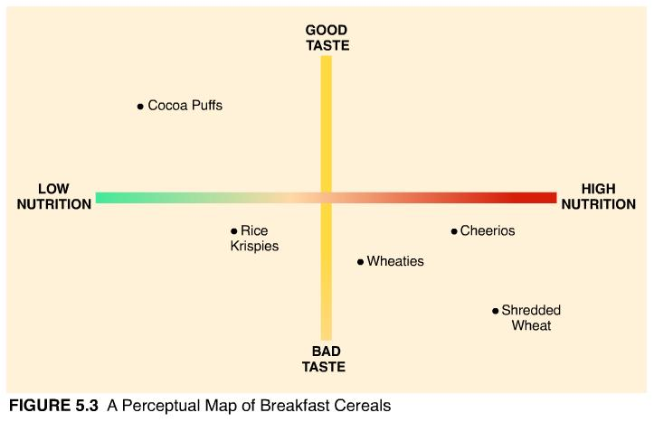
Benchmarking refers to finding the best-in-class product or process, measuring the performance of your product or process against it, and making recommendations for improvement based on the results. The benchmarked company may be in an entirely different line of business. For example, American Express is well-known for its ability to get customers to pay up quickly; Disney World, for its employee commitment; Federal Express, for its speed; McDonald's, for its consistency; and Xerox, for its benchmarking techniques.
Reverse engineering refers to carefully dismantling and inspecting a competitor's product to look for design features that can be incorporated into your own product. Ford used this approach successfully in its design of the Taurus automobile, assessing 400 features of competitor products and copying, adapting, or enhancing more than 300 of them, including Audi's accelerator pedal, Toyota's fuel-gauge accuracy, and BMW's tire and jack storage.
For many products and services, following consumer or competitor leads is not enough; customers are attracted by superior technology and creative ideas. In these industries, research and development is the primary source of new product ideas. Expenditures for R&D can be enormous ($2 million a day at Kodak!) and investment risky (only one in every twenty ideas ever becomes a product and only one of every ten new products is successful). In addition, ideas generated by R&D may follow a long path to commercialization.

Planning the Coming Home division
Home textiles represents a new direction for Lands' End. The company decided to enter the new market when it noticed a decline in the quality of mill output. In the 1980s, a dozen textile mills were consolidated into three major ones, whose focus was keeping the mills busy. Volume and efficiency were emphasized at the expense of quality. With expertise in both textiles and cut-and-sew, Lands' End saw its chance to provide high quality home textiles that would exceed customer expectations.
The Coming Home (CH) division was created and given the task of creating a better sheet. CH management held focus groups with potential customers and analyzed the entire sheet market. What they came up with was a sheet with a totally unique design--12 inch deep corners, six inches longer in length, and elastic that extends around the entire sheet with a 2-to-1 stretch ratio. Then they began looking for a mill that could produce a sheet of exceptional quality. They found one in Switzerland. The mill had never made sheets, but their operations were impressive. So their technical people and Lands' End product people worked together, testing two or three different runs of various weaves. They settled on a Swiss sateen. It took a year and a half to bring the new sheet to market, but the results were worth it. You've probably seen copies of the design in Lands' End competitor catalogs.
Of course, Lands' End isn't about to stand still. Their next new product venture in the CH division was window treatments. Why? Look at how the market for drapes is divided--ready-made, made-to-measure, and custom-made. Ready-mades are cheap and of lesser quality, but always available. Made-to-measure are better quality, but take four to six weeks for delivery. Custom-made are the best quality, but require an interior decorator and can take six months to a year to deliver. Lands' End found its niche by offering top quality window treatments in virtually any size or dimension delivered in a matter of days. And to replace the interior decorator--a catalog full of ideas, along with step-by-step instructions and an online "window expert."

Feasibility Study
Marketing takes the ideas that are generated and the customer needs that are identified from the first stage of the design process and formulates alternative product concepts. The promising concepts undergo a feasibility study that includes several types of analyses, beginning with a market analysis. Most companies have staffs of market researchers who can design and evaluate customer surveys, interviews, focus groups, or market tests. The market analysis assesses whether there's enough demand for the proposed product to invest in developing it further.
If the demand potential exists, then there's an economic analysis that looks at estimates of production and development costs and compares them to estimated sales volume. A price range for the product that is compatible with the market segment and image of the new product is discussed. Quantitative techniques such as cost/benefit analysis, decision theory, net present value, or internal rate of return are commonly used to evaluate the profit potential of the project. The data used in the analysis are far from certain. Estimates of risk in the new product venture and the company's attitude toward risk are also considered.
Finally, there are technical and strategic analyses that answer such questions as: Does the new product require new technology? Is the risk or capital investment excessive? Does the company have sufficient labor and management skills to support the required technology? Is sufficient capacity available for production? Does the new product provide a competitive advantage for the company? Does it draw on corporate strengths? Is it compatible with the core business of the firm?
Performance specifications are written for product concepts that pass the feasibility study and are approved for development. They describe the function of the product--that is, what the product should do to satisfy customer needs.

Preliminary Design
Design engineers take general performance specifications and translate them into technical specifications. The process involves creating a preliminary design: building a prototype, testing the prototype, revising the design, retesting, and so on, until a viable design is determined. Design incorporates both form and function.
Form design refers to the physical appearance of a product--its shape, color, size, and style. Aesthetics such as image, market appeal, and personal identification are also part of form design. In many cases, functional design must be adjusted to make the product look or feel right. For example, the form design of Mazda's Miata sports car went further than looks--the exhaust had to have a certain "sound," the gearshift lever a certain "feel," and the seat and window arrangement the proper dimensions to encourage passengers to ride with their elbows out.
Functional design is concerned with how the product performs. It seeks to meet the performance specifications of fitness for use by the customer. Two performance characteristics considered during this phase of design are reliability and maintainability.
Reliability is the probability that a given part or product will perform its intended function for a specified length of time under normal conditions of use. You may be familiar with reliability information from product warranties. A hair dryer might be guaranteed to function (i.e., blow air with a certain force at a certain temperature) for one year under normal conditions of use (defined to be 300 hours of operation). A car warranty might extend for three years or 50,000 miles. Normal conditions of use would include regularly scheduled oil changes and other minor maintenance activities. A missed oil change or mileage in excess of 50,000 miles in a three-year period would not be considered "normal" and would nullify the warranty.
A product or system's reliability is a function of the reliabilities of its component parts and how the parts are arranged. If all parts must function for the product or system to operate, then the system reliability is the product of the component part reliabilities. For example, if two component parts are required and they each have a reliability of 0.90, the reliability of the system is 0.90 ∞ 0.90 = 0.81, or 81 percent. The system can be visualized as a series of components as follows:

Note that the system reliability of 0.81 is considerably less than the component reliabilities of 0.90. As the number of serial components increases, system reliability will continue to deteriorate. This makes a good argument for simple designs with fewer components!
Failure of some components in a system is more critical than others--the brakes on a car, for instance. To increase the reliability of individual parts (and thus the system as a whole), redundant parts can be built in to back up a failure. Providing emergency brakes for a car is an example. Consider the following redundant design with R₁ representing the reliability of the original component and R₂ the reliability of the backup component.

These components are said to operate in parallel. If the original component fails (a 5 percent chance), the backup component will automatically kick in to take its place--but only 90 percent of the time. Thus, the reliability of the system is the 0.95 reliability of the original component plus the 0.90 reliability of the backup component, which is called in (1 − 0.95) of the time, or R₁ + R₂ (1 − R₁)= 0.95 + 0.90 (1 − 0.95) = 0.995.
Reliability can be improved by simplifying product design, improving the reliability of individual components, or adding redundant components. Products that are easier to manufacture or assemble, are well maintained, and have users who are trained in proper use have higher reliability.
Maintainability refers to the ease and/or cost with which a product is maintained or repaired. Products can be made easier to maintain by assembling them in modules, like computers, so that entire control panels, cards, or disk drives can be replaced when they malfunction. The location of critical parts or parts subject to failure affects the ease of disassembly and, thus, repair. Instructions that teach consumers how to anticipate malfunctions and correct them themselves can be included with the product. Specifying regular maintenance schedules is part of maintainability, as is proper planning for the availability of critical replacement parts.

Final Design and Process Planning
Final design produces detailed drawings and specifications for the new product after the preliminary design has been tested and trial production has taken place. Process planning converts designs into workable instructions for manufacture, selects and orders necessary equipment and tooling, decides which components will be made inhouse and which will be purchased from a supplier, prepares job descriptions and procedures for workers, determines the order of operations and assembly, and programs automated machines. We discuss process planning in more detail in the next chapter.
Referring to Figure 5.2, notice the circular flow from preliminary design to process planning to final design, and back around again, if necessary. This reflects the design-build-test-produce emphasis of concurrent design (which is analogous to Deming's plan-do-check-act cycle). Portions of the new product are designed in preliminary form; then a prototype is built and tested with other parts of the design. If the tests are successful, a trial process is run to simulate manufacture under actual factory conditions. Adjustments are made as needed before the final design is agreed upon. In this way, the design specifications for the new product have considered how the product is to be produced, and the manufacturing specifications more closely reflect the intent of the design. This should mean less revisions in the design as the product is manufactured. Design changes are a major source of delay and cost overruns in the product development process.

*5-4. Explore benchmarking at the International Benchmarking Clearinghouse and the Benchmarking Exchange. What are the ethics of benchmarking? What types of things do the Clearinghouse and the Exchange benchmark? Access one of the free benchmarking reports. Summarize the report's findings.
5-5. Find out if your university benchmarks itself against other universities. If so, write a summary of the characteristics that are considered, the measures that are used, and the results. Do the data support your views as a customer?
5-6. Describe the strategic significance of design.
5-7. Differentiate between performance specifications, design specifications, and manufacturing specifications.
5-8. Discuss several methods for generating new product ideas.
5-9. Construct a perceptual map for the following products or services: (a) business schools in your state or region, (b) spreadsheet packages, and (c) video rental stores. Label the axes with the dimensions you feel are most relevant. Explain how perceptual maps are used.
5-10. How does modular design differ from standardization?
*These exercises require a direct link to a specific Web site. Click Internet Exercises for the list of internet links for these exercises.

Improving the Design Process
Many companies known for creativity and innovation in product design are slow and ineffective at getting new products to the market. Problems in converting ideas to finished products may be caused by poor manufacturing practices, but more than likely they are the result of poor design.
Design decisions affect sales strategies, efficiency of manufacture, speed of repair, and product cost. The impact on product cost is significant. It has been estimated that from 60 percent to 80 percent of the cost to produce a product is fixed during the design process--before manufacturing has had a chance to see the design. Manufacturing requests for changes in product design are not well received because of the high cost of changes and because an adjustment in one part may cause an adjustment in other parts, "unraveling" the entire product design.
Changes in design, known as engineering change orders (ECOs), increase dramatically in cost as the product is closer to production. For example, a major design change for an electronics product might cost $1,000 during the design phase, $100,000 during the planning stage for manufacture, and $10,000,000 during final production! With these cost differentials in mind, examine Figure 5.4, which shows two scenarios for the distribution of design changes. Clearly, company 1 has a competitive advantage in product development costs. What is not so obvious is its quality advantage. For company 1, a stable design allows manufacturing personnel to "get used to" and become skilled at producing the new product, thereby making fewer mistakes.
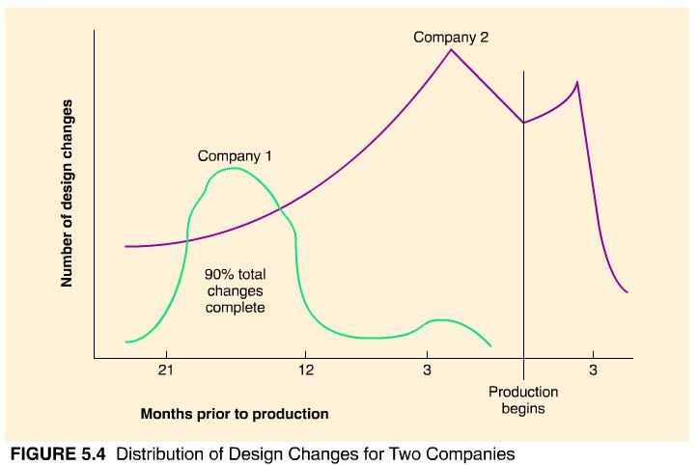
Improving the design process to remain competitive in the world market involves completely restructuring the decision-making process and the participants in that process. The series of walls between functional areas portrayed in Figure 5.1 must be broken down and replaced with new alliances and modes of interaction. This feat can be accomplished by:

- Establishing multifunctional design teams,
- Making product and process design decisions concurrently rather than sequentially,
- Designing for manufacture and assembly,
- Designing for the environment,
- Measuring design quality,
- Utilizing quality function deployment, and
- Designing for robustness.
We discuss each of these in the following sections.

Design Teams
The team approach to product design has proved to be successful worldwide. Full-time participants from marketing, manufacturing, and engineering are essential to effective product design. Customers, dealers, suppliers, lawyers, accountants, and others are also useful team members. A recent study of new product launchings in high-technology firms concluded that the critical factor between success and failure was the involvement and interaction of the "create, make, and market" functions from the beginning of the design project. Ford Motor Company has been a leader in the team approach to product design in the automotive industry and in U.S. industry. Team design of the Taurus automobile beat all previous development efforts by coming in well before schedule and $400 million under budget. Other automobile manufacturers followed suit.
Team Viper allowed DaimlerChrysler to bring the Viper sports car from concept to full production in less than three years and $2 million under budget. Working in a team was a cultural change for DaimlerChrysler engineers. The team (ranging from 20 to 85 members) met in one large room of a refurbished warehouse. Walls were literally torn down to encourage team members to communicate and work together.
Requests for bids on Viper parts were released to vendors with only functional dimensions. Vendors were given a Team Viper list and expected to contact team members directly if they ran into any problems. Four assembly line workers, called craftpersons, were trained at each manufacturing station of a mock assembly line set up in the design facility. By field-testing each work station as it was developed, the workers were able to point out potential assembly problems to the engineers before a design was committed. When the testing was complete, each worker had received more than 600 hours of training and could assemble the car from scratch.
One final note: The design team was not dismantled when the design was finished. Although smaller in size, it exists to this day and will remain intact for the life of the product to work on continuous improvements, either for ease of manufacture or to increase the product's fitness for use by the customer.
Team Neon used a technique called quality function deployment to convert customer needs into design specifications. From this they learned that consumers wanted a small car that felt like a big one and was reliable, fun to drive, and safe. Power windows and four-speed transmission weren't important, but standard dual airbags and reinforced doors were. Costs (but not corners) were cut by selling identical cars at Chrysler and Dodge dealerships (a $10 million savings in tooling costs) and allowing only one exterior molding (a savings of $50 per car). The team looked at cost in a broader sense. In one case, they chose a higher-cost fold-down seat because it saved $1.1 million in simplified final assembly. They also considered all 4,000 suggestions for improvement from assembly line workers.
Was the design team successful? The Neon design was finished 3 months ahead of schedule and right on its $1.3 billion budget (in comparison, Saturn took seven years to develop and cost $5 billion). The car went into production costing $500 less to build than any competing subcompact.

From a functional to a team approach
Prior to 1994, product development at Lands' End was separated into five different departments--creative ideas, merchandising, quality, inventory, and design--which were located on separate floors of the main building. Communication was difficult and the product development process was far too time-consuming. A task force decided that cross-functional teams would alleviate a lot of the problems. But how many teams were needed and how should they be formed?
The task force visited several vendors and respected companies to gain another perspective on the product development process (and to benchmark). The result? Teams were set up for major product categories, such as adult sleepwear. The teams were permanent--once team members were assigned, they were no longer shared with other teams. Each team consisted of a merchandiser, an inventory manager, a quality assurance specialist, a copywriter, an artist, and a support person. The members colocated and shared a workspace where team meetings, vendor appointments, and product-fit sessions could be held.
Since the teams have been operational, the average time to bring new products to market has decreased significantly, and fewer design changes are necessary. Teams helped people do their jobs better, improved communications, and sparked creativity--and besides, as LE employees will tell you--"they're just more fun."

Concurrent Design
Concurrent design helps improve the quality of early design decisions and thereby reduces the length and cost of the design process. Product-design decisions are extended to process decisions whenever possible. In this manner, one stage of design is not completely finished before another stage begins.
One example of concurrent design is suppliers who complete the detailed design for the parts they will supply. A study of product development in automobile manufacturing revealed that Japanese firms prepare an engineering design for only 30 percent of their parts (suppliers do the rest), whereas American firms design 81 percent of their component parts. In the traditional design process, U.S. manufacturers determine component design in detail, down to the fraction of an inch, including the specific material to be used. Detailed engineering drawings are made, and only then are suppliers called in to submit their bids. Japanese manufacturers, on the other hand, provide general performance specifications to their component suppliers, such as these:
Design a set of brakes that can stop a 2,200-pound car from 60 miles per hour in 200 feet ten times in succession without fading. The brakes should fit into a space 6 inches ∞ 8 inches ∞ 10 inches at the end of each axle and be delivered to the assembly plant for $40 a set.²
The supplier is asked to prepare a prototype for testing. Detailed decisions are left up to the supplier, as a member of the design team who is the expert in that area. This approach saves considerable development time and resources.
The role of design engineer is both expanded and curtailed in the concurrent design process. Design engineers are no longer totally responsible for the design of the product. At the same time, they are responsible for more than what was traditionally considered "design." Their responsibilities extend to the manufacture and continuous improvement of the product as well.
In many cases, design engineers do not have a good understanding of the capabilities or limitations of their company's manufacturing facilities. Increased contact with manufacturing can sensitize them to the realities of making a product. Simply consulting manufacturing personnel early in the design process about critical factors or constraints can improve the quality of product design. This is where most companies begin their efforts in changing the corporate culture from a separated design function to one that is integrated with operations. IBM called their efforts in this area EMI--early manufacturing involvement. Initially, one manufacturing engineer was assigned to each product-development group. Later, more engineering staff were reassigned and physically relocated. In at least one instance, new design facilities were built within walking distance of where manufacturing occurred. The increased communication between design and manufacturing so improved the quality of the final product that IBM quickly threw out the term EMI and adopted CMI--continuous manufacturing involvement.
One more difference between sequential design and concurrent design is the manner in which prices are set and costs are determined. In the traditional process, the feasibility study includes some estimate of price to be charged to the customer, but that selling price is not firmed up until the end of the design process, when all the product costs are accumulated, a profit margin is attached, and it is determined whether the original price estimate and the resulting figure are close. This is a cost-plus approach. If there are discrepancies, either the product is sold at the new price, a new feasibility study is made, or the designers go back and try to cut costs. Remember that design decisions are interrelated; the further back in the process you go, the more expensive are the changes.
Concurrent design uses a price-minus system. A selling price (that will give some advantage in the marketplace) is determined before design details are developed. Then a target cost of production is set and evaluated at every stage of product and process design. Techniques such as value analysis (which we discuss later) are used to keep costs in line.
Even with concurrent design, product design and development can be a long and tedious process. Because concurrent design requires that more tasks be performed in parallel, the scheduling of those tasks is even more complex than ever. Project-scheduling techniques, such as PERT/CPM (discussed in Chapter 17), are being used to coordinate the myriad of interconnected decisions that constitute concurrent design.

Design for Manufacture
Design for manufacture (DFM) describes designing a product so it can be produced easily and economically. DFM views product design as the first step in manufacturing a product. DFM identifies product-design characteristics that are easy to manufacture, focuses on the design of component parts that are easy to fabricate and assemble, and integrates product design with process planning. DFM ensures that manufacturing concerns are systematically incorporated into the design process. When successful, DFM not only improves the quality of product design but also reduces the time and cost of both product design and manufacture.
DFM guidelines are statements of good design practice that can lead to good--but not necessarily optimum--designs. Examples include the following:
- Minimize the number of parts.
- Develop a modular design.
- Design parts for many uses.
- Avoid separate fasteners.
- Eliminate adjustments.
- Make assembly easy and foolproof. If possible, design for top-down assembly.
- Design for minimal handling and proper presentation.
- Avoid tools.
- Minimize subassemblies.
- Use standard parts when possible.
- Simplify operations.
- Design for efficient and adequate testing and replacement of parts.
- Use repeatable, well-understood processes.
- Analyze failures.
- Rigorously assess value.
Let's see how these guidelines can be applied.
Consider the assembly shown in part (a) of Figure 5.5. It consists of 24 parts (lots of fasteners) and takes 84 seconds to assemble. The design is typical, in that the parts are common and cheap and nuts and bolts are used as fasteners. It does not appear to be complex, unless the assembly task is automated. For a robot to assemble this item, the method of fastening needs to be revised.
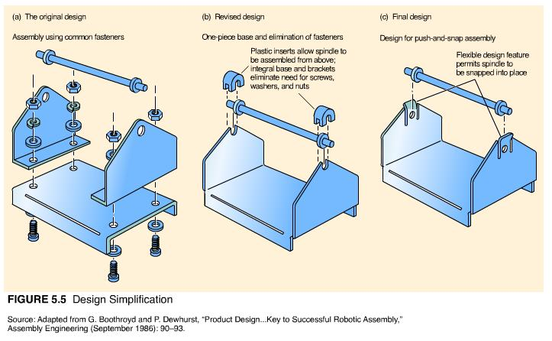
The design shown in Figure 5.5(b) has been simplified by molding the base as one piece and eliminating the fasteners. Plastic inserts snap over the spindle to hold it in place. The number of parts has been reduced to four, and the assembly time has been cut to 12 seconds. This represents a significant gain in productivity, from 43 assemblies per hour to 300 assemblies per hour.
Figure 5.5(c) shows an even simpler design consisting of only two parts, a base and spindle. The spindle is made of flexible material, allowing a quick, one-motion assembly: Snap the spindle downward into place. Now the assembly task seems too simple for a robot. Indeed, many manufacturers have followed this process in rediscovering the virtues of simplification--in redesigning a product for automation, they have found that automation isn't necessary!
Using standard parts in a product or throughout many products saves design time, tooling costs, and production worries. Standardization makes possible the interchangeability of parts among products, resulting in higher-volume production and purchasing, lower investment in inventory, easier purchasing and material handling, fewer quality inspections, and fewer difficulties in production. Some products, such as light bulbs, batteries, and VCR tapes, benefit from being totally standardized. For others being different is a competitive advantage. The question becomes how to gain the cost benefits of standardization without losing the market advantage of variety and uniqueness.
One solution is modular design. Modular design consists of combining standardized building blocks, or modules, in a variety of ways to create unique finished products. Modular design is common in the electronics industry and the automobile industry. Even Campbell's Soup Company practices modular design by producing large volumes of four basic broths (beef, chicken, tomato, and seafood bisque) and then adding special ingredients to produce 125 varieties of final soup products.
Design for assembly (DFA) is a set of procedures for reducing the number of parts in an assembly, evaluating methods for assembly, and determining an assembly sequence. DFA was developed by Professors Boothroyd and Dewhurst at the University of Massachusetts. It provides a catalog of generic part shapes classified by means of assembly, along with estimates of assembly times. For example, some parts are assembled by pushing; others, by pushing and twisting or pushing, twisting, and tilting. Guidelines are given for choosing manual versus automated assembly, avoiding part tangling or nesting in feeding operations, achieving the fewest number of reorientations of the parts during assembly, finding the fewest assembly steps, and determining the most foolproof sequence of assembly. The best sequence of assembly differs considerably for manual versus automated assembly. Manual assembly is concerned with maintaining a balance between operations on the assembly line; automated assembly is concerned with minimizing the reorientation of parts for assembly. Common assembly mistakes include hiding parts that later need to be inspected, disassembling already assembled parts to fit new parts in, and making it difficult to access parts that need maintenance or repair.
THE COMPETITIVE EDGE
Simplification and Standardization Save Money
Workers and engineers at Ford's Chicago and Atlanta plants formed plant vehicle teams to suggest ways to trim the cost of the 1997 Taurus. Design changes were approved on the spot, eliminating months of phone calls, electronic mail, and meetings. Their changes were minor--use recycled plastic for splash shields ($0.45 savings), redesign door hinge pins ($2 savings), put an integrated bracket on the air conditioner's accumulator bottle ($4 savings), use plastic moldings for the moon roof instead of metal ($7.85 savings), and so forth--totaling $180 per vehicle or $73 million per year!
Ford also saved money, reduced its inventory, and eased the transition to new vehicles by using the same parts on different models. Switching from eighteen different air filters to five saved $0.45 per vehicle or $3 million per year. Reducing types of carpet from nine to three saved $1.25 per vehicle or $9 million annually. Standardizing on one out of fourteen cigarette lighters and one trunk carpet instead of seven saved $1.16 per car or $5 million annually. That's a total savings of $17 million per year.
Of course, Ford competitors are cost-cutting their designs, too. The 1997 Camry sold for $1,500 less than the older version, Honda's new model Accord is priced 20% lower, and Nissan's Infiniti costs 10.5% less. And at the same time, standard features such as air bags and ultraviolet protection glass have been added. Toyota is known for enlisting the help of its suppliers in reducing cost--challenging a supplier to make seats for $20 instead of $30, for example--but few would have expected Chrysler to work so well with its suppliers in reducing costs. The SCORE program (for supplier cost reduction effort) asks vendors to identify cost-cutting opportunities equal to 5% of its annual billings to Chrysler. To prevent capricious cost-cutting that may affect quality, ideas are submitted to Chrysler for approval. So far 16,000 ideas have been received for a total savings of $2.5 billion. Chrysler's supplier base has been cut by 36% in the past five years and will be cut an additional 25% by the year 2000. An important factor in survival is a supplier's SCORE savings.
Chrysler "supplier expertise" was a key selling point in the DaimlerChrysler merger.
Sources: Oscar Suris "How Ford Cut Costs on Its 1997 Taurus, Little by Little," The Wall Street Journal, July 18, 1996; Karen Schwartz, "Small Changes Save Companies Big Bucks," Roanoke Times, March 23, 1996; and Justin Martin, "Are You as Good as You Think You Are?" Fortune (September 30, 1996): 14546.

Technology in Design
New products for more segmented markets have proliferated over the past decade. Changes in product design are more frequent and product life cycles are shorter. Hewlett-Packard derives more than 50 percent of its sales from products developed within the past three years. IBM estimates the average life of its new product offerings is about six months. Sony has introduced more than 160 different models of its Walkman over the past ten years. The ability to get new products to the market quickly has revolutionized the competitive environment and changed the nature of manufacturing.
Part of the impetus for the deluge of new products is the advancement of technology available for designing products. It begins with computer-aided design (CAD) and includes related technologies such as computer-aided engineering (CAE) and computer-aided manufacturing (CAM).

Computer-Aided Design
Computer-aided design (CAD) is a software system that uses computer graphics to assist in the creation, modification, and analysis of a design. CAD can be used for geometric modeling, automated drafting and documentation, engineering analysis, and design analysis. Geometric modeling uses basic lines, curves, and shapes to generate the geometry and topology of a part. The part may appear as a wire mesh image or as a shaded, solid model. Once an object has been input into the system, it can be displayed and manipulated in a variety of ways. The design can be rotated for a front, side, or top view, separated into different parts, enlarged for closer inspection, or shrunk back so that another feature can be highlighted. The CAD database created from the geometric design includes not only the dimensions of the product but also tolerance information and material specifications. Libraries of designs can be accessed so that designers can modify existing designs instead of building new ones from scratch.
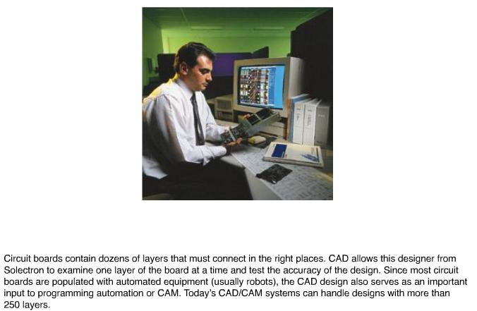
Automated drafting produces engineering drawings directly from the CAD database. More advanced documentation merges text and graphics to produce assembly drawings, bills of material, instruction manuals and reports, parts catalogs, and sales brochures. Figure 5.10 shows a series of CAD drawings and an engineering analysis of a sample product.
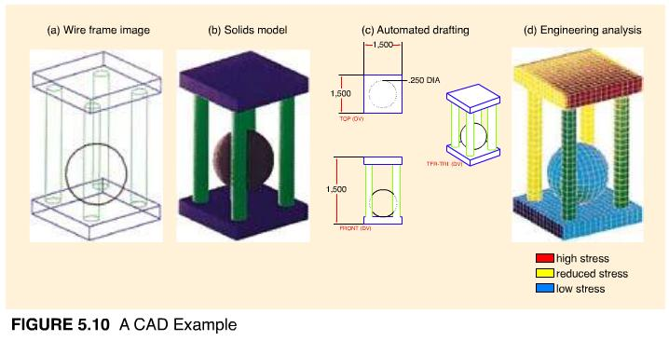
Although the ability to combine, copy, translate, scale, and rotate designs or portions of designs is impressive, CAD is more than a drafter's version of a word processor. Its real power is derived from the ability to electronically link design with other automated systems. Engineering analysis, when performed at a computer terminal with a CAD system, is called computer-aided engineering (CAE). CAE retrieves the description and geometry of a part from a CAD database and subjects it to testing and analysis on the computer screen without physically building a prototype. CAE can maximize the storage space in a car trunk, detect whether plastic parts are cooling evenly, and determine how much stress will cause a bridge to crack. With CAE, design teams can watch a car bump along a rough road, the pistons of an engine move up and down, or a golf ball soar through the air. In the field of chemistry, reactions of chemicals can be analyzed on a computer screen. And, in medicine, the effects of new drugs can be tested on computer-generated DNA molecules. Aerodynamic CAD/CAE software can replace expensive wind tunnels. Cyberman, a computer mannequin, tests the ergonomics of a design by examining arm reach, pedal position, and steering-column angle for automobiles.
The ultimate design-to-manufacture connection is a CAD/CAM system. CAM is the acronym for computer-aided manufacturing. It basically refers to control of the manufacturing process by computers. CAD/CAM involves the automatic conversion of CAD design data into processing instructions for computer-controlled equipment and the subsequent manufacture of the part as it was designed. This integration of design and manufacture can save enormous amounts of time, ensure that parts and products are produced precisely as intended, and facilitate revisions in design or customized production.
Benefits of CAD. CAD radically reduces the leadtime for new product introduction. CAD's time advantage is not being able to draw lines faster, but being able to find them faster. The drafting of an original design by computer is not significantly faster than drafting by hand, but revising and adapting existing designs is almost twelve times faster. The ability to sort, classify, and retrieve similar designs facilitates standardization of parts, prompts ideas, and eliminates building a design from scratch.
CAD-generated products can be introduced faster to the market because they can be tested more quickly. CAE systems interacting with CAD databases can test the functioning of a design so thoroughly that a prototype may never be built. Costly mistakes in design or production can be avoided because materials, parts fit, and conditions of use can be tested on the screen. Time to manufacture can also be reduced with CAD-initiated designs of molds, dies, and processing instructions. Documentation of CAD designs allows the information to be printed out in various forms for multiple users--as a parts list, sales catalog, or assembly instructions.
Besides the time savings, CAD and its related technologies have also improved the quality of designs and the products manufactured from them. The communications capabilities of CAD may be more important than its processing capabilities in terms of design quality. CAD systems enhance communication and promote innovation in multifunctional design teams by providing a visual, interactive focus for discussion. Watching a vehicle strain its wheels over mud and ice prompts ideas on product design and customer use better than stacks of consumer surveys or engineering reports. New ideas can be suggested and tested immediately, allowing more alternatives to be evaluated. To facilitate discussion or clarify a design, CAD data can be sent electronically between designer and supplier or viewed simultaneously on computer screens by different designers in physically separated locations. Rapid prototypes can be tested more thoroughly with CAD/CAE. More prototypes can be tested as well. CAD improves every stage of product design and is especially useful as a means of integrating design and manufacture.

*5-20. Visit IBM's CADAM site. Read about state-of-the-art CAD methodologies around the world. What kind of technology is currently available? What benefits does it provide?
*These exercises require a direct link to a specific Web site. Click Internet Exercises for the list of internet links for these exercises.

Service Design
Services that are allowed to just "happen" rarely meet customer needs. The service provider is left to figure out what the customer wants and how the service should be provided without sufficient support from management, policies and procedures, or physical surroundings. World-class services that come to mind--McDonald's, Nordstrom, Federal Express, Disney World--are all characterized by impeccable design. McDonald's plans every action of its employees (including forty-nine steps to making perfect french fries); Nordstrom creates a pleasurable shopping environment with well-stocked shelves, live music, fresh flowers in the dressing rooms, and legendary salespersons; Federal Express designs every stage of the delivery process for efficiency and speed; and Disney World in Japan was so well designed that it impressed even the zero-defect Japanese.
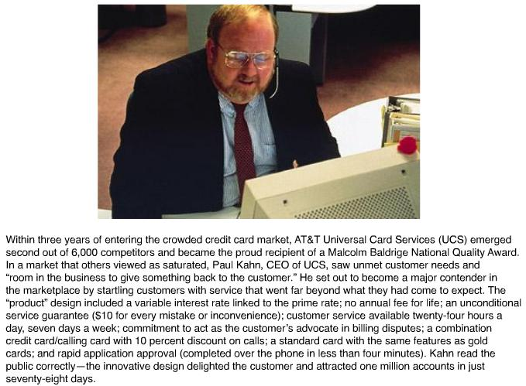
Can services be designed in the same manner as products? If we substitute the word service for product, and delivery for manufacture in Figure 5.2, the design process would look much the same, but there are some important differences. Let's examine them.

Characteristics of Services
Services can be distinguished from manufacturing by the following eight characteristics. Although not all services possess each of these characteristics, they do exhibit at least some of them to some degree.
- Services are intangible. It is difficult to design something you cannot see, touch, store on a shelf, or try on for size. Services are experienced, and that experience may be different for each individual customer. Designing a service involves describing what the customer is supposed to "experience," which can be a difficult task. Designers begin by compiling information on the way people think, feel, and behave (called psychographics).
Because of its intangibility, consumers perceive a service more risky to purchase than a product. Cues (such as physical surroundings, server's demeanor, and service guarantees) need to be included in service design to help form or reinforce accurate perceptions of the service experience and reduce the consumer's risk.
The quality of a service experience depends largely on the customer's service expectations. Expectations can differ according to a customer's knowledge, experience, and self-confidence. The medical profession has done a masterful job of conditioning patients to be told little, accept what happens to them on faith, and not to be disappointed when medical problems are not corrected. Medical personnel who exceed these expectations, even by a small margin, are perceived as delivering outstanding service.⁷
Customers also have different expectations of different types of service providers. You probably expect more from a department store than a discount store, or from a car dealer's service center than an independent repair shop. Understanding the customer and his or her expectations is essential in designing good service.
- Service output is variable. This is true because of the various service providers employed and the variety of customers they serve, each with his or her own special needs. Even though customer demands vary, the service experience is expected to remain consistent. According to a recent survey, reliability and consistency are the most important measures of service quality to the customer.⁸ Service design, then, must strive for predictability or robustness. Examples of services known for their consistency include McDonald's, Holiday Inn, and ServiceMaster. Extensive employee training, set operating procedures, and standardized materials, equipment, and physical environments are used by these companies to increase consistency.
- Services have high customer contact. The service "encounter" between service provider and customer is the service in many cases. Making sure the encounter is a positive one is part of service design. This involves giving the service provider the skills and authority necessary to complete a customer transaction successfully. Studies show a direct link between service provider motivation and customer satisfaction. Moreover, service providers are motivated primarily not by compensation but rather by concurrence with the firm's "service concept" and being able to perform their job competently.⁹
High customer contact can interfere with the efficiency of a service and make it difficult to control its quality (i.e., there is no opportunity for testing and rework). However, direct contact with customers can also be an advantage for services. Observing customers experiencing a service generates new service ideas and facilitates feedback for improvements to existing services.
- Services are perishable. Because services can't be inventoried, the timing and location of delivery are important. Service design should define not only what is to be delivered but also where and when.
- Consumers do not separate the service from the delivery of the service. That means service design and process design must occur concurrently. (This is one area in which services have an advantage over manufacturing--it has taken manufacturing a number of years to realize the benefits of concurrent design.) In addition to deciding "what, where, and when," service design also specifies how the service should be provided. "How" decisions include the degree of customer participation in the service process, which tasks should be done in the presence of the customer (called front-room activities) and which should be done out of the customer's sight (back-room activities), the role and authority of the service provider in delivering the service, and the balance of "touch" versus "tech" (i.e., how automated the service should be).
- Services tend to be decentralized and geographically dispersed. Many service employees are on their own to make decisions. Although this can present problems, careful service design will help employees deal successfully with contingencies. Multiple service outlets can be a plus in terms of rapid prototyping. New ideas can be field-tested with a minimum disturbance to operations. McDonald's considers each of its outlets a "laboratory" for new ideas.
- Services are consumed more often than products, so there are more opportunities to succeed or fail with the customer. Jan Carlzon of SAS Airlines calls these opportunities "moments of truth." In a sense, the service environment lends itself more readily to continuous improvement than does the manufacturing environment.
- Services can be easily emulated. Competitors can copy new or improved services quickly. New ideas are constantly needed to stay ahead of the competition. As a result, new service introductions and service improvements occur even more rapidly than new product introductions.

A Well-Designed Service System
A well-designed service system is¹⁰:
- Consistent with the strategic focus of the firm--if the firm competes on speed, then every element of the service process should encourage speed.
- User-friendly: Clear signs and directions, understandable forms, logical steps in the process, and accessible service providers.
- Robust: Able to cope with surges in demand, resource shortages, and varying customer expectations.
- Easy to sustain: Workers are given manageable tasks and the technology is supportive and reliable.
- Effectively linked between front office and back office activities.
- Cost-effective: No wasted time or resources, or appearance of inefficiency.
- Visible to the customer: Customers should clearly see the value of the service provided.
Service design is more comprehensive and occurs more often than product design. The inherent variability of service processes requires that the service system be carefully designed. In services, the design process incorporates both service design and delivery. As shown in Figure 5.11, service design begins with a service concept and ends with service delivery. Let's examine each step in more detail.
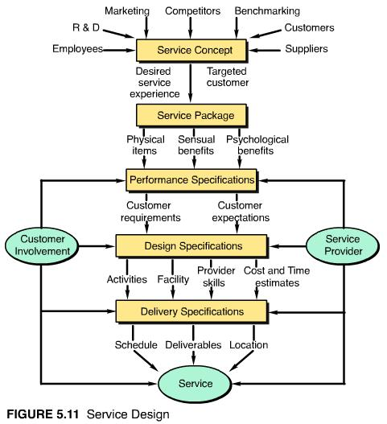

The Service Concept
Like the product concept described in Figure 5.2, ideas for new or improved services are generated from many sources--from customers to R&D, from suppliers to employees. The service concept that emerges defines the target customer and the desired customer experience.
From the service concept, a service package or bundle is created to meet customer needs. The package consists of a mixture of physical items, sensual benefits, and psychological benefits.¹¹ For a restaurant the physical items consist of the facility, food, drinks, tableware, napkins, and other touchable commodities. The sensual benefits include the taste and aroma of the food and the sights and sounds of the people. Psychological benefits could be rest and relaxation, comfort, status, or a sense of well-being.
The key to effective service design is to recognize and define all the components of a service package--none of the components should be left to chance. Finding the appropriate mix of physical items and sensual and psychological benefits and designing them to be consistent with each other is also important. A fast-food restaurant promises nourishment with speed. The customer is served quickly and is expected to consume the food quickly. Thus, the tables, chairs, and booths are not designed to be comfortable, nor does their arrangement encourage lengthy or personal conversations. The service package is consistent. This is not the case for an upscale restaurant located in a renovated train station. The food is excellent, but it is difficult to enjoy a full-course meal sitting on wooden benches in a drafty facility, where conversations echo and tables shake when the trains pass by. In the hospitality industry, Mariott Corporation is known for its careful design of specialty hotels. From its Courtyard Mariott to Fairfield Inn to residential centers, each facility "fits" its clientele with a well-researched service concept.
Sometimes services are successful because their service concept fills a previously unoccupied niche or differs from the generally accepted mode of operation. For example, ClubMed perfected the "packaged vacation" concept for a carefree vacation experience. Citicorp offers 15-minute mortgage approvals through online computer networks with real estate offices, credit bureaus, and builder's offices, and an expert system loan-application advisor. Shouldice Hospital performs only inguinal hernia operations, for which its doctors are very experienced and its facilities carefully designed. Local anesthesia is used; patients walk into and out of the operating room under their own power; and telephones, televisions, and dining facilities are located in a communal area some distance from patient rooms. As a result, patients quickly become ambulatory, are discharged within hours (compared to normal week-long stays), and pay one-third less for their operations.

Service Specifications
From the service package, service specifications are developed for performance, design, and delivery. Performance specifications outline expectations and requirements for general and specific customers. Performance specifications are converted into design specifications and, finally, delivery specifications (in lieu of manufacturing specifications).
Design specifications must describe the service in sufficient detail for the desired service experience to be replicated for different individuals at numerous locations. The specifications typically consist of drawings, physical models, and narrative descriptions of the service package. Employee training or guidelines for service providers as well as cost and time estimates are also included. Service delivery specifications outline the steps required in the work process including the work schedule, deliverables, and the location at which the work is to be performed.
Notice in Figure 5.11 that both customers and service providers may be involved in determining performance, design, and delivery specifications. The degree of involvement will vary by type of service. For example, a charter airline flight entails more customer and provider participation than a commercial flight. Recall that Figure 2.6 in Chapter 2 classified service processes according to degree of customization (involvement of the customer in service design and delivery) and labor intensity (involvement of the service provider in service design and delivery).
Taking the time to design a service carefully (often with direct customer participation) helps to prevent disagreements between customer and service provider and results in higher levels of customer satisfaction. For example, suppose a house-painting service based on the concept of fast, guaranteed work receives the following performance specifications from a customer¹²:
Paint the exterior of the house grey with white trim. Get rid of mildew stains on the north side of the house and use a type of paint that is resistant to peeling and fading from the sun. Complete the work as soon as possible for an amount not to exceed $2,500.
The service provider, in turn, translates the performance specifications into the following design specifications:
Paint exterior of house with 10 gallons of SwissBoy oil-base enamel, color Driftwood. Paint house trim with 3 gallons of SwissBoy White Smoke. Put two coats on all outside surfaces, including the garage. Trim does not include gutters, downspouts, or cement foundation. Scrape and sand surfaces to prevent peeling. Treat north-facing surfaces with 3 gallons of RotAway as primer coat. Begin job on Monday and complete within 10 working days (weather permitting). Provide three-year guarantee against peeling but not fading. Cost: $2,750 payable upon completion by personal check.
At this point, the customer and the service provider obviously have some negotiation to do. Cost and guarantees will have to be reconciled. The customer will need to approve a color swatch and may request testimonials or opinions of others who have used RotAway. The painter may suggest painting the garage first to identify any potential areas of discrepancy between the design specifications and service delivery. After reaching agreement, the service provider creates the following service delivery specifications:
- Order consumable materials (see design specifications).
- Contract labor (three full-time workers for eight days each).
- Deliver materials to site (three ladders, six brushes, six cloths).
- Scrape loose paint and sand and fill holes.
- Apply RotAway primer.
- Apply first white trim coat and first grey coat.
- Apply second trim coat.
- Apply second grey coat.
- Scrape windows and clean up.
- Collect fee and evaluate accuracy of time and cost estimates.
Service specifications are often more useful in a visual format. Figure 5.12 (on page 221 of your textbook) shows delivery specifications for a discount brokerage as a service blueprint. Notice the line of visibility behind which the back-room operations are performed. Potential failure points and time estimates are also noted. The term "blueprint" is used to reinforce the idea that service delivery needs to be as carefully designed as a physical product and documented with a blueprint of its own.
The next chapter on "Process Planning, Analysis, and Reengineering" contains process flowcharts, diagrams, and maps--some are even called "blueprints." The service blueprint in Figure 5.12 is included in this chapter because the design of a service and its delivery are one and the same. That type of design-process integration is still the goal of many product manufacturers.

5-21. Describe the service package for (a) a bank, (b) an airline, and (c) a lawn service.
5-22. Generate as many ideas as you can for additional services or improvements in service delivery for (a) automated banking, (b) higher education, and (c) health care.

⁷ J. L. Heskett, W. E. Sasser, and C. Hart, Service Breakthroughs: Changing the Rules of the Game (New York: Free Press, 1990), p. 7.
⁸ L. Berry, A. Parasuraman, and V. Zeithaml, "The Service Quality Puzzle," Business Horizons (SeptemberOctober 1988): 37.
⁹ Heskett, Sasser, and Hart, Service Breakthroughs, p. 15.
¹⁰ These characteristics are adapted from R. Chase and N. Aquilano, Production and Operations Management (Burr Ridge, Ill.: Irwin, 1995), p. 123.
¹¹ The concept of a service package and its contents comes from W. E. Sasser, R. P. Olsen, and D. Wyckoff, Management of Service Operations (Boston: Allyn and Bacon, 1978), pp. 810.
¹² This example is adapted from module 10 of Xerox's New Employee Quality Training Workbook, 1988.

