Forecasting
A forecast is a prediction of what will occur in the future. Meteorologists forecast the weather, sportscasters and gamblers predict the winners of football games, and companies attempt to predict how much of their product will be sold in the future. A forecast of product demand is the basis for most important planning decisions. Planning decisions regarding scheduling, inventory, production, facility layout and design, workforce, distribution, purchasing, and so on, are functions of customer demand. Long-range, strategic plans by top management are based on forecasts of the type of products consumers will demand in the future and the size and location of product markets.
Forecasting is an uncertain process. It is not possible to predict consistently what the future will be, even with the help of a crystal ball and a deck of tarot cards. Management generally hopes to forecast demand with as much accuracy as possible, which is becoming increasingly difficult to do. In the current international business environment, consumers have more product choices and more information on which to base choices. They also demand and receive greater product diversity, made possible by rapid technological advances. This makes forecasting products and product demand more difficult. Consumers and markets have never been stationary targets, but they are moving more rapidly now than they ever have before.
Management sometimes uses qualitative methods based on judgment, opinion, past experience, or best guesses, to make forecasts. A number of quantitative forecasting methods are also available to aid management in making planning decisions. In this chapter we discuss two of the traditional types of mathematical forecasting methods, time series analysis and regression, as well as several nonmathematical, qualitative approaches to forecasting. Although no technique will result in a totally accurate forecast, these methods can provide reliable guidelines in making decisions.

The Strategic Role of Forecasting in Supply Chain Management and TQM
In today's global business environment, strategic planning and design tend to focus on supply chain management and total quality management (TQM).

Supply Chain Management
A company's supply chain encompasses all of the facilities, functions, and activities involved in producing a product or service from suppliers (and their suppliers) to customers (and their customers). Supply chain functions include purchasing, inventory, production, scheduling, facility location, transportation, and distribution. All these functions are affected in the short run by product demand and in the long run by new products and processes, technology advances, and changing markets.
Forecasts of product demand determine how much inventory is needed, how much product to make, and how much material to purchase from suppliers to meet forecasted customer needs. This in turn determines the kind of transportation that will be needed and where plants, warehouses, and distribution centers will be located so that products and services can be delivered on time. Without accurate forecasts large stocks of costly inventory must be kept at each stage of the supply chain to compensate for the uncertainties of customer demand. If there are insufficient inventories, customer service suffers because of late deliveries and stockouts. This is especially hurtful in today's competitive global business environment where customer service and on-time delivery are critical factors.
Long-run forecasts of technology advances, new products, and changing markets are especially critical for the strategic design of a company's supply chain in the future. In today's global market if companies cannot effectively forecast what products will be demanded in the future and the products their competitors are likely to introduce, they will be unable to develop the production and service systems in time to compete. If companies do not forecast where newly emerging markets will be located and do not have the production and distribution system available to enter these markets, they will lose to competitors who have been able to forecast accurately.
A recent trend in supply chain design is continuous replenishment, wherein continuous updating of data is shared between suppliers and customers. In this system customers are continuously being replenished, daily or even more by their suppliers based on actual sales. Continuous replenishment, typically managed by the supplier, reduces inventory for the company and speeds customer delivery. Variations of continuous replenishment include quick response, JIT, VMI (vendor-managed inventory), and stockless inventory. Such systems rely heavily on extremely accurate short-term forecasts, usually on a weekly basis, of end-use sales to the ultimate customer. The supplier at one end of a company's supply chain must forecast the company's customer demand at the other end of the supply chain in order to maintain continuous replenishment. The forecast also has to be able to respond to sudden, quick changes in demand. Longer forecasts based on historical sales data for six to twelve months into the future are also generally required to help make weekly forecasts and suggest trend changes.
Levi Strauss employs a supply chain with regional clusters of suppliers, manufacturers, and distribution centers linked together, thereby reducing inventory and improving customer service. The goal of this supply chain design is to have inventory close to customers so that products can be delivered within seventy-two hours. Levi Strauss arranges weekly store orders based on actual sales patterns received electronically from stores through EDI (electronic data interchange). It uses weekly forecasts of demand that extend sixty weeks into the future. The forecast determines weekly inventory levels and weekly replenishment to customers. Suppliers also use this forecast and store sales patterns to manage and schedule their deliveries to customers.³

Total Quality Management
Forecasting is crucial in a total quality management (TQM) environment. More and more, customers perceive good-quality service to mean having a product when they demand it. This holds true for manufacturing and service companies. When customers walk into a McDonald's to order a meal, they do not expect to wait long to place orders. They expect McDonald's to have the item they want, and they expect to receive their orders within a short period of time. An accurate forecast of customer traffic flow and product demand enables McDonald's to schedule enough servers, to stock enough food, and to schedule food production to provide high-quality service. An inaccurate forecast causes service to break down, resulting in poor quality. For manufacturing operations, especially for suppliers, customers expect parts to be provided when demanded. Accurately forecasting customer demand is a crucial part of providing the high-quality service.
Continuous replenishment and JIT complement TQM. JIT is an inventory system wherein parts or materials are not provided at a stage in the production process until they are needed. This eliminates the need for buffer inventory, which, in turn, reduces both waste and inventory costs, a primary goal of TQM. For JIT to work, there must be a smooth, uninterrupted process flow with no defective items. Traditionally inventory was held at in-process stages to compensate for defects, but with TQM the goal is to eliminate defects, thus obviating the need for inventory. Accurate forecasting is critical for a company that adopts both JIT and TQM. It is especially important for suppliers, who are expected to provide materials as needed. Failure to meet expectations violates the principles of TQM and is perceived as poor-quality service. TQM requires a finely tuned, efficient production process, with no defects, minimal inventory, and no waste. In this way costs are reduced. Accurate forecasting is essential for maintaining this type of process.

Strategic Planning
There can be no strategic planning without forecasting. The ultimate objective of strategic planning is to determine what the company should be in the future--what markets to compete in, with what products, to be successful and grow. To answer these questions the company needs to know what new products its customers will want, how much of these products customers will want, and the level of quality and other features that will be expected in these products. Forecasting answers these questions and is a key to a company's long-term competitiveness and success. The determination of future new products and their design subsequently determines process design, the kinds of new equipment and technologies that will be needed, and the design of the supply chain, including the facilities, transportation, and distribution systems that will be required. These elements are ultimately based on the company's forecast of the long-run future.

Components of Forecasting Demand
The type of forecasting method to use depends on several factors, including the time frame of the forecast (i.e., how far in the future is being forecasted), the behavior of demand, and the possible existence of patterns (trends, seasonality, and so on), and the causes of demand behavior.

Time Frame
Forecasts are either short- to mid-range, or long-range. Short-range (to mid-range) forecasts are typically for daily, weekly, or monthly sales demand for up to approximately two years into the future, depending on the company and the type of industry. They are primarily used to determine production and delivery schedules and to establish inventory levels. At Unisys Corporation, an $8 billion producer of computer systems, monthly demand forecasts are prepared going out one year into the future. At Hewlett-Packard monthly forecasts for ink-jet printers are constructed from twelve to eighteen months into the future, while at Levi Strauss weekly forecasts are prepared for five years into the future.
A long-range forecast is usually for a period longer than two years into the future. A long-range forecast is normally used for strategic planning--to establish long-term goals, plan new products for changing markets, enter new markets, develop new facilities, develop technology, design the supply chain, and implement strategic programs such as TQM. At Unisys long-range strategic forecasts project three years into the future; Hewlett-Packard's long-term forecasts are developed for years two through six; and at Fiat, the Italian automaker, strategic plans for new and continuing products go ten years into the future.
These classifications are generalizations. The line between short- and long-range forecasts is not always distinct. For some companies a short-range forecast can be several years, and for other firms a long-range forecast can be in terms of months. The length of a forecast depends a lot on how rapidly the product market changes and how susceptible the market is to technological changes.

Demand Behavior
Demand sometimes behaves in a random, irregular way. At other times it exhibits predictable behavior, with trends or repetitive patterns, which the forecast may reflect. The three types of demand behavior are trends, cycles, and seasonal patterns.
A trend is a gradual, long-term up or down movement of demand. For example, the demand for personal computers has followed an upward trend during the past few decades, without any sustained downward movement in the market. Trends are the easiest patterns of demand behavior to detect and are often the starting points for developing forecasts. Figure 10.1 (a) illustrates a demand trend in which there is a general upward movement, or increase. Notice that Figure 10.1(a) also includes several random movements up and down. Random variations are movements that are not predictable and follow no pattern (and thus are virtually unpredictable).
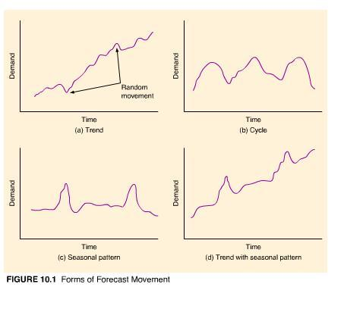
A cycle is an up-and-down movement in demand that repeats itself over a lengthy time span (i.e., more than a year). For example, new housing starts and, thus, construction-related products tend to follow cycles in the economy. Automobile sales also tend to follow cycles. The demand for winter sports equipment increases every four years before and after the Winter Olympics. Figure 10.1(b) shows the behavior of a demand cycle.
A seasonal pattern is an oscillating movement in demand that occurs periodically (in the short run) and is repetitive. Seasonality is often weather related. For example, every winter the demand for snowblowers and skis increases, and retail sales in general increase during the holiday season. However, a seasonal pattern can occur on a daily or weekly basis. For example, some restaurants are busier at lunch than at dinner, and shopping mall stores and theaters tend to have higher demand on weekends. Figure 10.1(c) illustrates a seasonal pattern in which the same demand behavior is repeated each year at the same time.
Demand behavior frequently displays several of these characteristics simultaneously. Although housing starts display cyclical behavior, there has been an upward trend in new house construction over the years. Demand for skis is seasonal; however, there has been an upward trend in the demand for winter sports equipment during the past two decades. Figure 10.1(d) displays the combination of two demand patterns, a trend with a seasonal pattern.
Instances when demand behavior exhibits no pattern are referred to as irregular movements, or variations. For example, a local flood might cause a momentary increase in carpet demand, or a competitor's promotional campaign might cause a company's product demand to drop for a period of time. Although this behavior has a cause and, thus, is not totally random, it still does not follow a pattern that can be reflected in a forecast.

Forecasting Methods
The factors discussed previously in this section determine to a certain extent the type of forecasting method that can or should be used. In this chapter we are going to discuss three basic types of forecasting: time series methods, regression methods, and qualitative methods.
Time series methods are statistical techniques that use historical demand data to predict future demand. Regression (or causal) forecasting methods attempt to develop a mathematical relationship (in the form of a regression model) between demand and factors that cause it to behave the way it does. Most of the remainder of this chapter will be about time series and regression forecasting methods. In this section we will focus our discussion on qualitative forecasting.
Qualitative methods use management judgment, expertise, and opinion to make forecasts. Often called "the jury of executive opinion," they are the most common type of forecasting method for the long-term strategic planning process. There are normally individuals or groups within an organization whose judgments and opinions regarding the future are as valid or more valid than those of outside experts or other structured approaches. Top managers are the key group involved in the development of forecasts for strategic plans. They are generally most familiar with their firms' own capabilities and resources and the markets for their products.
The sales force of a company represents a direct point of contact with the consumer. This contact provides an awareness of consumer expectations in the future that others may not possess. Engineering personnel have an innate understanding of the technological aspects of the type of products that might be feasible and likely in the future.
Consumer, or market, research is an organized approach using surveys and other research techniques to determine what products and services customers want and will purchase, and to identify new markets and sources of customers. Consumer and market research is normally conducted by the marketing department within an organization, by industry organizations and groups, and by private marketing or consulting firms. Although market research can provide accurate and useful forecasts of product demand, it must be skillfully and correctly conducted, and it can be expensive.
The Delphi method is a procedure for acquiring informed judgments and opinions from knowledgeable individuals using a series of questionnaires to develop a consensus forecast about what will occur in the future. It was developed at the Rand Corporation shortly after World War II to forecast the impact of a hypothetical nuclear attack on the United States. Although the Delphi method has been used for a variety of applications, forecasting has been one of its primary uses. It has been especially useful for forecasting technological change and advances.
Technological forecasting has become increasingly crucial to compete in the modern international business environment. New enhanced computer technology, new production methods, and advanced machinery and equipment are constantly being made available to companies. These advances enable them to introduce more new products into the marketplace faster than ever before. The companies that succeed manage to get a "technological" jump on their competitors by accurately predicting what technology will be available in the future and how it can be exploited. What new products and services will be technologically feasible, when they can be introduced, and what their demand will be are questions about the future for which answers cannot be predicted from historical data. Instead, the informed opinion and judgment of experts are necessary to make these types of single, long-term forecasts.

Forecasting Process
Forecasting is not simply identifying and using a method to compute a numerical estimate of what demand will be in the future. It is a continuing process that requires constant monitoring and adjustment illustrated by the steps in Figure 10.2.
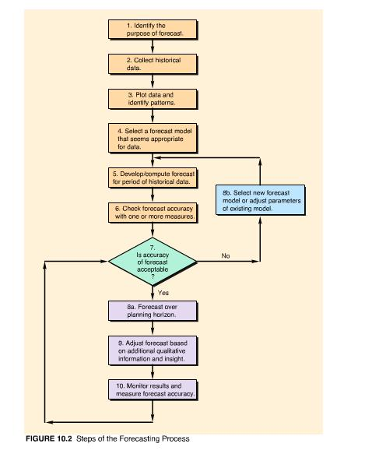
In the next few sections we present several different forecasting methods applicable for different patterns of demand behavior. Thus, one of the first steps in the forecasting process is to plot the available historical demand data and, by visually looking at them, attempt to determine the forecasting method that best seems to fit the patterns the data exhibit. Historical demand is usually past sales or orders data. There are several measures for comparing historical demand with the forecast to see how accurate the forecast is. Following our discussion of the forecasting methods, we present several measures of forecast accuracy. If the forecast does not seem to be accurate, another method can be tried until an accurate forecast method is identified. After the forecast is made over the desired planning horizon, it may be possible to use judgment, experience, knowledge of the market, or even intuition to adjust the forecast to enhance its accuracy. Finally, as demand actually occurs over the planning period, it must be monitored and compared with the forecast in order to assess the performance of the forecast method. If the forecast is accurate, then it is appropriate to continue using the forecast method. If it is not accurate, a new model or adjusting the existing one should be considered.

Time Series Methods
Time series methods are statistical techniques that make use of historical data accumulated over a period of time. Time series methods assume that what has occurred in the past will continue to occur in the future. As the name time series suggests, these methods relate the forecast to only one factor--time. They include the moving average, exponential smoothing, and linear trend line; and they are among the most popular methods for short-range forecasting among service and manufacturing companies. These methods assume that identifiable historical patterns or trends for demand over time will repeat themselves.

Moving Average
A time series forecast can be as simple as using demand in the current period to predict demand in the next period. This is sometimes called a naive or intuitive forecast.⁴ For example, if demand is 100 units this week, the forecast for next week's demand is 100 units; if demand turns out to be 90 units instead, then the following week's demand is 90 units, and so on. This type of forecasting method does not take into account historical demand behavior; it relies only on demand in the current period. It reacts directly to the normal, random movements in demand.
The simple moving average method uses several demand values during the recent past to develop a forecast. This tends to dampen, or smooth out, the random increases and decreases of a forecast that uses only one period. The simple moving average is useful for forecasting demand that is stable and does not display any pronounced demand behavior, such as a trend or seasonal pattern.
Moving averages are computed for specific periods, such as three months or five months, depending on how much the forecaster desires to "smooth" the demand data. The longer the moving average period, the smoother it will be. The formula for computing the simple moving average is
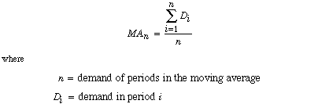
EXAMPLE
10.1
Computing a Simple Moving Average

The Instant Paper Clip Office Supply Company sells and delivers office supplies to companies, schools, and agencies within a 50-mile radius of its warehouse. The office supply business is competitive, and the ability to deliver orders promptly is a factor in getting new customers and keeping old ones. (Offices typically order not when they run low on supplies, but when they completely run out. As a result, they need their orders immediately.) The manager of the company wants to be certain enough drivers and vehicles are available to deliver orders promptly and they have adequate inventory in stock. Therefore, the manager wants to be able to forecast the number of orders that will occur during the next month (i.e., to forecast the demand for deliveries).
From records of delivery orders, management has accumulated the following data for the past 10 months, from which it wants to compute 3- and 5-month moving averages.
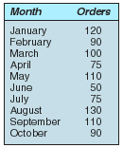
SOLUTION:
Let us assume that it is the end of October. The forecast resulting from either the 3- or the 5-month moving average is typically for the next month in the sequence, which in this case is November. The moving average is computed from the demand for orders for the prior 3 months in the sequence according to the following formula:
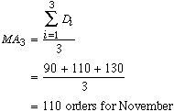
The 5-month moving average is computed from the prior 5 months of demand data as follows:
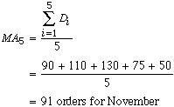
The 3- and 5-month moving average forecasts for all the months of demand data are shown in the following table. Actually, only the forecast for November based on the most recent monthly demand would be used by the manager. However, the earlier forecasts for prior months allow us to compare the forecast with actual demand to see how accurate the forecasting method is--that is, how well it does.
Three- and Five-Month Averages
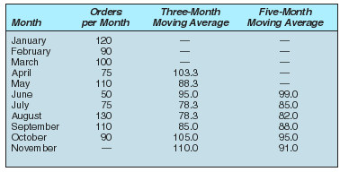
Both moving average forecasts in the table above tend to smooth out the variability occurring in the actual data. This smoothing effect can be observed in the following figure in which the 3-month and 5-month averages have been superimposed on a graph of the original data:
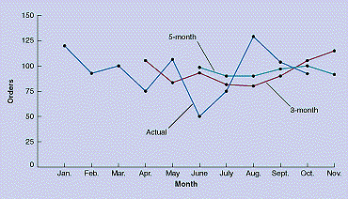
The 5-month moving average in the previous figure smooths out fluctuations to a greater extent than the 3-month moving average. However, the 3-month average more closely reflects the most recent data available to the office supply manager. In general, forecasts using the longer-period moving average are slower to react to recent changes in demand than would those made using shorter-period moving averages. The extra periods of data dampen the speed with which the forecast responds. Establishing the appropriate number of periods to use in a moving average forecast often requires some amount of trial-and-error experimentation.
The disadvantage of the moving average method is that it does not react to variations that occur for a reason, such as cycles and seasonal effects. Factors that cause changes are generally ignored. It is basically a "mechanical" method, which reflects historical data in a consistent way. However, the moving average method does have the advantage of being easy to use, quick, and relatively inexpensive. In general, this method can provide a good forecast for the short run, but it should not be pushed too far into the future.

Weighted Moving Average
The moving average method can be adjusted to more closely reflect fluctuations in the data. In the weighted moving average method, weights are assigned to the most recent data according to the following formula:
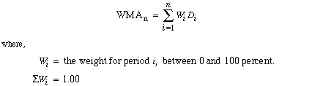
EXAMPLE
10.2
Computing a Weighted Moving Average

The Instant Paper Clip Company in Example 10.1 wants to compute a 3-month weighted moving average with a weight of 50 percent for the October data, a weight of 33 percent for the September data, and a weight of 17 percent for the August data. These weights reflect the company's desire to have the most recent data influence the forecast most strongly.
SOLUTION:
The weighted moving average is computed as
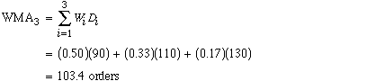
Notice that the forecast includes a fractional part, 0.4. In general, the fractional parts need to be included in the computation to achieve mathematical accuracy, but when the final forecast is achieved, it must be rounded up or down.
This forecast is slightly lower than our previously computed 3-month average forecast of 110 orders, reflecting the lower number of orders in October (the most recent month in the sequence).
Determining the precise weights to use for each period of data usually requires some trial-and-error experimentation, as does determining the number of periods to include in the moving average. If the most recent periods are weighted too heavily, the forecast might overreact to a random fluctuation in demand. If they are weighted too lightly, the forecast might underreact to actual changes in demand behavior.

Exponential Smoothing
Exponential smoothing is also an averaging method that weights the most recent data more strongly. As such, the forecast will react more to recent changes in demand. This is useful if the recent changes in the data result from a change such as a seasonal pattern instead of just random fluctuations (for which a simple moving average forecast would suffice).
Exponential smoothing is one of the more popular and frequently used forecasting techniques, for a variety of reasons. Exponential smoothing requires minimal data. Only the forecast for the current period, the actual demand for the current period, and a weighting factor called a smoothing constant are necessary. The mathematics of the technique are easy to understand by management. Virtually all POM and forecasting computer software packages include modules for exponential smoothing. Most importantly, exponential smoothing has a good track record of success. It has been employed over the years by many companies that have found it to be an accurate method of forecasting.
The exponential smoothing forecast is computed using the formula
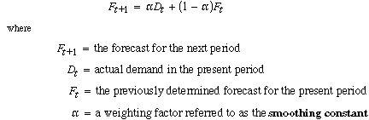
The smoothing constant, α, is between 0.0 and 1.0. It reflects the weight given to the most recent demand data. For example, if α = 0.20,
which means that our forecast for the next period is based on 20 percent of recent demand (D_{t}) and 80 percent of past demand (in the form of the forecast F_{t}, since F_{t} is derived from previous demands and forecasts). If we go to one extreme and let α = 0.0, then
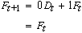
and the forecast for the next period is the same as the forecast for this period. In other words, the forecast does not reflect the most recent demand at all.
On the other hand, if α = 1.0, then
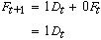
and we have considered only the most recent data (demand in the present period) and nothing else. Thus, the higher  is, the more sensitive the forecast will be to changes in recent demand, and the smoothing will be less. The closer  is to zero, the greater will be the dampening, or smoothing, effect. As  approaches zero, the forecast will react and adjust more slowly to differences between the actual demand and the forecasted demand. The most commonly used values of  are in the range 0.01 to 0.50. However, the determination of  is usually judgmental and subjective and is often based on trial-and-error experimentation. An inaccurate estimate of  can limit the usefulness of this forecasting technique.
EXAMPLE
10.3
Computing an Exponentially Smoothed Forecast

PM Computer Services assembles customized personal computers from generic parts. Formed and operated by part-time State University students Paulette Tyler and Maureen Becker, the company has had steady growth since it started. The company assembles computers mostly at night, using part-time students. Paulette and Maureen purchase generic computer parts in volume at a discount from a variety of sources whenever they see a good deal. Thus, they need a good forecast of demand for their computers so that they will know how many computer component parts to purchase and stock.
The company has accumulated the demand data shown in the accompanying table for its computers for the past twelve months, from which it wants to consider exponential smoothing forecasts using smoothing constants (α) equal to 0.30 and 0.50.
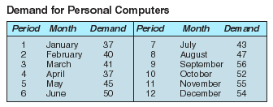
SOLUTION:
To develop the series of forecasts for the data in this table, we will start with period 1 (January) and compute the forecast for period 2 (February) using α = 0.30. The formula for exponential smoothing also requires a forecast for period 1, which we do not have, so we will use the demand for period 1 as both demand and forecast for period 1. Other ways to determine a starting forecast include averaging the first three or four periods or making a subjective estimate. Thus, the forecast for February is
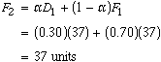
The forecast for period 3 is computed similarly:
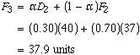
The remainder of the monthly forecasts are shown in the following table. The final forecast is for period 13, January, and is the forecast of interest to PM Computer Services:
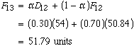
Exponential Smoothing Forecasts, α = .30 and α = .50
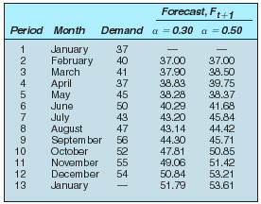
This table also includes the forecast values using α = 0.50. Both exponential smoothing forecasts are shown in Figure 10.3 together with the actual data.
In Figure 10.3, the forecast using the higher smoothing constant, α = 0.50, reacts more strongly to changes in demand than does the forecast with α = 0.30, although both smooth out the random fluctuations in the forecast. Notice that both forecasts lag behind the actual demand. For example, a pronounced downward change in demand in July is not reflected in the forecast until August. If these changes mark a change in trend (i.e., a long-term upward or downward movement) rather than just a random fluctuation, then the forecast will always lag behind this trend. We can see a general upward trend in delivered orders throughout the year. Both forecasts tend to be consistently lower than the actual demand; that is, the forecasts lag the trend.
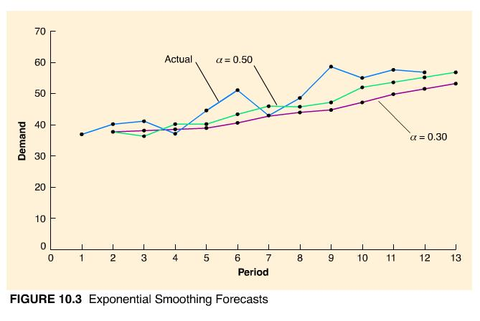
Based on simple observation of the two forecasts in Figure 10.3, α = 0.50 seems to be the more accurate of the two in the sense that it seems to follow the actual data more closely. (Later in this chapter we discuss several quantitative methods for determining forecast accuracy.) When demand is relatively stable without any trend, a small value for α is more appropriate to simply smooth out the forecast. When actual demand displays an increasing (or decreasing) trend, as is the case in the figure, a larger value of α is better. It will react more quickly to more recent upward or downward movements in the actual data. In some approaches to exponential smoothing, the accuracy of the forecast is monitored in terms of the difference between the actual values and the forecasted values. If these differences become larger, then α is changed (higher or lower) in an attempt to adapt the forecast to the actual data. However, the exponential smoothing forecast can also be adjusted for the effects of a trend.
In Example 10.3, the final forecast computed was for one month, January. A forecast for two or three months could have been computed by grouping the demand data into the required number of periods and then using these values in the exponential smoothing computations. For example, if a three-month forecast were needed, demand for January, February, and March could be summed and used to compute the forecast for the next three-month period, and so on, until a final three-month forecast results. Alternatively, if a trend is present the final period forecast can be used for an extended forecast by adjusting it by a trend factor.

Adjusted Exponential Smoothing
The adjusted exponential smoothing forecast consists of the exponential smoothing forecast with a trend adjustment factor added to it:
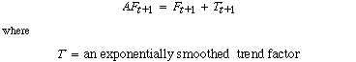
The trend factor is computed much the same as the exponentially smoothed forecast. It is, in effect, a forecast model for trend:
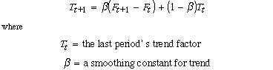
β is a value between 0.0 and 1.0. It reflects the weight given to the most recent trend data. β is usually determined subjectively based on the judgment of the forecaster. A high β reflects trend changes more than a low β. It is not uncommon for β to equal α in this method.
Notice that this formula for the trend factor reflects a weighted measure of the increase (or decrease) between the current forecast, F_{t+1}, and the previous forecast, F_{t}.
EXAMPLE
10.4
Computing an Adjusted Exponentially Smoothed Forecast

PM Computer Services now wants to develop an adjusted exponentially smoothed forecast using the same twelve months of demand shown in the table for Example 10.3. It will use the exponentially smoothed forecast with α = 0.5 computed in Example 10.3 with a smoothing constant for trend, β, of 0.30.
SOLUTION:
The formula for the adjusted exponential smoothing forecast requires an initial value for T_{t} to start the computational process. This initial trend factor is often an estimate determined subjectively or based on past data by the forecaster. In this case, since we have a long sequence of demand data (i.e., 12 months) we will start with the trend, T_{t}, equal to zero. By the time the forecast value of interest, F₁₃, is computed, we should have a relatively good value for the trend factor.
The adjusted forecast for February, AF₂, is the same as the exponentially smoothed forecast, since the trend computing factor will be zero (i.e., F₁ and F₂ are the same and T₂ = 0). Thus, we compute the adjusted forecast for March, AF₃, as follows, starting with the determination of the trend factor, T₃:
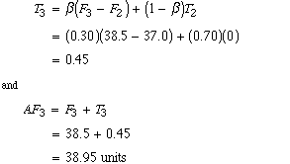
This adjusted forecast value for period 3 is shown in the accompanying table, with all other adjusted forecast values for the 12-month period plus the forecast for period 13, computed as follows:
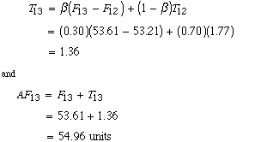
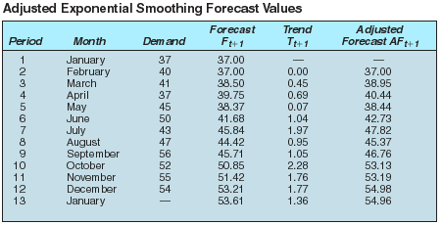
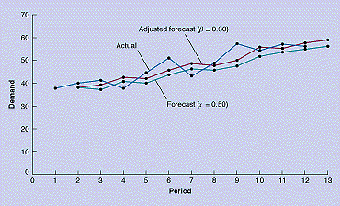
The adjusted exponentially smoothed forecast values shown in the table are compared with the exponentially smoothed forecast values and the actual data in the figure. Notice that the adjusted forecast is consistently higher than the exponentially smoothed forecast and is thus more reflective of the generally increasing trend of the actual data. However, in general, the pattern, or degree of smoothing, is very similar for both forecasts.

Linear Trend Line
Linear regression is a causal method of forecasting in which a mathematical relationship is developed between demand and some other factor that causes demand behavior. However, when demand displays an obvious trend over time, a least squares regression line, or linear trend line, can be used to forecast demand.
A linear trend line relates a dependent variable, which for our purposes is demand, to one independent variable, time, in form of a linear equation:
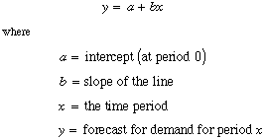
These parameters of the linear trend line can be calculated using the least squares formulas for linear regression:
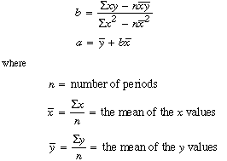
EXAMPLE
10.5
Computing a Linear Trend Line

The demand data for PM Computer Services (shown in the table for Example 10.3) appears to follow an increasing linear trend. The company wants to compute a linear trend line to see if it is more accurate than the exponential smoothing and adjusted exponential smoothing forecasts developed in Examples 10.3 and 10.4.
SOLUTION:
The values required for the least squares calculations are as follows:
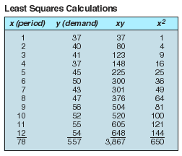
Using these values, the parameters for the linear trend line are computed as follows:
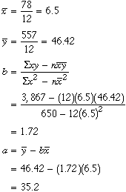
Therefore, the linear trend line equation is
To calculate a forecast for period 13, let x = 13 in the linear trend line:
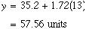
The following graph shows the linear trend line compared with the actual data. The trend line appears to reflect closely the actual data--that is, to be a "good fit"--and would thus be a good forecast model for this problem. However, a disadvantage of the linear trend line is that it will not adjust to a change in the trend, as the exponential smoothing forecast methods will; that is, it is assumed that all future forecasts will follow a straight line. This limits the use of this method to a shorter time frame in which you can be relatively certain that the trend will not change.
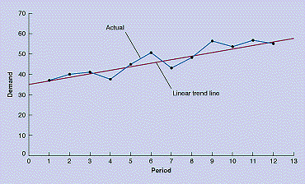

Seasonal Adjustments
A seasonal pattern is a repetitive increase and decrease in demand. Many demand items exhibit seasonal behavior. Clothing sales follow annual seasonal patterns, with demand for warm clothes increasing in the fall and winter and declining in the spring and summer as the demand for cooler clothing increases. Demand for many retail items, including toys, sports equipment, clothing, electronic appliances, hams, turkeys, wine, and fruit, increase during the holiday season. Greeting card demand increases in conjunction with special days such as Valentine's Day and Mother's Day. Seasonal patterns can also occur on a monthly, weekly, or even daily basis. Some restaurants have higher demand in the evening than at lunch or on weekends as opposed to weekdays. Traffic--hence sales--at shopping malls picks up on Friday and Saturday.
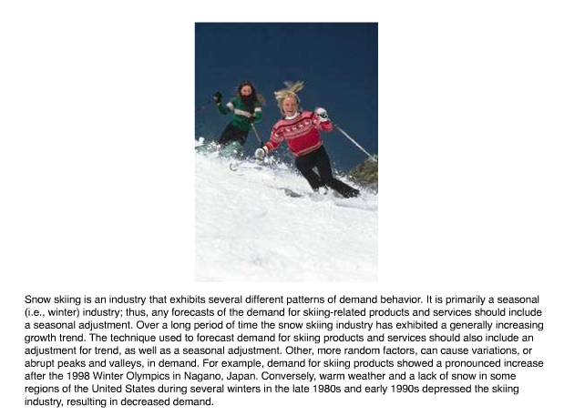
There are several methods for reflecting seasonal patterns in a time series forecast. We will describe one of the simpler methods using a seasonal factor. A seasonal factor is a numerical value that is multiplied by the normal forecast to get a seasonally adjusted forecast.
One method for developing a demand for seasonal factors is to divide the demand for each seasonal period by total annual demand, according to the following formula:
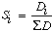
The resulting seasonal factors between 0 and 1.0 are, in effect, the portion of total annual demand assigned to each season. These seasonal factors are multiplied by the annual forecasted demand to yield adjusted forecasts for each season.
EXAMPLE
10.6
Computing a Forecast with Seasonal Adjustments

Wishbone Farms grows turkeys to sell to a meat-processing company throughout the year. However, its peak season is obviously during the fourth quarter of the year, from October to December. Wishbone Farms has experienced the demand for turkeys for the past three years shown in the following table:
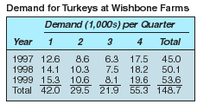
SOLUTION:
Because we have three years of demand data, we can compute the seasonal factors by dividing total quarterly demand for the three years by total demand across all three years:
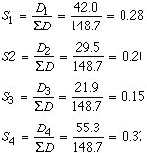
Next, we want to multiply the forecasted demand for the next year, 2000, by each of the seasonal factors to get the forecasted demand for each quarter. To accomplish this, we need a demand forecast for 2000. In this case, since the demand data in the table seem to exhibit a generally increasing trend, we compute a linear trend line for the three years of data in the table to get a rough forecast estimate:
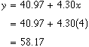
Thus, the forecast for 2000 is 58.17, or 58,170 turkeys.
Using this annual forecast of demand, the seasonally adjusted forecasts, SF_{i}, for 2000 are
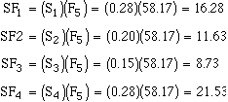
Comparing these quarterly forecasts with the actual demand values in the table, they would seem to be relatively good forecast estimates, reflecting both the seasonal variations in the data and the general upward trend.

Forecast Accuracy
A forecast is never completely accurate; forecasts will always deviate from the actual demand. This difference between the forecast and the actual is the forecast error. Although forecast error is inevitable, the objective of forecasting is that it be as slight as possible. A large degree of error may indicate that either the forecasting technique is the wrong one or it needs to be adjusted by changing its parameters (for example, α in the exponential smoothing forecast).
There are different measures of forecast error. We will discuss several of the more popular ones: mean absolute deviation (MAD), mean absolute percent deviation (MAPD), cumulative error, and average error or bias (E).

Mean Absolute Deviation
The mean absolute deviation, or MAD, is one of the most popular and simplest to use measures of forecast error. MAD is an average of the difference between the forecast and actual demand, as computed by the following formula:
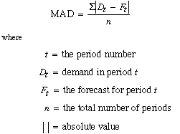
EXAMPLE
10.7
Measuring Forecasting Accuracy with MAD

In Examples 10.3, 10.4, and 10.5, forecasts were developed using exponential smoothing, (α = 0.30 and α = 0.50), adjusted exponential smoothing (α = 0.50, β = 0.30), and a linear trend line, respectively, for the demand data for PM Computer Services. The company wants to compare the accuracy of these different forecasts using MAD.
SOLUTION:
We will compute MAD for all four forecasts; however, we will present the computational detail for the exponential smoothing forecast only with α = 0.30. The following table shows the values necessary to compute MAD for the exponential smoothing forecast:
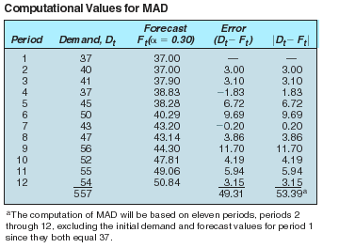
Using the data in the table, MAD is computed as
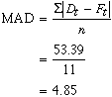
The smaller the value of MAD, the more accurate the forecast, although viewed alone, MAD is difficult to assess. In this example, the data values were relatively small and the MAD value of 4.85 should be judged accordingly. Overall it would seem to be a "low" value; that is, the forecast appears to be relatively accurate. However, if the magnitude of the data values were in the thousands or millions, then a MAD value of a similar magnitude might not be bad either. The point is, you cannot compare a MAD value of 4.85 with a MAD value of 485 and say the former is good and the latter is bad; they depend to a certain extent on the relative magnitude of the data.
One benefit of MAD is to compare the accuracy of several different forecasting techniques, as we are doing in this example. The MAD values for the remaining forecasts are as follows:
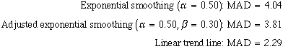
Since the linear trend line has the lowest MAD value of 2.29, it would seem to be the most accurate, although it does not appear to be significantly better than the adjusted exponential smoothing forecast. Further, we can deduce from these MAD values that increasing α from 0.30 to 0.50 enhanced the accuracy of the exponentially smoothed forecast. The adjusted forecast is even more accurate.
The mean absolute percent deviation (MAPD) measures the absolute error as a percentage of demand rather than per period. As a result, it eliminates the problem of interpreting the measure of accuracy relative to the magnitude of the demand and forecast values, as MAD does. The mean absolute percent deviation is computed according to the following formula:
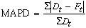
Using the data from the table in Example 10.7 for the exponential smoothing forecast (α = 0.30) for PM Computer Services,
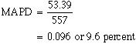
A lower percent deviation implies a more accurate forecast. The MAPD values for our other three forecasts are
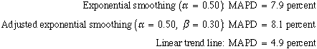

Cumulative Error
Cumulative error is computed simply by summing the forecast errors, as shown in the following formula.
A large positive value indicates that the forecast is probably consistently lower than the actual demand, or is biased low. A large negative value implies the forecast is consistently higher than actual demand, or is biased high. Also, when the errors for each period are scrutinized, a preponderance of positive values shows the forecast is consistently less than the actual value and vice versa.
The cumulative error for the exponential smoothing forecast (α = 0.30) for PM Computer Services can be read directly from the table in Example 10.7; it is simply the sum of the values in the "Error" column:
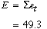
This large positive error for cumulative error, plus the fact that the individual errors for all but two of the periods in the table are positive, indicates that this forecast is consistently below the actual demand. A quick glance back at the plot of the exponential smoothing (α = 0.30) forecast in Figure 10.3 visually verifies this result.
The cumulative error for the other forecasts are
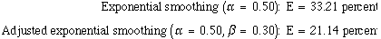
We did not show the cumulative error for the linear trend line. E will always be near zero for the linear trend line.
A measure closely related to cumulative error is the average error, or bias. It is computed by averaging the cumulative error over the number of time periods:
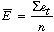
For example, the average error for the exponential smoothing forecast (α = 0.30) is computed as follows. (Notice a value of 11 was used for n, since we used actual demand for the first-period forecast, resulting in no error, that is, D₁ = F₁ = 37.)
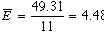
The average error is interpreted similarly to the cumulative error. A positive value indicates low bias and a negative value indicates high bias. A value close to zero implies a lack of bias.
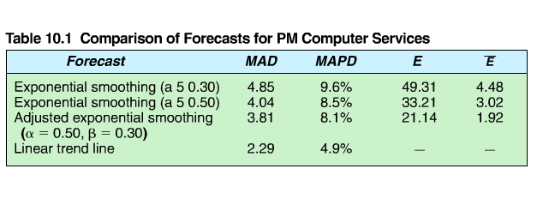
Table 10.1 summarizes the measures of forecast accuracy we have discussed in this section for the four example forecasts we developed in Examples 10.3, 10.4, and 10.5 for PM Computer Services. The results are consistent for all four forecasts, indicating that for the PM Computer Services example data, a larger value of α is preferable for the exponential smoothing forecast. The adjusted forecast is more accurate than the exponential smoothing forecasts, and the linear trend is more accurate than all the others. Although these results are for specific examples, they do not indicate how the different forecast measures for accuracy can be used to adjust a forecasting method or select the best method.

Regression Methods
Regression is used for forecasting by establishing a mathematical relationship between two or more variables. We are interested in identifying relationships between variables and demand. If we know that something has caused demand to behave in a certain way in the past, we would like to identify that relationship so if the same thing happens again in the future, we can predict what demand will be. For example, there is a relationship between increased demand in new housing and lower interest rates. Correspondingly, a whole myriad of building products and services display increased demand if new housing starts increase. The rapid increase in sales of VCRs has resulted in an increase in demand for video movies.
The simplest form of regression is linear regression, which we used previously to develop a linear trend line for forecasting. Now we will show how to develop a regression model for variables related to demand other than time.

Linear Regression
Linear regression is a mathematical technique that relates one variable, called an independent variable, to another, the dependent variable, in the form of an equation for a straight line. A linear equation has the following general form:
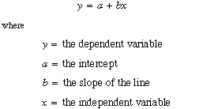
Because we want to use linear regression as a forecasting model for demand, the dependent variable, y, represents demand, and x is an independent variable that causes demand to behave in a linear manner.

To develop the linear equation, the slope, b, and the intercept, α, must first be computed using the following least squares formulas:
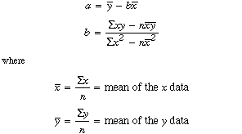
EXAMPLE
10.9
Developing a Linear Regression Forecast

The State University athletic department wants to develop its budget for the coming year using a forecast for football attendance. Football attendance accounts for the largest portion of its revenues, and the athletic director believes attendance is directly related to the number of wins by the team. The business manager has accumulated total annual attendance figures for the past eight years:
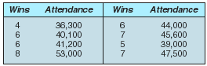
Given the number of returning starters and the strength of the schedule, the athletic director believes the team will win at least seven games next year. Develop a simple regression equation for this data to forecast attendance for this level of success.
SOLUTION:
The computations necessary to compute α and b using the least squares formulas are summarized in the accompanying table. (Note that y is given in 1,000s to make manual computation easier.)
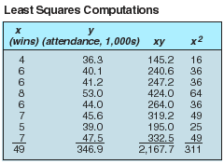
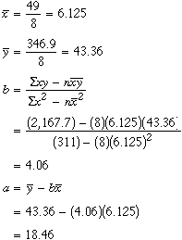
Substituting these values for α and b into the linear equation line, we have
Thus, for x = 7 (wins), the forecast for attendance is
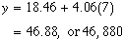
The data points with the regression line are shown in the figure. Observing the regression line relative to the data points, it would appear that the data follow a distinct upward linear trend, which would indicate that the forecast should be relatively accurate. In fact, the MAD value for this forecasting model is 1.41, which suggests an accurate forecast.
