Capacity Planning
Capacity planning is a long-term strategic decision that establishes a firm's overall level of resources. It extends over a time horizon long enough to obtain those resources--usually a year or more for building new facilities or acquiring new businesses. Capacity decisions affect product lead times, customer responsiveness, operating costs, and a firm's ability to compete. Inadequate capacity can lose customers and limit growth. Excess capacity can drain a company's resources and prevent investments in more lucrative ventures. When to increase capacity and how much to increase capacity are critical decisions.
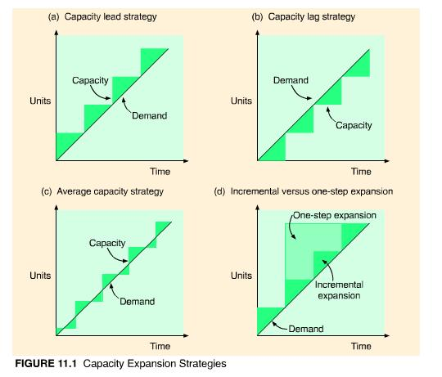
Figure 11.1(a), (b), and (c) show three basic strategies for the timing of capacity expansion in relation to a steady growth in demand.
- Capacity lead strategy. Capacity is expanded in anticipation of demand growth. This aggressive strategy is used to lure customers from competitors who are capacity constrained or to gain a foothold in a rapidly expanding market.
- Capacity lag strategy. Capacity is increased after an increase in demand has been documented. This conservative strategy produces a higher return on investment but may lose customers in the process. It is used in industries with standard products and cost-based or weak competition. The strategy assumes that lost customers will return from competitors after capacity has expanded.
- Average capacity strategy. Capacity is expanded to coincide with average expected demand. This is a moderate strategy in which managers are certain they will be able to sell at least some portion of the additional output.
Consider higher education's strategy in preparing for a tripling of the state's college-bound population in the next decade. An established university, guaranteed applicants even in lean years, may follow a capacity lag strategy. A young university might lead capacity expansion in hopes of capturing those students not admitted to the more established universities. A community college may choose the average capacity strategy to fulfill its mission of educating the state's youth but with little risk.
How much to increase capacity depends on (1) the volume and certainty of anticipated demand; (2) strategic objectives in terms of growth, customer service, and competition; and (3) the costs of expansion and operation.
Capacity can be increased incrementally or in one large step as shown in Figure 11.1(d). Incremental expansion is less risky but more costly. An attractive alternative to expanding capacity is outsourcing, in which suppliers absorb the risk of demand uncertainty.
The best operating level for a facility is the percent of capacity utilization that minimizes average unit cost. Rarely is the best operating level at 100 percent of capacity--at higher levels of utilization, productivity slows and things start to go wrong. Average capacity utilization differs by industry. An industry with an 80 percent average utilization would have a 20 percent capacity cushion for unexpected surges in demand or temporary work stoppages. Large capacity cushions are common in industries where demand is highly variable, resource flexibility is low, and customer service is important. Utilities, for example, maintain a 20 percent capacity cushion. Capital-intensive industries with less flexibility and higher costs maintain cushions under 10 percent. Airlines maintain a negative cushion--overbooking is a common practice!
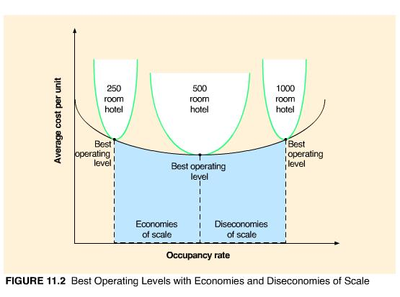
Figure 11.2 shows the best operating level--in this case, the optimal occupancy rate--for three different size hotels. Of the three alternatives, the 500-room hotel has the lowest average unit cost. This is the point where the economies of scale have reached their peak and the diseconomies of scale have not yet begun.
High levels of output tend to cost less per unit. Called economies of scale, this holds true when:
- Fixed costs can be spread over a larger number of units,
- Production costs do not increase linearly with output levels,
- Quantity discounts are available for material purchases, and
- Production efficiency increases as workers gain experience.
The electronics industry provides a good case example of economies of scale. The average cost per chip placement for printed circuit-board assembly is 32 cents in factories with a volume of 25 million placements, 15 cents in factories with 200 million placements, and only 10 cents in factories with 800 million placements.²
Economies of scale do not continue indefinitely. Above a certain level of output, diseconomies of scale can occur. Overtaxed machines and material handling equipment break down, service time slows, quality suffers requiring more rework, labor costs increase with overtime, and coordination and management activities become difficult. In addition, if customer preferences suddenly change, high-volume production can leave a firm with unusable inventory and excess capacity.
Long-term capacity decisions concerning the number of facilities and facility size provide the framework for making more intermediate-term capacity decisions--such as inventory policies, production rates, and staffing levels. These decisions are collectively known as aggregate production planning or just plain aggregate planning.

Aggregate Production Planning
Aggregate production planning (APP) determines the resource capacity a firm will need to meet its demand over an intermediate time horizon--six to twelve months in the future. Within this time frame, it is usually not feasible to increase capacity by building new facilities or purchasing new equipment; however, it is feasible to hire or lay off workers, increase or reduce the work week, add an extra shift, subcontract out work, use overtime, or build up and deplete inventory levels.
We use the term aggregate because the plans are developed for product lines or product families, rather than individual products. An aggregate production plan might specify how many bicycles are to be produced but would not identify them by color, size, tires, or type of brakes. Resource capacity is also expressed in aggregate terms, typically as labor or machine hours. Labor hours would not be specified by type of labor, nor machine hours by type of machine. And they may be given only for critical work centers.
For services, capacity is often limited by space--number of airline seats, number of hotel rooms, number of beds in a correctional facility. Time can also affect capacity. The number of customers who can be served lunch in a restaurant is limited by the number of seats, as well as the number of hours lunch is served. In overcrowded schools, lunch begins at 10:00 a.m. so that all students can be served by 2:00 p.m.!
There are two objectives to aggregate planning:
- To establish a company-wide game plan for allocating resources, and
- To develop an economic strategy for meeting demand.
The first objective refers to the long-standing battle between the marketing and production functions within a firm. Marketing personnel--who are evaluated solely on sales volume--have the tendency to make unrealistic sales commitments (either in terms of quantity or timing) that production is expected to meet, sometimes at an exorbitant price. Production personnel--who are evaluated on keeping manufacturing costs down--may refuse to accept orders that require additional financial resources (such as overtime wage rates) or hard-to-meet completion dates. The job of production planning is to match forecasted demand with available capacity. If capacity is inadequate, it can usually be expanded, but at a cost. The company needs to determine if the extra cost is worth the increased revenue from the sale, and if the sale is consistent with the strategy of the firm. Thus, the aggregate production plan should not be determined by manufacturing personnel alone; rather, it should be agreed upon by top management from all the functional areas of the firm--manufacturing, marketing, and finance. Furthermore, it should reflect company policy (such as avoiding layoffs, limiting inventory levels, or maintaining a specified customer service level) and strategic objectives (such as capturing a certain share of the market or achieving targeted levels of quality or profit). Because of the various factors and viewpoints that are considered, the production plan is often referred to as the company's game plan for the coming year, and deviations from the plan are carefully monitored.
The rest of this chapter covers the second objective--developing an economic strategy for meeting demand. Demand can be met by adjusting capacity or managing demand. First, we will discuss several quantitative techniques for choosing the most cost-effective method of adjusting capacity. Then, we will discuss some alternatives for managing demand.
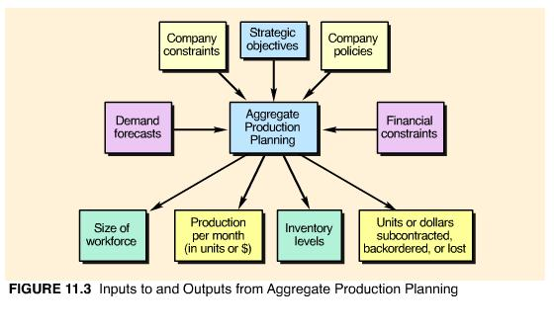
Figure 11.3 shows the inputs to and outputs from aggregate production planning. The inputs are demand forecasts, capacity constraints, strategic objectives, company policies, and financial constraints. The outputs include size of the workforce, production expressed as either units or sales dollars, inventory levels that support the production plan, and the number of units or dollars subcontracted, backordered, or lost.

Strategies for Meeting Demand
If demand for a company's products or services are stable over time or its resources are unlimited, then aggregate planning is trivial. Demand forecasts are converted to resource requirements, the resources necessary to meet demand are acquired and maintained over the time horizon of the plan, and minor variations in demand are handled with overtime or undertime. Aggregate production planning becomes a challenge when demand fluctuates over the planning horizon. For example, seasonal demand patterns can be met by:
- Producing at a constant rate and using inventory to absorb fluctuations in demand (level production)
- Hiring and firing workers to match demand (chase demand)
- Maintaining resources for high-demand levels
- Increasing or decreasing working hours (overtime and undertime)
- Subcontracting work to other firms
- Using part-time workers
- Providing the service or product at a later time period (backordering)
When one of these is selected, a company is said to have a pure strategy for meeting demand. When two or more are selected, a company has a mixed strategy.
The level production strategy, shown in Figure 11.4(a), sets production at a fixed rate (usually to meet average demand) and uses inventory to absorb variations in demand. During periods of low demand, overproduction is stored as inventory, to be depleted in periods of high demand. The cost of this strategy is the cost of holding inventory, including the cost of obsolete or perishable items that may have to be discarded.
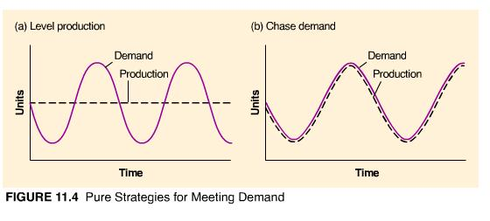
The chase demand strategy, shown in Figure 11.4(b), matches the production plan to the demand pattern and absorbs variations in demand by hiring and firing workers. During periods of low demand, production is cut back and workers are laid off. During periods of high demand, production is increased and additional workers are hired. The cost of this strategy is the cost of hiring and firing workers. This approach would not work for industries in which worker skills are scarce or competition for labor is intense, but it can be quite cost-effective during periods of high unemployment or for industries with low-skilled workers.
Maintaining resources for high-demand levels ensures high levels of customer service but can be very costly in terms of the investment in extra workers and machines that remain idle during low-demand periods. This strategy is used when superior customer service is important (such as Nordstrom's department store) or when customers are willing to pay extra for the availability of critical staff or equipment. Professional services trying to generate more demand may keep staff levels high, defense contractors may be paid to keep extra capacity "available," child-care facilities may elect to maintain staff levels for continuity when attendance is low, and full-service hospitals may invest in specialized equipment that is rarely used but is critical for the care of a small number of patients.
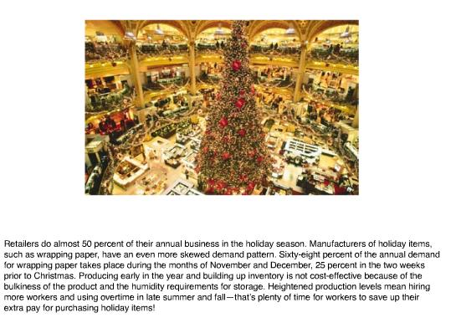
Overtime and undertime are common strategies when demand fluctuations are not extreme. A competent staff is maintained, hiring and firing costs are avoided, and demand is met temporarily without investing in permanent resources. Disadvantages include the premium paid for overtime work, a tired and potentially less efficient work force, and the possibility that overtime alone may be insufficient to meet peak demand periods.
Subcontracting or outsourcing is a feasible alternative if a supplier can reliably meet quality and time requirements. This is a common solution for component parts when demand exceeds expectations for the final product. The subcontracting decision requires maintaining strong ties with possible subcontractors and first-hand knowledge of their work. Disadvantages of subcontracting include reduced profits, loss of control over production, long lead times, and the potential that the subcontractor may become a future competitor.
Using part-time workers is feasible for unskilled jobs or in areas with large temporary labor pools (such as students, homemakers, or retirees). Part-time workers are less costly than full-time workers--no health-care or retirement benefits--and are more flexible--their hours usually vary considerably. Part-time workers have been the mainstay of retail, fast-food, and other services for some time and are becoming more accepted in manufacturing and government jobs. Japanese manufacturers traditionally use a large percentage of part-time or temporary workers. IBM staffs its entire third shift at Research Triangle Park, North Carolina, with temporary workers (college students). Part-time and temporary workers now account for about one third of our nation's work force. The temp agency Manpower, Inc. is the largest private employer in the world. Problems with part-time workers include high turnover, accelerated training requirements, less commitment, and scheduling difficulties.
Backordering is a viable alternative only if the customer is willing to wait for the product or service. For some restaurants you may be willing to wait an hour for a table; for others you may not.
One aggregate planning strategy is not always preferable to another. The most effective strategy depends on the demand distribution, competitive position, and cost structure of a firm or product line. Several quantitative techniques are available to help with the aggregate planning decision. We will discuss pure and mixed strategies using trial and error, the transportation method, and other quantitative techniques.

APP by Trial and Error
Using trial and error to solve aggregate production planning problems involves formulating several strategies for meeting demand, constructing production plans from those strategies, determining the cost and feasibility of each plan, and selecting the lowest cost plan from among the feasible alternatives. The effectiveness of trial and error is directly related to management's understanding of the cost variables involved and the reasonableness of the scenarios tested. Example 11.1 compares the cost of two pure strategies. Example 11.2 uses Excel to compare pure and mixed strategies for a more extensive problem.
EXAMPLE
11.1
Aggregate Production Planning Using Pure Strategies

The Good and Rich Candy Company makes a variety of candies in three factories worldwide. Its line of chocolate candies exhibits a highly seasonal demand pattern, with peaks during the winter months (for the holiday season and Valentine's Day) and valleys during the summer months (when chocolate tends to melt and customers are watching their weight). Given the following costs and quarterly sales forecasts, determine whether a level production or chase demand production strategy would more economically meet the demand for chocolate candies:
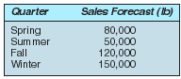
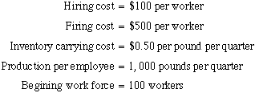
SOLUTION:
For the level production strategy, we first need to calculate average quarterly demand.
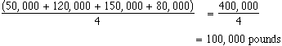
This becomes our planned production for each quarter. Since each worker can produce 1,000 pounds a quarter, 100 workers will be needed each quarter to meet the production requirements of 100,000 pounds. Production in excess of demand is stored in inventory, where it remains until it is used to meet demand in a later period. Demand in excess of production is met by using inventory from the previous quarter. The production plan and resulting inventory costs are given in Exhibit 11.1.
For the chase demand strategy, production each quarter matches demand. To accomplish this, workers are hired and fired at a cost of $100 for each one hired and $500 for each one fired. Since each worker can produce 1,000 pounds per quarter, we divide the quarterly sales forecast by 1,000 to determine the required workforce size each quarter. We begin with 100 workers and hire and fire as needed. The production plan and resulting hiring and firing costs are given in Exhibit 11.2.
Comparing the cost of level production with chase demand, chase demand is the best strategy for the Good and Rich line of chocolate candies.
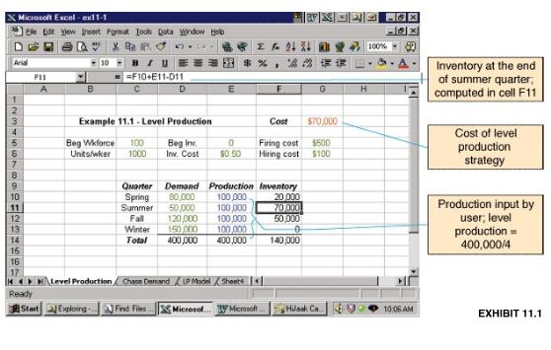
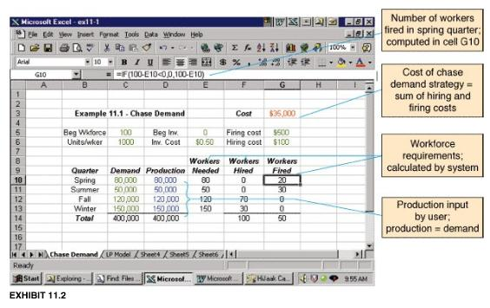
Although chase demand is the better strategy for Good and Rich from an economic point of view, it may seem unduly harsh on the company's workforce. An example of a good "fit" between a company's chase demand strategy and the needs of the workforce is Hershey's, located in rural Pennsylvania, with a demand and cost structure much like that of Good and Rich. The location of the manufacturing facility is essential to the effectiveness of the company's production plan. During the winter, when demand for chocolate is high, the company hires farmers from surrounding areas, who are idle that time of year. The farmers are let go during the spring and summer, when they are anxious to return to their fields and the demand for chocolate falls. The plan is cost-effective, and the extra help is content with the sporadic hiring and firing practices of the company.
Probably the most common approach to production planning is trial and error using mixed strategies and spreadsheets to evaluate different options quickly. Mixed strategies can incorporate management policies, such as "no more than x percent of the workforce can be laid off in one quarter" or "inventory levels cannot exceed x dollars." They can also be adapted to the quirks of a company or industry. For example, many industries that experience a slowdown during part of the year may simply shut down manufacturing during the low-demand season and schedule everyone's vacation during that time. Furniture manufacturers typically close down for the month of July each year, and shipbuilders close down for the month of December.
For some industries, the production planning task revolves around the supply of raw materials, not the demand pattern. Consider Motts, the applesauce manufacturer whose raw material is available only 40 days during a year. The workforce size at its peak is 1,500 workers, but it normally consists of around 350 workers. Almost 10 percent of the company's payroll is made up of unemployment benefits--the price of doing business in that particular industry.
EXAMPLE
11.2
Aggregate Production Planning Using Pure and Mixed Strategies

Demand for Quantum Corporation's action toy series follows a seasonal pattern--growing through the fall months and culminating in December, with smaller peaks in January (for after-season markdowns, exchanges, and accessory purchases) and July (for Christmas-in-July specials).
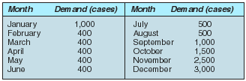
Each worker can produce on average 100 cases of action toys each month. Overtime is limited to 300 cases, and subcontracting is unlimited. No action toys are currently in inventory. The wage rate is $10 per case for regular production, $15 for overtime production, and $25 for subcontracting. No stockouts are allowed. Holding cost is $1 per case per month. Increasing the workforce costs approximately $1,000 per worker. Decreasing the workforce costs $500 per worker.
Management wishes to test the following scenarios for planning production:
- Level production over the twelve months.
- Produce to meet demand each month.
- Increase or decrease the workforce in five-worker increments.
SOLUTION:
Excel was used to evaluate the three planning scenarios. The solution printouts are shown in Exhibit 11.3, Exhibit 11.4, and Exhibit 11.5, respectively. From the scenarios tested, step production yields the lowest cost.
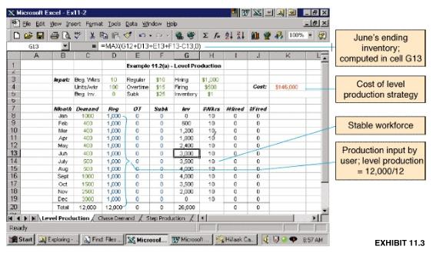
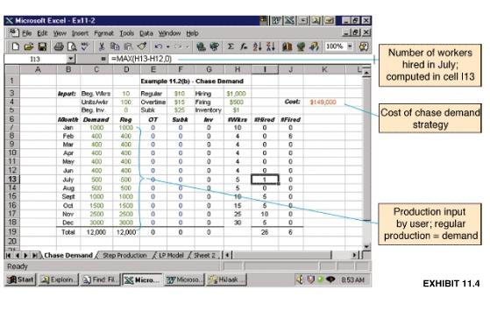
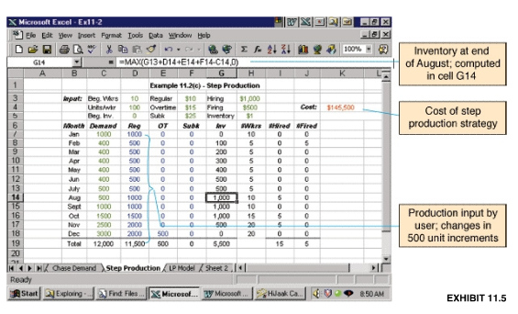

APP by the Transportation Method
For those cases in which the decision to change the size of the workforce has already been made or is prohibited, the transportation method of linear programming can be used to develop an aggregate production plan. The transportation method gathers all the cost information into one matrix and plans production based on the lowest-cost alternatives. Example 11.4 illustrates the procedure. Table 11.1 shows a blank transportation tableau for aggregate planning.
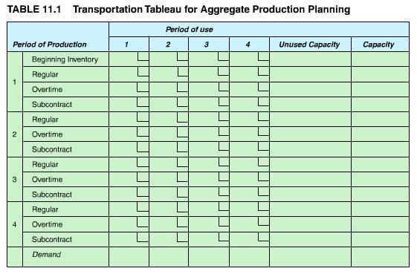
EXAMPLE
11.4
APP by the Transportation Method of Linear Programming

Burruss Manufacturing Company uses overtime, inventory, and subcontracting to absorb fluctuations in demand. An aggregate production plan is devised annually and updated quarterly. Cost data, expected demand, and available capacities in units for the next four quarters are given here. Demand must be satisfied in the period it occurs; that is, no backordering is allowed. Design a production plan that will satisfy demand at minimum cost.
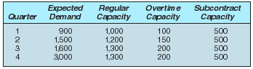
 | Regular production cost per unit | $20
 | Overtime production cost per unit | $25
 | Subcontracting cost per unit | $28
 | Inventory holding cost per unit per period | $3
 | Beginning inventory | 300 | units
SOLUTION:
The problem is solved using the transportation tableau shown in Table 11.2. The tableau is a worksheet that is completed as follows:
- To set up the tableau, demand requirements for each quarter are listed on the bottom row and capacity constraints for each type of production (i.e., regular, overtime, or subcontracting) are placed in the far right column.
- Next, cost figures are entered into the small square at the corner of each cell. Reading across the first row, inventory on hand in period 1 that is used in period 1 incurs zero cost. Inventory on hand in period 1 that is not used until period 2 incurs $3 holding cost. If the inventory is held until period 3, the cost is $3 more, or $6. Similarly, if the inventory is held until period 4, the cost is an additional $3, or $9.
- Interpreting the cost entries in the second row, if a unit is produced under regular production in period 1 and used in period 1, it costs $20. If a unit is produced under regular production in period 1 but is not used until period 2, it incurs a production cost of $20 plus an inventory cost of $3, or $23. If the unit is held until period 3, it will cost $3 more, or $26. If it is held until period 4, it will cost $29. The cost calculations continue in a similar fashion for overtime and subcontracting, beginning with production costs of $25 and $28, respectively.
- The costs for production in periods 2, 3, and 4 are determined in a similar fashion, with one exception. Half of the remaining transportation tableau is blocked out as infeasible. This occurs because no backordering is allowed for this problem, and production cannot take place in one period to satisfy demand that occurs in previous periods.
- Now that the tableau is set up, we can begin to allocate units to the cells and develop our production plan. The procedure is to assign units to the lowest-cost cells in a column so that demand requirements for the column are met, yet capacity constraints of each row are not exceeded. Beginning with the first demand column for period 1, we have 300 units of beginning inventory available to us at no cost. If we use all 300 units in period 1, there is no inventory left for use in later periods. We indicate this fact by putting a dash in the remaining cells of the beginning inventory row. We can satisfy the remaining 600 units of demand for period 1 with regular production at a cost of $20 per unit.
- In period 2, the lowest-cost alternative is regular production in period 2. We assign 1,200 units to that cell and, in the process, use up all the capacity for that row. Dashes are placed in the remaining cells of the row to indicate that they are no longer feasible choices. The remaining units needed to meet demand in period 2 are taken from regular production in period 1 that is inventoried until period 2, at a cost of $23 per unit. We assign 300 units to that cell.
- Continuing to the third period's demand of 1,600 units, we fully utilize the 1,300 units available from regular production in the same period and 200 units of overtime production. The remaining 100 units are produced with regular production in period 1 and held until period 3, at a cost of $26 per unit. As noted by the dashed line, period 1's regular production has reached its capacity and is no longer an alternative source of production.
- Of the fourth period's demand of 3,000 units, 1,300 come from regular production, 200 from overtime, and 500 from subcontracting in the same period. 150 more units can be provided at a cost of $31 per unit from overtime production in period 2 and 500 from subcontracting in period 3. The next-lowest alternative is $34 from overtime in period 1 or subcontracting in period 2. At this point, we can make a judgment call as to whether our workers want overtime or whether it would be easier to subcontract out the entire amount. As shown in Table 11.2, we decide to use overtime to its full capacity of 100 units and fill the remaining demand of 250 from subcontracting.
- The unused capacity column is filled in last. In period 2, 250 units of subcontracting capacity are available but unused. This information is valuable because it tells us the flexibility the company has to accept additional orders.
The optimum production plan, derived from the transportation tableau, is given in Table 11.3.⁵ The values in the production plan are taken from the transportation tableau one row at a time. For example, the 1,000 units of a regular production for period 1 is the sum of 600 + 300 + 100 from the second row of the transportation tableau. Ending inventory is calculated by summing beginning inventory and all forms of production for that period and then subtracting demand. For example, the ending inventory for period 1 is
The cost of the production plan can be determined directly from the transportation tableau by multiplying the units in each cell times the cost in the corner of the cell and summing them. Alternatively, the cost can be determined from the production plan by multiplying the total units produced in each production category or held in inventory by their respective costs and summing them, as follows:
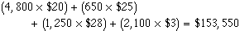
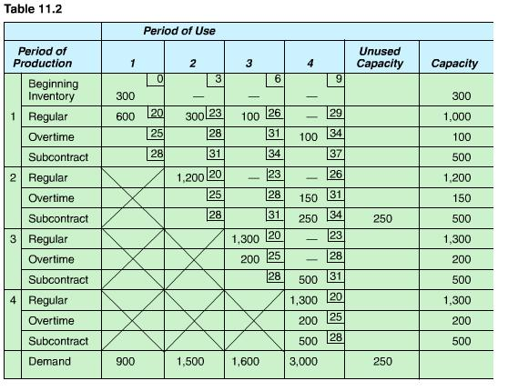
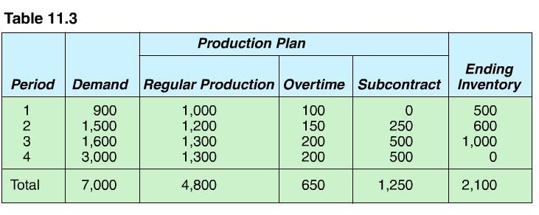Although linear programming models will yield an optimum solution to the aggregate planning problem, there are some limitations. The relationships among variables must be linear, the model is deterministic, and only one objective is allowed (usually minimizing cost).

Other Quantitative Techniques
The linear decision rule (LDR) is an optimizing technique originally developed for aggregate planning in a paint factory. It solves a set of four quadratic equations that describe the major capacity-related costs in the factory: payroll costs, hiring and firing, overtime and undertime, and inventory costs. The results yield the optimal workforce level and production rate.
The search decision rule (SDR) is a pattern search algorithm that tries to find the minimum cost combination of various workforce levels and production rates. Any type of cost function can be used. The search is performed by computer and may involve the evaluation of thousands of possible solutions, but an optimum solution is not guaranteed. The management coefficients model uses regression analysis to improve the consistency of planning decisions. Techniques like SDR and management coefficients are often embedded in commercial decision support systems or expert systems for aggregate planning.

Strategies for Managing Demand
Aggregate planning can actively manage demand by:
- Shifting demand into other time periods with incentives, sales promotions, and advertising campaigns;
- Offering products or services with countercyclical demand patterns; and
- Partnering with suppliers to reduce information distortion along the supply chain.
Winter coat specials in July, bathing-suit sales in January, early-bird discounts on dinner, lower long-distance rates in the evenings, and getaway weekends at hotels during the off-season are all attempts to shift demand into different time periods. Electric utilities are especially skilled at off-peak pricing. Promotions can also be used to extend high demand into low-demand seasons. Holiday gift buying is encouraged earlier each year, and beach resorts plan festivals in September and October to extend the season. Frito-Lay, which normally experiences a dip in sales in October, recently teamed up with Hershey to display its potato chips alongside traditional Halloween candy. The coveted display space, plus special individual-sized bags with ghoulish characters, brought October chip sales in line with the rest of the year.
The second approach to managing demand involves examining the idleness of resources and creating a demand for those resources. McDonald's offers breakfast to keep its kitchens busy during the prelunch hours, pancake restaurants serve lunch and dinner, and heating firms also sell air conditioners.
An example of a firm that has done an especially good job of finding countercyclical products to smooth the load on its manufacturing facility is a small U.S. manufacturer of peanut-harvesting equipment. The company is a job shop that has general-purpose equipment, fifty highly skilled workers, and a talented engineering staff. With these flexible resources, the company can make anything its engineers can design. Inventories of finished goods are frowned upon because they represent a significant investment in funds and because the product is so large that it takes up too much storage space. Peanut-harvesting equipment is generally purchased on an as-needed basis from August to October, so during the spring and early summer, the company makes bark-scalping equipment for processing mulch and pine nuggets used by landscaping services. Demand for peanut-harvesting equipment is also affected by the weather each growing season, so during years of extensive drought, the company produces and sells irrigation equipment. The company also decided to market its products internationally with a special eye toward countries whose growing seasons are opposite to that of the United States. Thus, many of its sales are made in China and India during the very months when demand in the United States is low.
The third approach to managing demand recognizes the information distortion caused by ordering goods in batches along a supply chain. Even though a customer may require daily usage of an item, he or she probably does not purchase that item daily. Neither do retail stores restock their shelves continuously. By the time a replenishment order reaches distributors, wholesalers, manufacturers, and their suppliers, the demand pattern for a product can appear extremely erratic.
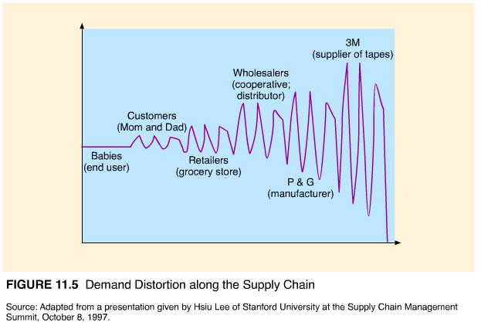
Figure 11.5 illustrates this phenomenon, sometimes called the bull-whip effect, for a common product, baby diapers. To control this situation, manufacturers, their suppliers, and customers form partnerships in which demand information is shared and orders are placed in a more continuous fashion. The textile, electronics, and automotive industries are leaders in supply chain integration. Look for the topic "continuous replenishment" in the next chapter for more details.

Hierarchical Planning Process
By determining a strategy for meeting and managing demand, aggregate planning provides a framework within which shorter-term production and capacity decisions can be made. In production planning, the next level of detail is a master production schedule, in which weekly (not monthly or quarterly) production plans are specified by individual final product (not product line). At another level of detail, material requirements planning plans the production of the components that go into the final products. Shop floor scheduling schedules the manufacturing operations required to make each component.
In capacity planning, we might develop a resource requirements plan, to verify that an aggregate production plan is doable, and a rough-cut capacity plan as a quick check to see if the master production schedule is feasible. One level down, we would develop a much more detailed capacity requirements plan that matches the factory's machine and labor resources to the material requirements plan. Finally, we would use input/output control to monitor the production that takes place at individual machines or work centers. At each level, decisions are made within the parameters set by the higher-level decisions. The process of moving from the aggregate plan to the next level down is called disaggregation. Each level of production and capacity planning is shown in Figure 11.6. We discuss them more thoroughly in Chapter 13.
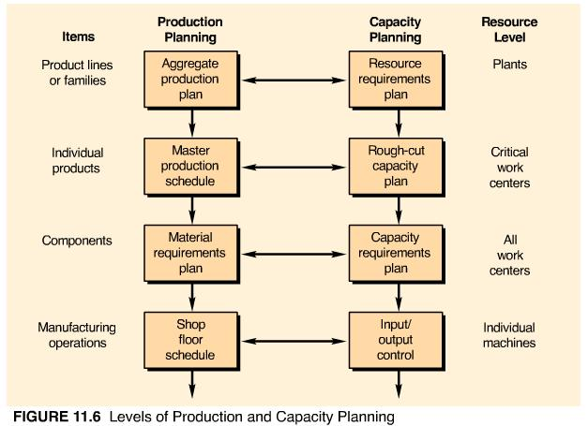

Aggregate Planning for Services
The aggregate planning process is different for services in the following ways:
- Most services cannot be inventoried. It is impossible to store an airline seat, hotel room, or hair appointment for use later when demand may be higher. When the goods that accompany a service can be inventoried, they typically have a very short life. Newspapers are good for only a day; flowers, at most a week; and cooked hamburgers, only ten minutes.
- Demand for services is difficult to predict. Demand variations occur frequently and are often severe. The exponential distribution is commonly used to simulate the erratic demand for services--high-demand peaks over short periods of time with long periods of low demand in between. Customer service levels established by management express the percentage of demand that must be met and, sometimes, how quickly demand must be met. This is an important input to aggregate planning for services.
- Capacity is also difficult to predict. The variety of services offered and the individualized nature of services make capacity difficult to predict. The "capacity" of a bank teller depends on the number and type of transactions requested by the customer. Units of capacity can also vary. Should a hospital define capacity in terms of number of beds, number of patients, size of the nursing or medical staff, or number of patient hours?
- Service capacity must be provided at the appropriate place and time. Many services have branches or outlets widely dispersed over a geographic region. Determining the range of services and staff levels at each location is part of aggregate planning.
- Labor is usually the most constraining resource for services. This is an advantage in aggregate planning because labor is very flexible. Variations in demand can be handled by hiring temporary workers, using part-time workers, or using overtime. Summer recreation programs and theme parks hire teenagers out of school for the summer. Federal Express staffs its peak hours of midnight to 2 a.m. with area college students. McDonald's, Wal-Mart, and other retail establishments woo senior citizens as reliable part-time workers.
Workers can also be cross-trained to perform a variety of jobs and can be called upon as needed. A common example is the sales clerk who also stocks inventory. Less common are the police officers in a suburb of Detroit who are cross-trained as firefighters and paramedics.
There are several services that have unique aggregate planning problems. Doctors, lawyers, and other professionals have emergency or priority calls for their service that must be meshed with regular appointments. Hotels and airlines routinely overbook their capacity in anticipation of customers who do not show up. The pricing structure for different classes of customers adds an extra factor to the aggregate planning decision. Pricing structures for airlines are especially complex. As part of the aggregate planning process, planners must determine the percentage of seats or rooms to be allocated to different fare classes in order to maximize profit or yield. This process is called yield management.

