Basic Elements of JIT
In the 1950s, the entire Japanese automobile industry produced 30,000 vehicles, fewer than a half day's production for U.S. automakers. With such low levels of demand, the principles of mass production that worked so well for U.S. manufacturers could not be applied in Japan. Further, the Japanese were short on capital and storage space. So it seems natural that efforts to improve performance (and stay solvent) would center on reducing that asset that soaks up both funds and space--inventory. What is significant is that a system originally designed to reduce inventory levels eventually became a system for continually improving all aspects of manufacturing operations. The stage was set for this evolution by the president of Toyota, Eiji Toyoda, who gave a mandate to his people to "eliminate waste." Waste was defined as "anything other than the minimum amount of equipment, materials, parts, space, and time which are absolutely essential to add value to the product."³ Examples of waste in operations are shown in Figure 15.1.
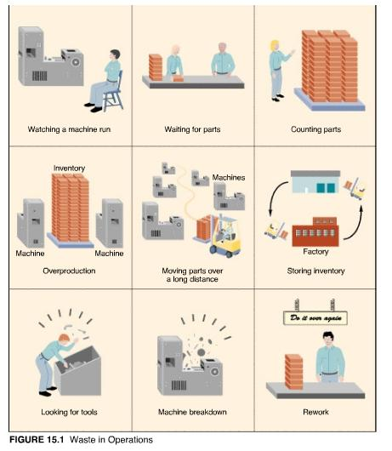
The JIT production system is the result of the mandate to eliminate waste. It is composed of the following elements:
- Flexible resources
- Cellular layouts
- Pull production system
- Kanban production control
- Small-lot production
- Quick setups
- Uniform production levels
- Quality at the source
- Total productive maintenance
- Supplier networks
Let us explore each of these elements and determine how they work in concert.⁴

Flexible Resources
The concept of flexible resources, in the form of multifunctional workers and general-purpose machines, is recognized as a key element of JIT, but most people do not realize that it was one of the first elements to fall into place. Taiichi Ohno had transferred to Toyota from Toyoda textile mills with no knowledge of (or preconceived notions about) automobile manufacturing. His first attempt to eliminate waste (not unlike U.S. managers) concentrated on worker productivity. Borrowing heavily from U.S. time and motion studies, he set out to analyze every job and every machine in his shop. He quickly noted a distinction between the operating time of a machine and the operating time of the worker. Initially, he asked each worker to operate two machines rather than one. To make this possible, he located the machines in parallel lines or in L-formations. After a time, he asked workers to operate three or four machines arranged in a U-shape. The machines were no longer of the same type (as in a job shop layout) but represented a series of processes common to a group of parts (i.e., a cellular layout).
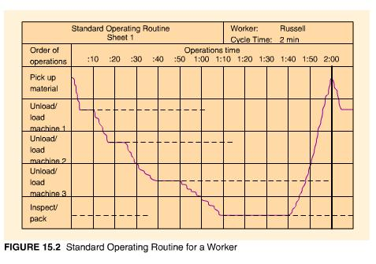
The operation of different, multiple machines required additional training for workers and specific rotation schedules. Figure 15.2 shows a standard operating routine for an individual worker. The solid lines represent operator processing time (e.g., loading, unloading, or setting up a machine), the dashed lines represent machine processing time, and the squiggly lines represent walking time for the operator from machine to machine. The time required for the worker to complete one pass through the operations assigned is called the operator cycle time.
With single workers operating multiple machines, the machines themselves also required some adjustments. Limit switches were installed to turn off machines automatically after each operation was completed. Changes in jigs and fixtures allowed machines to hold a workpiece in place, rather than rely on the presence of an operator. Extra tools and fixtures were purchased and placed at their point of use so that operators did not have to leave their stations to retrieve them when needed. By the time Ohno was finished with this phase of his improvement efforts, it was possible for one worker to operate as many as seventeen machines (the average was five to ten machines).
The flexibility of labor brought about by Ohno's changes prompted a switch to more flexible machines. Thus, although other manufacturers were interested in purchasing more specialized automated equipment, Toyota preferred small, general-purpose machines. A general-purpose lathe, for example, might be used to bore holes in an engine block and then do other drilling, milling, and threading operations at the same station. The waste of movement to other machines, setting up other machines, and waiting at other machines was eliminated.

Cellular Layouts
While it is true that Ohno first reorganized his shop into manufacturing cells to utilize labor more efficiently, the flexibility of the new layout proved to be fundamental to the effectiveness of JIT as a whole. The concept of cellular layouts did not originate with Ohno. It was first described by a U.S. engineer in the 1920s, but it was Ohno's inspired application of the idea that brought it to the attention of the world. We discussed cellular layouts (and the concept of group technology on which it is based) in Chapter 7. Let us review some of that material here.
Cells group dissimilar machines together to process a family of parts with similar shapes or processing requirements. The layout of machines within the cell resembles a small assembly line and is usually U-shaped. Work is moved within the cell, ideally one unit at a time, from one process to the next by a worker as he or she walks around the cell in a prescribed path. Figure 15.3 shows a typical manufacturing cell with worker routes.
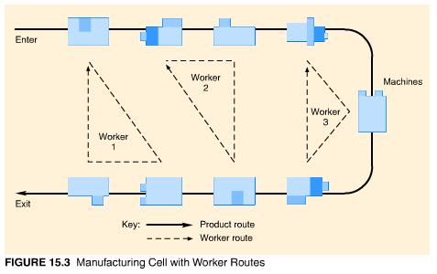

Work normally flows through the cell in one direction and experiences little waiting. In a one-person cell, the cycle time of the cell is determined by the time it takes for the worker to complete his or her path through the cell. This means that, although different items produced in the cell may take different amounts of time to complete, the time between successive items leaving the cell remains virtually the same because the worker's path remains the same. Thus, changes of product mix within the cell are easy to accommodate. Changes in volume can be handled by adding or subtracting workers to the cell and adjusting their walking routes accordingly. Figure 15.4 shows how worker routes can be adjusted in a system of integrated cells.
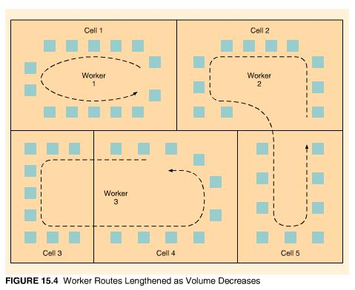
Because cells produce similar items, setup time requirements are low and lot sizes can be reduced. Movement of output from the cells to subassembly or assembly lines occurs in small lots and is controlled by kanbans (which we discuss later). Cellular layouts, because of their manageable size, work flow, and flexibility, facilitate another element of JIT, pull production.

The Pull System
A major problem in automobile manufacturing is coordinating the production and delivery of materials and parts with the production of subassemblies and the requirements of the final assembly line. It is a complicated process, not because of the technology, but because of the thousands of large and small components produced by thousands of workers for a single automobile. Traditionally, inventory has been used to cushion against lapses in coordination, and these inventories can be quite large. Ohno struggled for five years trying to come up with a system to improve the coordination between processes and thereby eliminate the need for large amounts of inventory. He finally got the idea for his pull system from another American classic, the supermarket. Ohno read (and later observed) that Americans do not keep large stocks of food at home. Instead, they make frequent visits to nearby supermarkets to purchase items as they need them. The supermarkets, in turn, carefully control their inventory by replenishing items on their shelves only as they are removed. Customers actually "pull through" the system the items they need, and supermarkets do not order more items than can be sold.
Applying this concept to manufacturing requires a reversal of the normal process/information flow, called a push system. In a push system, a schedule is prepared in advance for a series of workstations, and each workstation pushes its completed work to the next station. With the pull system, workers go back to previous stations and take only those parts or materials they need and can process immediately. When their output has been taken, workers at the previous station know it is time to start producing more, and they replenish the exact quantity that the subsequent station just took away. If their output is not taken, workers at the previous station simply stop production; no excess is produced. This system forces operations to work in coordination with one another. It prevents overproduction and underproduction; only necessary quantities are produced. "Necessary" is not defined by a schedule that specifies what ought to be needed; rather, it is defined by the operation of the shop floor, complete with unanticipated occurrences and variations in performance.
Although the concept of pull production seems simple, it can be difficult to implement because it is so different from normal scheduling procedures. After several years of experimenting with the pull system, Ohno found it necessary to introduce kanbans to exercise more control over the pull process on the shop floor.

Kanban Production Control System
Kanban is the Japanese word for card. In the pull system, each kanban corresponds to a standard quantity of production or size of container. A kanban contains basic information such as part number, brief description, type of container, unit load (i.e., quantity per container), preceding station (where it came from), and subsequent station (where it goes to). Sometimes the kanban is color-coded to indicate raw materials or other stages of manufacturing. The information on the kanban does not change during production. The same kanban can rotate back and forth between preceding and subsequent workstations.
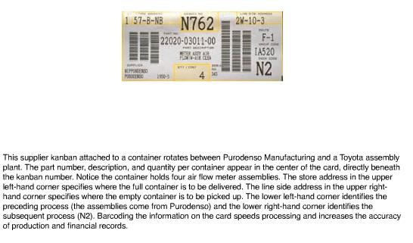
Kanbans are closely associated with the fixed-quantity inventory system we discussed in Chapter 12. Recall that in the fixed-quantity system, a certain quantity, Q, is ordered whenever the stock on hand falls below a reorder point. The reorder point is determined so that demand can be met while an order for new material is being processed. Thus, the reorder point corresponds to demand during lead time. A visual fixed-quantity system, called the two-bin system, illustrates the concept nicely. Referring to Figure 15.5(a), two bins are maintained for each item. The first (and usually larger bin) contains the order quantity minus the reorder point, and the second bin contains the reorder point quantity. At the bottom of the first bin is an order card that describes the item and specifies the supplier and the quantity that is to be ordered. When the first bin is empty, the card is removed and sent to the purchasing department to order a new supply. While the order is being filled, the quantity in the second bin is used. If everything goes as planned, when the second bin is empty, the new order will arrive and both bins will be filled again.
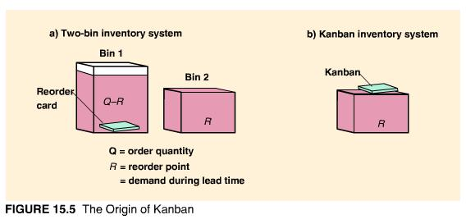
Ohno looked at this system and liked its simplicity, but he could not understand the purpose of the first bin. As shown in Figure 15.5(b), by eliminating the first bin and placing the order card (which he called a kanban) at the top of the second bin, Q-R inventory could be eliminated. In this system, an order is continually in transit. When the new order arrives, the supplier is reissued the same kanban to fill the order again. The only inventory that is maintained is the amount needed to cover usage until the next order can be processed. This concept is the basis for the kanban system.
Kanbans do not make the schedule of production; they maintain the discipline of pull production by authorizing the production and movement of materials. If there is no kanban, there is no production. If there is no kanban, there is no movement of material. There are many different types and variations of kanbans. The most sophisticated is probably the dual kanban system used by Toyota which uses two types of kanbans: production kanbans and withdrawal kanbans. As their names imply, a production kanban is a card authorizing production of goods, and a withdrawal kanban is a card authorizing the movement of goods. Each kanban is physically attached to a container. Let us follow the example in Animated Figure 15.6(a) to see how they work:
- Process B receives a production kanban. It must produce enough of the item requested to fill the empty container to which the production kanban is attached.
- To complete the requirements of production, process B uses a container of inputs and generates a request for more input from the preceding workstation, process A.
- The request for more input items takes the form of a withdrawal kanban sent to process A.
- Since process A has some output available, it attaches the withdrawal kanban to the full container and sends it immediately to process B.
- The production kanban that originally accompanied the full container is removed and placed on the empty container, thereby generating production at process A.
- Production at process A requires a container of inputs.
The dual kanban approach is used when material is not necessarily moving between two consecutive processes, or when there is more than one input to a process and the inputs are dispersed throughout the facility (as for an assembly process). If the processes are tightly linked, a single kanban can be used. For example, in Figure 15.6(a), if process B always followed process A, the output for process A would also be the input for process B. A kanban could be permanently attached to the containers that rotate between A and B. An empty container would be the signal for more production, and the distinction between production and withdrawal kanban would no longer be necessary. To take the concept one step further, if two processes are physically located near each other, the kanban system can be implemented without physical cards.
Animated Figure 15.6(b) shows the use of kanban squares placed between successive workstations. A kanban square is a marked area that will hold a certain number of output items (usually one or two). If the kanban square following his or her process is empty, the worker knows it is time to begin production again. Kanban racks, illustrated in Figure 15.6(c), can be used in a similar manner. When the allocated slots on a rack are empty, workers know it is time to begin a new round of production to fill up the slots. If the distance between stations prohibits the use of kanban squares or racks, the signal for production can be a colored golf ball rolled down a tube, a flag on a post, a light flashing on a board, or an electronic or verbal message requesting more.
Signal kanbans are used when inventory between processes is still necessary. It closely resembles the reorder point system. As shown in Figure 15.6(d), a triangular marker is placed at a certain level of inventory. When the marker is reached (a visual reorder point), it is removed from the stack of goods and placed on an order post, thereby generating a replenishment order for the item. The rectangular-shaped kanban in the diagram is called a material kanban. In some cases it is necessary to order the material for a process in advance of the initiation of the process.
Kanbans can also be used outside the factory to order material from suppliers. The supplier brings the order (e.g., a filled container) directly to its point of use in the factory and then picks up an empty container with kanban to fill and return later. It would not be unusual for 5,000 to 10,000 of these supplier kanbans to rotate between the factory and suppliers. To handle this volume of transactions, a kind of kanban "post office" can be set up, with kanbans sorted by supplier, as in Figure 15.6(e). The supplier then checks his or her "mailbox" to pick up new orders before returning to the factory. Bar-coded kanbans and electronic kanbans can also be used to facilitate communication between customer and supplier.
It is easy to get caught up with the technical aspects of kanbans and lose sight of the objective of the pull system, which is to reduce inventory levels. The kanban system is actually very similar to the reorder point system. The difference is in application. The reorder point system attempts to create a permanent ordering policy, whereas the kanban system encourages the continual reduction of inventory. We can see how that occurs by examining the formula for determining the number of kanbans needed to control the production of a particular item.
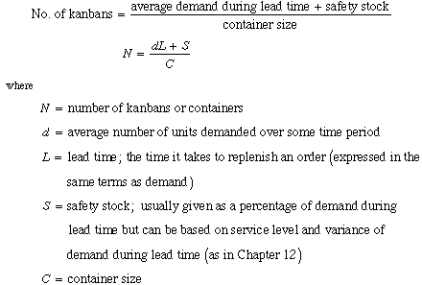
To force the improvement process, the container size is usually much smaller than the demand during lead time. At Toyota, containers can hold at most 10 percent of a day's demand. This allows the number of kanbans (i.e., containers) to be reduced one at a time. The smaller number of kanbans (and corresponding lower level of inventory) causes problems in the system to become visible. Workers and managers then attempt to solve the problems that have been identified.
EXAMPLE
15.1
Determining the Number of Kanbans

Julie Hurling works in a cosmetic factory filling, capping, and labeling bottles. She is asked to process an average of 150 bottles per hour through her work cell. If one kanban is attached to every container, a container holds 25 bottles, it takes 30 minutes to receive new bottles from the previous workstation, and the factory uses a safety stock factor of 10 percent, how many kanbans are needed for the bottling process?
SOLUTION:
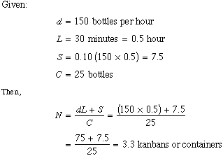
We can round either up or down (3 containers would force us to improve operations, and 4 would allow some slack).

Small-Lot Production
Small-lot production requires less space and capital investment than systems that incur large inventories. By producing small amounts at a time, processes can be physically moved closer together and transportation between stations can be simplified. In small-lot production, quality problems are easier to detect and workers show less tendency to let poor quality pass (as they might in a system that is producing huge amounts of an item anyway). Lower inventory levels make processes more dependent on each other. This is beneficial because it reveals errors and bottlenecks more quickly and gives workers an opportunity to solve them.
The analogy of water flowing over a bed of rocks is useful here. As shown in Figure 15.7, the inventory level is like the level of water. It hides problems but allows for smooth sailing. When the inventory level is reduced, the problems (or rocks) are exposed. After the exposed rocks are removed from the river, the boat can again progress, this time more quickly than before.
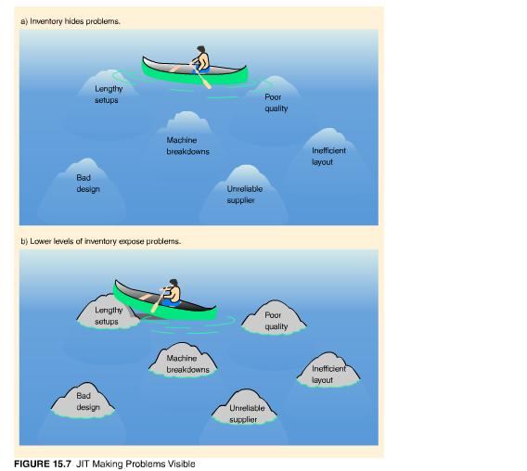
Although it is true that a company can produce in small lot sizes without using the pull system or kanbans, from experience we know that small-lot production in a push system is difficult to coordinate. Similarly, using large lot sizes with a pull system and kanbans would not be advisable. Let us look more closely at the relationship between small lot sizes, the pull system, and kanbans.
From the kanban formula, it becomes clear that a reduction in the number of kanbans (given a constant container size) requires a corresponding reduction in safety stock or in lead time itself. The need for safety stock can be reduced by making demand and supply more certain. Flexible resources allow the system to adapt more readily to unanticipated changes in demand. Demand fluctuations can also be controlled through closer contact with customers and better forecasting systems. Deficiencies in supply can be controlled through eliminating mistakes, producing only good units, and reducing or eliminating machine breakdowns.
Lead time is typically made up of four components:
- Processing time,
- Move time,
- Waiting time, and
- Setup time.
Processing time can be reduced by reducing the number of items processed and the efficiency or speed of the machine or worker. Move time can be decreased if machines are moved closer together, the method of movement is simplified, routings are standardized, or the need for movement is eliminated. Waiting time can be reduced through better scheduling of materials, workers, and machines and sufficient capacity. In many companies, however, lengthy setup times are the biggest bottleneck. Reduction of setup time is an important part of JIT.

Quick Setups
Several processes in automobile manufacturing defy production in small lots because of the enormous amount of time required to set up the machines. Stamping is a good example. First, a large roll of sheet steel is run through a blanking press to produce stacks of flat blanks slightly larger than the size of the desired parts. Then, the blanks are inserted into huge stamping presses that contain a matched set of upper and lower dies. When the dies are held together under thousands of pounds of pressure, a three-dimensional shape emerges, such as a car door or fender. Because the dies weigh several tons each and have to be aligned with exact precision, die changes typically take an entire day to complete.
Obviously, manufacturers are reluctant to change dies often. Ford, for example, might produce 500,000 right door panels and store them in inventory before switching dies to produce left door panels. Some Western manufacturers have found it easier to purchase several sets of presses and dedicate them to stamping out a specific part for months or years. Due to capital constraints, that was not an option for Toyota. Instead, Ohno began simplifying die-changing techniques. Convinced that major improvements could be made, a consultant, Shigeo Shingo, was hired to study die setup systematically, to reduce changeover times further, and to teach these techniques to production workers and Toyota suppliers.
Shingo proved to be a genius at the task. He reduced setup time on a 1,000-ton press from six hours to three minutes using a system he called SMED (single-minute exchange of dies). SMED is based on the following principles, which can be applied to any type of setup:
- Separate internal setup from external setup. Internal setup has to be performed while the machine is stopped; it cannot take place until the machine has finished with the previous operation. External setup, on the other hand, can be performed in advance, while the machine is running. By the time a machine has finished processing its current operation, the worker should have completed the external setup and be ready to perform the internal setup for the next operation. Applying this concept alone can reduce setup time by 30 to 50 percent.
- Convert internal setup to external setup. This process involves making sure that the operating conditions, such as gathering tools and fixtures, preheating an injection mold, centering a die, or standardizing die heights, are prepared in advance.
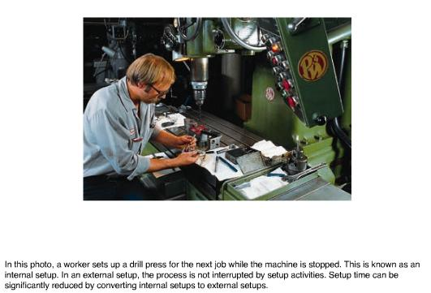
- Streamline all aspects of setup. External setup activities can be reduced by organizing the workplace properly, locating tools and dies near their points of use, and keeping machines and fixtures in good repair. Internal setup activities can be reduced by simplifying or eliminating adjustments. Examples include precoding desired settings, using quick fasteners and locator pins, preventing misalignment, eliminating tools, and making movements easier. Figure 15.8 provides some common analogies for these improvements.
- 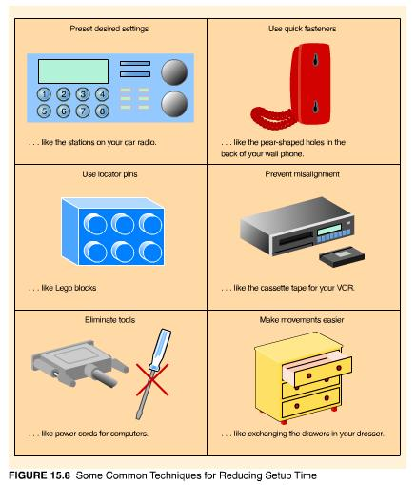Perform setup activities in parallel or eliminate them entirely. Adding an extra person to the setup team can reduce setup time considerably. In most cases, two people can perform a setup in less than half the time needed by a single person. In addition, standardizing components, parts, and raw materials can reduce and sometimes eliminate setup requirements.
In order to view the setup process objectively, it is useful to assign the task of setup-time reduction to a team of workers and engineers. Videotaping the setup in progress often helps the team generate ideas for improvement. Time and motion study principles (like those we discussed in Chapter 8) can be applied. After the new setup procedures have been agreed upon, they need to be practiced until they are perfected. One only has to view the pit crews at the Indy 500 to realize that quick changeovers have to be orchestrated and practiced.

Uniform Production Levels
In addition to eliminating waste, JIT systems attempt to maintain uniform production levels by smoothing the production requirements on the final assembly line. Changes in final assembly often have dramatic effects on component production upstream. When this happens in a kanban system, kanbans for certain parts will circulate very quickly at some times and very slowly at others. Adjustments of plus or minus 10 percent in monthly demand can be absorbed by the kanban system, but wider demand fluctuations cannot be handled without substantially increasing inventory levels or scheduling large amounts of overtime.⁵
One way to reduce variability in production is to guard against unexpected demand through more accurate forecasts. To accomplish this, the sales division of Toyota takes the lead in production planning. Toyota Motor Sales conducts surveys of tens of thousands of people twice a year to estimate demand for Toyota cars and trucks. Monthly production schedules are drawn up from the forecasts two months in advance. The plans are reviewed one month in advance and then again ten days in advance. Daily production schedules, which by then include firm orders from dealers, are finalized four days from the start of production. Model mix changes can still be made the evening before or the morning of production. This flexibility is possible because schedule changes are communicated only to the final assembly line. Kanbans take care of dispatching revised orders to the rest of the system.
Another approach to achieving uniform production is to level or smooth demand across the planning horizon. Demand is divided into small increments of time and spread out as evenly as possible so that the same amount of each item is produced each day, and item production is mixed throughout the day in very small quantities. The mix is controlled by the sequence of models on the final assembly line.
Toyota assembles several different vehicle models on each final assembly line. The assembly lines were initially designed this way because of limited space and resources and lack of sufficient volume to dedicate an entire line to a specific model. However, the mixed-model concept has since become an integral part of JIT. Daily production is arranged in the same ratio as monthly demand, and jobs are distributed as evenly as possible across the day's schedule. This means that at least some quantity of every item is produced daily, and the company will always have some quantity of an item available to respond to variations in demand. The mix of assembly also steadies component production, reduces inventory levels, and supports the pull system of production. Let us look at an example of mixed-model sequencing.
EXAMPLE
15.2
Mixed-Model Sequencing

If Toyota receives a monthly demand estimate of 1,200 small cars (S), 2,400 midsize cars (M), and 2,400 luxury cars (L), how should the models be produced in order to smooth production as much as possible? (Assume 30 days in a month.)
SOLUTION:
Our first step is to convert monthly demand to a daily schedule by dividing by the number of days in a month. As a result, we need to produce 40, 80, and 80 of each model, respectively, per day. In mixing the production of models as much as possible throughout the day, we want to produce twice as many midsize and luxury cars as small cars. One possible final assembly sequence is L-M-S-M-L. This sequence would be repeated 40 times a day.
If the preceding example sounds extreme, it is not. Toyota assembles three models in 100 variations on a single assembly line at its Tahara plant, and the mix is jiggled daily with almost no warning.⁶ The plant is highly automated, and each model carries with it a small yellow disc that transmits instructions to the next workstation. Cars roll off the final assembly line in what looks like unit production--a black Lexus sedan, a blue Camry, a red Lexus sports coupe, a white Camry with left-hand drive, and so on.
This is in sharp contrast to the large lots of similar items produced by mass production factories, in which 2,400 luxury cars might be produced the first week and a half of the month, 2,400 midsize cars, the second week and a half, and 1,200 small cars, the final week. Under this system, it would be difficult to change product mix midway through the month, and small-car customers would have to wait three to four weeks before their order would be available.

Quality at the Source
For a JIT system to work well, quality has to be extremely high. There is no extra inventory to buffer against defective units. Producing poor-quality items and then having to rework or reject them is a waste that should be eliminated. Quality improvement efforts at Toyota accelerated as processes were being streamlined and the JIT system was formulated. It soon became obvious that smaller lot sizes actually encouraged better quality. Workers can observe quality problems more easily; when problems are detected, they can be traced to their source and remedied without reworking too many units. Also, by inspecting the first and the last unit in a small batch or by having a worker make a part and then use the part, virtually 100 percent inspection can be achieved.
Toyota's quality objective is zero defects (just as its inventory objective is zero inventory). In pursuit of zero defects the company seeks to identify quality problems at their source, to solve them, and never to pass on a defective item. To this end, Ohno was determined that the workers, not inspectors, should be responsible for product quality. To go along with this responsibility, he also gave workers the unprecedented authority of jidoka--the authority to stop the production line if quality problems were encountered.
To encourage jidoka, each worker is given access to a switch that can be used to activate call lights or to halt production. The call lights, called andons, flash above the workstation and at several andon boards throughout the plant. Green lights indicate normal operation, yellow lights show a call for help, and red lights indicate a line stoppage. Supervisors, maintenance personnel, and engineers are summoned to troubled workstations quickly by flashing lights on the andon board. At Toyota, the assembly line is stopped for an average of twenty minutes a day because of jidoka. Each jidoka drill is recorded on easels kept at the work area. A block of time is reserved at the end of the day for workers to go over the list and work on solving the problems raised. For example, an eight-hour day might consist of seven hours of production and one hour of problem solving.
This concept of allocating extra time to a schedule for nonproductive tasks is called undercapacity scheduling. Another example of undercapacity scheduling is producing for two shifts each day and reserving the third shift for preventive maintenance activities. Making time to plan, train, solve problems, and maintain the work environment is an important part of JIT's success.
Quality improves when problems are made visible and workers have clear expectations of performance. Production systems designed with quality in mind include visible instructions for worker or machine action, and direct feedback on the results of that action. This is known as visual control. Examples include kanbans, standard operation sheets, andons, process control charts, and tool boards. A factory with visual control will look different than other factories. You may find machines or stockpoints in each section painted different colors, material handling routes marked clearly on the floor, demonstration stands and instructional photographs placed near machines, graphs of quality or performance data displayed at each workstation, and explanations and pictures of recent improvement efforts posted by work teams. Figure 15.9 shows several examples of visual control.
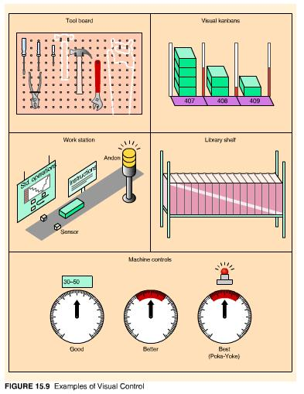
Visual control of quality often leads to what the Japanese call a poka-yoke. A poka-yoke is any foolproof device or mechanism that prevents defects from occurring. For example, a dial on which desired ranges are marked in different colors is an example of visual control. A dial that shuts off a machine whenever the instrument needle falls above or below the desired range is a poka-yoke. Machines set to stop after a certain amount of production are poka-yokes, as are sensors that prevent the addition of too many items into a package or the misalignment of components for an assembly.
Finally, quality in JIT is based on kaizen, the Japanese term for continuous improvement. As a practical system for production created from trial-and-error experiences in eliminating waste and simplifying operations, JIT continually looks for ways to reduce inventory, quicken setups, improve quality, and react faster to customer demand. Continuous improvement is not something that can be delegated to a department or a staff of experts. It is a monumental undertaking that requires total employee involvement TEI--the participation of every employee at every level. The essence of JIT success is the willingness of workers to spot quality problems, halt production when necessary, generate ideas for improvement, analyze process, perform different functions, and adjust their working routines.

Total Productive Maintenance
Machines cannot operate continuously without some attention. Maintenance activities can be performed when a machine breaks down to restore the machine to its original operating condition, or at different times during regular operation of the machine in an attempt to prevent a breakdown from occurring. The first type of activity is referred to as breakdown maintenance; the second is called preventive maintenance.
Breakdowns seldom occur at convenient times. Lost production, poor quality, and missed deadlines from an inefficient or broken-down machine can represent a significant expense. In addition, the cost of breakdown maintenance is usually much greater than preventive maintenance. (Most of us know that to be true from our own experience at maintaining an automobile. Regular oil changes cost pennies compared to replacing a car engine.) For these reasons, most companies do not find it cost-effective to rely solely on breakdown maintenance. The question then becomes, how much preventive maintenance is necessary and when should it be performed?
With accurate records on the time between breakdowns, the frequency of breakdowns, and the cost of breakdown and preventive maintenance, we can mathematically determine the best preventive maintenance schedule. But even with this degree of precision, breakdowns can still occur. JIT requires more than preventive maintenance--it requires total productive maintenance.
Total productive maintenance (TPM) combines the practice of preventive maintenance with the concepts of total quality--employee involvement, decisions based on data, zero defects, and a strategic focus. Machine operators maintain their own machines with daily care, periodic inspections, and preventive repair activities. They compile and interpret maintenance and operating data on their machines, identifying signs of deterioration prior to failure.⁷ They also scrupulously clean equipment, tools, and workspaces to make unusual occurrences more noticeable. Oil spots on a clean floor may indicate a machine problem, whereas oil spots on a dirty floor would go unnoticed. In Japan this is known as the five S's--seiri, seiton, seiso, seiketsu, and shitsuke--roughly translated as organization, tidiness, cleanliness, maintenance, and discipline.
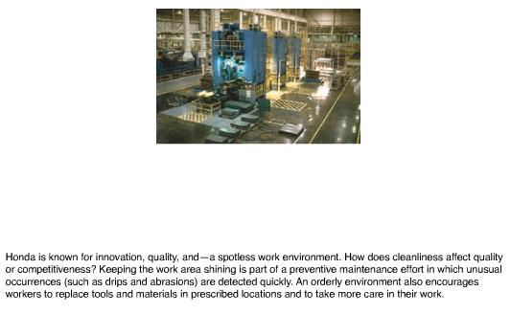
In addition to operator involvement and attention to detail, TPM requires management to take a broader, strategic view of maintenance. That means:
- Designing products that can easily be produced on existing machines;
- Designing machines for easier operation, changeover, and maintenance;
- Training and retraining workers to operate and maintain machines properly;
- Purchasing machines that maximize productive potential; and
- Designing a preventive maintenance plan that spans the entire life of each machine.
The goal of TPM is zero breakdowns. Does it work? One Deming prize-winning company, Aishin Seiki, has not experienced an equipment breakdown in more than four years. Prior to TPM, they had more than 700 breakdowns a month!

Supplier Networks
A network of reliable suppliers is also essential to JIT. Toyota mastered this element by selecting a small number of suppliers and developing strong, long-term working relationships with them. Twelve Toyota plants are located near Toyota City, in an area two-thirds the size of Connecticut. Suppliers encircle the plants, most within a fifty-mile radius. This enables parts to be delivered several times a day. Bulky parts, such as engines and transmissions, are delivered every fifteen to thirty minutes. Supplier kanbans and JIT at supplier plants are used to accomplish this feat.
Toyota began working with its suppliers in 1962 to improve responsiveness and quality. By 1970, 60 percent of them were using kanbans and by 1982, 98 percent were. Suppliers who met stringent quality standards could forego inspection of incoming goods. This meant goods could be brought right to the assembly line or area of use without being counted, inspected, tagged, or stocked. Because of geography, manufacturers in the United States can probably never match the frequency of delivery enjoyed by Toyota, but they can reduce the number of suppliers, work more closely with them in the design of parts and the quality of parts, and expect prompt--even daily--deliveries.
One of the common misconceptions about JIT is that inventory is pushed back to the suppliers. That is true only if producers are not really using JIT or if suppliers try to meet JIT demand requirements without practicing JIT themselves. Otherwise, suppliers can benefit from the guaranteed demand, steadiness of demand, advanced notice of volume changes, minimal design changes, engineering and management assistance, and sharing of profits characteristic of the close vendor-producer partnerships of JIT. That said, JIT has certainly changed the manner in which suppliers are chosen and goods are supplied to producers. The following is a list of trends in supplier policies since the advent of JIT:
- Locate near to the customer. Although this is not possible in all cases, it does occur, as evidenced by the circle of suppliers that surrounds the Tennessee valley where the Nissan and Saturn plants are located. Nissan receives deliveries of vehicle seats four times an hour and notifies the supplier two hours in advance the exact sequence (i.e., type and color) in which the seats are to be unloaded.
- Use small, side-loaded trucks and ship mixed loads. These trucks are easier to load and can be loaded in the sequence that the customer will be using the items. Several suppliers may combine their loads on one truck that will tour the supplier plants to pick up items for delivery to the customer.
- Consider establishing small warehouses near the customer or consolidating warehouses with other suppliers. The small warehouses could be used for frequently delivered items, and the consolidation warehouses could become load-switching points when geographic distances between supplier and customer prohibit daily deliveries. Yellow Freight has been very successful with this approach.
- Use standardized containers and make deliveries according to a precise delivery schedule. Exchanging containers makes deliveries and replenishment move along quickly. Delivery windows are becoming very short, and penalties for missing them are high. Chrysler penalizes its trucking firm $32,000 for each hour a delivery is late.
- Become a certified supplier and accept payment at regular intervals rather than upon delivery. This eliminates much of the paperwork and waiting time associated with traditional delivery. Certified suppliers are subjected to a limited amount of quality and quantity checks or may be exempt from them altogether.

Benefits of JIT
A study of the average benefits accrued to U.S. manufacturers over a five-year period from implementing JIT are impressive: 90 percent reductions in manufacturing cycle time, 70 percent reductions in inventory, 50 percent reductions in labor costs, and 80 percent reductions in space requirements.
While not every company can achieve results at this level, JIT does provide a wide range of benefits, including:
- Reduced inventory
- Improved quality
- Lower costs
- Reduced space requirements
- Shorter lead time
- Increased productivity
- Greater flexibility
- Better relations with suppliers
- Simplified scheduling and control activities
- Increased capacity
- Better use of human resources
- More product variety

JIT Implementation
Japanese industry embraced JIT in the mid-1970s, after manufacturers observed Toyota's superior ability to withstand the 1973 oil crisis. Many U.S. firms, in turn, adopted JIT in some form in the 1980s. Those firms that tried to implement JIT by slashing inventory and demanding that their suppliers make frequent deliveries missed the power of the system. Supplier deliveries and kanbans are some of the last elements of JIT to implement.
The firms that have been most successful in implementing JIT understood the breadth and interrelatedness of the concepts and adapted them to their own particular environment. This makes sense when you consider the essence of JIT--eliminate waste, speed up changeovers, work closely with suppliers, streamline the flow of work, use flexible resources, pay attention to quality, expose problems, and use worker teams to solve problems. None of these concepts or techniques are new or particularly revolutionary. How they are applied can differ considerably from company to company. What is unique and remarkable is how the pieces are tied together into a finely tuned operating system and how synchronized that system can be with both the external and internal business environments.
Many firms have their own name for their version of just-in-time. JIT is called stockless production at Hewlett-Packard, material as needed (MAN) at Harley-Davidson, continuous-flow manufacturing (CFM) at IBM, zero inventory production system (ZIPS) at Omark Industries, and lean production in the landmark book The Machine That Changed the World by Womack, Jones, and Roos that chronicles the automobile industry.
JIT applications on U.S. soil, whether in Japanese- or U.S.-run plants, differ somewhat from the original Japanese versions. U.S. JIT plants are typically larger, deliveries from suppliers are less frequent, more buffer inventory is held (because of the longer delivery lead times), and kanbans, if used at all, are very simple. Worker-designed feedback systems are different, too. Instead of alarms and flashing lights when things go wrong, workers at the Saturn plant hear a recording of "The Pink Panther." At the Nissan plant, workers are reminded to change workstations along an S-shaped assembly line by the changing tempo of piped-in music (from country to rock). Morning calisthenics are out for most U.S. plants, but the placement of ping-pong tables and basketball hoops alongside the assembly line for exercise during worker-designated breaks is popular.

As might be expected, JIT is still evolving. Toyota has learned from its U.S. plants that the stress of arbitrarily reducing inventory to reveal problems does not necessarily make workers more creative in improving the system.⁸ To the contrary, creating an environment that is receptive to change, without forcing it, seems to work just as well. Shorter workdays and longer breaks during the day do not seriously impede productivity either. In Japan, Toyota's practice of clustering plants and suppliers in geographic proximity to one another has worked well for frequent deliveries and small-lot production, but it has also used up the available labor in the area. Toyota's new plants are more dispersed, like U.S. plants, and require more inventory. They are also more automated. The Tahara plant, for example, is almost entirely automated, with buffers of inventory between the seven major sections of the final assembly line.⁹ Although this seems to be a divergence from the principles of JIT, it may merely reflect that JIT, like other management systems, must be adapted to the manufacturing environment.
We should note that JIT is not appropriate for every type of operation. For high-volume, repetitive items, mass production is still the best process to use. Even Toyota produces high-demand components (typically small items that require stamping and forging) in lots as large as 10,000 units, sending them to subsequent processes in small batches only when requested. Similarly, JIT is inappropriate for very low-volume items or unique orders. For JIT to be successful, there must be some stability of demand. A true make-to-order shop would find it difficult to operate under JIT. Even in make-to-order businesses, however, there are usually some parts or processes that are common or repetitive and can benefit from JIT concepts. What we are finding is that there are more operations that can benefit from JIT than cannot.

JIT in Services
Most people who think of JIT as a system for reducing inventory do not consider the system to be applicable to services. However, you know from reading this chapter that JIT consists of more than low inventory levels. It eliminates waste, streamlines operations, promotes fast changeovers and close supplier relations, and adjusts quickly to changes in demand. As a result, products and services can be provided quickly, at less cost, and in more variety. Although it is rarely referred to as such, we can readily observe the basic elements of JIT in service operations. Think about:
- McDonald's, Domino's, and Federal Express, who compete on speed and still provide their products and services at low cost and with increasing variety;
- Construction firms that coordinate the arrival of material "just as it is needed" instead of stockpiling them at the site;
- Multifunctional workers in department stores that work the cash register, stock goods, arrange displays, and make sales;
- Level selling with "everyday low prices" at Wal-Mart, Hills, and Food Lion;
- Work cells at fast-food restaurants that allow workers to be added during peak times and reduced during slow times;
- "Dollar" stores that price everything the same and simply count the number of items purchased as the customer leaves;
- Process mapping that has streamlined operations and eliminated waste in many services (especially in terms of paper flow and information processing);
- Medical facilities that have the flexibility to fill prescriptions, perform tests, and treat patients without routing them from one end of the building to another;
- Just-in-time publishing that allows professors to choose material from a variety of sources and construct a custom-made book in the same amount of time off-the-shelf books can be ordered and at competitive prices;
- Lens providers, cleaners, and car-repair services that can turn around customer orders in an hour;
- Cleaning teams that follow standard operations routines in quickly performing their tasks; and
- Supermarkets that replenish their shelves according to what the customer withdraws.
As you can see, JIT concepts are flourishing in services!
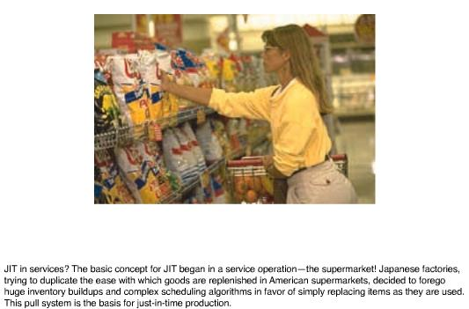
Services have also been dramatically affected by JIT in manufacturing. Order entry, accounting practices, product development, and supply chains have been reengineered along JIT lines. Trucking firms, railroads, and delivery services have increased the speed at which their services are performed and increased their reliability in response to JIT. Retail stores can provide customers with more choices faster than ever before. Milliken promises custom-ordered carpets within two weeks, Benetton can create and ship new product lines within ten days of redesign, and Motorola can provide customized pagers overnight. With this type of rapid response, stores can order and receive goods faster from the manufacturer than they can retrieve them from their warehouses.
Finally, much of the emphasis of JIT comes from being close to the customer, close to the supplier, and close to the worker. Services have traditionally excelled in those areas.

