Uses of Energy
The United States is a highly developed and industrialized society. We use a lot of energy - in our homes, in businesses, in industry, and for travelling between all these different places.
The industrial sector uses about one-third of the total energy. The residential and commercial sectors combined use 0 percent of all energy. These two sectors include all types of buildings, such as houses, offices, stores, restaurants, and places of worship. Energy used for transportation accounts for more than a quarter of all energy.
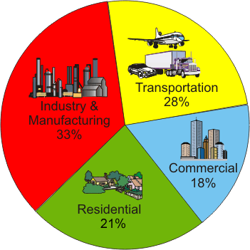

Share of Energy Consumed by
Major Sectors of the Economy

USES OF ENERGY IN HOMES
The ability to maintain desired temperatures is one of the most important accomplishments of modern technology. Our ovens, freezers, and homes can be kept at any temperature we choose, a luxury that wasn't possible 100 years ago. Keeping our homes comfortable uses a lot of energy. Almost half of the average home's energy consumption is used for heating. Another 17 percent is used for water heating, 6 percent for cooling rooms, and 5 percent for refrigeration.
Almost one-fourth of the energy used in homes is used for lighting and appliances. Lighting is essential to a modern society. Lights have revolutionized the way we live, work, and play.
How Energy is Used in Homes
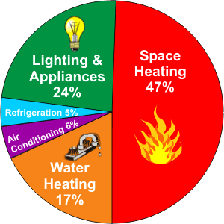
Due to rounding, percentages may not add to exactly 100 percent.
Most homes still use the traditional incandescent bulbs invented by Thomas Edison. These bulbs convert only about ten percent of the electricity they use to produce light, the other 90 percent is converted into heat. With new technologies, such as better filament designs and gas mixtures, incandescent bulbs are more efficient than they used to be. In 1879, the average bulb produced only 14 lumens per watt, compared to about 17 lumens per watt today. By adding halogen gases, the efficiency can be increased to 20 lumens per watt.
Compact fluorescent bulbs, or "CFLs", have made inroads into home lighting systems in the last few years. These bulbs are more expensive to purchase, but last much longer and use much less energy, producing significant savings over the life of the bulb.
Appliances such as water heaters, refrigerators, washing machines and dryers are also more energy efficient than they used to be. In 1990 Congress passed the National Appliance Energy Conservation Act, which requires new appliances to meet strict energy efficiency standards. Learn more about energy efficient light bulbs and appliances, and other ways to save energy at home.

TYPES OF ENERGY USED IN HOMES
Natural gas is the most widely used energy source in American homes, followed by electricity, heating oil and propane. Natural gas and heating oil (fuel oil) are used mainly for home heating. Electricity may also be used for heating and cooling, plus it lights our homes and runs almost all of our appliances including refrigerators, toasters, and computers. Many homes in rural areas use propane for heating, while others use it to fuel their barbecue grills.
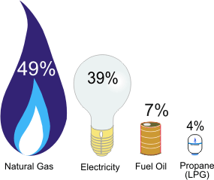

ENERGY USE IN COMMERCIAL BUILDINGS
Commercial buildings include a wide variety of building types—offices, hospitals, schools, police stations, places of worship, warehouses, hotels, barber shops, libraries, shopping malls—and that’s just the beginning of the list. These different commercial activities all have unique energy needs but, as a whole, commercial buildings use more than half their energy for heating and lighting.
How Energy is Used in Commercial Buildings
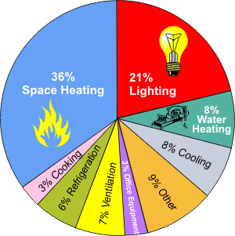
Note: Total may not equal 100 percent due to independent rounding.

TYPES OF ENERGY USED IN COMMERCIAL BUILDINGS
Electricity and natural gas are the most common energy sources used in commercial buildings. Commercial buildings also use another source that you don’t usually find used in residential buildings—district energy. When there are many buildings close together, like on a college campus or in a big city, it is sometimes more efficient to have a central heating and cooling plant that distributes steam, hot water, or chilled water to all of the different buildings. A district system can reduce equipment and maintenance costs, as well as save energy.
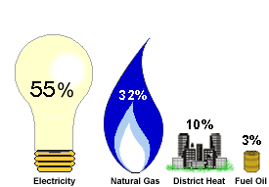

ENERGY USE BY TYPE OF BUILDING
Retail and service buildings use the most total energy of all the commercial building types. This isn’t too surprising when you think of all the stores and service businesses in most towns. Offices use a large share of energy, too. Education buildings, like your school, use 13 percent of all total energy, which is even more than all hospitals and other medical buildings combined! Lodging buildings (like hotels or dormitories) use 8 percent of all energy. Warehouses and food service (like restaurants) each use 7 percent. Public assembly buildings, which can be anything from libraries to sports arenas, use 6 percent; food sales buildings (like grocery stores and convenience stores) use 4 percent. All other types of buildings, like places of worship, fire stations, police stations, and laboratories, account for the remaining 10 percent of commercial building energy.

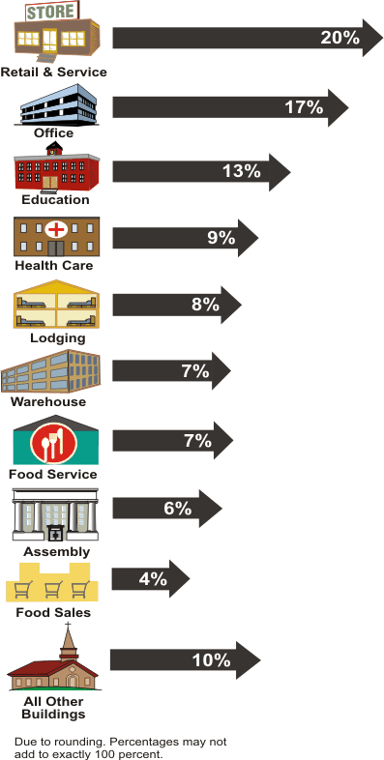

ENERGY USE IN INDUSTRY/MANUFACTURING
The United States is highly industrialized. Industry accounts for about one-third of the energy used in the country.
There are many different uses and a variety of different energy sources in the manufacturing sector. One main use is as boiler fuel, which means producing heat that is transferred to the boiler vessel to generate steam or hot water. Another use is as process heating, which is when energy is used directly to raise the temperature of products in the manufacturing process; examples are separating components of crude oil in petroleum refining, drying paint in automobile manufacturing, and cooking packaged foods.
Major End Uses of Some Common Energy Sources
(Percent of Energy Source Used for an End Use)
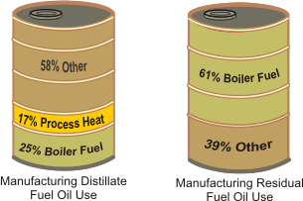
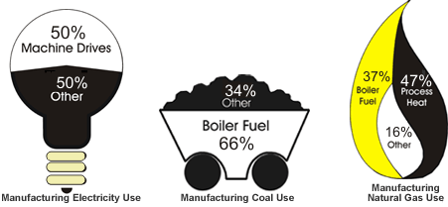

TYPES OF ENERGY FOR INDUSTRY/MANUFACTURING
In the manufacturing sector, the predominant energy sources are natural gas and electricity (a secondary source). Manufacturers also use other energy sources for heat, power, and electricity generation. Many uncommon energy sources are also used by manufacturers as a feedstock(a raw material used to make other products).
Sources of Energy Used for Industry and Manufacturing
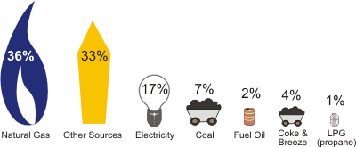

ENERGY USE BY TYPE OF INDUSTRY
Every industry uses energy, but there are a handful of energy-intensive industries that use the bulk of the energy consumed by the industrial sector.
The chemical industry is the largest industrial consumer of energy, followed closely by petroleum refining. The refining, chemical, paper and metal industries together use:
- 94% of the feedstock
- 92% of the by-product energy
- 70% of total inputs of energy for heat, power, and electricity generation
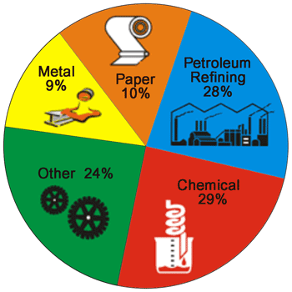

TYPES OF ENERGY USED FOR TRANSPORTATION
Gasoline is used mainly by cars, motorcycles, and light trucks; diesel is used mainly by heavier trucks, buses, and trains. Together, gasoline and diesel make up 86 percent of all the energy used in transportation.
There is currently a push to develop vehicles that run on fuels other than petroleum products, or on blended fuels. Today, there are some vehicles that run on electricity, natural gas, propane, and ethanol. Hybrid-electric vehicles combine the benefits of gasoline engines and electric motors, reducing the amount of fuel required for moving a vehicle. This is why hybrid-electric vehicles can get more miles per gallon of gasoline compared to vehicles that run on gasoline alone.
Fuels Used for Transportation

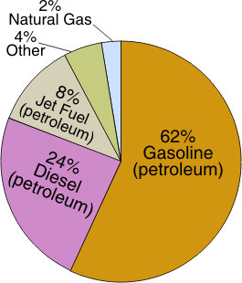

ENERGY USE BY TYPE OF VEHICLE
The people in the United States have always had a love affair with the automobile. Personal vehicles (like cars and light trucks) consume 63 percent of the total energy used for transportation, while commercial vehicles (like large trucks and construction vehicles), mass transit (like airplanes, trains, and buses), and pipelines account for the rest.

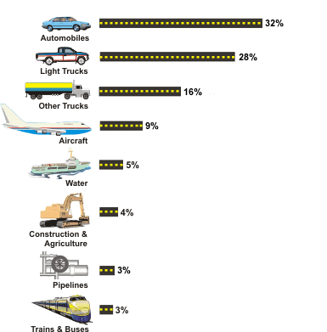

How Was Oil Formed?
Oil was formed from the remains of animals and plants that lived millions of years ago in a marine (water) environment before the dinosaurs. Over the years, the remains were covered by layers of mud. Heat and pressure from these layers helped the remains turn into what we today call crude oil . The word "petroleum" means "rock oil" or "oil from the earth."
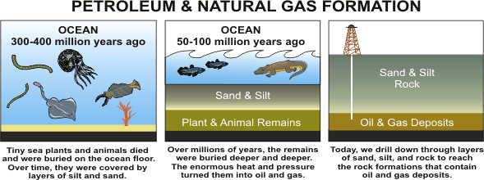

Where Do We Get Our Oil?
Crude oil is a smelly, yellow-to-black liquid and is usually found in underground areas called reservoirs. Scientists and engineers explore a chosen area by studying rock samples from the earth. Measurements are taken, and, if the site seems promising, drilling begins. Above the hole, a structure called a 'derrick' is built to house the tools and pipes going into the well. When finished, the drilled well will bring a steady flow of oil to the surface.
The world's top five crude oil-producing countries are:
- Saudi Arabia
- Russia
- United States
- Iran
- China

What Fuels Are Made From Crude Oil?
Products Made from a Barrel of Crude Oil
(Gallons)
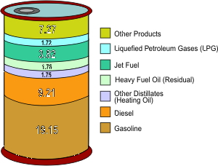

After crude oil is removed from the ground, it is sent to a refinery by pipeline, ship or barge. At a refinery, different parts of the crude oil are separated into useable petroleum products. Crude oil is measured in barrels (abbreviated "bbls"). A 42-U.S. gallon barrel of crude oil provides slightly more than 44 gallons of petroleum products. This gain from processing the crude oil is similar to what happens to popcorn, it gets bigger after it is popped.
One barrel of crude oil, when refined, produces about 20 gallons of finished motor gasoline, and 7 gallons of diesel, as well as other petroleum products. Most of the petroleum products are used to produce energy. For instance, many people across the United States use propane to heat their homes and fuel their cars. Other products made from petroleum include: ink, crayons, bubble gum, dishwashing liquids, deodorant, eyeglasses, records, tires, ammonia, and heart valves.

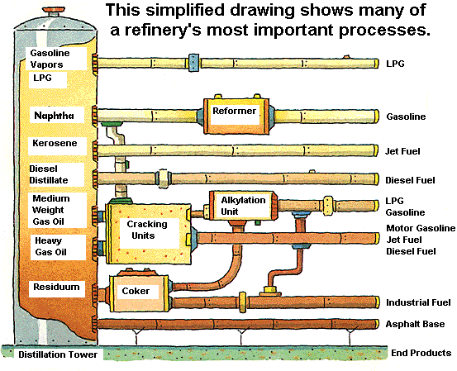

How Does Oil Impact The Environment?
Products from oil (petroleum products) help us do many things. We use them to fuel our airplanes, cars, and trucks, to heat our homes, and to make products like medicines and plastics. Even though petroleum products make life easier - finding, producing, moving, and using them can cause problems for our environment like air and water pollution. Over the years, new technologies and laws have helped to reduce problems related to petroleum products. As with any industry, the government monitors how oil is produced, refined, stored, and sent to market to reduce the impact on the environment. Since 1990, fuels like gasoline and diesel fuel have also been improved so that they produce less pollution when we use them.
Exploring and drilling for oil may disturb land and ocean habitats. New technologies have greatly reduced the number and size of areas disturbed by drilling, sometimes called "footprints." Satellites, global positioning systems, remote sensing devices, and 3-D and 4-D seismic technologies, make it possible to discover oil reserves while drilling fewer wells. Plus, the use of horizontal and directional drilling makes it possible for a single well to produce oil from much bigger areas. Today's production footprints are only about one-fourth the size of those 30 years ago, due to the development of movable drilling rigs and smaller "slim-hole" drilling rigs. When the oil in a well is gone, the well must be plugged below ground, making it hard to tell that it was ever there. As part of the "rig-to-reefs" program, some old offshore rigs are toppled and left on the sea floor to become artificial reefs that attract fish and other marine life. Within six months to a year after a rig is toppled, it becomes covered with barnacles, coral, sponges, clams, and other sea creatures.
If oil is spilled into rivers or oceans it can harm wildlife. When we talk about "oil spills" people usually think about oil that leaks from ships when they crash. Although this type of spill can cause the biggest shock to wildlife because so much oil is released at one time, only 2 percent of all oil in the sea comes from ship or barge spills. The amount of oil spilled from ships dropped a lot during the 1990's partly because new ships were required to have a "double-hull" lining to protect against spills. While oil spills from ships are the most well-known problem with oil, more oil actually gets into water from natural oil seeps coming from the ocean floor. Or, from leaks that happen when we use petroleum products on land. For example, gasoline that sometimes drips onto the ground when people are filling their gas tanks, motor oil that gets thrown away after an oil change, or fuel that escapes from a leaky storage tank. When it rains, the spilled products get washed into the gutter and eventually go to rivers and the ocean. Another way that oil sometimes gets into water is when fuel is leaked from motorboats and jet skis.
A refinery is a factory where crude oil is processed into petroleum products. Because many different pollutants can escape from refineries into the air, the government monitors refineries and other factories to make sure that they meet environmental standards.
When a leak in a storage tank or pipeline occurs, petroleum products can also get into the ground, and the ground must be cleaned up. To prevent leaks from underground storage tanks, all buried tanks are supposed to be replaced by tanks with a double-lining. This hasn't happened everywhere yet. In some places where gasoline leaked from storage tanks, one of the gasoline ingredients called methyl tertiary butyl ether (MTBE) made its way into local water supplies. Since MTBE made water taste bad and many people were worried about drinking it, a number of states banned the use of MTBE in gasoline, and the refining industry voluntarily moved away from using it when blending reformulated gasoline.
Gasoline is used in cars, diesel fuel is used in trucks, and heating oil is used to heat our homes. When petroleum products are burned as fuel, they give off carbon dioxide, a greenhouse gas that is linked with global warming. The use of petroleum products also gives off pollutants - carbon monoxide, nitrogen oxides, particulate matter, and unburned hydrocarbons - that help form air pollution. Since a lot of air pollution comes from cars and trucks, many environmental laws have been aimed at changing the make-up of gasoline and diesel fuel so that they produce fewer emissions. These "reformulated fuels" are much cleaner-burning than gasoline and diesel fuel were in 1990. In the next few years, the amount of sulphur contained in gasoline and diesel fuel will be reduced dramatically so that they can be used with new, less-polluting engine technology.

What is Renewable Energy?
Renewable energy sources can be replenished in a short period of time. The five renewable sources used most often are:
  - biomass - including wood and wood waste, municipal solid waste, landfill and biogas, ethanol, and biodiesel
  - water (hydropower)
  - geothermal
  - wind
  - solar

What Role Does Renewable Energy Play in the United States?
The use of renewable energy is not new. Five generations (125 years) ago, wood, which is one form of biomass, supplied up to 90 percent of our energy needs. Due to the convenience and low prices of fossil fuels, wood use has fallen in the United States.
Overall consumption from renewable sources in the United States totalled 6.8 quads (quadrillion Btu) in 2007, or about 7 percent of all energy used nationally. Consumption from renewable sources was at its highest point in 1997, at about 7.2 quads.
The Role of Renewable Energy Consumption
in the Nation's Energy Supply, 2007
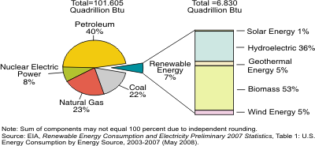

Over half of renewable energy goes to producing electricity. The next largest use is the production of heat and steam for industrial purposes. Renewable fuels, such as ethanol, are also used for transportation and to provide heat for homes and businesses.
Renewable energy plays an important role in the supply of energy. When renewable energy sources are used, the demand for fossil fuels is reduced. Unlike fossil fuels, non-biomass renewable sources of energy (hydropower, geothermal, wind, and solar) do not directly emit greenhouse gases.

Why Don’t We Use More Renewable Energy?
In the past, renewable energy has generally been more expensive to use than fossil fuels. Plus, renewable resources are often located remote areas and it is expensive to build power lines to the cities where they are needed. The use of renewable sources is also limited by the fact that they are not always available (for example, cloudy days reduce solar energy, calm days mean no wind blows to drive wind turbines, droughts reduce water availability to produce hydroelectricity).
The production and use of renewable fuels has grown more quickly in recent years due to higher prices for oil and natural gas, and a number of State and Federal Government incentives, including the Energy Policy Acts of 2002 and 2005. The use of renewable fuels is expected to continue to grow over the next 30 years, although we will still rely on non-renewable fuels to meet most of our energy needs.

