Unit 15: Vocabulary
Complete the sentences with the word in bold. Change the form of the word where appropriate.
manage
1 I work as a _____________________ in a supermarket.
2 _____________________ consultancy is a lucrative area to get into.
3 They said I didn’t have enough _____________________ experience.
regulate
4 A new _____________________ body set up by the government will monitor TV commercials shown before 9pm.
5 There are so many rules and _____________________ nowadays that it’s become really hard for small businesses to employ people.
consult
6 Certain accounting firms are banned from carrying out certain _____________________ and legal services.
7 The document has been prepared in _____________________ with a number of leading experts from industry and the business world.
finance
8 I really don’t know how we’re going to be able to _____________________ this new venture.
9 This is my colleague who deals with all the _____________________ matters.
strategy
10 This is something which really needs to be discussed at a _____________________ level.
knowledge
11 I really wish I’d _____________________ about all this.
12 The problem is that none of us are experts in this field. We need to bring in someone really _____________________ in the area of restructuring.
---------------------------------------------------------------------------------------------------------------------------------------------------
Unit 15: Reporting Verbs

1 Match the sentences in column A with the reported statements in column B.

A |  | B
1 | `Don't forget to sign the contract.' | A | He apologized for signing the contract.
2 | `I didn't sign the contract.' | B | He warned me not to sign the contract.
3 | `Go on, sign the contract. It's a really good idea.' | C | He encouraged me to sign the contract.
4 | `If I were you, I would sign the contract.' | D | He ordered me to sign the contract.
5 | `No, I will not sign this contract under any circumstances.' | E | He refused to sign the contract.
6 | `I am so sorry I signed the contract.' | F | He admitted signing the contract.
7 | `Yes, I am afraid to say that it was me who signed the contact.' | G | He reminded me to sign the contract.
8 | `I'll sign the contract if you like.' | H | He offered to sign the contract.
9 | `Sign the contract NOW!' | I | He advised me to sign the contract.
10 | `I really wouldn't sign the contract. You haven't read it. It could be a disaster.' | J | He denied signing the contract.
2 Complete the sentences using the verbs in brackets.
1 She was offered a very good job, so ... (advise) _______________________________________________.
2 He said that the guarantee was out of date, and ... (refuse) _______________________________________.
3 They said that they couldn't bring the price down any more, but ... (offer) __________________________.
4 The bank realized that they were in the wrong, and they ... (apologize) ____________________________.

3 Complete the sentences. Report what was said.

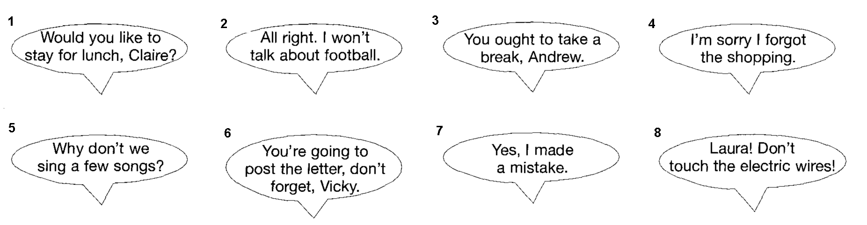
1 Sarah invited _______________________________________________________________________________.
2 Tom agreed _________________________________________________________________________________.
3 Matthew advised ____________________________________________________________________________.
4 Mike apologized ___________________________________________________________________________.
5 Tom suggested ____________________________________________________________________________.
6 Rachel reminded _____________________________________________________________________________.
7 Mr Atkins admitted ____________________________________________________________________________.
8 Trevor warned _______________________________________________________________________________.

4 Report the sentences. They were all spoken last week. Use the verbs in brackets.
1 Anna to Janet: Don't forget to sign the form. (remind)
Anna _________________________________________________________________________________.
2 Robert: What time will the office close this evening? (ask)
Robert _________________________________________________________________________________.
3 A policeman to Christopher: Stop shouting. (tell)
A policeman _____________________________________________________________________________.
4 Tessa: It was me. I ate all the cake yesterday. (admit)
Tessa _________________________________________________________________________________.
5 Adrian: I'm sorry I was rude. (apologize)
Adrian _________________________________________________________________________________.
6 Simon to Susan: Would you like to join me for lunch? (invite)
Simon _________________________________________________________________________________.
7 Martin to Nancy: Did someone ring you an hour ago? (ask)
Martin _________________________________________________________________________________.
8 Peter: I really must leave. (insist)
Peter ____________________________________________________________________________________.

