Language of change and development

TASK Below you will find an extract from a presentation comparing stock market performance in four European countries. Complete is by using the words given in the lists.

PART 1
around at downs so upward of

First, let´s have a look at this graph, which shows us the ups and 1)______ in the “footsie“ over the last three months. As you can see, the overall trend is 2) ___________ with the index finishing up 3) _____ 4) __________ 3,200 in mid-May. This trend, however, can´t hide the fact that there was a fall 5)____ some eighty points or 6)______ between the middle of February and the beginning of March. We´ll be looking at the reasons for this unexpected dip in a moment.

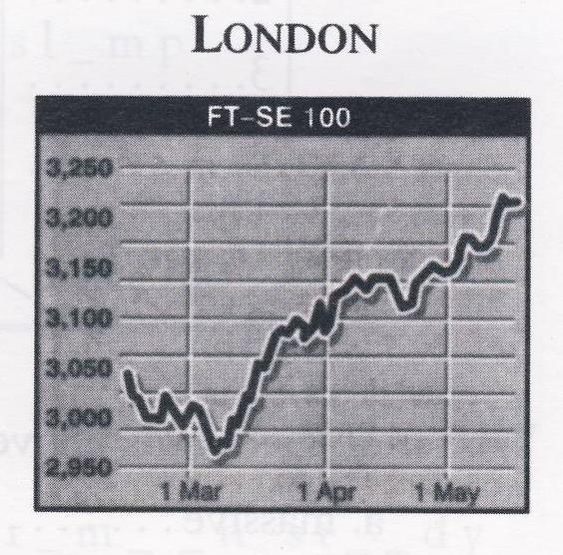

PART 2
at about of over to from

In Paris it´s been the same story, with CAC falling 1) _______ just 2) _______ 1850 in mid-February 3) ______ 4) ________1720 three weeks later. Again, though, overall performance has been good, the CAC putting on roughly 120 points over the three-month period, peaking 5) ________just short 6) ______2020, give or take a point.

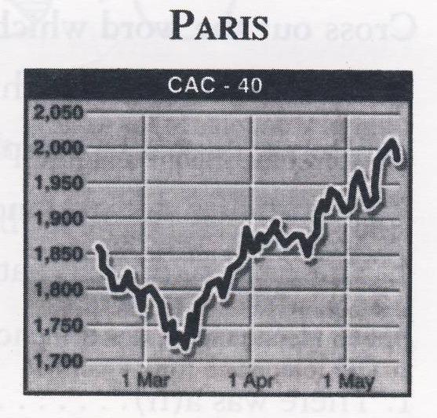

PART 3
down between over of by downward

As you can see, the picture in Milan is rather different. The early trend was decidedly 1)________ . In fact, the MIBTel had already fallen 2) ______ in excess 3) _____ 1400 points by mid-March.
It then fluctuated 4) _________ 9700 and 9300 for the best part of a month, before partially recovering to end up well 5) _______ a hundred points 6) _______ on the figure for mid-February.

Vocab.
in excess of = more than
down on = less than
for the best part of sth = almost all of sth, esp. a period of time

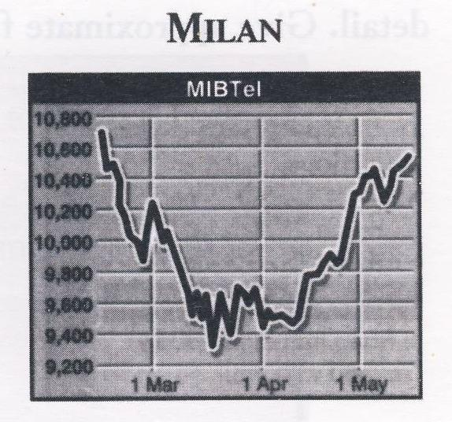

PART 4
for in below near down up

If anything, the DAX has fared rather worse. In mid-February it was well 1) _______ at getting on 2) _______ 2200 and looking strong. But by the end of March it was way 3) _______ the 1950 threshold and nowhere 4) _______ where our forecasts had put it. And it´s still well 5) _________ at somewhere 6) ______ the region of 2080.

Vocab.
to fare = used for saying how well or how badly someone does something, to do

