**1. Complete the sentences with correct prepositions or particles.**

I'd love to jack _____ my job and go and live in the Bahamas.

The sale of the house only brought _____ about £45,000.

The council has failed to deal _____ the problem of homelessness in the city.

Employees need to keep _____ _____ the latest technical developments.

He is always helping people without expecting anything _____ return.

They felt the British economy was being held _____ by excessive government controls.

Minicab drivers are not allowed to tout _____ business.

The government then called _____ troops to stop the disturbances.

Simmons specialized _____ contract law.

We're taking _____ 50 new staff this year.

Be very clear _____ what jobs should be completed, and by when.

A survey is now being carried _____ nationwide.

Before taking a loan _____, calculate your monthly outgoings.

An increasing number of people are consulting their accountants _____ the tax laws.

Her show never really got _____ the ground in the UK.

Many children with learning difficulties are integrated _____ ordinary schools.

**2. Find the terms for the following definitions**

1.**___________________ -** money that you earn very easily by doing a job that is not difficult

2. _____________________ - a product or business that earns a lot of money

3. _____________________ - the department of a bank or other financial institution that manages or organizes the work of the institution, but that does not deal with customers

4. _____________________- behaving in an unfair or dishonest way

5. _____________________ - the department in a company that deals with employing, training, and helping people

6. ____________________ - an amount of money that you pay to do something or that you pay to a professional person for their work

7. ____________________ - a large amount of data stored in a computer system so that you can find and use it easily

8. ____________________- Written guidelines issued by an official body or a professional association to its members to help them comply with its ethical standards.

9. ____________________ - Report or item that must be completed and delivered under the terms of an agreement or contract

10. **_________________** - Arrangement in which a contractor is paid on the basis of (1) actual cost of direct labour, usually at specified hourly rates, (2) actual cost of materials and equipment usage, and (3) agreed upon fixed add-on to cover the contractor's overheads and profit (income).

11. ___________________ - To reduce the size of a business hierarchy, especially in terms of a reduction in management. This creates a flatter (less layered) organizational structure.

12. ___________________ - Thorough rethinking of all business processes, job definitions, management systems, organizational structure, work flow, and underlying assumptions and beliefs. Its main objective is to break away from old ways of working, and effect radical redesign of processes to achieve dramatic improvements in critical areas (such as cost, quality, service, and response time).

13. ___________________ - All [management](http://www.businessdictionary.com/definition/management.html) [activities](http://www.investorwords.com/92/activity.html) and [functions](http://www.businessdictionary.com/definition/function.html) involved in determination of [quality policy](http://www.businessdictionary.com/definition/quality-policy.html) and its implementation through [means](http://www.businessdictionary.com/definition/mean.html) such as [quality planning](http://www.businessdictionary.com/definition/quality-planning.html) and [quality assurance](http://www.investorwords.com/3995/quality_assurance.html).

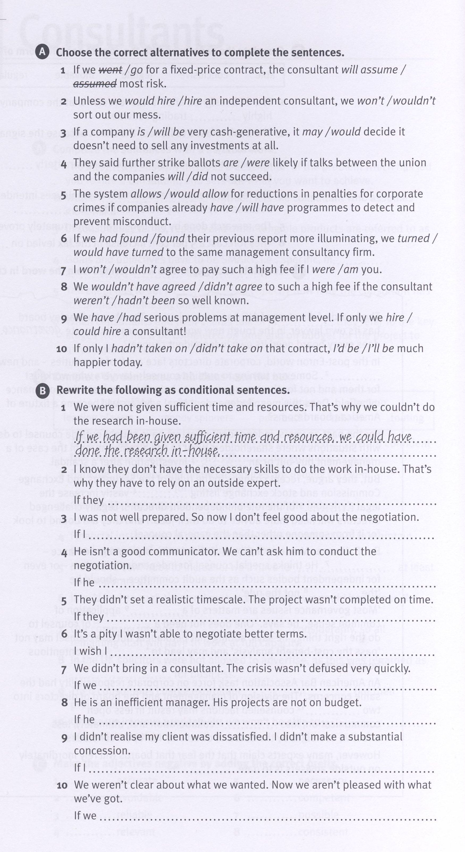

**Article Unit 8 – questions**

1. What is the appeal of becoming a consultant?
2. What is the current trend in employing the services of professional consultancies in the UK?
3. What types of companies mainly use consultancies and what do they expect of them?
4. What are the perks of being a consultant and what is expected of them?
5. What risky situations may consultancies find themselves in?
6. What is the role of the Institute of Management Consultancy?
7. How was the situation different 25 years ago?
8. How can companies make sure they´ll get a high quality consultancy service?
9. How did Barclays Bank succeed and fail in hiring a consultancy?