17 May
REPORTED SPEECH
Reporting questions
· The word order in reported questions is like a normal statement (this is the same rule
as for indirect questions). Tense changes follow those given above.
‘Where is it?’ _ He asked me where it was. (NOT where was it)
· When we report question word questions (when, what, why, where, how, etc.) we use
the question word.
‘When will the goods arrive?’ _ They asked me when the goods would arrive.
‘Why have your sales gone down?’ _ I was asked why our sales had gone down.
A year ago, I was asked how this wonderful merger between Daimler and Chrysler would work,
and I said I was waiting for the interpersonal problems. They were bound to happen, as our
experiences with Seat had shown.’ – CEO of Volkswagen (Der Spiegel website)
· When we report yes/no questions (Do you, Did you, Are you, etc.) we use if or whether.
‘Do you speak French?’ _ She asked me if I spoke French.
‘Are you going to pay in cash?’ _ He asked me whether I was going to pay in cash.
· Notice in the examples that reported questions have no question mark in writing.

Reporting commands and requests
· Commands are reported with tell and the infinitive.
‘Take us to the airport.’ _ She told the driver to take us to the airport.
‘Don’t worry. I’ll deal with it.’ _ She told me not to worry.
· Requests are reported with ask and the infinitive.
‘Would you mind waiting for a moment?’ He asked me to wait.
‘Please don’t wait for me, I’ll come along later.’ He asked us not to wait.

Say or tell
· We say something and we tell somebody.
Simon said he was confident about the success of the Beta project.
Simon told me the project was going well.
· We never use to between tell and the object.
He told me what happened in the meeting. (NOT told to me)
- We can use to after say, especially when the actual words are not reported.
What did he say to you?
I think the boss wanted to say something to Susan.

EXERCISES

1) Rewrite each sentence in reported speech.
1. ‘Are you on holiday for the whole of August?’ she asked me.
She asked me if/whether I was on holiday for the whole of August.
2. ‘What do the letters ‘URL’ mean?’ I asked him.
I asked him ______________________________________________________.
3. ‘Have you prepared the figures?’ my boss asked me.
My boss asked me __________________________________________________.
4. ‘When is your birthday?’ I asked Francesca.
I asked Francesca __________________________________________________.
5. ‘Did you remember to back up the file?’ she asked him.
She asked him ____________________________________________________.
6. ‘Why have you turned off the air conditioning?’ Ellen asked me.
Ellen asked me ____________________________________________________.
7. ‘Do you speak Italian?’ they asked me at the interview.
They asked me at the interview _________________________________________.
8. ‘How much did you pay for your car?’ I asked Pablo.
I asked Pablo _____________________________________________________.

2) Underline the correct words.
1. Sally told/told me that she had lost the catalogue.
2. This is confidential, please don’t say/tell anything about it.
3. This is confidential, please don’t say/tell anyone about it.
4. Chris said/said me he must leave early.
5. I said/told them about the meal, and they said/told they would come.
6. ‘You see,’ told/said Steve, ‘I always told/said you’d get a promotion.’
7. ‘You see,’ told/said Steve, ‘I always told/said you you’d get a promotion.’
8. ‘Look,’ I told to/said to her, ‘why don’t you tell/say me what you mean?’

Self-check exercises (below)
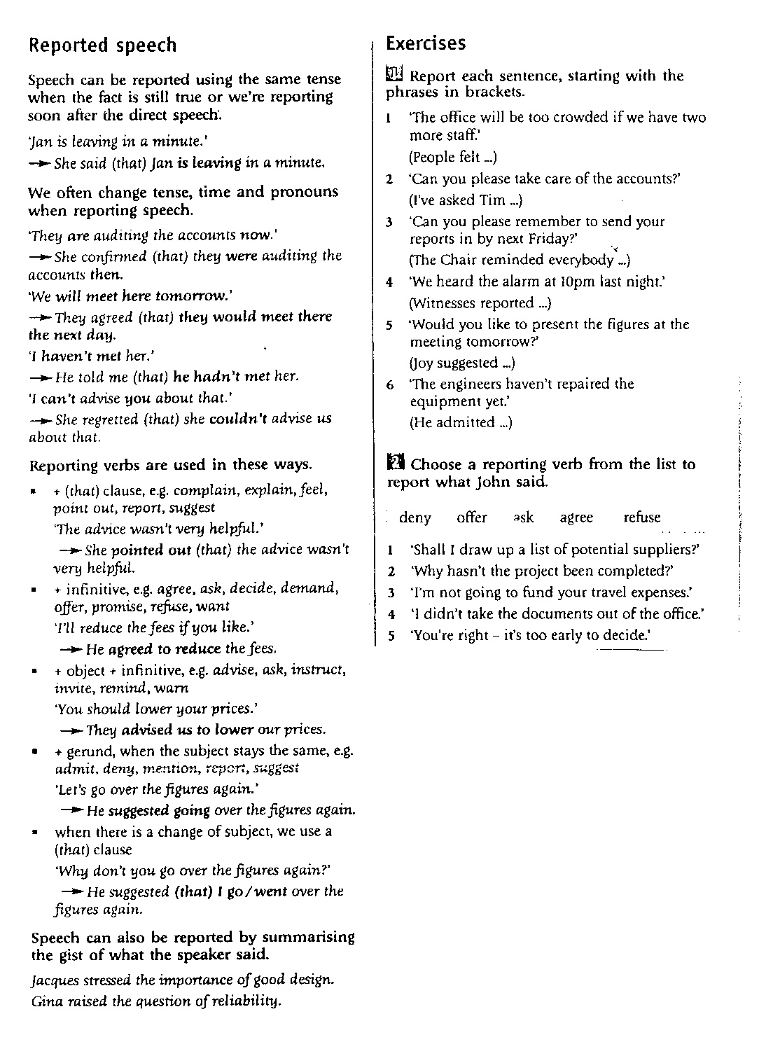
KEY

Exercise 1
1) People felt that the office would be too crowded if they had two more staff.
2) I’ve asked Tim to take care of the accounts.
3) The Chair reminded everybody to send their reports in by next Friday.
4) Witnesses reported hearing / that they has heard the alarm at 10 pm the previous night/the night before.
5) Joy suggested that I present the figures at the meeting the next/following day. (you cannot use suggested presenting in this example as there are 2 different persons/subjects involved)
6) He admitted that the engineers had not repaired the equipment yet. (you cannot use admitted not repairing in this example as there are 2 different persons/subjects involved)

Exercise 2

1 John offered me to draw up a list of potential clients. (OFFER SB TO DO ST)
2 John asked why the project hadn´t been completed.
3 John refused to fund their/my travel expenses. (REFUSE + TO + inf)
4 John denied taking the documents out of the office. (DENY + -ing)
5 John agreed that it was too early to decide.

