Unit 15: Reported Speech & Reported Questions

A. REPORTED SPEECH – Changes of place and time
Put in here, that day, the day before, the next day.
1 Rachel (a week ago): I’m taking my driving test tomorrow.
You (today): When I saw Rachel, she said she ______________________________________________________
2 Emma (two days ago): I’ve only had this new computer since yesterday.
You (today): Emma said ______________________________________________________________________
3 Matthew (a week ago): I’m meeting a friend at the station later today.
You (today): Matthew said ____________________________________________________________________
4 Mark (in the street): I’ll see you in the office.
You (in the office): Mark said _________________________________________________________________

B. REPORTED QUESTIONS
Rewrite each sentence in reported speech.
1 ‘Are you on holiday for the whole of August?’ she asked me.
She asked me ______________________________________________________________________________
2 What do the letters ‘URL’ mean? I asked him.
I asked him ________________________________________________________________________________
3 ‘Have you prepared the figures?’ my boss asked me.
My boss asked me ___________________________________________________________________________
4 ‘When is your birthday?’ I asked Francesca.
I asked Francesca ___________________________________________________________________________
5 ‘Did you remember to back up the file?’ she asked him.
She asked him ______________________________________________________________________________
6 ‘Do you speak Italian?’ they asked me at the interview.
They asked me at the interview _________________________________________________________________
7 ‘How much do you hope to earn?’ he asked me.
He asked me _______________________________________________________________________________
8 ‘How will you travel to work?’ I asked Vicky.
I asked Vicky ______________________________________________________________________________

Unit 15: Reporting Verbs
1. Report the sentences. They were all spoken last week. Use the verbs in brackets.
1 Anna to Janet: Don’t forget to sign the form. (remind)
Anna _________________________________________________________________________________.
2 Robert: What time will the office close this evening? (ask)
Robert _________________________________________________________________________________.
3 A policeman to Christopher: Stop shouting. (tell)
A policeman _____________________________________________________________________________.
4 Tessa: It was me. I ate all the cake yesterday. (admit)
Tessa _________________________________________________________________________________.
5 Adrian: I’m sorry I was rude. (apologize)
Adrian _________________________________________________________________________________.
6 Simon to Susan: Would you like to join me for lunch? (invite)
Simon _________________________________________________________________________________.
7 Martin to Nancy: Did someone ring you an hour ago? (ask)
Martin _________________________________________________________________________________.
8 Peter: I really must leave. (insist)
Peter ____________________________________________________________________________________.

2. Complete the sentences. Report what was said.

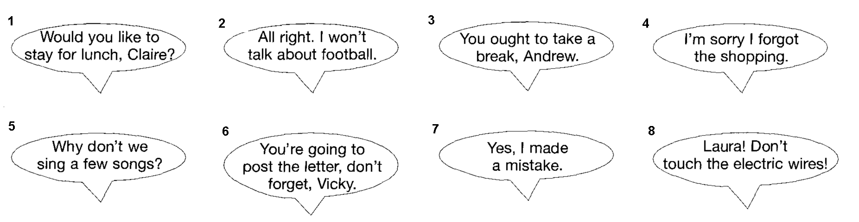
1 Sarah invited _____________________________________________________________________________.
2 Tom agreed ______________________________________________________________________________.
3 Matthew advised __________________________________________________________________________.
4 Mike apologized __________________________________________________________________________.
5 Tom suggested ___________________________________________________________________________.
6 Rachel reminded __________________________________________________________________________.
7 Mr Atkins admitted ________________________________________________________________________.
8 Trevor warned ___________________________________________________________________________.

