6 April

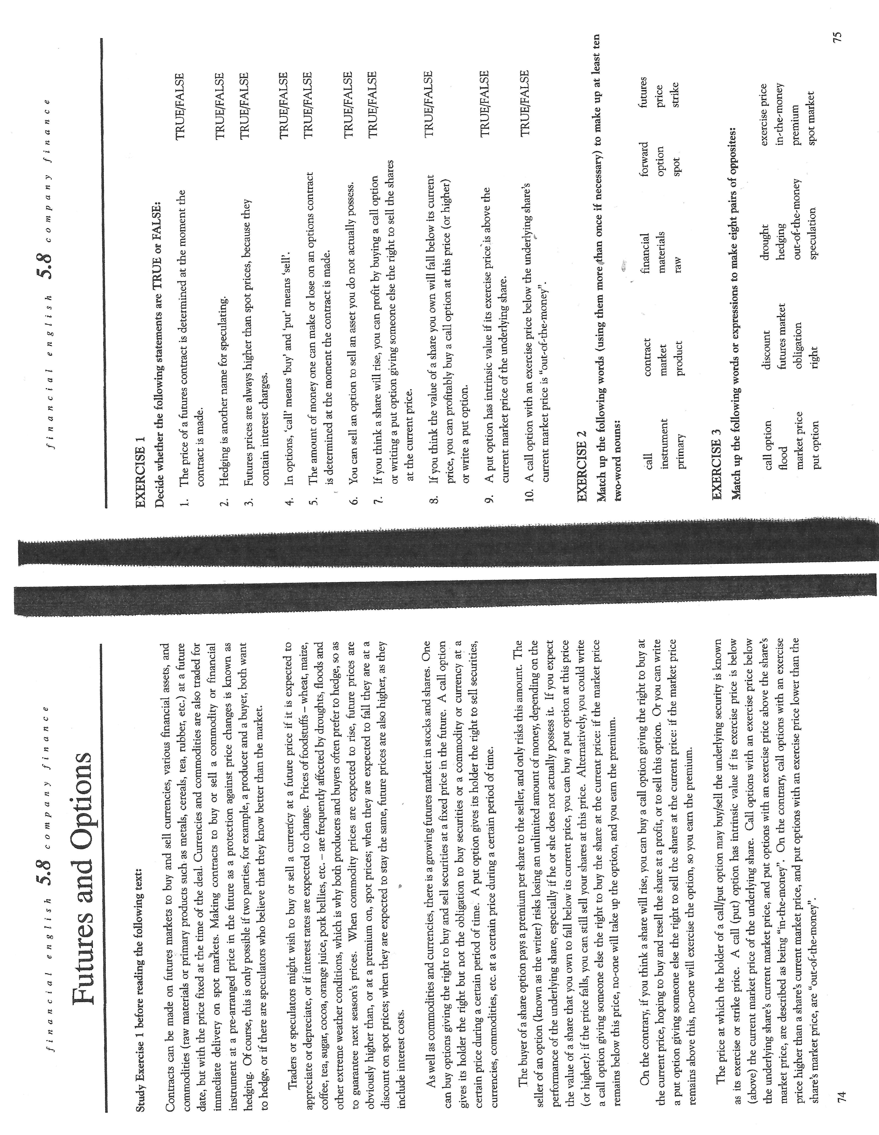

Fill in the blanks using the words from the box below:
contracts determined hedge speculative dependent market indexes derived merely swaps

Derivative - in finance, a security whose price is 1. ______________ on or 2.______________ from one or more underlying assets. The derivative itself is 3.______________ a contract between two or more parties. Its value is 4.______________ by fluctuations in the underlying asset. The most common underlying assets include stocks, bonds, commodities, currencies, interest rates and 5.______________. Futures contracts, forward contracts, options and 6. ______________ are the most common types of derivatives. Because derivatives are just 7.______________, just about anything can be used as an underlying asset. There are even derivatives based on weather data, such as the amount of rain or the number of sunny days in a particular region. Derivatives are generally used to 8. ______________ risk, but can also be used for 9. ______________ purposes.
NOTE:
The difference between futures and forwards is that futures are standardized deals and forwards are individual ´over-the-counter´ agreements between two parties.
The risk with currency and interest rate swaps is that the exchange and interest rates may change unfavourably.

CB 92/Discussion
Complete the gaps using the words that will fit the context.
1 If the price of cocoa does change before the date of the …………………………. contract, wither the producer or the buyer will have lost money by signing the contract.
2 The company could try to arrange an interest rate ………………………….with a company with ………………………….rate debt that expected interest rates to rise.
3 Such an investor can buy a ………………………….option giving the right to ………………………….the stock in the future at the current market price.
4 Such an investor can buy a ………………………….option giving the right to ………………………….the stock in the future at the current market price.
5 “………………………….” is the situation when one party´s gains are equal to the other party´s losses, e.g futures, options and swaps. In contrast, “………………………….” are mutually beneficial such as negotiations and business partnerships.

