Unit 27 (additional material)
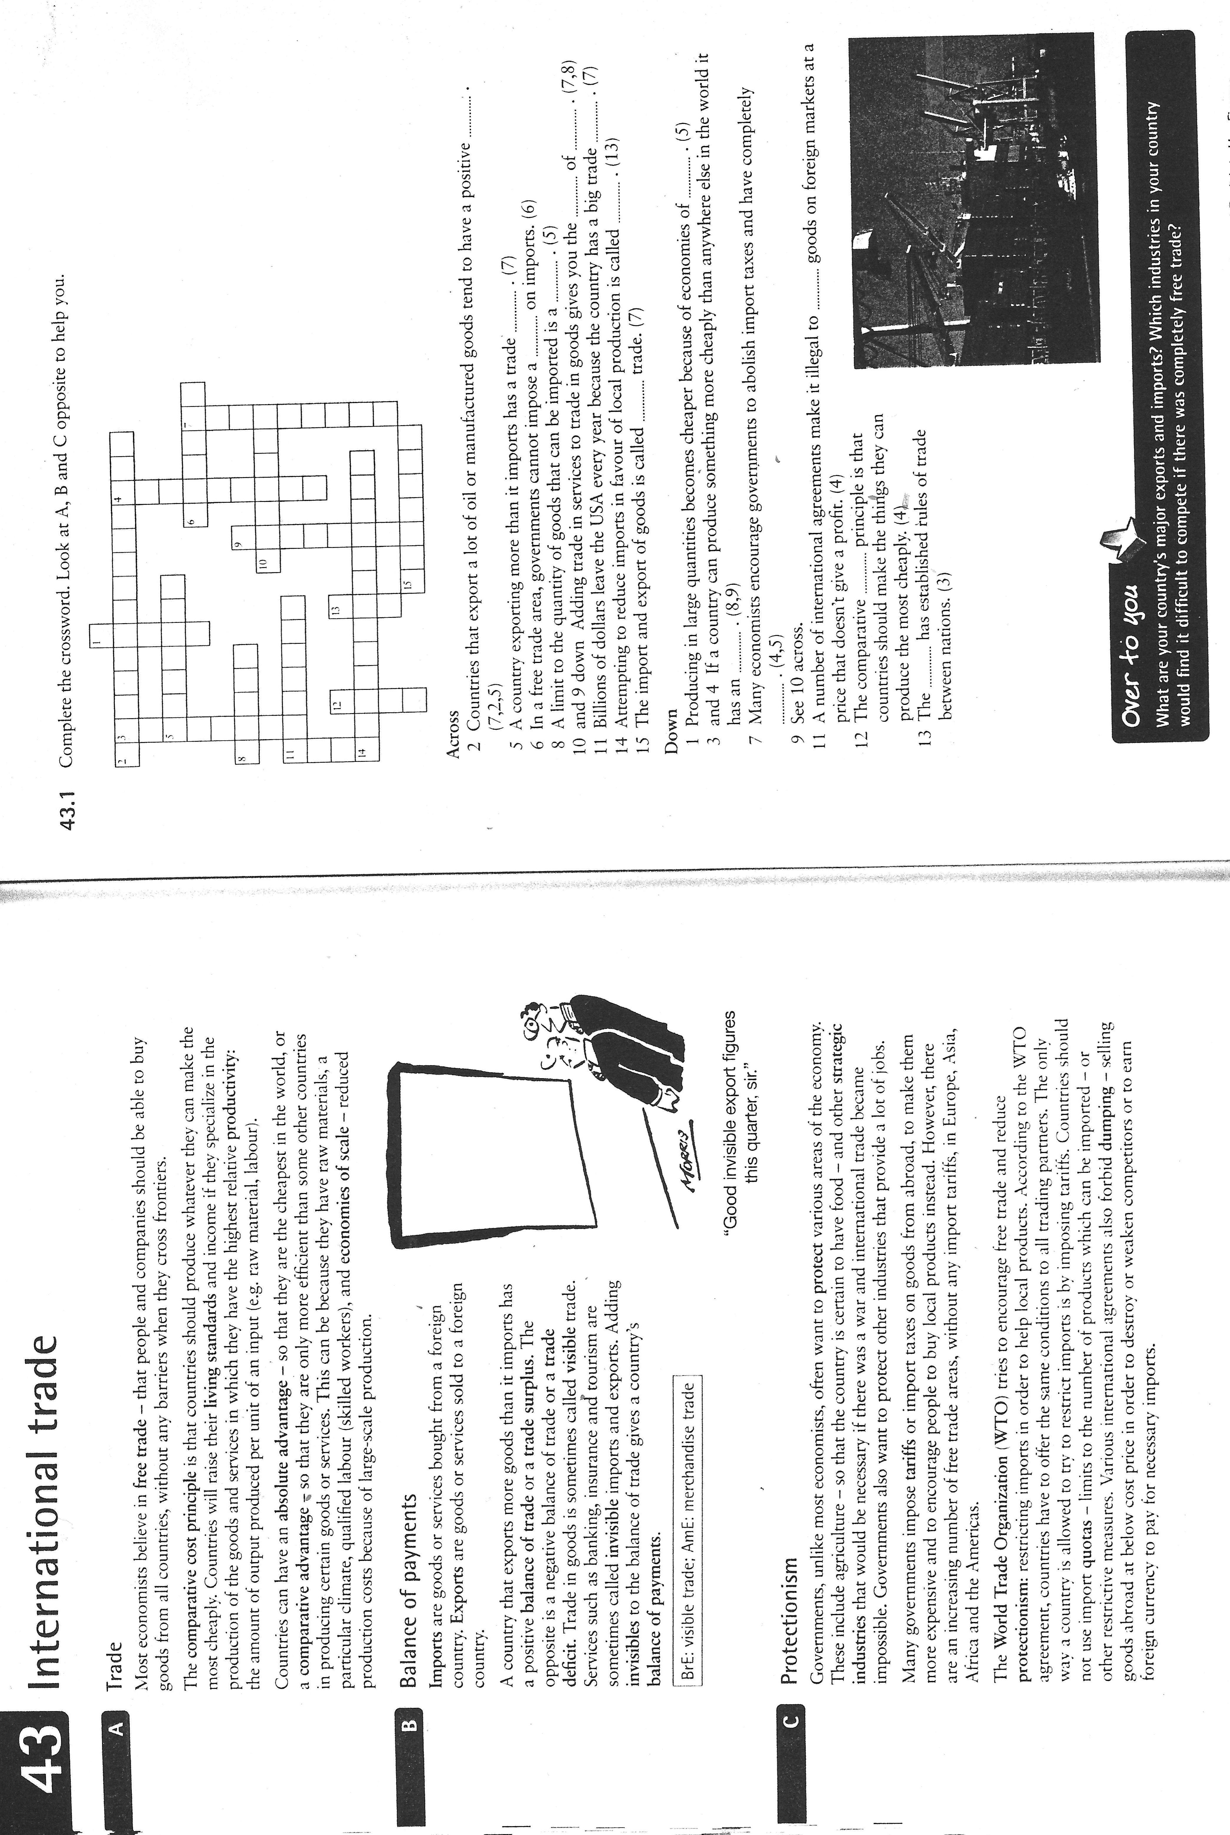

KEY
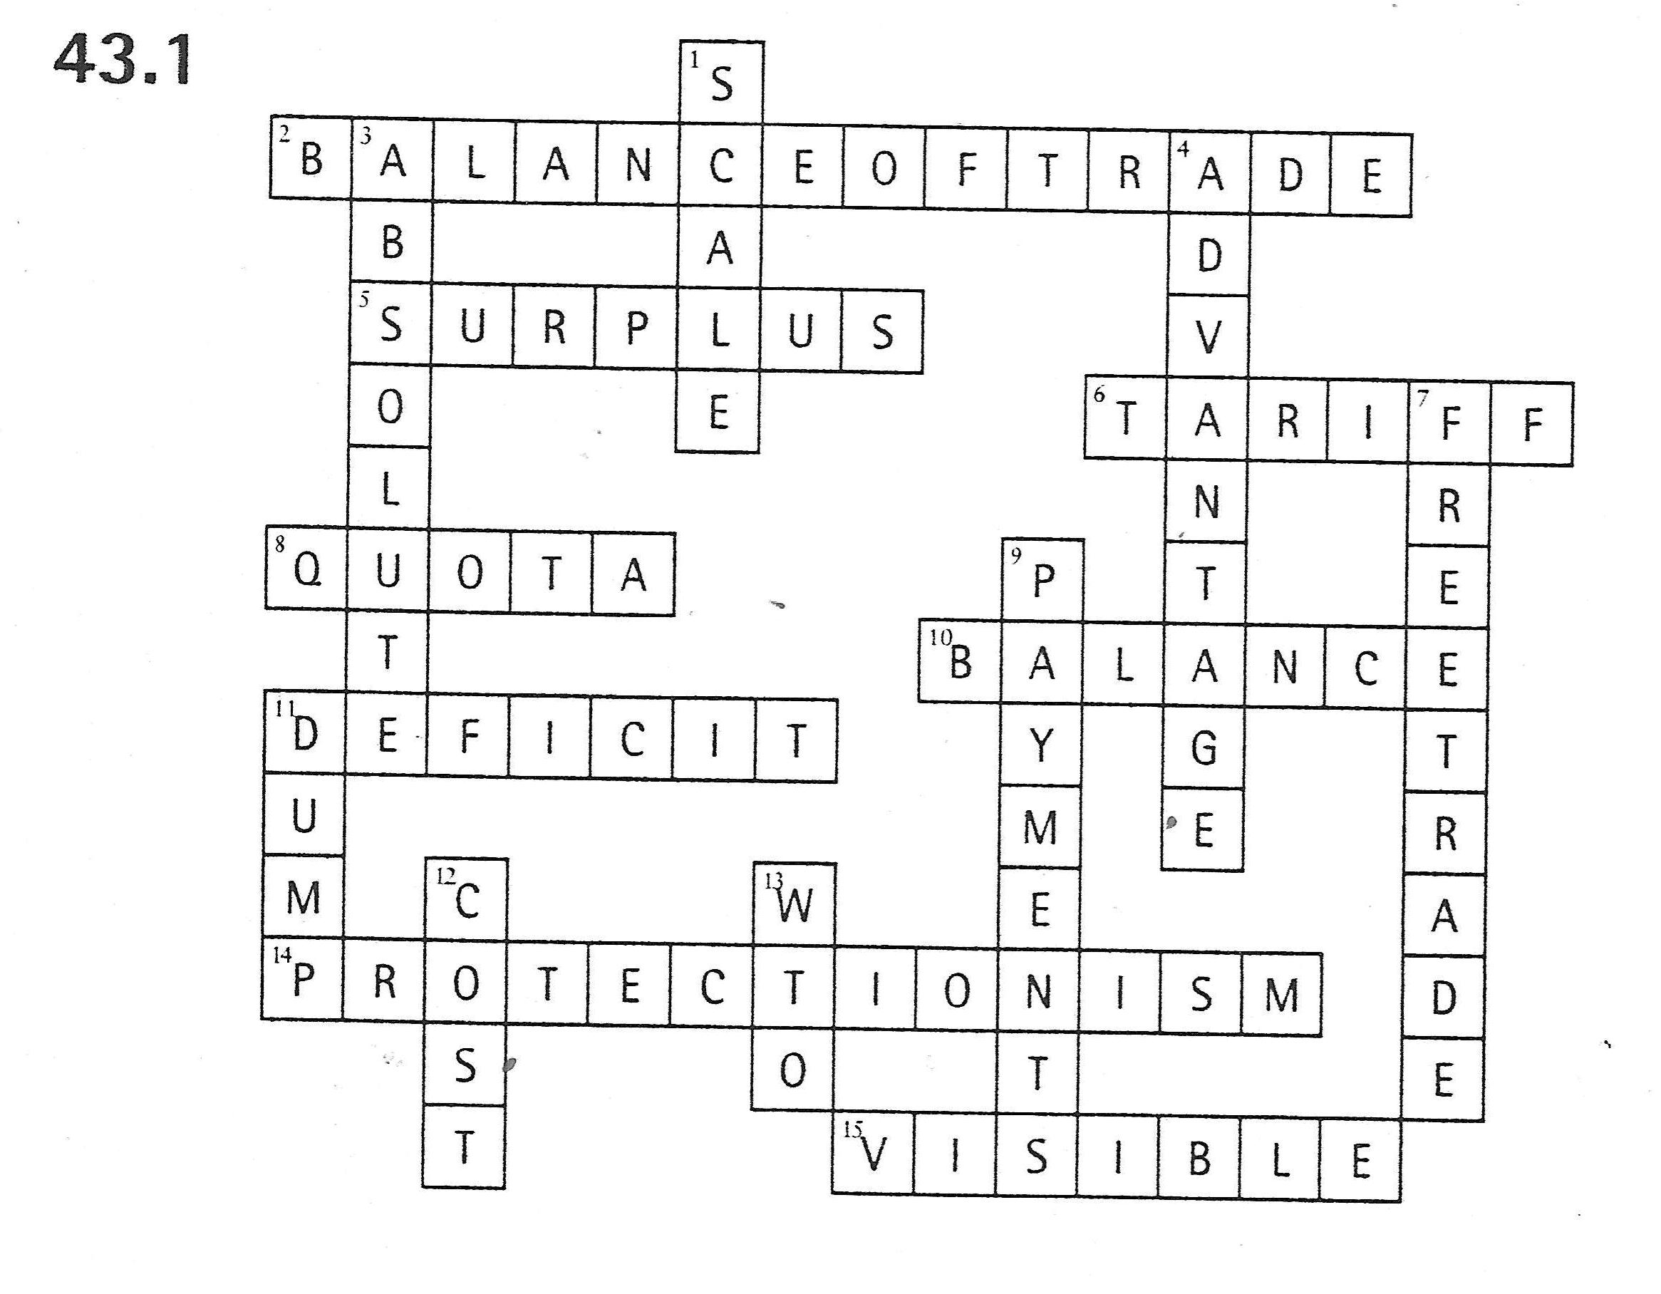

Find appropriate terms matching to these descriptions:

- An international trade philosophy/policy that favors the creation of barriers against the importing of goods to shelter domestic industries from foreign competition. / The restriction of international trade = ……………………………..

- The practice of selling goods in foreign markets at prices below the cost of production, usually with the aim of driving competitors out of the market. / The selling of goods or services in a buying country at less than the production unit price in the selling country . = ……………………………..

- Concept in economics that a country should specialize in producing and exporting only those goods and services which it can produce more efficiently (at lower opportunity-cost) than other goods and services (which it should import). = ……………………………..

- Provision in a commercial treaty ensuring equal commercial opportunities, especially concerning import duties and freedom of investment to promote free trade. I tis an idea of non-discrimination. Countries achieving …………………………….. status are given specific trade advantages such as reduced tariffs on imported goods. . =

- Establishment of the European Union as successor to the European Community. = ……………………………..

- The increase in efficiency of production as the number of goods being produced increases. Typically, a company that achieves ……………………………..lowers the average cost per unit through increased production since fixed costs are shared over an increased number of goods. = ……………………………..

- A particular type of specialisation where the production of a good is broken up into many separate tasks each performed by one person The ……………………………..raises output, thereby reducing costs per unit. = ……………………………..

KEY

- An international trade philosophy/policy that favors the creation of barriers against the importing of goods to shelter domestic industries from foreign competition. / The restriction of international trade = protectionism

- The practice of selling goods in foreign markets at prices below the cost of production, usually with the aim of driving competitors out of the market. / The selling of goods or services in a buying country at less than the production unit price in the selling country . = dumping

- Concept in economics that a country should specialize in producing and exporting only those goods and services which it can produce more efficiently (at lower opportunity-cost) than other goods and services (which it should import). = comparative cost principle

- Provision in a commercial treaty ensuring equal commercial opportunities, especially concerning import duties and freedom of investment to promote free trade. It is an idea of non-discrimination. Countries achieving most favoured nation status are given specific trade advantages such as reduced tariffs on imported goods. = most favoured nation clause

- Establishment of the European Union as successor to the European Community. = Maastricht Treaty / the Treaty of the European Union

- The increase in efficiency of production as the number of goods being produced increases. Typically, a company that achieves economies of scale lowers the average cost per unit through increased production since fixed costs are shared over an increased number of goods. = economies of scale

- A particular type of specialisation where the production of a good is broken up into many separate tasks each performed by one person The division of labour raises output, thereby reducing costs per unit. = division of labour

