40 Making a presentation
Exercises

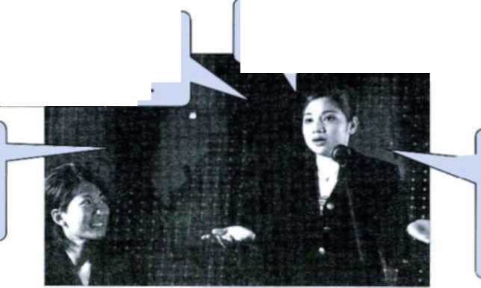
The language of presentations often contains less formal vocabulary than that of academic writing, so take care not to use the less formal expressions in your written work.
Introducing the presenter
Let's welcome Carmen Gregori, who's going to talk to us today on the subject of 'Healthcare in Paraguay'
'In this presentation I'd like to focus on recent developments in biomass fuels. I'll speak for about 45 minutes, to allow time for questions and comments. Feel free to' interrupt if you have any questions or want to make a comment.'
Now I'd like to call on Mieko to make/give her presentation. Mieko, thank you.
OK, thank you everybody. Now, Dr Ulla Fensei is going to present her research to us.
I'd like to introduce
Dr Li Meiju, who's going to address' the topic of 'Preventive medicine'.
1 rather formal; we can also say formally speak to the topic ofX, or, less formally talk about X Getting started
'First I'll give a brief overview of the current situation with regard to intellectual property rights, then I'd like to raise a few issues concerning the internet. I'll try to leave² time for questions at the end.'
'I'd like to begin by looking at some previous studies of ocean temperatures. There's a handout going round', and there are some spare⁴ copies here if you want them.' 'In this talk I'll present the results of a study I did⁵ for my dissertation. I'll try not to go over time and keep to 20 minutes.'
' an informal way of giving permission ² less formal than allow - see 1 ³ a more formal version would be which is being distributed ⁴ extra ⁵ or, more formal, carried out I conducted
During the presentation - and closing it

Now let's turn to the problem of workplace stress. | begin to examine or talk about
Moving on, I'd like to look at the questionnaire results in more detail. | going on to the next point; less formal than in greater detail
1 also want to talk about the supply of clean water, but I'll come back to that later. | or, more formal, return to
I'd just like to go back to the graph on the previous slide. | or, more formal, return to
Anyway, getting back to / to return to the question of inflation, let's look at the Thai economy. | getting back to is less formal than to return to
The results were not very clear. Having said that, 1 feel the experiment was worthwhile. | a less formal way of saying nevertheless
I'll skip the next slide as time is (running) short. | skip (informal) = leave out / omit
To sum up, then, urban traffic has reached a crisis. That's all 1 have to say⁴¹. Thank you for listening. | have no more time left * informal - not used in writing
Well, I'll stop there as I've run out of time.Thank you. | have no time left
Dr Woichek will now take questions*. Are there any questions or comments? | * rather formal = accept and answer questions
40.1 Fill in the missing words in these introductions to presentations.
- Dr Anwar Musat will now his research on soil erosion in Malaysian forests.
- I'd now like to on our next speaker, Eva Karlsson, to (give two
answers) her presentation.
- Ladies and gentlemen, let's our next speaker, Professor Prodromou from the
University of Athens.
- Thanks, everybody. So, Masanori is going to talk to us now
subject 'Mental health issues in Japan'.
- I'd like to today's speaker, Dr Krishnan Guptar, who is going to
the topic of metal fatigue in rail tracks.
40.2 Rewrite these sentences by changing the words in bold so they are less formal. Remember
that both formal and informal styles may be correct, but that it may not always be
appropriate to be informal.
- We need to consider family income too, but I'll return to that later.
- So, to proceed to the next point, I'll omit item 4 on the handout and instead talk about number 5 in greater detail.
- I'll try to finish by 3.30, but don't feel you need to ask permission to leave if you have a class or other appointment to go to.
- There is a handout being distributed and I have some further copies too if anyone wants them.
- I'll finish there as my time has come to an end.
- We didn't want to make people uncomfortable by having a camera in the room. Nevertheless, we did want to video as many of the sessions as possible.
- I'd like to return to a point I made earlier about river management.
- So, I believe our experiments have been successful. I shall end there. Thank you.
- To return to the problem of large class sizes, I'd like to look at a study carried out in Australia in 2002.
10 I'll try not to exceed my time, so I'll speak for 30 minutes, to allow time for questions at the end.
40.3 Fill in the missing prepositions.
- I'd like to focus waterborne diseases in this presentation.
- The situation regard exports has been very good in recent years.
- I'd now like to turn a different problem.
- I always find it difficult to keep just 30 minutes, so please tell me when I have
five minutes left.
- I'd like to begin asking you all to do a small task.
Box A
take
40.4 Write six sentences you might hear during a presentation using appropriate combinations of
the words in boxes A and B. You may use words in box A more than once.
Box B
present

overview comment questions

College and university libraries and departments often have audio or video recordings of talks, guest lectures and other presentations which can be borrowed. If you are able to do this, make a note of any useful words or expressions the speaker uses.

(from Academic Vocabulary in Use, pp. 89 + 90)

