**Unit 14 – Banking**

***1. Fill in the gaps with appropriate banking expressions from the box below.***

|  |
| --- |
| **standing orders, current account, collateral, withdraw, cash dispensers/ATMs, interest, fixed, credits, mortgages, overdrafts, debits, savings account, statements, bank transfer, repossess, credits, loans,** |

A _______________ is and account which allows customers to take out or ______________money at ______________ or in local branches of a bank with no restrictions. Money in the account does not usually earn a high rate of _______________. However, many people also have a ________________ or deposit account which pays more interest but has restrictions on when you can _______________ your money. Banks usually send monthly ______________ listing recent sums of money going out, called _________________, and sums of money coming in, called _____________________. Many people prefer to pay their bills by ________________, which adds to the popularity of e-banking. These include __________________, which are used to pay regular ________________ sums of money.

Commercial banks offer ____________ – fixed sums of money that are lent for a fixed period of time. Customers can also have _________________, which allow them to overdraw their account. Banks also offer ____________________ to people who want to buy a place to live. These are long-term loans on which the property acts as ________________or a guarantee for the bank. If the borrower does not repay the mortgage, the bank can ___________________ the house or flat, i.e. takes it back.

***2. Listen and complete the Chairman´s statement with the expressions you hear.***

I am delighted to present my third report to shareholders as Chairman of Castel international following another year of strong performance. Our company has consistently delivered superior total shareholder __________ since its creation in 1989. The results of the company were very strong and at the top end of the industry peer group. Net _________ rose by 9 per cent while net __________ rose by 22 percent to ____________.

In May, the company announced its intention to return ___________ cash to shareholders through a progressive ____________ policy and rolling share ____________ programme. Both of these have been initiated. The ___________ dividend was increased by 8 per cent, and the directors propose that the ____________ dividend be increased by 7 per cent giving a total for the year of 40 cents a share, an ____________ increase of 12 per cent.

This dividend, if ____________ at the Annual General Meeting, will be paid on 30 March next year to shareholders on the register on 15 January.

At the same time, the company has begun its rolling share buyback programme, and had already ____________ two million shares by the year end. It is the company´s intention to ____________ with this programme through next year.

**Quantitative Easing – QE** (BBC definition)

First, with the permission of the Treasury, the Bank of England creates lots of money. It does this by just crediting its own bank account. It plans to have created £200bn in this way by early 2010. The Bank of England then spends the cash, mainly on buying government bonds from other banks, although it has also spent some of it on buying bonds issued by big companies. 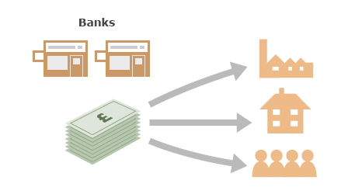The idea is that the banks will take that money and lend it to companies and individuals. They in turn will spend the money on things like expanding their businesses or buying new homes, which boost the economy. 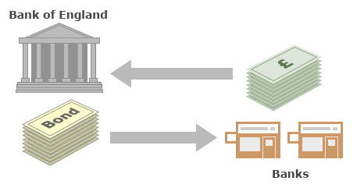Theoretically, when the economy has recovered, the Bank of England sells the bonds it has bought back to the banks and destroys the cash it receives. That means in the long term there has been no extra cash created.

The idea is that the banks will take that money and lend it to companies and individuals. They in turn will spend the money on things like expanding their businesses or buying new homes, which boost the economy. Theoretically, when the economy has recovered, the Bank of England sells the bonds it has bought back to the banks and destroys the cash it receives. That means in the long term there has been no extra cash created.

***3. Listen to a part of a BBC programme, in which the reporter explains how quantitative easing works and answer the questions below.***

1. What is quantitative easing wrongly described as?
2. What does central bank do to boost the economy?
3. Which three countries have used quantitative easing as a way of helping economies?
4. What is the US government expected to do?
5. What is the purpose of QE?
6. Why can´t the US government cut interest rates?
7. What do they do instead and what do they buy? What should the consequence of QE be?
8. What is the disadvantage of the QE?

***4. Read the article below***

**Britain's stuttering economy** Jan 27th 2011 | from PRINT EDITION

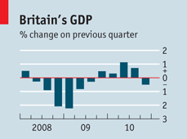CRISIS may be too strong a word for it, but Britain’s economic predicament is more than a little uncomfortable. Only a year after climbing out of recession, the economy shrank again in the final quarter of last year. The surprising weakness was caused in part by unusually cold weather but it is not fully explained by it. A frail economy ought at least to be free of price pressures but Britons have had no such luck. Inflation rose to 3.7% in December. Further increases in the cost of imported commodities and this month’s rise in value-added tax (VAT) are likely to push the rate above 4% by spring. The VAT hike was needed to help shrink a budget deficit that is on track to reach 10% of GDP this financial year. This toxic mix of falling GDP, high inflation and a big budget deficit is rare among rich countries but not unique; Greece suffers from it, too.

Such a run of bad news looks like an argument for a policy rethink. If the economy stays weak, it may not be robust enough to withstand further deficit-cutting measures, including a planned rise in national-insurance contributions this April. The persistence of high inflation (it has been well above the 2% target for most of the last three years) calls into question the idea that the Bank of England could counter the effects of fiscal tightening by easing monetary policy. Its benchmark interest rate is already as low as it can feasibly go, and a further round of “quantitative easing” would stretch too far the gap between the bank’s objective of low inflation and its actions. A concern that businesses and wage earners might think policymakers were going soft on inflation led two of the bank’s nine-strong monetary-policy committee to vote for an increase in interest rates this month.

Yet nasty as these numbers are, they should not lead the government to change its policy. For all the understandable anxiety, the economy has proved stronger than seemed possible in June when George Osborne, the chancellor of the exchequer, first set out his budget plans. Much of the pressure on inflation will subside in a year’s time. The slump in output may not endure either. The cold kept customers away from hotels, restaurants, airports and leisure centres, and stopped building work. Britain’s statisticians reckon that, without the bad weather, GDP would have been flat, but that is far from certain. Business surveys suggest the economy had slowed but was still growing. It is not unusual for recoveries to stall. America’s economy slowed last year before reviving. Britain’s endured a dud quarter or two as it emerged from previous recessions.

Experience cautions against a panic reaction to one bad number. But what if it transpires that the weather was not the main culprit and the economy has lost momentum? Mr Osborne has often seemed too confident that private-sector spending will fill the gap in demand left by fiscal austerity. That he has a medium-term plan for fixing the deficit is welcome (it would be nice if America had one). Indeed, his very enthusiasm for budget cuts gives him room with bond markets to postpone some of the pain. Spending cuts tend to reduce budget deficits more effectively than tax increases, so these should not be delayed. But if more bad figures emerge a reprieve on new taxes may prove to be wise. Deficit-financed public spending is not a growth strategy. At best, it can provide a bridge between the consumer-led growth that Britain leant on before recession to the export- and investment-driven recovery it needs now. Strong global growth, high corporate profits and a weaker currency should allow Britain to grow. If the economy cannot thrive in these circumstances, it is in real trouble.

***4A. Questions to the article:***

1. What are the underlying reasons for the British economy not doing very well at the moment?
2. Why did the government decide to increase VAT?
3. Why should economists worry about the current state of affairs?
4. Should the government persist on pursuing the path they have chosen to take? Why/Why not?
5. Who is Pr. Osborne and what is his solution to the current situation? interest

***4B. In the text, find expression which mean:***

1. when a government has a deliberate policy of trying to reduce the amount of money it spends
2. a product that is bought and sold
3. the process of returning to a normal condition after a period of trouble or difficulty
4. to warn someone that something might be dangerous, difficult ETA
5. to be in a difficult or painful situation for a long time without complaining
6. an official document promising that a government or company will pay back money that it has borrowed, often with interest
7. a difficult or unpleasant situation in which you do not know what to do, or in which you have to make a difficult choice
8. to become or to make something smaller in amount, size, or value
9. not seen or found very often, or not happening very often
10. if a feeling, pain, sound, etc subsides, it gradually becomes less and then stops

***5. Listen to Peter Day´s BBC programme on micro-lending and answer the questions.***

1. Where does Peter Day report from and what is the important aspect of this country in relation to micro-lending?
2. What does PD want to know about micro-lending and what does he compare it with?
3. When and by whom was the idea of micro-lending introduced?
4. What do poor people put at stake by borrowing money?
5. Who was micro-lending originally designed for?
6. What is the size of Ghrameen bank now and what is the volume of their monthly lending?
7. What impact has micro-lending had on Bangladeshi people?
8. How did the woman P.Day spoke to make use of the money she had originally borrowed?
9. What are the professor´s from Yale university reservations concerning micro-lending about?