Unit 10: Fractions

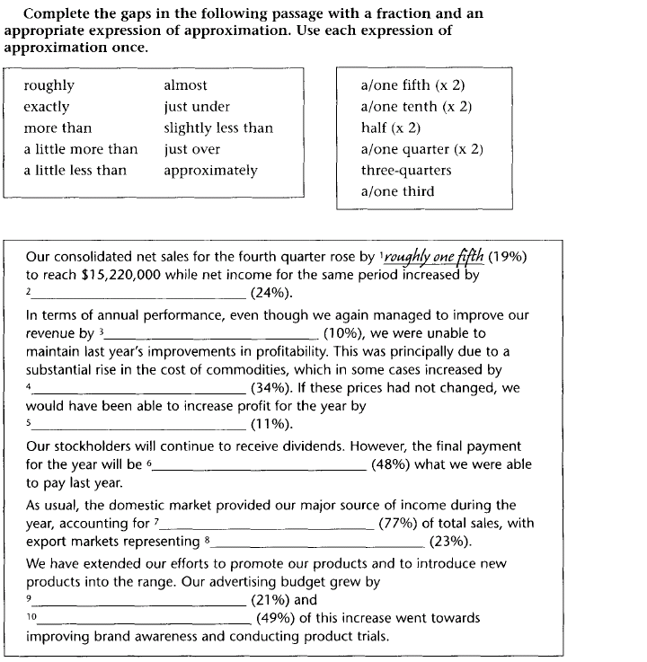

(New Insights into Business, Workbook, p. 54)

