SAMPLE REPORT

Console & PC Games for Christmas

Introduction
This report will analyse the games available for purchase using a mixture of desk and field research. The report will then make a selection of the best games available that are likely to appeal to as many people as possible.

Web Based Research
According to CNET news The World of War Craft expansion pack recently broke all sales records. Nintendo have sold 803,000 Wiis and Microsoft sold 317,000 X-Box 360s. According to Gartner analyst Van Baker the Playstation 3 maybe harder to shift, because of its higher price tag. Key games include: Wrath of the Lich King, Gears of War 2 and the latest edition of Call of Duty, from Activision. On the Handheld front Edge reports that Nintendo DS continues to outsell PSP significantly.

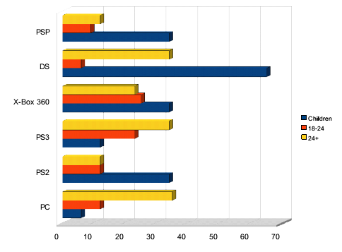

Surveys
The figures show that most people in the area prefer to play games on consoles. Comparing the three age groups it is clear to see that DS sales are strongest among children although there is a significant market amongst 24+ year olds. The PS2 is also still used by children.
The surveys also showed a keen interest from children and 18-24 to buy more games, whereas people over 24 were less interested in buying games for themselves. This indicates that the main markets for games and new consoles are children and 18-24 year olds. Many parents expect to buy consoles for their children and they consider the Nintendo Wii to be a good choice for this.

Conclusion
The indicators show that children and 18-24 year olds are the main buyers of games and parents are likely to be buying Nintendo Wiis for children.

Recommendations
The key console to stock is the Nintendo Wii, because parents are looking for gifts for their children. The other consoles should be stocked in smaller quantities, because they are less in demand. In terms of games, it maybe worth offering some packages with the Nintendo Wii and DS aimed at children. 18-24 years old seem most likely to be buying PS3s and X-box 360s so the key games for these systems need to be in stock and for the PC a good stock of World of Warcraft is essential.

