BPH_EPS1 (Enterprise Resource Planning Systems) – questions spring term 2015
Created by : Ing. J.Skorkovský,CSc. KPH ESF MU BRNO, Czech Republic ; 1730@mail.muni.cz; miki@econ.muni.cz; jaromir.skorkovsky@navertica.co, tel : +420 731 113 517
Date : 24.04.2015
Version : I.

All questions could be studied with the help of related study materials handed over to students during lessons held in Brno during spring term 2015)

Will be shortly reviewed (explained) during last one of the last lessons (17.4.2015) taking into consideration, that the first date (15.5.2015) is partly assigned date for exams. Important parts of below specified questions may be found in your Seminar works

Resources (see original in is.muni.cz):
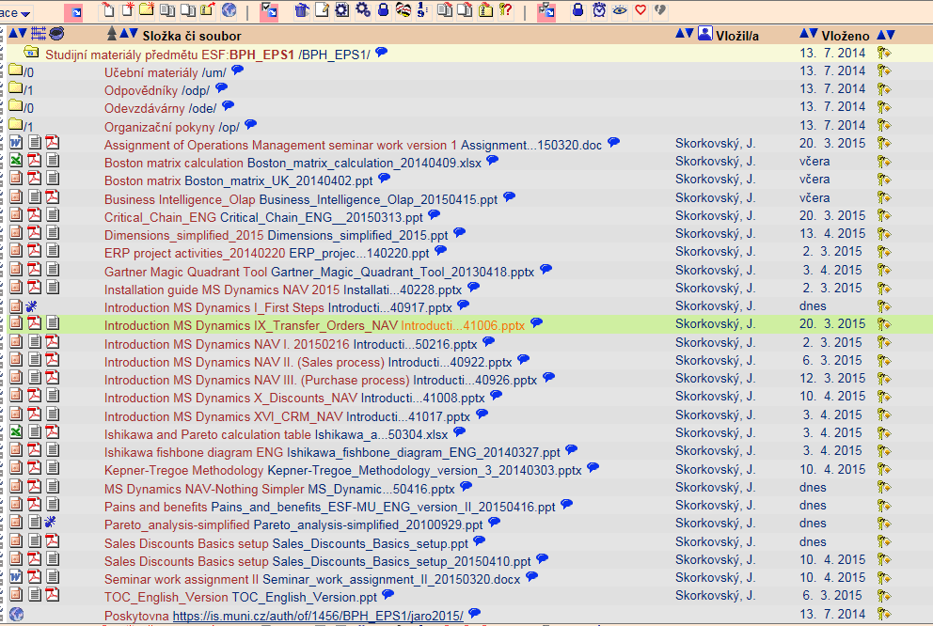

Below listed material (are including in the copy of the student material above as well ) have to be used for MS Dynamics NAV 2009 studies. Mind you, that access to ERP system MS Dynamics NAV 2009 ENG version is possible also in all public computer rooms! It is expected, that the system was installed on Your computer if technical conditions were suitable, meaning all PC with any kind of Microsoft operating system.

Sales discount basics setup (was already concisely presented and it uploaded in the above listing of the study material. This material is complementary material to PWP Introduction MS Dynamics-X Discounts). This material was uploaded to the study material 16.4.2015

Pain and benefits –PWP ( was uploaded to the study material 16.4.2015)

MS Dynamics NAV-Nothing Simpler – PWP (helping and complementing material to standard PWPs about MS Dynamics NAV ( was uploaded to the study material 16.4.2015)

Pareto analysis Simplified –PWP ( was uploaded to the study material 16.4.2015- mind you that you have to study only first 3 slides regarding Pareto principles and Lorenz curve )

Introduction MS Dynamics First Steps –PWP ( was uploaded to the study material 16.4.2015- mind you that it is a complement to the practice question .Do not take into consideration slides describing filtering and searching )

Listing of Theory Resources – will be used below to show you mapping knowledge -resources

A. ERP project activities PWP presentation
B. Pains and Benefits
C. Critical Chain ENG
D. TOC PMPINSA English
E. Boston Matrix Calculation (and Product Life Cycle)
F. Magic Quadrant Matrix from Gartner
G. Ishikawa and Pareto calculation table
H. Pareto Analysis Simplified
I. Business Intelligence-OLAP
- Magic quadrant from Gartner
- Kepner-Tregoe methodology

ERP Resources (practice)

- Installation MS Dynamics NAV
- Introduction MS Dynamics NAV-IX-Transfers
- Introduction MS Dynamics NAV-I-Introduction
- Introduction MS Dynamics NAV-II-Sales
- Introduction MS Dynamics NAV-III-Purchase
- Introduction MS Dynamics NAV-XVI-CRM- Customer Relationship Management
- Introduction MS Dynamics NAV-X-Discounts
- Dimensions simplified
- Sales discount basic setup
- MS Dynamics NAV Nothing Simpler
- Introduction to MS NAV-First steps

Theory Questions (resources A-K):

Structure of the theory question:

Number Description : Resource (slides if required )

1. What qualification (knowledge) should be required of ERP consultant of project managers? A , B,C D, E, K
2. Name key activities of the implementation project (project steps): A
4. What is a Gantt chart: A and C
5. Simplified chart (diagram) of ERP functions (feedback diagram) : A
8. Specify the basic concept of the Theory of Constraints: D
9. TOC metrics : D
10. Cost World and Throughput World : D
12. TOC five steps: D
13. Basic trees (Thinking process tools) – Current Reality Tree, Evaporating Cloud Tree and Future Reality Tree : D
14. What is bad multitasking? : C
16. Critical path and Critical Chain: C
17. Use of project buffer (buffer management concept) : C
18. Pains and benefits : B
19. Ishikawa fishbone diagram: G
20. Boston matrix and Product Life Cycle(PLC) : E
21. Gartner Magic matrix : F
21. Pareto analysis: G and H (first three slides)
22. Business Intelligence- OLAP : I
23. Kepner-Tregoe basics : K

Practice Questions (resources L-V):

1. Modularity of the ERP systems. What areas can be controlled by ERP MS Dynamics NAV : N,U
2. Main windows (forms) used in ERP and syntax for Debits and Credits (posted General Ledger Entries) – card window, line window, matrix window, header and line window : N, U, V
3. Main tables (Item, Customer and Vendor) : M, U, V
5. Purchase of an item and impacts of F11 (posting) -> item and vendor entries, G/L entries : P
6. Sale of an item and impacts of F11 (posting) -> item and customer entries, G/L entries : O
7. Discounts and the use of this (incentives, type of discounts): R, T
8. Transfer of an Item form one stock Location to another stock location : M
10. Contact Card and its profile and use of it. Connection to Customer (Vendor) card : Q
11. Dimension and its use : S

