BPH_EPS1 (Enterprise Resource Planning Systems) – questions spring term 2017
Created by : Ing. J.Skorkovský,CSc. KPH ESF MU BRNO, Czech Republic ; 1730@mail.muni.cz; miki@econ.muni.cz; jaromir.skorkovsky@navertica.co, tel : +420 731 113 517
Date : 05.05.2017
Version : I.

All questions could be studied with the help of related study materials handed over to students during lessons held in Brno during spring term 2017

Will be shortly reviewed (explained) during last one of the last lessons (5.5.2016 and possibly 12.5.2016) taking into consideration, that the first date (19.5.2016) is partly assigned date for exams. Important parts of below specified questions may be found in your Seminar works.

Resources (see original in is.muni.cz):

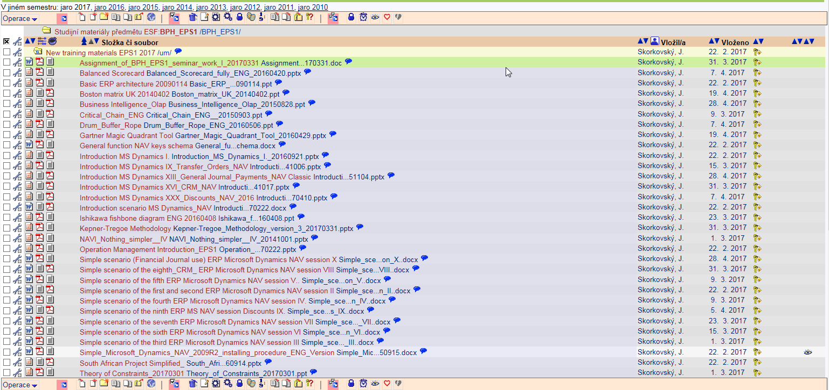

Below listed material (these are including in the copy of the student material above as well ) have to be used for MS Dynamics NAV 2009 studies. Mind you, that access to ERP system MS Dynamics NAV 2009 ENG version is possible also in all public computer rooms! It is expected, that the system was installed on Your computer (You have got Scenario how to do it) if technical conditions were suitable, meaning all PC with any kind of Microsoft operating system. So far I have learnt, that nobody reported any problems regarding installation of the MS Dynamics NAV product.

OLAP and Business Intelligence presentation - PWP presentation (was uploaded to the study material) and was concisely presented 28.4.2017

Pain and benefits - PWP presentation (was not uploaded to the study material for this term so far) If this will be presented on 5.5.2017 you will see it in the appropriate file)

MS Dynamics NAV dimension and their use in BI applications - PWP presentation ( was uploaded to the study material)) and will be concisely presented 5.5.2017

NAVI Nothing Simpler - PWP presentation ( was uploaded to the study material 1.3.2017. This material was not directly used during practical lessons, but includes all basic principles needed to understand concisely basics of ERP MS Dynamics NAV.

Listing of Theory Resources – will be used below to show you mapping knowledge -resources

A. OM introduction - PWP presentation - uploaded 22.2.2017
B. Pains and Benefits (will be presented 5.5.2017)
C. Critical Chain ENG
D. TOC English
E. Boston Matrix Calculation (and Product Life Cycle)
F. Magic Quadrant Matrix from Gartner company
G. Ishikawa use and Pareto calculation and use (Lorenz curve)
H. Pareto Analysis Simplified
I. Business Intelligence-OLAP (will be presented 28.4.2017)
- Kepner-Tregoe methodology
- Balanced Score Card
- Basic ERP architecture – uploaded 22.2.2017

List of ERP Resources (practice)

- Installation MS Dynamics NAV
- Introduction MS Dynamics NAV-IX-Transfers
- Introduction MS Dynamics NAV-I-Introduction and Introduction II
- Introduction MS Dynamics NAV-II-Sales
- Introduction MS Dynamics NAV-III-Purchase
- Introduction MS Dynamics NAV-XVI-CRM- Customer Relationship Management
- Introduction MS Dynamics NAV-X-Discounts
- Dimensions simplified-will be presented and uploaded on 12.5.2017
- MS Dynamics NAV Nothing Simpler
- General Ledger Journal and payment

Comment: Sets of Scenarios covering all basic processing areas were created and handed over. So please use mainly these materials!!!!

Theory Questions (resources A-L):

Structure of the theory question:

Number Description : Resource (slides if required )

1. What qualification (knowledge) should be required of ERP consultants or project managers? A ,B,C D,E,K ,I
2. No applied this year
4. What is a Gantt chart: A and C
5. Simplified chart (diagram) of ERP functions (feedback diagram) : L
8. Specify the basic concept of the Theory of Constraints: D
9. TOC metrics : D
10. Cost World and Throughput World: D
12. TOC five steps: D
13. Basic trees (Thinking process tools) – Current Reality Tree, Evaporating Cloud Tree and Future Reality Tree : D
14. What is bad multitasking? : C
16. Critical path and Critical Chain: C
17. Use of project buffer (buffer management concept) : C
18. Pains and benefits : B
19. Ishikawa fishbone diagram: G
20. Boston matrix and Product Life Cycle(PLC) : E
21. Gartner Magic Quadrant (matrix) : F
21. Pareto analysis: G and H (first three slides)
22. Business Intelligence- OLAP : I
23. Kepner-Tregoe basics : J
24. Balanced Score Cards : K

Practice Questions (resources M-V):

1. Modularity of the ERP systems. What areas can be controlled by ERP MS Dynamics NAV : N,T
2. Main windows (forms) used in ERP and syntax for Debits and Credits (posted General Ledger Entries) – card window, line window, matrix window, header and line windows : U,P,Q,..
3. Main tables (Item, Customer and Vendor) : U,O
4. Purchase of an item and impacts of F11 (posting) -> item and vendor entries, G/L entries : Q
5. Sale of an item and impacts of F11 (posting) -> item and customer entries, G/L entries : P
6. Discounts and the use of this (incentives, type of discounts): P,Q,S
7. Transfer of an Item from one stock Location to another stock Location (Blue-Red) : N
8. Contact Card and its profile and use of it. Opportunity. Interactions. Connection to Customer (Vendor) cards : R
9. Dimension and its use : T was presented on 5.5.2017
10. Basic used of General Ledger Journal (payment from customer- apply open invoice to payment) : V

