Obsah

1 Zpracování dat – další programy 3

1.1 Databázové 3

1.1.1 Microsoft SQL 3

1.1.2 IBM 3

1.1.3 SAP 4

1.1.4 Access 4

1.1.5 ORACLE 5

1.1.6 SQL lite 5

1.1.7 postgreSQL 6

1.1.8 FileMaker 6

1.1.9 Informix 6

1.1.10 Teradata 6

1.1.11 ADABAS 6

1.2 Microsoft 7

1.2.1 Excel 7

1.2.2 PowerBI 7

1.3 Google 8

1.3.1 Google data studio 8

1.3.2 AdWords 8

1.3.3 AdSense 9

1.3.4 Google analytics 9

1.3.5 Gtabulky 10

1.3.6 Fusion tables 10

1.4 OpenOffice 11

1.5 Tabelau 11

1.6 Rko 12

1.7 Open refine 12

1.8 HADOP 13

1.9 KNIME 13

1.10 rapidminer 14

1.11 Wolframalpha 14

1.12 Import.io 15

1.13 Google Search Operators 15

1.14 NodeXL 15

# Zpracování dat – další programy

## Databázové

### Microsoft SQL

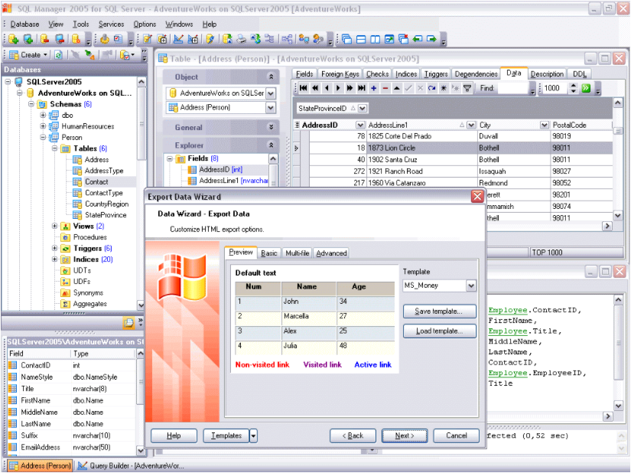

### IBM

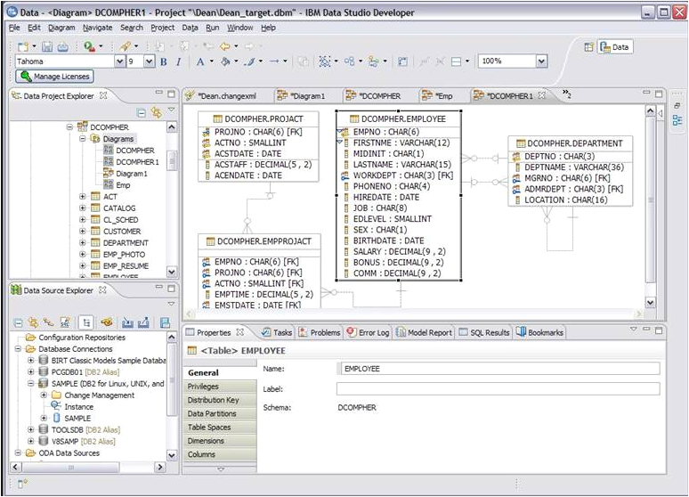

### SAP

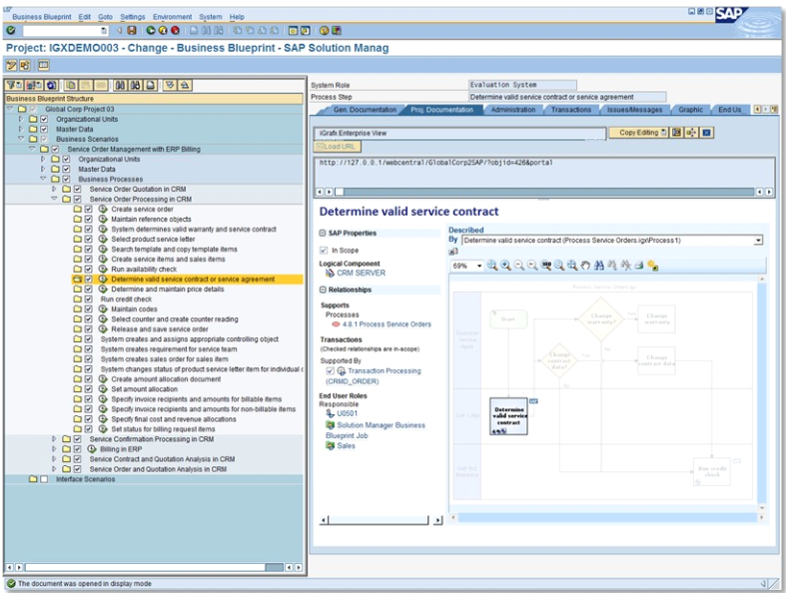

### Access

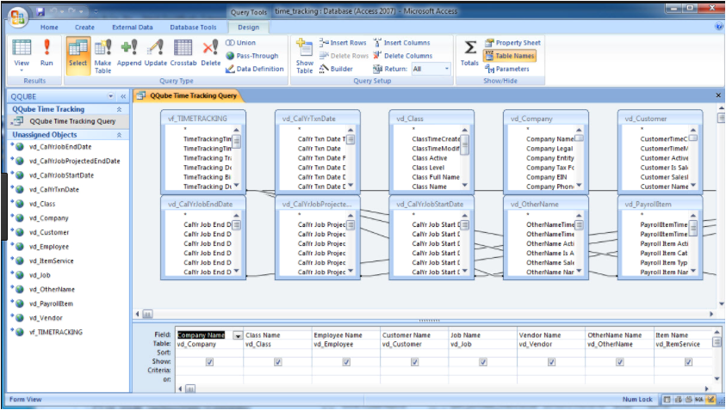

### ORACLE

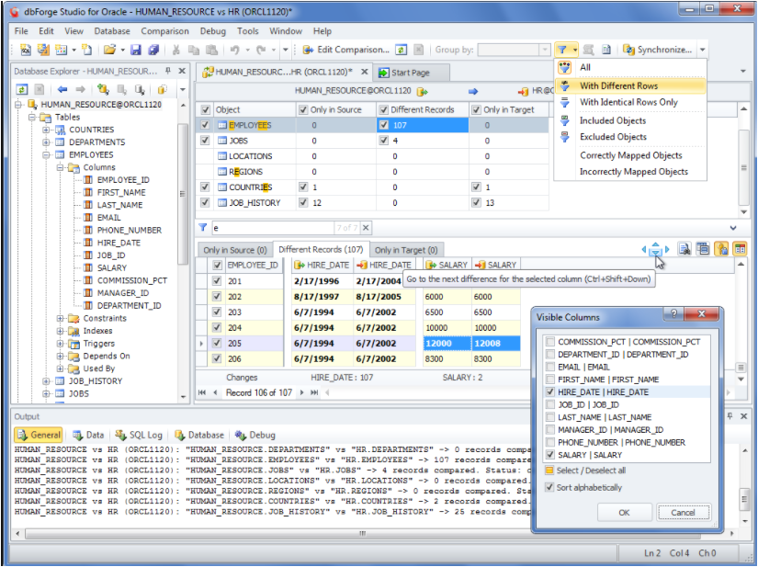

### SQL lite

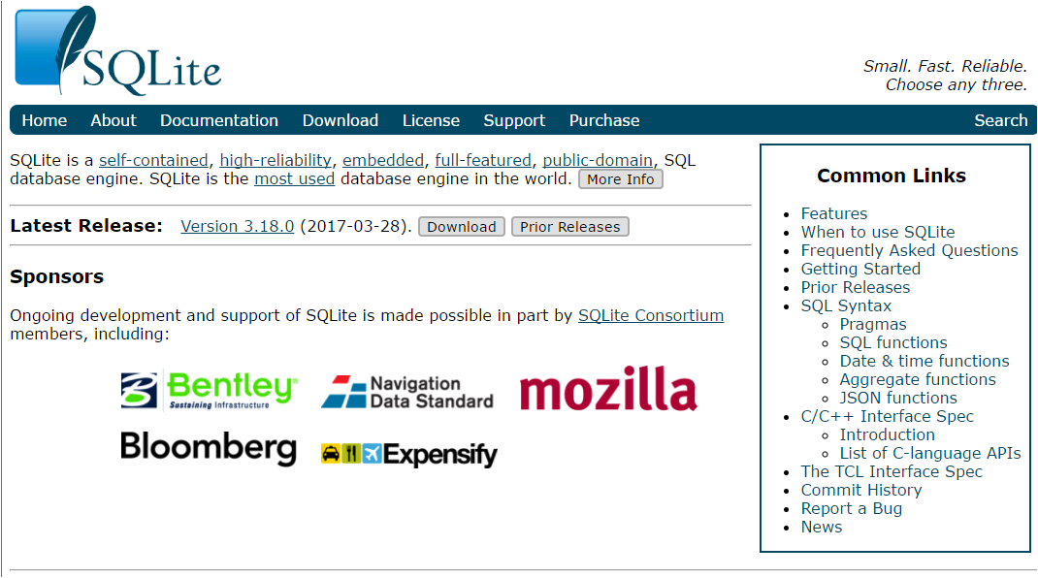

### postgreSQL

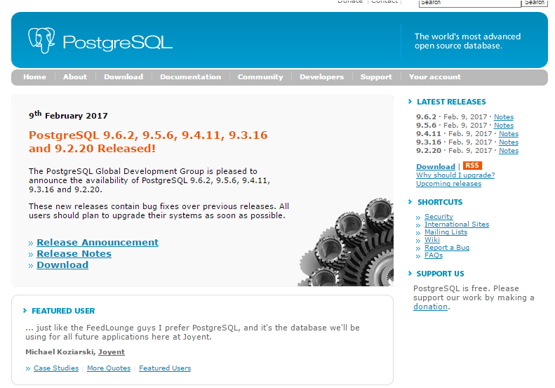

### FileMaker

### Informix

### Teradata

### ADABAS

## Microsoft

### Excel

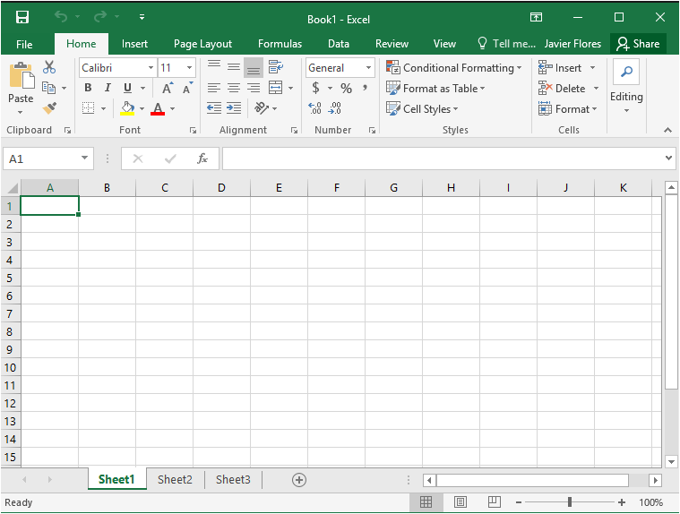

### PowerBI

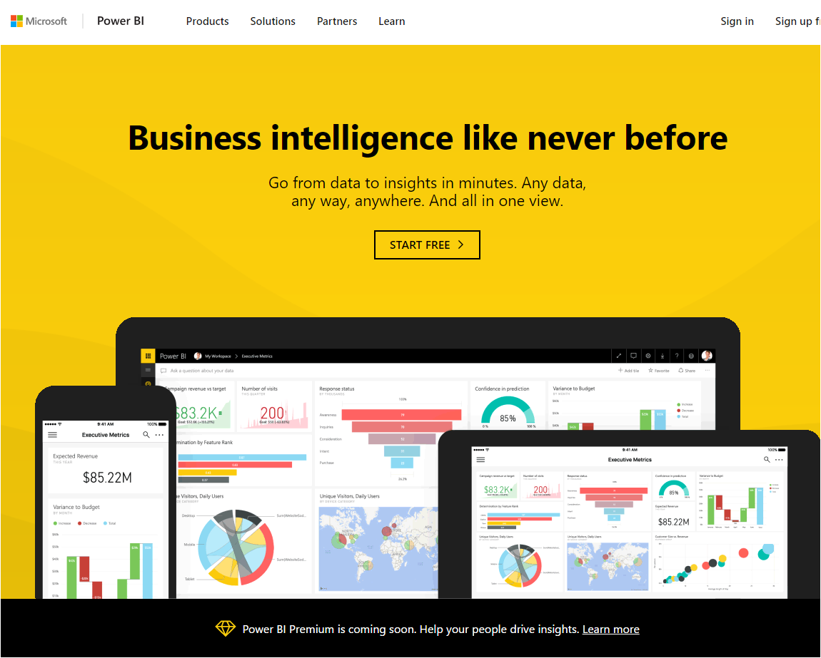

## Google

### Google data studio

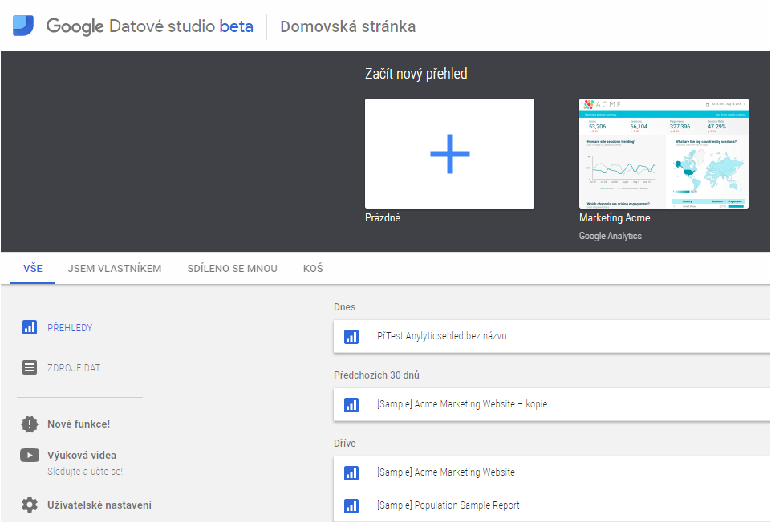

### AdWords

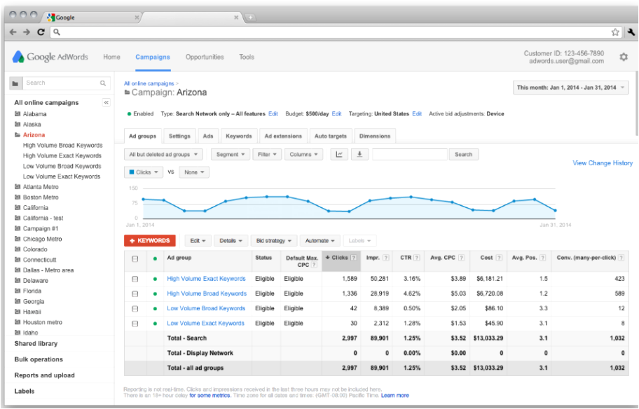

### AdSense

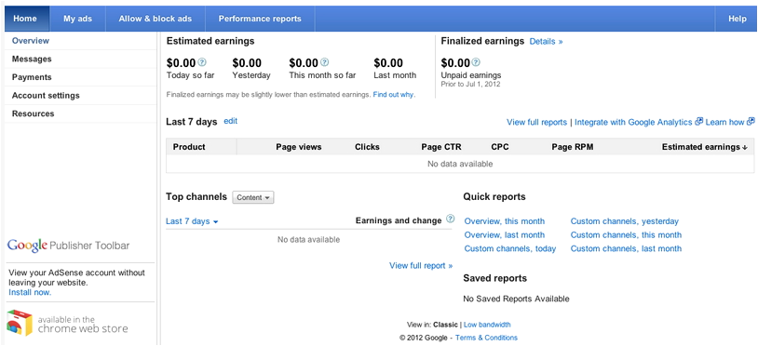

### Google analytics

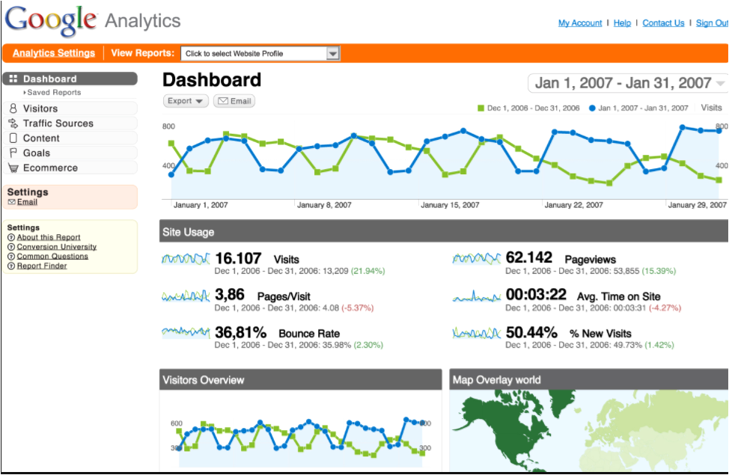

### Gtabulky

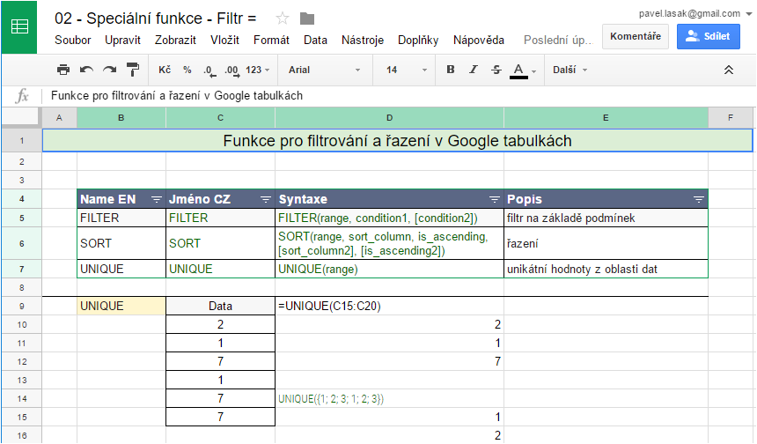

### Fusion tables

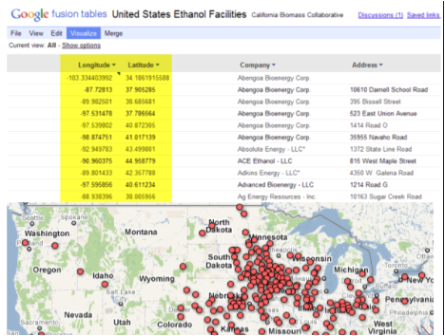

## OpenOffice

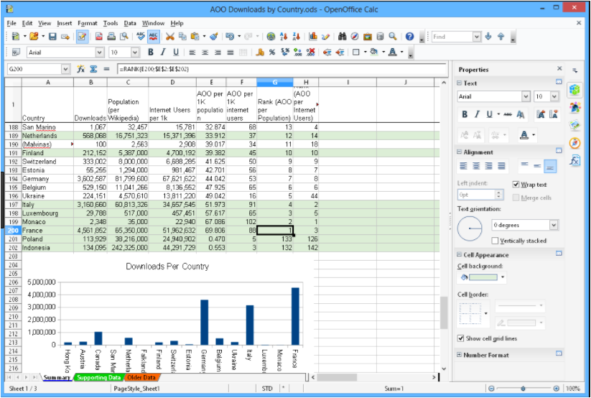

## Tabelau

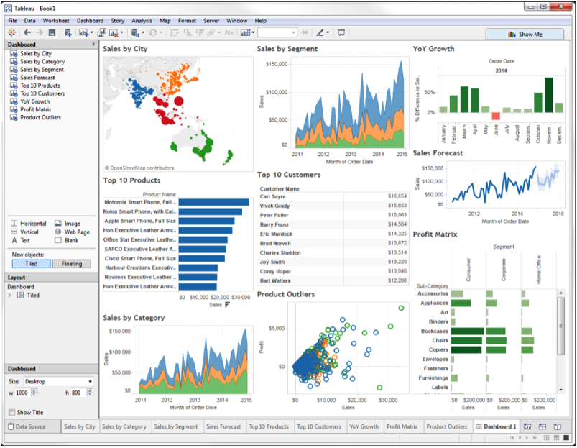

## Rko

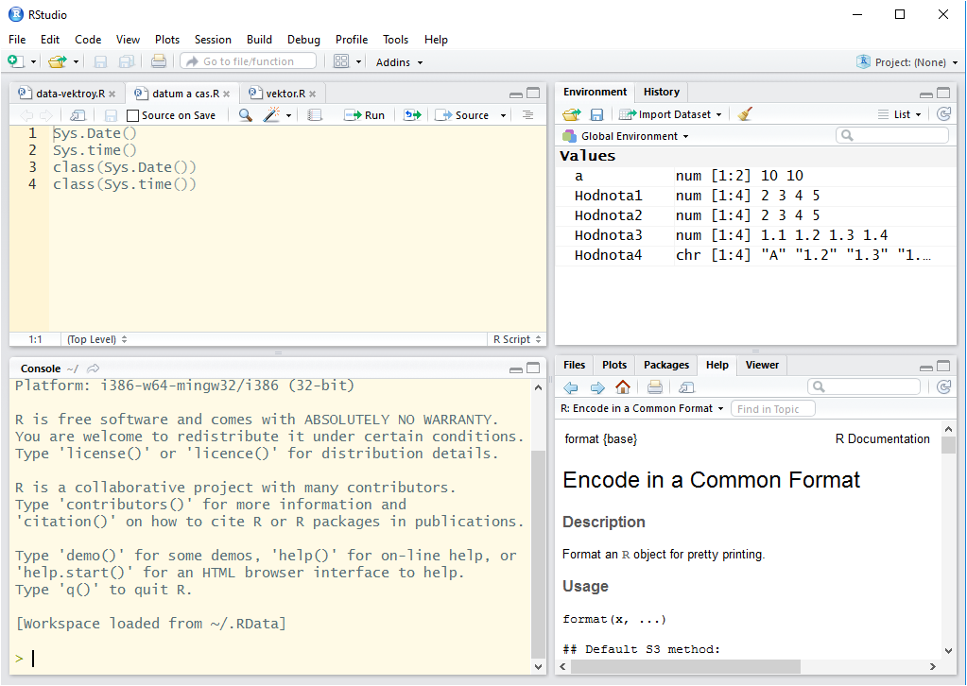

## Open refine

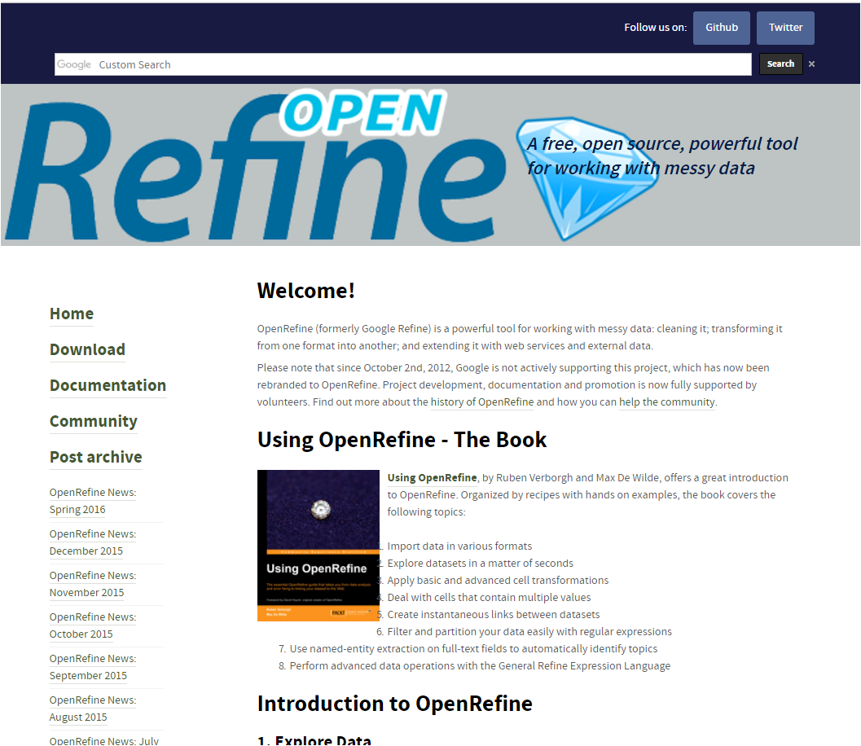

## HADOP

<http://hadoop.apache.org/>

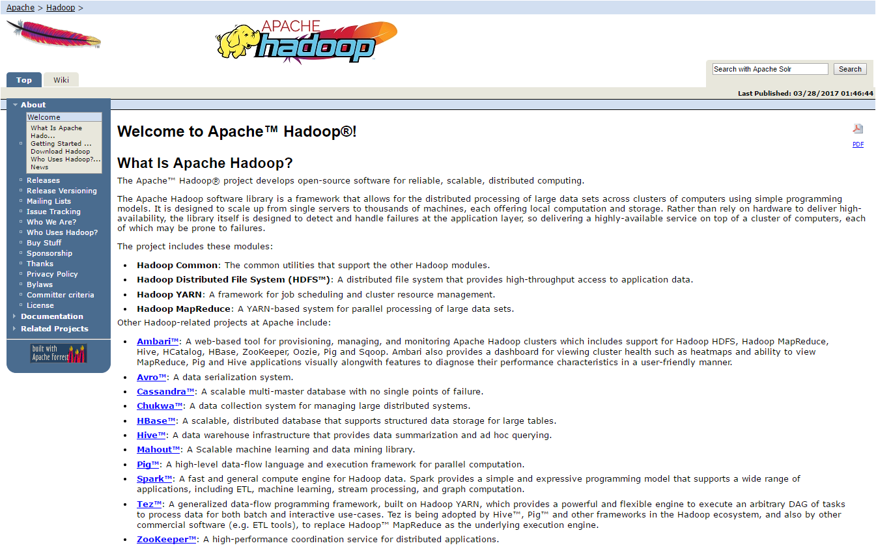

## KNIME

<http://www.knime.org/>



## rapidminer

<https://sourceforge.net/projects/rapidminer/>

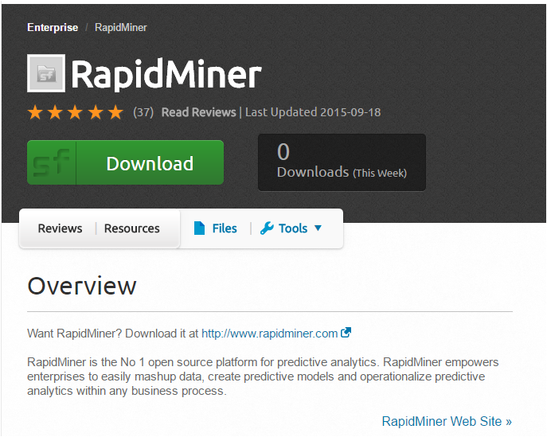

## Wolframalpha

<http://www.wolframalpha.com/>

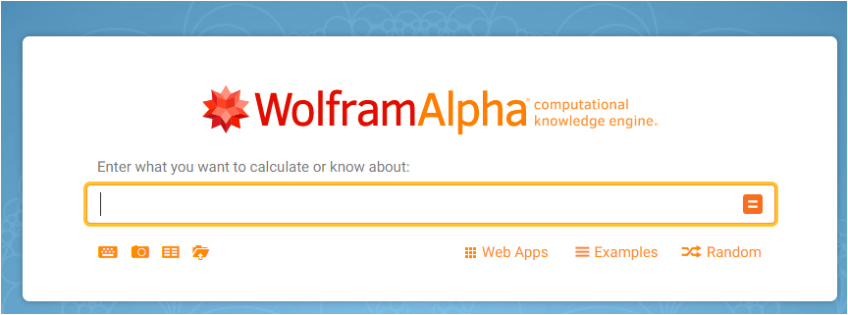

## Import.io

<https://www.import.io/>

## Google Search Operators

<http://www.sourcinghacks.com/google-search-operators-and-more/>

## NodeXL

<http://nodexl.codeplex.com/>



ELKI

DATAIKU DSS

Gephi

DataMelt

Data Applied

Dev Info

<http://www.predictiveanalyticstoday.com/top-data-analysis-software/>

<http://www.informationweek.com/big-data/big-data-analytics/16-top-big-data-analytics-platforms/d/d-id/1113609>