**Simple scenario CRM-Customer Relationship Management in Dynamics NAV .**

Created by : Jaromír Skorkovský

Date : 20.4.2018

Reason : Customer Relationship (CRM) basic function in ERP systems

For : MPH_AOMA students, **BPH_EPS1 students**

Used database : MS Dynamics NAV 2016 W1 (British database)

Used keys : **F5, F3, F6** (look-up) and **Ctrl-F5** (from card to entries) and **Shift-F5**

in order to go to chosen card. **F7-** filter on one field. **F9**-Statistics

Used abbreviations : Q=question, G/L=General Ledger, Simple Scenario = SS,

PWP=Power-Point, SO=Sales Order, TO=Transfer Order, PO-Purchase Order , **MC=Mouse cursor, ENTER**🡪key enter

Related documents : Scenarios I-VII

Intention : Training and hands on

1. Searching window->Contacts. What can you see? We do have two types of Contact card (Company, Person). Bold and not bold texts
2. Reasons of having Contact card : contact card could be simple prospective buyer, interested party,.. and so on. Briefly meanwhile the one who did not signed a contract (deal) or did not ordered goods or services or both.
3. You see listof all contacts. Explain why some of them are typed in **bold** whilst the other are not!
4. See one card of company (bold) and one card o person (not bold). Use icon EDIT. See structure oc the contact card .
5. See differences in contact lines related to companies and to persons.
6. **How to do action described in clause 4 ?**  Put your cursor to answer in contact line field for person. And make Edit icon.
7. See lined of the contact card (both company and person). See answer and questions. See small icon with 3 dots on the right side of the field. This is symbol for so called drill down function. When you click on it you see predefined questioner. Make your choice (e.g. change marital status- if person is involved). You seeimmediately modified line in question.
8. Some of the Contact card are not connected to Customer card some of them already is. Teacher will explain this more in detail.
9. Go to bar menu above and see in the section Related information icon Customer/Vendor/Bank. Make **ENTER .**You will go from Contact card to Customer card. From there you can go back by use of ESC or button **Customer**-> Contact choice.
10. See other tabs on contact card. Contact information, Segmentation and Foreign trade.
11. Teacher will explain what it is interaction and relate interaction entries (planning meeting, telephone calls, direct e-mail action, invitation to seminars and so on).
12. Go to menu Bar Action and Icon **Create Interaction** and follow instruction given by wizard. Type of interaction: meeting, describe your interaction : meeting invitation**, NEXT**, cost of interaction : 10, how log :40 and **FINISH**
13. From to contact card make **Ctrl-F7 ->**see interaction entries. The last one is yours.

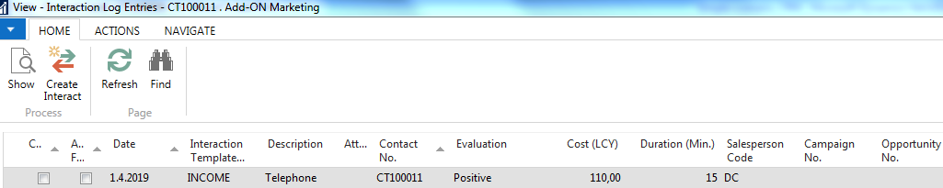

1. From contact card **CT000007** use button Navigate and Opportunity icon. The list of opportunities will be open. You can go also to **CT000007 from Customer card 10000.**  Make a choice of fist one and EDIT in order to go to the opportunity card. Use OP00017 !!!
2. Teacher will explain the structure of header and opportunity lines. Cycle stages, Estimated value of deal on which salesperson is working, estimated close date, probability of the closing and so on.
3. From Opportunity card go to statistics (**F7**) and then go back by **ESC**.
4. Go back from Opportunity card by ESC to Contact card and see Statistics **(F7)**.
5. Go to te section Home - >Process and see Sales Quotes choice! Create new quotation
6. New document is open. Make Enter to create new unique document number
7. Immediately the header is automatically fulfilled by data from Customer card relate to Contact card from where we created Quote
8. Enter data (base on your knowledge from previous scenarios especially related to Purchase and Sales orders)

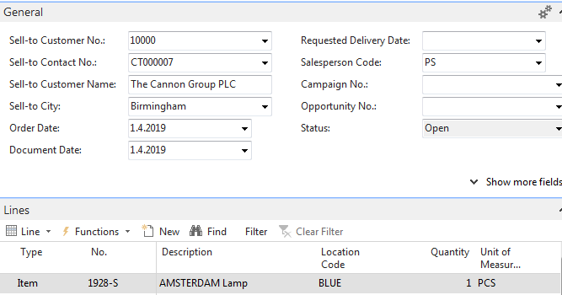



1. If you create a new quote (use similar data) and **do not** push button **Make Order**