1. **Introduction scenario – MS Dynamics NAV**

**Based on :**  MS courses and Miki Skorkovský modifications

**Date** : 22.2.2017

Pictures are parts of PWP show number Intro_I_NAV 2016_20170111

**Materials :** Scenarios, PWP, videos,…

**Resources :** MS courses, internet, MS Dynamics NAV demo helps,…

**What are the goals for this Section ?**

* **Explain the concept of ERP and Microsoft Dynamics NAV**

**ERP** =Enterprise Resource Planning System

**Resources**  : financial resources, machines, people, items,…….

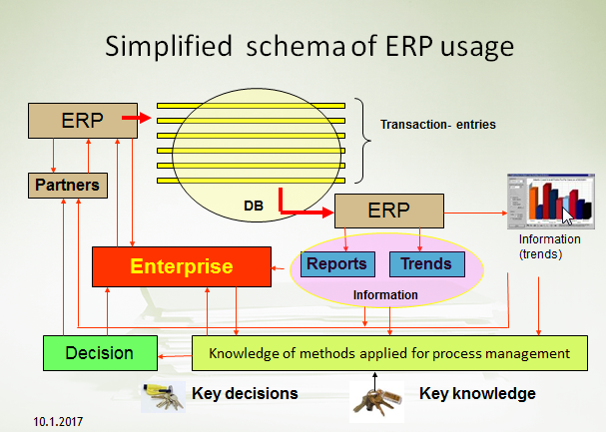

Decision making based on data created and structured by transaction system (ERP) .

Different data, different requirements in different times, different set of reports ,…

Comment (BSC- trainer se below)

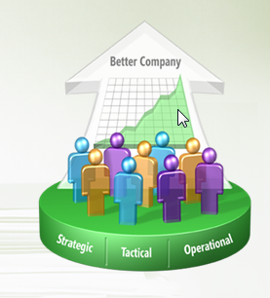

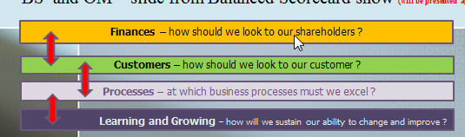

**3 tiers** (will be more in detail presented later in technology section)

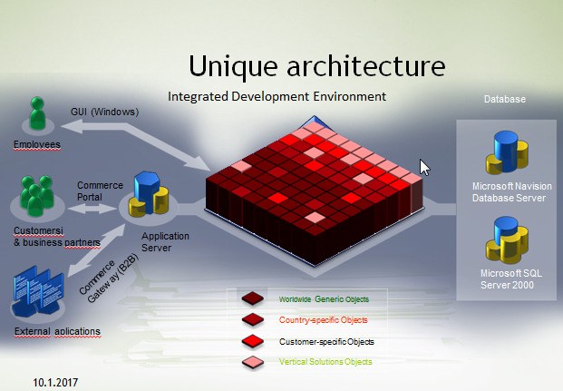

**Objects :** tables, forms, reports and data ports.

**Table :** how to store data

**Form:** how to see data

**Reports :** how to give you right information based on stored data

**Menu :** how to navigate user throughout ERP system

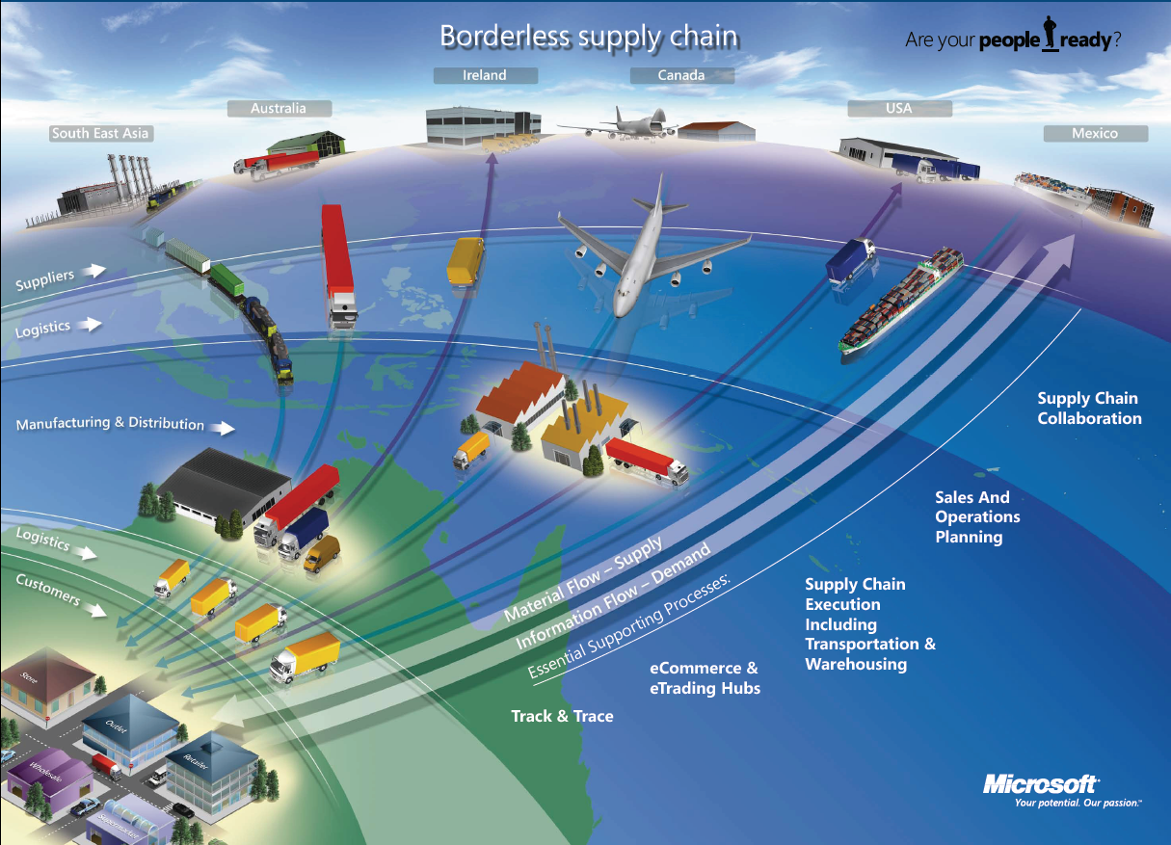

1. **What makes MS Dynamics NAV an ERP system ?**

So Microsoft Dynamics NAV is an ERP system.  But why is it an ERP system? What are the main features of an ERP system and how do we recognize these in Microsoft Dynamics NAV? Let's have a look at the overview slide.  So one of the challenges that some companies might have to address is the one **of island systems**.  And that's what you see typically when a company is using bookkeeping software in which only the bookkeeping can be done.  That same company might also have a warehouse, might have a production department, is selling goods and services and so on, but in the bookkeeping software, items, physical locations, the actual stock count is not maintained.  And what you will see, and that's why we call it island systems, they're using different software products.  And in some cases this might also be Excel in which they keep their item master, for example.  So they're using different software products to maintain all these data.  But they can -- as you can see here in warehouse data, we need items; in production data we also need items; and in sales and customers we also need items.  So this means that in a typical island system you have to maintain, you have to enter data several times.  And that's, of course, first of all, a lot of work, but also a lot of errors could be made. So and that's why the island system is not, of course, the ideal system.  In an ERP system we will work in a different way.  In an ERP system we have a common database that contains all the information.  So item information is maintained in the common database and can be used by the manufacturing department, by the sales department, and so on.  So everyone working with the system, for example, the bookkeeper in financial management, the sales representative in sales and marketing, the warehouse worker in the warehouse management, the HR manager in human resources and so on, so they all work with the system in their specific application department but with a **common database**.  And that's very, very important.  That's one of the main features of an ERP system.  Because the item master should be maintained only one time in that common database and everyone can use items in the way that they prefer and based on the information that they need.  So that's a very important feature of ERP.  Some other features that are important is, of course, real time.  Because of the common database, we have all the information available at **real time**.  So we don't have to wait, we don't have to carry out processes, imports, exports.  No !!!!.  Everything is there in real time.

Also typically for an ERP system is that it **can grow with a company**.  So you can start in a very simple way without, for example, using warehouse management, but if your company grows and you're starting to use a new warehouse, you might be interested in implementing, for example, a warehouse management system.  And an ERP system will allow this.  So it's tied to the company's business processes and it will grow with the company.  So if we require warehouse management at a specific point, then we can start using that in our ERP system.  And then of course also typically for an ERP system are the job roles and the authorization.  So we can set up a security system, we can assign different job roles, you have bookkeepers, as we just saw in the previous slide, we have salespeople, we have warehouse workers and so on. So all these job roles are based on these job roles we will start using the system in a specific way, and of course we also need a security system in order to define what users can or cannot do in our ERP system.  So these are the main features, and that's also why we can consider Microsoft Dynamics NAV as an ERP system.  So we have a central database on SQL Server, we can work in real time, we can define users and apply security and so on.

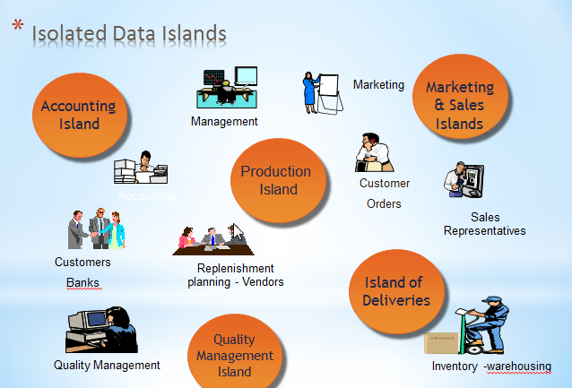

**Another example of island system (resource Microsoft)**

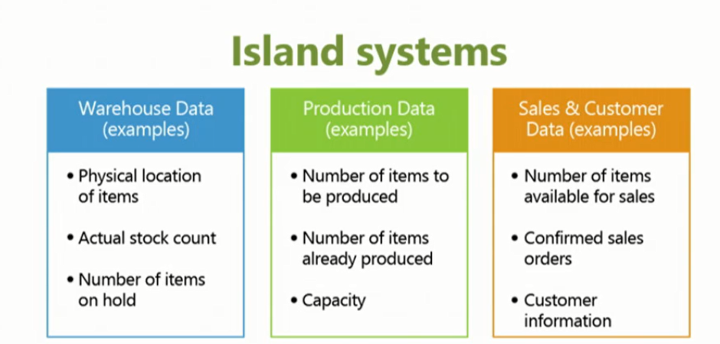

Simple example about problems related to different applications delivered by different SW suppliers

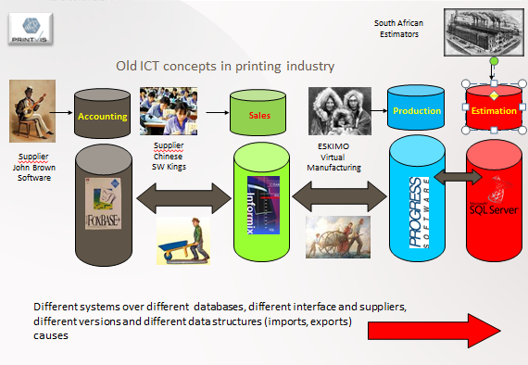

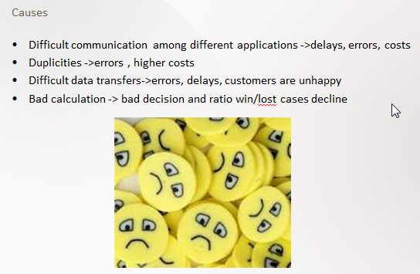

**Ideal ERP solution** : One Application- one database

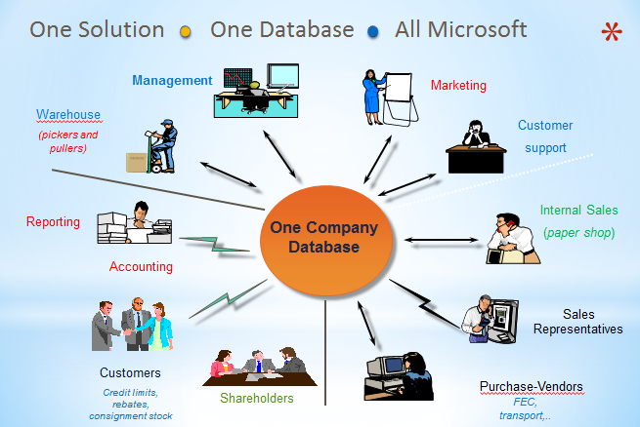

¨

**Similar picture about data island (see below)**

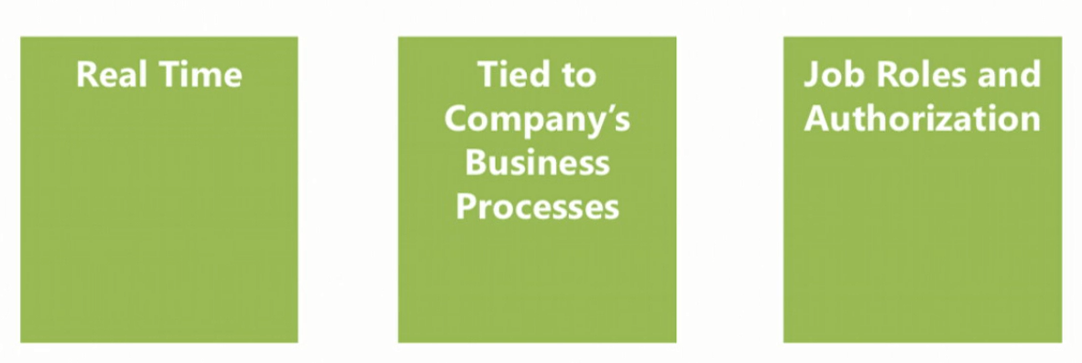

**b) Browse application areas**

## Module Overview (text part)

So now that we know why Microsoft Dynamics NAV is an ERP system, I thought it would be interesting to have a look at everything that we can do with NAV because we just saw that one of the main features of an ERP system is the common database around which we have all these different application areas.  Now, what are the application areas that we can use in NAV? So in this module we will browse all these application areas.  And we will start with financial management, then a little bit combined with financial management we also will have a look at reporting and analysis.  Then there's a marketing module and trade.  There is, of course, inventory management because the item can be something very important in a NAV application.  And we can also extend inventory management with warehouse management.  There is manufacturing, so for companies that manufacture and that produce their own items.  We have jobs and resources for service-oriented companies.  There is a service management and human resources.  So these are all the different application areas at which we will have a very short look in the upcoming lessons of this module.

**c) User interface – main working area**

**d) User personalization ..lines (Hide and Show,…)**

**e) Basic functionalities (searching filtering,…)**

f) **Master data :** Customer, Item, Vendor, Sales Order and Purchase Order and G/L accounts

This picture will be part of course section regarding **Dimension and BI**

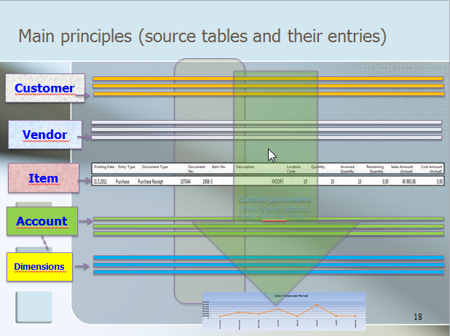

**This 10 bullets represents basic sections during introduction of this course**

* Discuss the concept of the ribbon and its different components
* Demonstrate how to use the Navigation pane
* Explain how to customize the Microsoft Dynamics NAV user interface
* Use function keys and basic keyboard shortcuts
* Enter and edit information
* Use zooms, search, filters, and other navigation functions
* Integrate with Microsoft Office products such as OneNote, Word, and Excel
* Introduction to customer cards, vendor cards and item cards and G/L account as well
* Describe the different client types
* Explain the multi-language functionality
* How to enter data (numbers, dates, periods)

## 