**Case #9. Sweden vs. Maine Lobsters**

**Sweden Complaint Over Lobsters Has Maine Leaders Boiling as Proposal to add North American crustaceans to EU’s invasive species list prompts outcry**

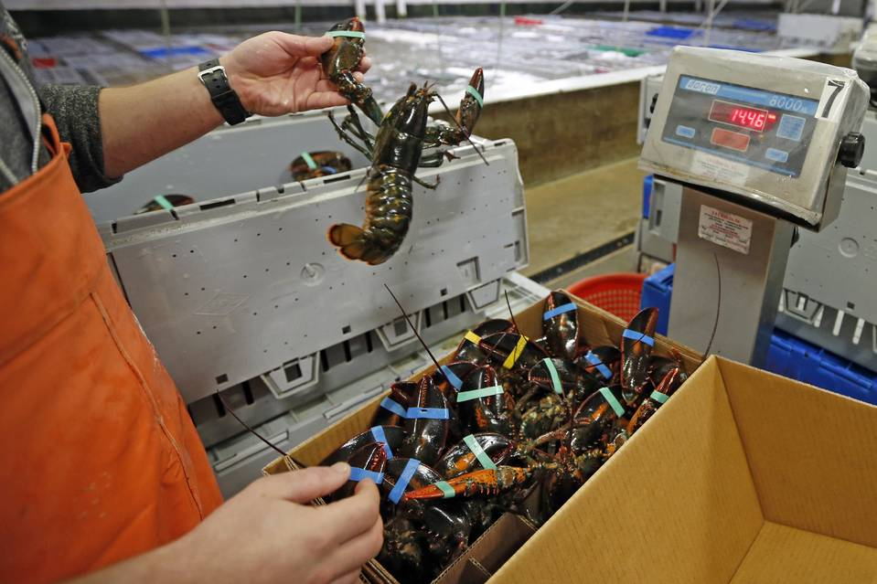

Photo: Robert F. Bukaty/Associated Press

By

Jennifer Levitz **Wall Street Journal**

Updated April 24, 2016 9:17 p.m. ET

**The Maine congressional delegation** **(MCD)** (i.e., *its Senators and Representatives* *from the U.S. state of Maine*, *a small state on the northeast Atlantic coast)*, is very unhappy over a push by **Sweden** to get the **European Commission (EC)** to designate the North American lobster as an invasive alien species, which would halt live imports to the EU’s 28 member countries.

The Swedes say the lobsters have the potential to spread diseases, but U.S. politicians and **Maine lobster industry (MLI)** questions the science. The **Scientific Forum at the European Commission** **(SFEC)** which reports to the European Union’s executive body, the **European Commission (EC)**, expects to take up the matter in June 2016.

The clash stems from the finding off Sweden’s west coast of 32 live lobsters from along the east coast of the U.S. and Canada between 2008 and 2015, according to a February report by the **Swedish Agency for Marine and Water Management (SAMWM)**.

Some of the lobsters had exporters’ rubber bands around their claws, suggesting they hadn’t arrived naturally but may have escaped or been released from storage cages, according to a [statement](https://www.havochvatten.se/en/swam/facts--leisure/non-native-species/american-lobster.html) on the **SAMWM** website.

The American lobster “is considered an alien species in Swedish waters” and “its presence can introduce new and very serious diseases” that affect native European lobster and other shellfish,” the **SAMWM** statement said.

The **SAMWM** statement said diseases associated with North American lobsters include a bacterial condition that occurs in tanks where lobsters are stored for export, a shell disease and a parasite that can eat a lobster’s eggs. It is vague on other diseases, saying, “The species carries many other diseases but the scientific knowledge behind them is still low.

Robert Bayer, executive director of the **University of Maine’s Lobster Institute (MLI)**, said the bacterial disease mentioned “hasn’t been seen for at least 10 years,” the shell disease isn’t contagious, and that the parasite is uncommon and that he’s never seen it.

The **SAMWM** also worries about crossbreeding, saying it isn’t fully known “how American lobsters and European lobsters affect each other.”

The **Maine lobster industry (MLI)** is “clawing” back.

“We need to understand how 32 lobsters found in EU waters over an eight-year period constitutes an `invasion,’” said Gavin Gibbons, spokesman for the **U.S. National Fisheries Institute** **(USNFI),** the largest seafood trade association in the U.S.

Some in the industry have questioned whether the move is meant to protect Swedish lobster fishing, but a Swedish official said that line of work doesn’t generate much income for local fishermen.

“This is totally an environmental thing,” said Sofia Brockmark, an investigator at the **SAMWM’s** unit for biodiversity.

Maine’s Congressional delegation appealed to the **U.S.** State **Department (USState) [the equivalent of a European foreign Ministry]** to intervene, writing in a March 28 letter to that Maine has shipped its lobster globally safely for decades. Attempts to halt imports “could have serious ramifications for Maine lobstermen and their families,” wrote a contingent including Maine Republican Sen. Susan Collins and Democratic U.S. Rep. Chellie Pingree.

U.S. and Canadian exports of live lobsters to EU countries generated $196 million in 2015, according to the **U.S. National Fisheries Institute (USNFI)**.

Maine is the largest lobster producer in the U.S. and has been enjoying a resurgence in lobster prices after enduring [a supply glut](http://www.wsj.com/articles/SB10001424052702304388004577529080951019546) that slashed prices.

“Prices have been very good for the last year; almost everyone is happy,” said Mr. Bayer.

Meanwhile, the specter of the possible trade obstacle is prompting **U.S. State Department** officials to get involved. The government is “working to evaluate the scientific basis of Sweden’s request” and is “in close contact with European colleagues to ensure that legitimate trade is not unjustifiably restricted,” a **U.S.** **State Department** official said Friday.

If the **European Commission** does add North American lobsters to its list of “invasive alien species of Union concern,” commercial imports would have to be phased out, said Iris Petsa, a spokeswoman for the **European Commission**.

The **Scientific Forum at the European Commission** **(SFEC)** will discuss Sweden’s request in June, but multiple steps would follow before any final decision.

“We are at an early stage to say whether the American lobster will be listed,” Ms. Petsa, spokesperson for **SFEC** said.

***NOTE: There have been a few editorial changes to the original WSJ article to make it clearer to a non-US reader.***

**Questions:**

1. **(5) Draw a power diagram showing relations among the primary actors in the case.**
2. **(3) Summarize the power situation facing the Maine lobster industry in the EU**
3. **(3) What model will best describe the public policy decision-making of each of the key governmental actors in this case (there are many)? Be sure to explain your choice (see Module 9 for guidance).**
4. **(4) Based on your answer to Q2 and Q3, recommend a strategy for the Maine Lobster Industry that would enable it to remain in the EU market?**

**NOTE: You are to incorporate your answers for Q2 and Q3 into your answer to Q4!!! In effect, you are to argue as follows; The Maine lobster industry strategy should be able to remain in the EU market……., based on my assessment of (1) the power of ……….and ……….over …….., etc. and because (2) the key government decision-makers make decision based on a………….model,**

There is no word limit.