# SQL status (stav)

## Server

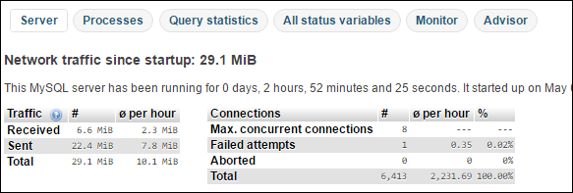

## Procesy

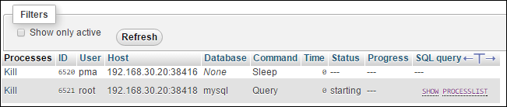

## Query statistic

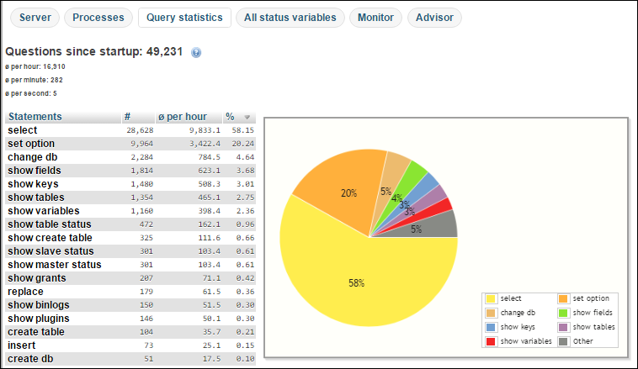

## Monitor

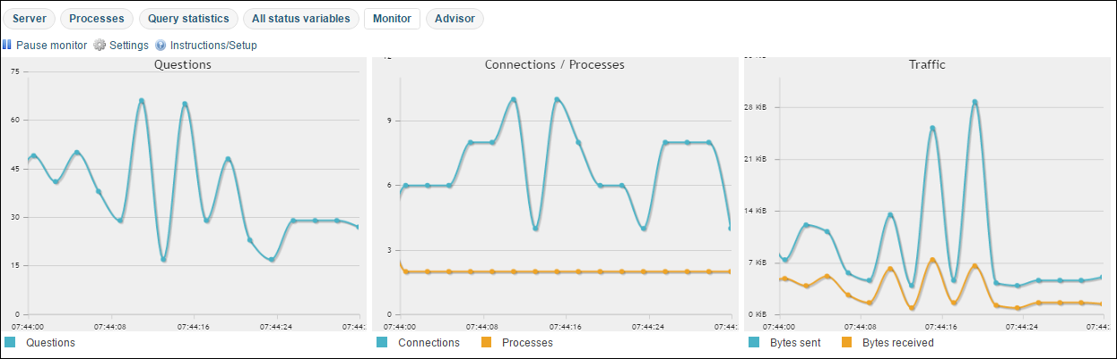

## Advisor