# Unit 2 Accidents, insurance services

## A Underwriting and claims

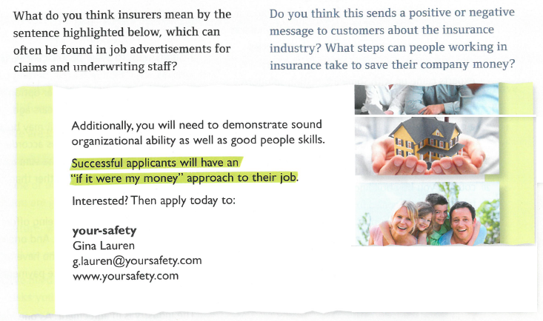

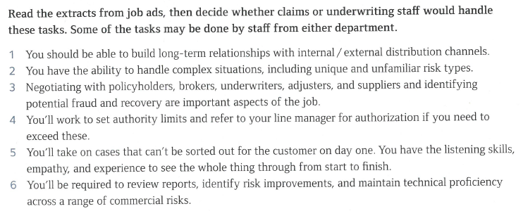

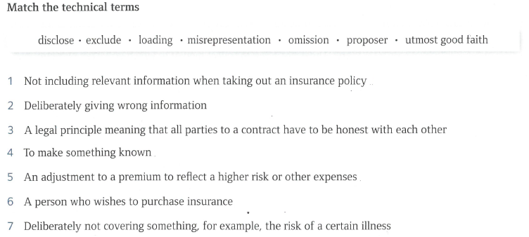

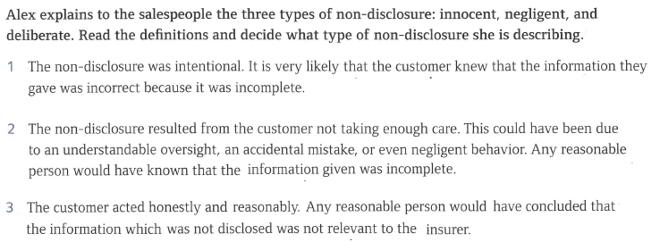

## B Past tenses – past simple

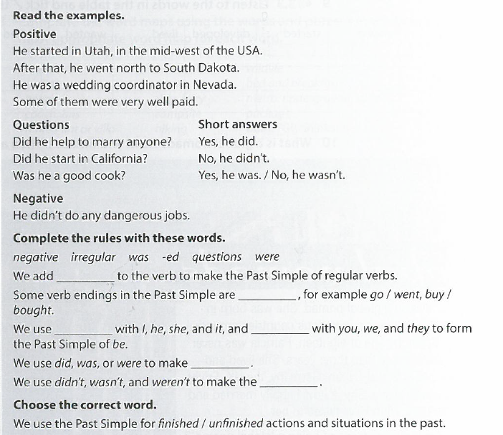

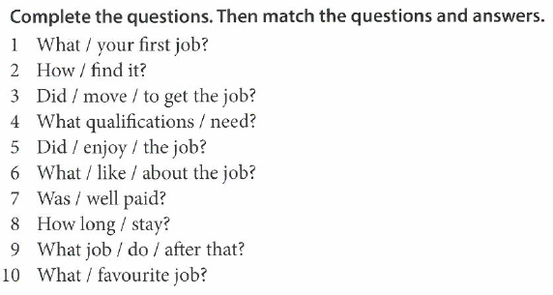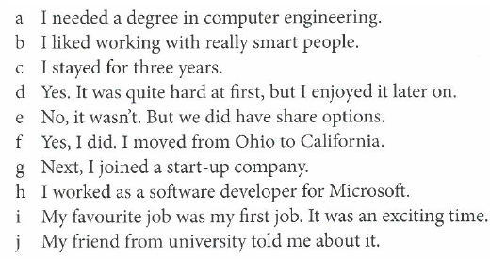

## C Past tenses – past continuous

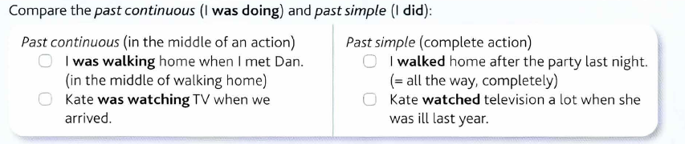

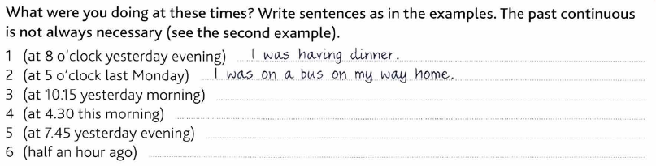

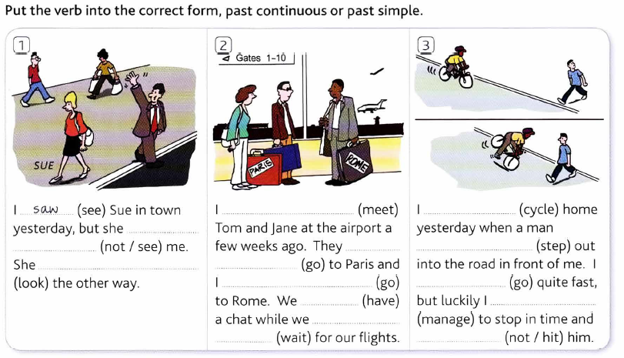

## D Describing accidents – what happened? What were you doing at the time?

1 Can you list some types of accidents?

2 Which accidents are most common?

3 Do you remember any accidents that you had in your life?

4 Role-play: describe an accident to an actuary.

## E Work skills – telephoning



**2 Put the phrases in the correct order.**

