Case #2. A Future Fuel Dilemma at Airbus

(The main body of this case is drawn from the website of Transport & Environment, a 30 year-old Europe-based NGO that describes itself as “Europe's leading clean transport campaign group whose vision is a zero-emission mobility system that is affordable and has minimal impacts on our health, climate and environment.)
https://www.transportenvironment.org/newsroom/blog/can-airbus-deliver-guilt-free-flying
Aviation has long had a special place in the human imagination. From Daedalus and Icarus to Da Vinci and Amelia Earhart, it has always been our dream to conquer the skies.

However, in part thanks to Greta Thunberg, Flygskam, or “flight shame”, aviation is losing its cherished status as aviation accounts for 2.4% of global Greenhouse gas (GHG) emissions. Could a different type of fuel help?
Now Airbus, the world’s largest aircraft manufacturer, has given kids something fresh to dream about: hydrogen aircraft. By 2035 the company claims it will have hydrogen aircraft in the sky, carrying 100-200 passengers over distances of 1,000-2,000 nautical miles - think Berlin to Lisbon or Warsaw to Madrid. As hydrogen aircraft give off no emissions, could this be the invention to cure us of our flygskam? (See Appendix A for details about Hydrogen fuel.)
Technically speaking, hydrogen planes could fly. There are some real challenges though. Hydrogen is light but takes up to four times as much space as jet fuel. That makes it hard to store sufficient energy on board to operate long distance - on transatlantic flights, for example. This matters. For example, a small plane carrying 100 passengers with a range of 1,000 miles would eliminate just 4% of EU aviation CO2 emissions. One capable of carrying 165 passengers a distance of 2,000 miles would cover 20% [1].
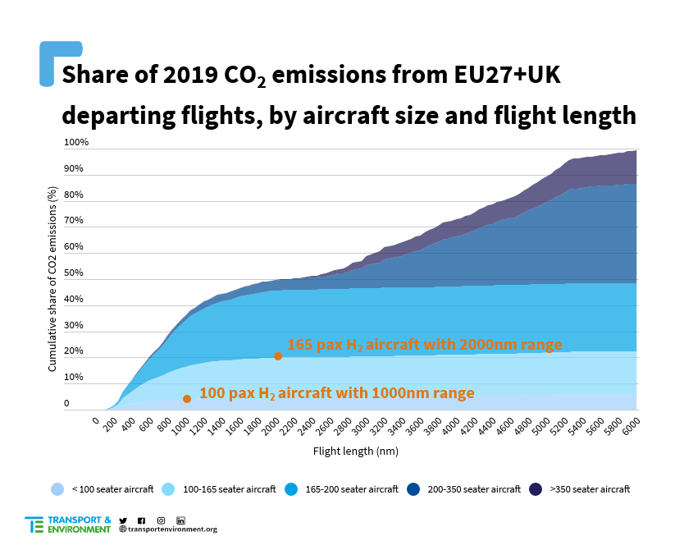
But the real challenge, as so often for hydrogen technologies, is cost. Plane designs would need to be adjusted; bulky hydrogen storage tanks added; and refueling and storage infrastructure created around airports. Fuel costs, which make up around 40% of aircraft operating costs, would also be higher. A 165 seater H2 aircraft would still cost 14% to 33% more than an aircraft running on conventional kerosene. And that’s without counting any of the development or hydrogen supply chain costs.
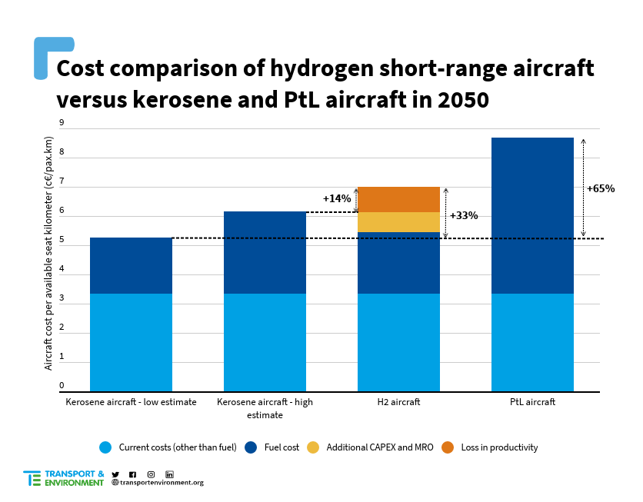
In summary, it most likely can be done, but it would be expensive and would cover only part of the problem.
So, will Airbus hit the EU objective and have a large hydrogen aircraft in the sky by 2035? Probably not. The main reason is that no sensible CEO or board would make the kind of investment needed to develop a speculative new airplane for which no clear market exists. This explains why Airbus talks mostly about what others need to do, such as converting airports and creating a green hydrogen economy.
But that doesn’t mean we should give up. A truly zero-emission solution for aviation is worth pursuing. And who’s to say it can’t be done? We have achieved remarkable technology breakthroughs in the clean energy space recently. So, if this is to be a moonshot project, how do we make it a success?
First, governments should tell the aviation industry clearly that the age of kerosene powered jets will end. Governments are banning combustion engine car sales. They should also ban short-haul fossil fuel powered flights by the early 2030s. This is a sure way to focus the industry’s minds. Rail will be able to replace some flights, but in most instances the only option will be to deploy clean technology; or fuels. At this stage regulators need to keep an open mind. So, if hydrogen aircraft don’t take off, flights powered 100% by e-kerosene, or simply electricity, are a good alternative.
Second, we need to put in place regulations to require and incentivise the use of hydrogen in aviation. The Commission’s aviation fuels regulation should introduce a hydrogen fuel mandate for aviation of 1-2% by 2030 and increasing after that, creating a market for hydrogen fuel credits in the aviation industry. That would benefit not just Airbus but also new start-ups. Remember, Tesla’s rise was greatly aided by sales credits provided by the California Zero Emission Vehicle programme.
Third, we need an industrial strategy to accompany these regulations. Between its Clean Skies Undertaking with the aerospace industry and Covid recovery funds, the EU is poised to spend billions on aviation R&D in the coming years. All of this funding should be used to promote zero-emission technologies such as hydrogen or electric aircraft and e-kerosene. And of course, the Commission taxonomy should only recognise zero-emission aircraft as sustainable.
The order here is important - targets, regulations and then funding. Do it backwards, and you pump money into aircraft that no one will buy or operate. Airbus, so confident in their innovation, should welcome such targets and regulations. After all, its motto is: “we make it fly”.

NOTE: A second alternative to Hydrogen as an aviation fuel is what is known as “Power-to-Liquid or “PtL.” See Appendix B for details about PtL.
[1] In-house calculation of emissions based on ICAO emission calculator methodology, using AIS aircraft data purchased to PlaneFinder.
[2] This calculation, adapted from the “Destination 2050” report (p43), takes into account costs related to fuel, aircraft ownership, maintenance, flight crew and charges. It does not take into account the following costs for an airline: sales, administration, passenger service, cabin attendant, IT and communication. The cost of development of the aircraft is also not included.
The following costs of fuel are assumed:
- 2050 kerosene price, low estimate: 690€/t [Destination2050, 2020]
- 2050 kerosene price, high estimate: 1,000€/t [Stratas Advisors, 2020]
- 2050 H2 price: 2,200€/t [Destination2050, 2020] (See Appendix A)
- 2050 PtL price: 1,900€/t [Ricardo, 2020] (See Appendix B)
Case Questions
1. Create a supporting argument for each of the following assertions:
a. (2) Airbus should pursue hydrogen-fueled aircraft.
b. (2) Airbus should forget hydrogen fuel for now and focus on Power-to-Liquid (PtL) fuel because it is already approved for use in aircraft by the American Society for Testing and Materials.

(total maximum for two answers-- 250 words)

Appendix A. The Potential of Hydrogen as Aviation Fuel
(the following text is from the Airbus website.)
Research into hydrogen as a potential energy carrier to power future zero-emission aircraft has been intensifying in recent years. But the road to hydrogen-powered aircraft requires significant effort inside the aviation industry and beyond. From hydrogen storage, cost and infrastructure to public perceptions about safety, the aviation sector is working to mature the technology while tackling some major challenges.
Hydrogen is increasingly considered as one of the most promising zero-emission technologies for future aircraft. However, despite the fact that hydrogen has an energy-density-per-unit mass that is three times higher than traditional jet fuel, a variety of challenges must be addressed before widespread adoption can happen.
From the technical side, aeronautical engineers will need to take the technologies developed in the automotive and space industries and make the technology compatible with commercial aircraft operations, notably by bringing the weight and cost down. One specific challenge is how to store hydrogen on board the aircraft. Today, liquid hydrogen storage is among the most promising options, while storing hydrogen as compressed gas poses challenges with current aircraft weight and volume requirements.
In addition, the aviation industry will need to achieve the same or better safety targets than what has been achieved with existing commercial aircraft. Indeed, extensive safety precautions are currently taken into account in the design and operation of today’s kerosene-powered aircraft. This stringent approach has ensured the industry’s consistent safety record throughout the years. Future hydrogen-propulsion systems will thus need to achieve equivalent or better safety levels before hydrogen-powered aircraft can take to the skies.
Cost-competitive green hydrogen and cross-industry partnerships will be mandatory to bring zero emission flying to reality.
- Glenn Llewellyn, Airbus VP, Zero-Emission Aircraft
On the road towards green hydrogen
Another key challenge for widespread adoption is liquid hydrogen availability and cost at airports. Hydrogen is available in vast quantities in oceans, lakes and the atmosphere, however, it must be separated from oxygen in water in order to be used for industrial purposes.
Today, more than 70 million tonnes of hydrogen are produced every year, the primary extraction source of which is natural gas (i.e. grey hydrogen). When extracted via fossil fuels, hydrogen production is energy-intensive, responsible for around 830 million tonnes of CO2 emissions per year. However, electrolysers, powered by electricity generated from renewables, offer a low-emission alternative. This process, resulting in “green hydrogen,” involves water electrolysis to extract hydrogen.
Less than 0.1% of global dedicated hydrogen production today is considered green hydrogen but that could change. Between 2014 and 2019, global wind electricity production doubled while global solar electricity production quadrupled. The International Energy Agency (IEA) predicts the rapid market growth of renewables, particularly solar and wind, over the next decade will exponentially increase the availability of renewable electricity, thereby driving down its cost. And demand for electrolysers capable of producing green hydrogen is already growing rapidly with an expected electrolyser capacity of 40 GW in the EU by 2030. The increased availability of green hydrogen will thus help to decrease its cost by as much as 30% by 2030 and 50% by 2050.
This 2030 timeline is in line with Airbus’ anticipated delivery of its ZEROe programme. Indeed, according to Glenn Llewellyn, VP of Zero-Emission Aircraft, Airbus is targeting the use of green hydrogen to fuel its future zero-emission aircraft. He believes declining costs for renewable energy and the scaling up of hydrogen production could make green hydrogen increasingly cost-competitive with existing options, such as jet fuel and sustainable aviation fuels.
“Cost-competitive green hydrogen and cross-industry partnerships will be mandatory to bring zero-emission flying to reality,” he says.
Ensuring hydrogen availability at airports worldwide
But for hydrogen to really achieve widespread adoption across the aviation industry, it must be made available at airports worldwide.
And advancement in this area is in its infancy. One main challenge is developing the large-scale transport and infrastructure solutions required to supply airports with the necessary quantities of hydrogen needed to fuel aircraft.
A recent IEA study suggests that repurposing existing infrastructure, including the millions of kilometers of pipelines used today to transport natural gas, could be a cost-effective solution. Larger quantities of hydrogen could thus be transported via pipeline from production sites, while smaller quantities could be transported by truck. In addition, some airport locations could develop the necessary infrastructure to support on-site hydrogen production, particularly if a renewable energy supply is within close proximity.
Airbus is currently collaborating with both airports and airlines to ensure the necessary hydrogen infrastructure is in place. This includes research into how all airport-associated ground transport (i.e. cargo trucks, passenger buses, aircraft tugs, etc.) could be decarbonised throughout the 2020s timeframe using a stepped approach, which is expected to pave the way to hydrogen availability for aircraft over the 2030s timeframe.
Changing public perceptions about hydrogen
For over 40 years, hydrogen has been safely used in vast quantities as an industrial chemical and as fuel for space exploration. In fact, several million cubic meters of hydrogen are transported and handled every year. However, public perception on hydrogen’s safety is still mixed: only 49.5% of respondents to a recent survey believed that hydrogen is “generally safe.” Throughout the years, this perception has undoubtedly been negatively shaped by incidents like the 1937 Hindenburg disaster.
However, what is interesting about the survey is that 73.2% of participants responded favourably to the second question about “willingness to use hydrogen-powered modes of transportation.” As hydrogen increasingly becomes a mainstay in the development of new transport solutions like cars and buses, public perceptions on hydrogen are likely to change–which should positively influence hydrogen adoption in aircraft.
The road to widespread hydrogen adoption in aviation is still long. But international coordination across industries is expected to support the development of the hydrogen economy–an important endeavour to help meet ambitious global decarbonisation targets over the next two decades.
https://www.airbus.com/newsroom/stories/hydrogen-aviation-understanding-challenges-to-widespread-adoption.html

Appendix B. Power-to-Liquid (PtL) for Aviation
​The purpose is to provide the scientific basis on Power-to-Liquid (PtL), an alternative fuel​ production pathway. The pathway doesn´t depend on biomass, thus has no demand for arable land and low demand for water. PtL is a drop-in replacement for conventional jet fuel.
Description
​Power-to-Liquid (PtL) is a new alternative fuel production pathway from renewable energy sources, water and carbon dioxide:
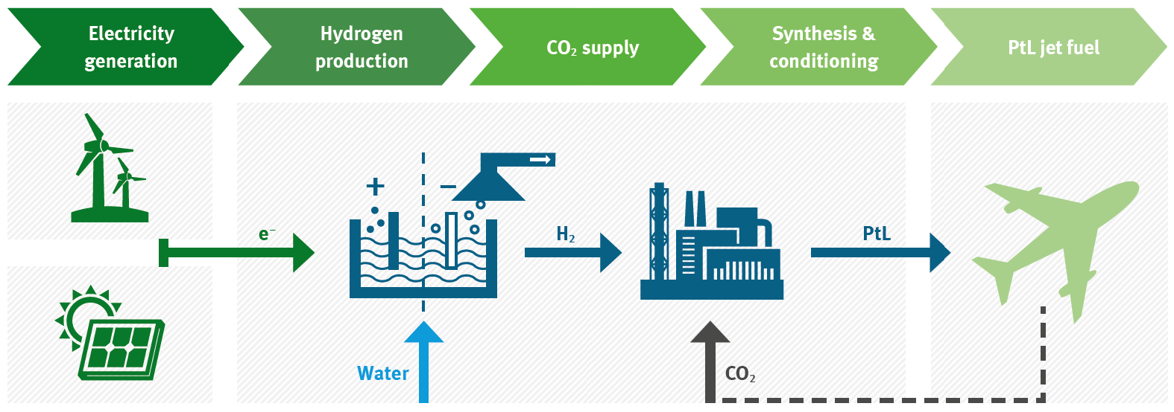
The alternative fuel produced through this process is drop-in compatible and, if produced through the Fischer-Tropsch conversion process, it is already approved for use in aircraft by the ASTM (American Society for Testing and Materials, is an international standards organization that develops and publishes voluntary consensus technical standards for a wide range of materials, products, systems, and services.).
Compared to conventional aviation fuel, the production of PtL has a favourable GHG (Greenhouse Gas) balance, while using water and land more efficiently than the production of aviation alternative fuels made from biomass. The main outstanding challenge for commercial scale PtL production is the production cost compared to that of conventional aviation fuel.

Appendix C. Public-Private Organizations Working in the Area of Reducing the Climate Change Impact of Aviation

The World Economic Forum
The World Economic Forum is a leading International Organization for Public-Private Cooperation.
The Forum engages the foremost political, business, cultural and other leaders of society to shape global, regional and industry agendas.
It was established in 1971 as a not-for-profit foundation and is headquartered in Geneva, Switzerland. It is independent, impartial and not tied to any special interests. The Forum strives in all its efforts to demonstrate entrepreneurship in the global public interest while upholding the highest standards of governance. Moral and intellectual integrity is at the heart of everything it does.
Our activities are shaped by a unique institutional culture founded on the stakeholder theory, which asserts that an organization is accountable to all parts of society. The institution carefully blends and balances the best of many kinds of organizations, from both the public and private sectors, international organizations and academic institutions.
We believe that progress happens by bringing together people from all walks of life who have the drive and the influence to make positive change.
https://www.weforum.org/about/world-economic-forum

The Clean Skies for Tomorrow Coalition provides a crucial global mechanism for top executives and public leaders, across and beyond the aviation value chain, to align on a transition to sustainable aviation fuels as part of a meaningful and proactive pathway for the industry to achieve carbon-neutral flying and inform the EU’s “RefuelEU” initiative and the UK Government of what is possible. Taken together, this industry-backed policy package provides a clearly defined strategy to scaling sustainable aviation fuels (SAF) in Europe, focused on measures that collectively increase both supply and demand signals for creating a balanced market.

Energy Transitions Commission (ETC)

The Energy Transitions Commission (ETC) is a global coalition of leaders from across the energy landscape working together to accelerate the transition to a zero-emissions future. We develop transition roadmaps and tools building on robust analysis and extensive exchanges with experts and practitioners across energy-intensive value chains. This work is generally undertaken with a range of partners, industry associations, NGOs and experts. In the harder-to-abate sectors specifically, we work under the umbrella of the Mission Possible Platform, an initiative established by the ETC and the World Economic Forum.

https://www.energy-transitions.org/

