INSTALLMENT C.

Module 9. Environmental Forecasting and Scenario Building

Module 9: Outline

- Scenario Building
  - The past as prologue for the future
  - Predicting actor behavior
  - Predicting future events
  - Constructing “What if?” statements
  - Connecting the dots (and possible future events)
  - Assessing your assumptions about the future

- Environmental Forecasting
  - economic forecasting
  - technological forecasting
  - political forecasting
  - social forecasting

Module 9: Text

Scenario-building
When one detects a signal in the environment, often it is not interpreted in terms of its potential impact on the firm. The process of deriving a path of decisions and events which could ultimately come to have an impact on a firm is called "scenario-building." Scenario building consists of a series of "What if?" statements: "What if this decision was made?" "What if that event occurred?" and then this decision followed, then that event, etc. A scenario is only as good as its inherent assumptions. The utility of scenario-building is in identifying the critical assumptions and looking at variations on those assumptions that could alter projected or assumed outcomes.
A firm will want to undertake a scenario or forecast for those signals which it believes could ultimately have a SIGNIFICANT impact on the firm. The scenario not only clarifies the probability of a possible outcome for the firm, but also identifies the key junctions in the path where the scenario builder could intervene and somehow change the outcome.
A scenario also points the firm toward the important actors and developments to which it should turn the focus of its environmental monitoring system. For example, if the key junction in a scenario is a decision by a potential new competitor, major customer, specific government agency or non-governmental organization (NGO), the firm will want to track the actions of this actor very closely so as to detect any movement toward the key decision that could make the hypothetical scenario a reality.

Environmental Forecasting
Scenario-building can be compared to a closely-related process called "social forecasting." The former focuses on what could occur in the future and the process by which it would occur. The latter focuses on what probably will occur, i.e., it forecasting starts with what could occur and then assigns probabilities to various possible events. Thus, there is overlap in these two concepts.
Most firms do economic forecasting on an on-going basis. Using past trends and known information as to how the present situation could alter these trends, extrapolations are made into the future at the time a decision and the time horizon of the associated planning process under consideration. Depending on the nature of the firm, economic forecasts are made of all or some of the major macroeconomic factors--interest rates, equity markets, the money supply, government revenues and spending, disposable consumer income, demographics--as well as economic factors more specific to the firm or industry--competitor sales, new product success, pricing strategy, etc.
In recent years, some firms have sought to apply the techniques of economic forecasting to forecasting changes in other sectors of the corporate environment. Technological forecasting is an attempt to predict the rate and direction of technological innovation in a particular industry, market or technology, based on past experience and current trends. The lifetime of a new product in the semiconductor industry, for example, can be predicted on the basis of past changes in this market. Historical data tells forecasters that a new semiconductor product has an average life expectancy of about five years, and development costs should be allocated accordingly. Technological forecasting has also attempted to actually forecast new technological innovations. Leonardo de Vinci and Jules Verne had a remarkable knack for this kind of technological forecasting. However, the forecasts of their more systematic successors have proven to be far less accurate. For example, at one point in the 11050s, some analysts predicted that the typical American family garage would contain a car and a helicopter, and below the garage would be a nuclear fallout shelter.
Political forecasting is an attempt to anticipate changes in the political environment, to include everything from broad changes--the electorate is becoming more conservative, less concerned about government regulation, more concerned about the budget deficit, etc.--to predictions of the reelection or defeat of a candidate, to possible new legislation that will be introduced, and its success in the legislature, to the status of a particular government agency, to the decisions that will be made in the courts (the highest court in a country is becoming more conservative, m ore politicized, etc.)
Political forecasting becomes the basis for a firm's contribution and lobbying strategy. It may lead a firm to back favorite parties or candidates who might be in trouble or abandon others who have no hope of winning. It will also lead to decisions to exert efforts at one point in the public policy-making process rather than another. The role of political forecasting in formulating political strategy is discussed further in Modules 8 and 10.
Finally, some companies have attempted social forecasting--forecast major social changes, changes that would include emerging "hot" issues, political activism among youth, e.g., the “Arab Spring” or social unrest because of unemployment among young Spaniards, more leisure, bankrupt pension systems, etc. Among the proponents of social forecasting, there has been only a modest success in persuading corporations to undertake this effort. Those inroads which forecasting has made in corporations have been in the strategic planning process. Managers are being required to specify their assumptions about the environment within which their firm will operate at the time horizon of the plan. At a minimum, this requirement has forced the managers to think beyond a simple extrapolation of existing operational history and seriously consider what parts of their environment could change appreciable over the period of the plan.

Best, Worst and Most Probable Scenarios

Having identified the important actors and developments that will influence the future in various parts of the environment for a firm, the next question is to assess the probability of various futures occurring. While we could assess gradations of probability to various futures, at the simplest level we can speak in terms of what are the best, worst and most probable scenarios for the future. With these three scenarios defined, we can then adjust them as developments in the key environmental areas and among key environmental actors occur. The Figure below depicts a worst case scenario, proposed by an economist in September 2012, whereby the Euro Zone collapses. How realistic is this scenario today? For example, in terms of the worst Euro Zone scenario, what didn’t happen and why not? At this time, what is now your best, worst and most probable case scenarios for the future of the Euro Zone, i.e., what would a scenario for the collapse of the EU look like if the starting point was today, given the “Brexit” vote in the UK?

See Exhibit 8.2 for a good scenario example from a previous case.

Assigning Probabilities to Individual Scenario Elements
As noted above, we assign aggregate probabilities to various scenarios using a simple scale—best, worst and most likely. However, we could assign probabilities to individual scenario elements. For example, in the scenario above, we could assign a probability to each of the evet boxes or “cells,” starting with the probability of a Greek default. We then would move to assess the probability of Bond rates rising in Italy and Spain and a Run on the EU Banks. If all of these individuals probabilities are low, then the overall probability of the Euro Collapse is low—our best case scenario. If they are all high, it is our worst case scenario. But if any of the intervening probability are mixed, we can construct a “most likely” scenario.

Entry-level Employee Perspective
As an entry-level employee, given the environmental monitoring system you have set up for the company, you could then be asked by your supervisor or a senior manager in your company to forecast developments in key area of your business operations, e.g., technological developments, governmental actions in a key country, customer buying trends, or competitors in a key product market. Would you be comfortable doing this—trying to predict the future? (If it is any comfort, any commitment to set up a company, develop a product, manufacture that product, and market it assumes a future in which the necessary supply-side resources will be available and the market demand will be there among customers. In doing so, could you highlight key actors and possible developments in your forecast that would require closer tracking and recommend adjustments to your forecast and best, worst and most-likely scenarios on a recommended frequency, e.g., daily, weekly, monthly, annually?
In another context, could you respond to a proposed action by your supervisor or a senior manager in your company by identifying the key assumptions about the future in that proposed action and politely ask for clarification of the basis for his or her certainty as to how the future will likely play out?

What are Shell Scenarios?

https://www.shell.com/energy-and-innovation/the-energy-future/scenarios/what-are-scenarios.html

(See videos)
Shell has been developing possible visions of the future since the early 1970s, helping generations of Shell leaders, academics, governments and businesses to explore ways forward and make better decisions. Shell Scenarios ask “what if?” questions, encouraging leaders to consider events that may only be remote possibilities and stretch their thinking.

How are Shell Scenarios used?
The sheer breadth and depth of perspective gained from our scenarios continues to inspire many successful partnerships and initiatives around the world, on individual country levels as well as regional and global.
We have been developing Scenarios within Shell for almost 50 years. They are plausible and challenging descriptions of the future landscape. They stretch our thinking and help us to make crucial choices in times of uncertainty and transitions as we grapple with tough energy and environmental issues.
Watch: Navigating an uncertain future

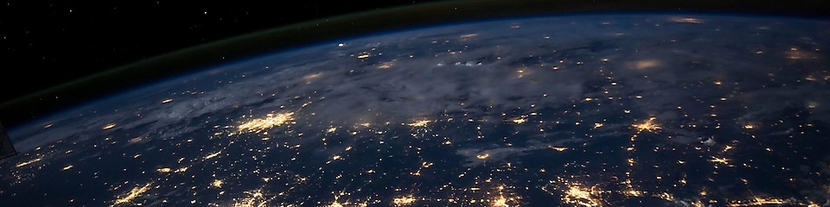

What are Shell Scenarios?
Shell has been developing possible visions of the future since the early 1970s, helping generations of Shell leaders, academics, governments and businesses to explore ways forward and make better decisions. Shell Scenarios ask “what if?” questions, encouraging leaders to consider events that may only be remote possibilities and stretch their thinking.

How are Shell Scenarios used?
The sheer breadth and depth of perspective gained from our scenarios continues to inspire many successful partnerships and initiatives around the world, on individual country levels as well as regional and global.
We have been developing Scenarios within Shell for almost 50 years. They are plausible and challenging descriptions of the future landscape. They stretch our thinking and help us to make crucial choices in times of uncertainty and transitions as we grapple with tough energy and environmental issues.
Watch: Navigating an uncertain future
Read the transcript

Shell Scenarios in action
Here are just some of the projects that the Shell Scenarios team has been involved with recently.

China
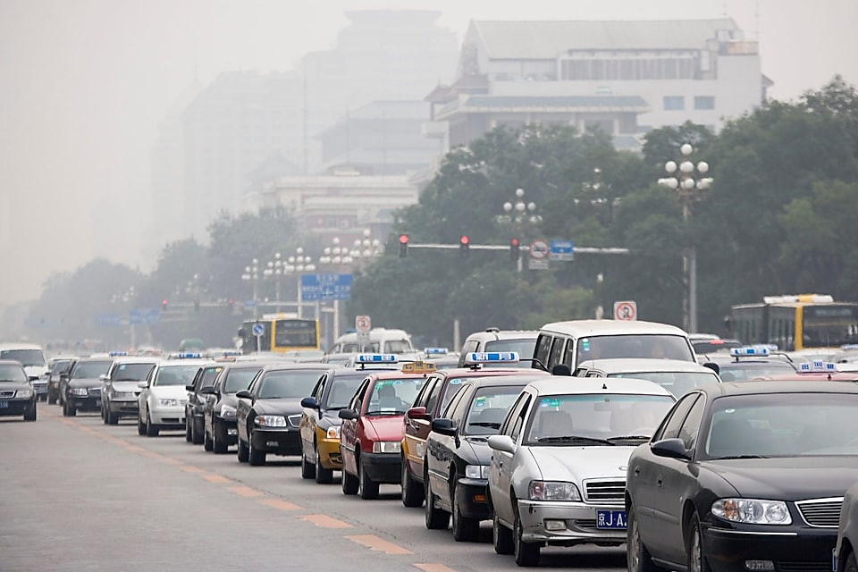

Developing natural gas in China
The Scenarios team has produced a joint study with the Development Research Centre (DRC) of China’s State Council to examine how natural gas could evolve as a mainstream energy source in China.
Natural gas is the ideal alternative to coal, as it is cleaner, more efficient and easier to transport and store. But although its use globally has grown rapidly over the last decade or two, gas has significant challenges to overcome before it can become a core component of China’s energy system.
The Shell-DRC study sets out a strategic aim to increase the share of gas in the energy mix to 10% in 2020 and 15% in 2030, up from 5.8% in 2014. This reflects the goals set out in China's Twelfth Five Year Plan and the 2016 Paris Agreement on climate change.
Markets alone will not be able to deliver this increase in the share of gas, and additional policy frameworks and incentives will be required. Based on detailed economic modelling, the joint study has put forward recommendations for strengthening environmental regulations including effective carbon pricing. The study also recommends comprehensive reform of gas market mechanisms, regulations, and institutions, including greater competition in upstream gas exploration and production, diversifying sources of imported gas to drive greater competition in wholesale and retail gas markets, and effective regulation of gas transmission and distribution infrastructure to ensure third party access on competitive terms.
The study was a key input into China’s Thirteenth Five Year Plan.
China’s Gas Development Strategies (PDF, 16 MB)

Germany
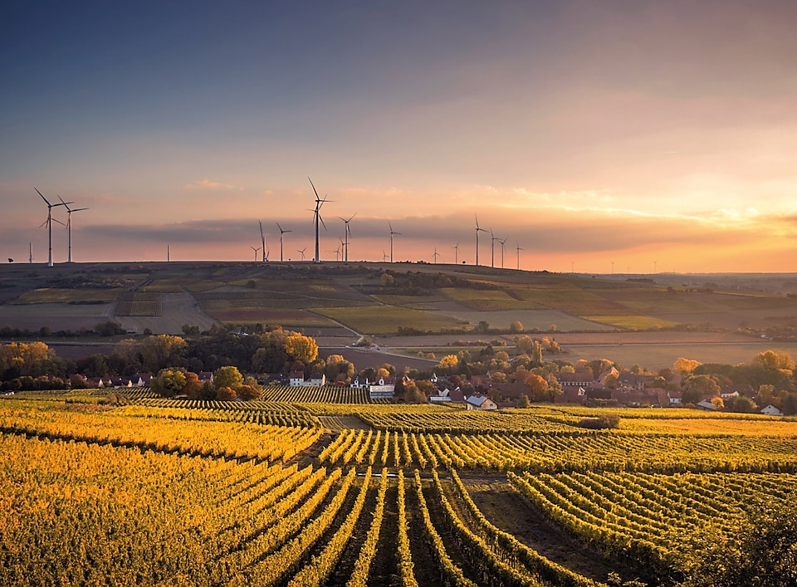

Exploring Germany’s energy pathways
Shell has long recognised the importance of the global climate challenge. Since the 2015 Paris Agreement, which set out a global action plan to put the world on track to avoid dangerous climate change by limiting global warming to well below 2°C, the hard work is underway as countries develop and evolve their roadmaps to build secure, affordable and sustainable energy systems.
The main focus was first to understand how Germany’s specific energy scenarios could evolve and then to understand the challenges and opportunities. The greatest progress so far in this highly industrialised economy has been in power generation, and is now increasingly focused on mobility and heating.
After identifying the biggest potential drivers of cross-sector energy transformation, a joint Shell Scenarios and local Germany team effort with contributions from external experts developed two possible energy transition scenarios: 'Winning the Marathon’ and 'Slowing Momentum’.
These scenarios look at how Germany's future energy pathways could evolve in response to societal, economic, political and technological change. They are designed to help German society and government explore all the implications and support key energy decisions in the coming years.
Shell Energy Scenarios Germany brochure

Africa
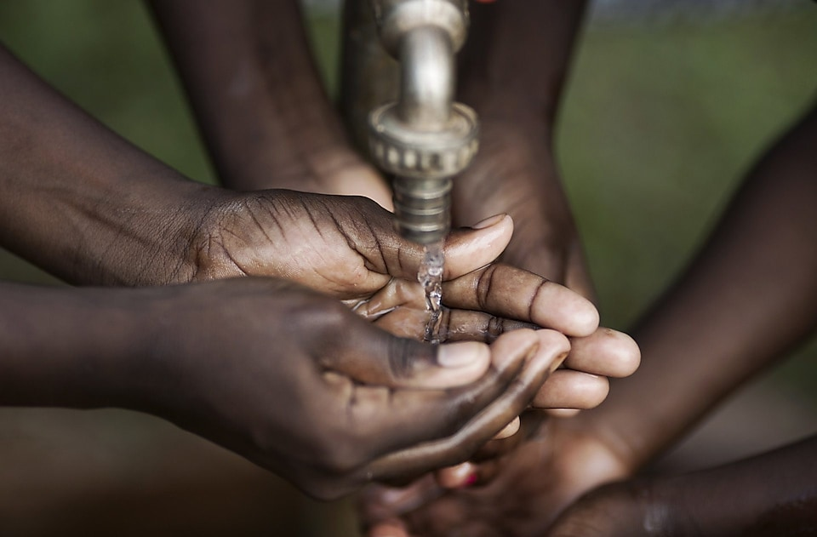

Improving responses to AIDS (2005)
Our scenarios work is also useful for advising public bodies, institutions and governments across a range of sectors, as it draws together expertise from a number of disciplines. This is also true of community health, mainly in developing countries.
In Africa, drawing on experience gained through our operations in sub-Saharan African countries, where HIV/AIDS is a major health concern, we worked with UNAIDS to develop scenarios for ways in which the disease could spread in future.
While the number of new cases of HIV/AIDS may be falling,1.8 million people were newly infected in this region in 2009 alone. The United Nations drew on Shell’s approach to scenarios to devise three versions of the future that explored the consequences of different government actions.
These scenarios helped to guide the leaders’ response to the epidemic and to work out which response to the crisis would create the best outcome for Africa and the rest of the world by 2025. This work also helped the UN and other bodies to identify the actions required to respond appropriately to different circumstances.
Aids in Africa: Three scenarios to 2025

Watch the video
Learn what others say about the importance of Shell Scenarios
Read the transcript
Title: Impact and Influence of Scenarios
Duration: 5:17 minutes
[Tim Harford in vision:]
Caption: Tim Harford, Author, columnist for the Financial Times and Presenter on Radio 4
“So, I'm very interested in bringing together different ideas and I found the scenario process was great for that. You wouldn't just stick in your familiar silo of economics, you'd be talking to people outside your area of expertise and getting different perspectives and that's really enriched my writing.”
[Philip Bobbitt in vision:]
Caption: Herbert Wechsler Professor of Jurisprudence at Columbia University
“I think there's an enormous necessity for this kind of approach because…”
[Philip Bobbitt voice over:]
“…our futures right now are unpredictable.”
[Video footage:]
Aerial view, pan along a city street in a high-rise city
[Philip Bobbitt in vision:]
“Perhaps the worst temptation in scenario planning is to think…”
[Philip Bobbitt voice over:]
“…that it's about the future.”
[Video footage:]
Billboard saying: looking ahead with Hydrogen; in the background another billboard with Shell Pecten
[Philip Bobbitt in vision:]
“It's really not.”
[Philip Bobbitt voice over:]
“It's really about the present It's about how…”
[Video footage:]
Busy city street, two buses coming towards camera, cyclist moves into shot from camera right
[Philip Bobbit in vision:]
“…you make decisions now.”
[Paul J. H. Schoemaker in vision:]
Caption: Paul J. H. Schoemaker Ph.D, Research Director Mack Center for Technological Innovation, The Wharton School, University of Pennsylvania
“Scenario planning can be used for multiple purposes. I think the most common one that I see, and that we participate in, is simply stress testing an existing strategy. Secondly, you can try to come up with new growth options, not the existing strategy, but make the strategy better. And thirdly…”
[Paul J. H. Schoemaker voice over:]
“… you can use it to just educate people in the organisation so you have a framework for better dialogue.”
[Video footage:]
Two engineers, overalls, safety gear, discussing piping at a plant, followed by two further engineers in front of plant in distant background
[Amory Lovins in vision:]
Caption: Amory Lovins, Chairman & Chief Scientist Rocky Mountain Institute
“Shell scenarios are a unique resource for all of us who think about…”
[Amory Lovins voice over:]
“…the energy future.”
[Video footage:]
Wide shot of motorist at petrol station as he inserts the petrol pump nozzle into his car, followed by close up as the nozzle goes in
[Amory Lovins in vision:]
“Like all good scenarios, and indeed many of them built on that model, they're not predictions, they're a vehicle for telling stories.”
[Amory Lovins voice over:]
“But the stories they tell, to change the picture of reality in the minds of the leaders reading them…”
[Video footage:]
Wide of a busy city street in a low-rise city, followed by a hydrogen car from front on as it turns a corner, then another car, emblazoned with Shell Pecten, travelling across camera on a busy city street at night
[Amory Lovins in vision:]
“…are often provocative, fresh, and of course the underlying trick is to choose the axes correctly. That's the hardest part. Once you ask the right questions…”
[Amory Lovins voice over:]
“…the answers tend to become self-evident. I think it's been a vital intellectual contribution to the world of energy. I can't imagine our…”
[Video footage:]
Several mopeds/small motorcycles move across a city street at night, followed by wide shot of a long avenue in a high-rise city, then street level of traffic at night
[Amory Lovins in vision:]
“…having the progress that we now see in the global energy transformation without this important foundation.”
[Peter Ho in vision:]
Caption: Peter Ho, Senior Advisor, Centre for Strategic Futures and Former Head of Civil Service, Singapore
“Well, Shell has played a very critical role, especially in the early years, in helping…”
[Peter Ho voice over:]
“…the Singapore government develop scenario planning as a basic…”
[Video footage:]
Wide shot of Singapore high rise from street level, then a busy narrow Singapore street of small shops
[Peter Ho in vision:]
“…tool for strategic…”
[Peter Ho voice over:]
“… planning. Without scenario planning, we would not have gone as far as we have come in terms of our…”
[Video footage:]
Boat passes left to right across camera on river, Singapore high seen in background, followed by pan up Singapore building, bus passes across shot
[Peter Ho in vision:]
“…ability and capacity to plan for the future.”
[Koosum Kalyan in vision:]
Caption: Koosum Kalyan, Chairman of Edgomerap Energy and Chairman of the Thabo Mbeki Foundation
“You start from the premise of not what you know...it's what you don't know...and plan for those uncertainties. So, scenarios became part of everybody's planning processes…”
[Koosum Kalyan voice over:]
“…in South Africa. Soon after the Mont Fleur scenarios…”
[Video footage]
Speeded up pan along a South African highway, Table Mountain and Cape Town in the background
[Koosum Kalyan in vision:]
“…trade unions, the NUM, COSATU were using it in their organisations. But what it allowed the government to do, and the people of South Africa, is to think about the future…”
[Koosum Kalyan voice over:]
“…from the same premise. All that Shell wanted to say was that…”
[Video footage:]
African street painting fixed in foreground as camera pans around on street below a hill
[Koosum Kalyan in vision:]
“…we have a tool, and the methodology that we use in scenario planning can be used anywhere in the world.”
[Professor Dr Bjorn Stigson in vision:]
Caption: Professor Dr Bjorn Stigson, Chairman, Stigson & Partners AB
“I think it has been used by a number of companies…”
[Professor Dr Bjorn Stigson voice over:]
“…for complex issues where you need to find a language to talk about things.”
[Video footage:]
People on a worksite with small three-wheeled work vehicles, car moves across street in foreground, followed by people walking in a city street
[Professor Dr Bjorn Stigson in vision:]
“So what Shell started, once upon a time, has spun off a whole industry and you have given us…”
[Professor Dr Bjorn Stigson voice over:]
“…a picture, a story about the future world…”
[Video footage:]
Pan up exterior of high rise glass building
[Professor Dr Bjorn Stigson in vision:]
“…that is highly relevant for our thinking about the OECD.”
[Pei Minxin in vision:]
Caption: Pei Minxin, Professor of Government, Claremont McKenna College
“The standard of living is rising in the developing world, and with that…”
[Pei Minxin voice over:]
“…the demand for energy will grow as well.”
[Video footage:]
City street, motorcycles and a car travel through shot
[Pei Minxin in vision:]
“So, if there's one word to describe the future of energy…”
[Pei Minxin voice over:]
“…it's bright, but complex.”
[Video footage:]
Wide time-lapse of London Eye at night as seen from Shell Centre, followed by close up of edge of London Eye with Houses of Parliament in the background
[Pei Minxin in vision:]
“Preparing for different futures does not require upfront investment right away. It requires intellectual preparation.”
[Napier Collyns in vision:]
Caption: Napier Collyns, Co-Founder, Global Business Network
“I think what the scenarios do is to…”
[Napier Colllyns voice over:]
“…make you realise that there will be many unexpected developments.”
[Video footage:]
Wide of low rise city, desert in background, followed by aerial shot of a city on a delta
[Napier Collyns in vision:]
“The one that's obvious today, is the fact…”
[Napier Collyns voice over:]
“…all over the world now we're having shale developments for Berita oil and for natural gas, which has changed the structure of oil and energy developments worldwide.”
[Video footage:]
The City of London high rises seen from the Thames river bank, followed by a pan across the top of a high-rise city with sea in the background, then close up of a man re-fuelling a bus from a Shell pump, then Shell Fuel Cell Bus travelling through a European town, then a low level support bridge over a river with large official buildings in the background, then the Jesus statue above Rio de Janeiro
[Napier Collyns in vision:]
“I think it's essential…”
[Napier Collyns voice over:]
“…that we keep looking for oil and gas, and luckily in the United States, we've found oil and gas unexpectedly.”
[Video footage:]
Cars travelling along an American city street towards camera left, then cars travelling along an American city street to camera right, then further cars travelling in both directions along a city street with a hill in the background
[Napier Collyns in vision:]
“When I say unexpectedly, even then the most interesting scenarios…”
[Napier Collyns voice over:]
“…ten or fifteen years ago, we weren't really thinking…”
[Video footage:]
Sign for Shell Hydrogen Fuel station Ventristoo
[Napier Collyns in vision:]
“…of the kind of ways…”
[Napier Collyns voice over:]
“…we've developed oil and gas since.”
[Video footage:]
Several engineers, overalls, safety gear, at a plant
[Michael Jefferson in vision:]
Caption: Michael Jefferson, Visiting Professor, Department of Economics & International Studies, University of Buckingham
“We are dealing so often with unknowledge...and unforeknowledge.”
[Michael Jefferson voice over:]
“So with that…”
[Video footage:]
Heavy traffic travels in both directions along a wide city avenue, followed by shot of a car travelling left to right across screen, parked cars, police officer, cinema in the background
[Michael Jefferson in vision:]
“…clear idea that we don't know the future, we can't just forecast.”
[Michael Jefferson voice over:]
“We can't create a model, turn a handle.”
[Video footage:]
Pedestrians in a crowded city street, woman with smog mask walks towards camera
[Philip Bobbitt in vision:]
“I think scenario planning is perhaps the most important analytical tool we have, and Shell is...and has been...the most important innovator in that process.”
[Background music fades:]
Graphic: Shell Pecten
Text: ©Shell International 2013
Fade to black

