Exercise Session 1

1) Which of the following is a final good or service?
A) diesel fuel bought for a delivery truck
B) fertilizer purchased by a farm supplier
C) a haircut
D) Chevrolet windows purchased by a General Motors assembly plant

2) Tereza grows tomatoes for home consumption. This activity is:
A) excluded from GDP in order to avoid double counting.
B) excluded from GDP because an intermediate good is involved.
C) productive but is excluded from GDP because no market transaction occurs.
D) included in GDP because it reflects production.

3) Net exports are negative when:
A) a nation's imports exceed its exports.
B) the economy's stock of capital goods is declining.
C) depreciation exceeds domestic investment.
D) a nation's exports

4) Which of the following do national income accountants consider to be investment?
A) the purchase of an automobile for private, nonbusiness use
B) the purchase of a new house
C) the purchase of corporate bonds
D) the purchase of gold coins

5) Suppose that inventories were $40 billion in 2003 and $50 billion in 2004. In 2004, accountants would:
A) add $10 billion to other elements of investment in calculating total investment.
B) subtract $10 billion from other elements of investments in calculating total investment.
C) add $45 billion (= $90/2) to other elements of investment in calculating total investment.
D) subtract $45 billion (= $90/2) from other elements of investment in calculating total investment.

6) The ZZZ Corporation issued $25 million in new common stock in 2004. It used $18 million of the proceeds to replace obsolete equipment in its factory and $7 million to repay bank loans. As a result, investment:
A) of $7 million has occurred.
B) of $25 million has occurred.
C) of $18 million has occurred.
D) has not occurred.

7) If depreciation (consumption of fixed capital) exceeds domestic investment, we can conclude that:
A) nominal GDP is rising but real GDP is declining.
B) net investment is negative.
C) the economy is importing more than it exports.
D) the economy's production capacity is expanding.

8) Answer the next question on the basis of the following data. All figures are in billions of dollars.

Gross investment | 18
National income | 100
Net exports | 2
Personal income | 85
Personal consumption expenditures | 70
Saving | 5
Government purchases | 20
Net domestic product | 105

What is the GDP for the above economy? =18+70+20+2=110

9) In the second quarter (3-month period) of 2001, U.S. nominal GDP increased but U.S. real GDP declined.
We can conclude that:
A) nominal income declined by more than personal income.
B) the price level rose by more than nominal GDP.
C) real wages declined by more than real GDP.
D) the price level fell by more than real GDP.

10) Use the following table for a hypothetical single-product economy. 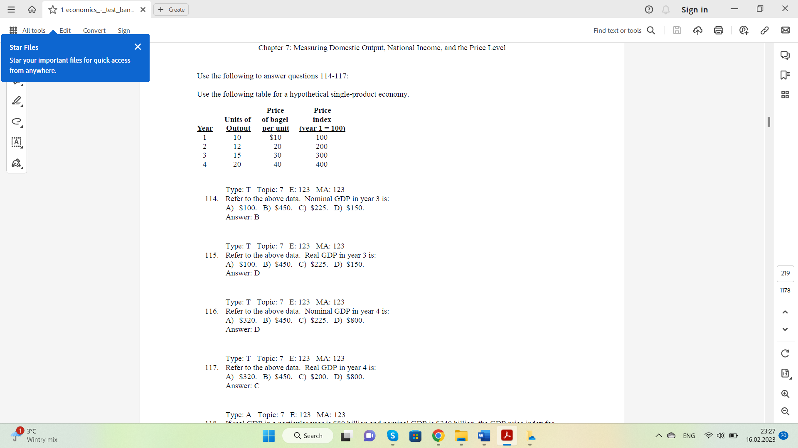

- Refer to the above data. What is the nominal GDP in year 3? 450$
- Refer to the above data. What is the real GDP in year 3? 150$
- What is the price deflator in year 3? 450/150*100=300

