Exercise Session 7

- Use the following to answer questions
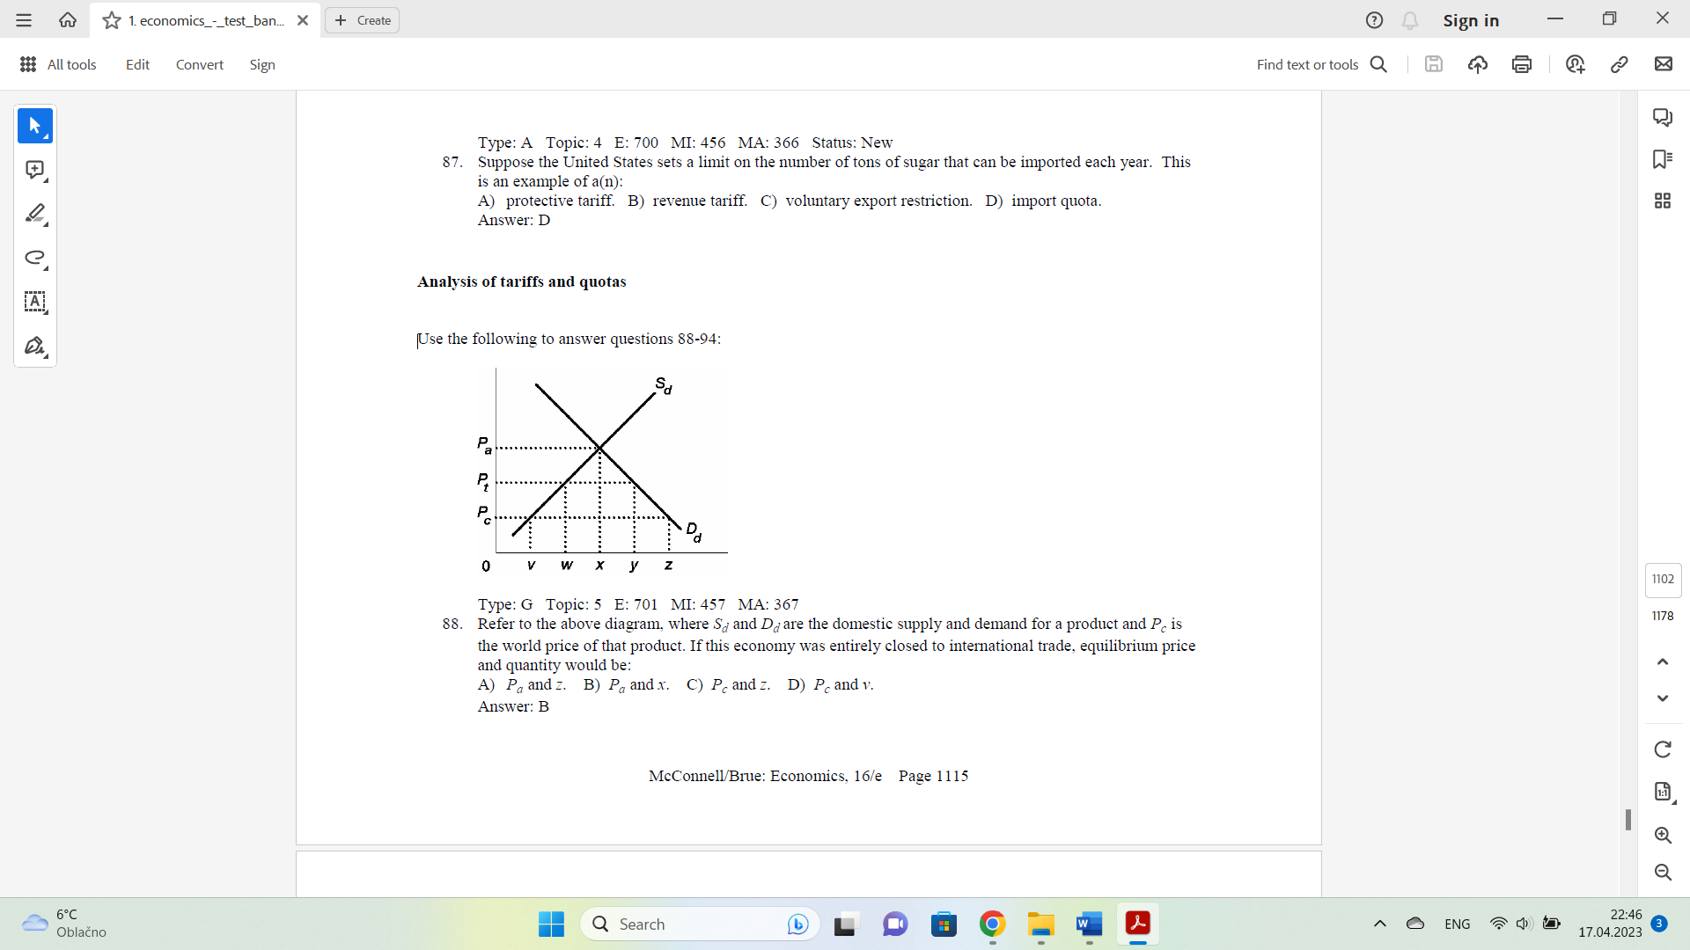
- Refer to the above diagram, where Sd and Dd are the domestic supply and demand for a product and Pc is
the world price of that product. If this economy was entirely closed to international trade, what would equilibrium price and quantity be?
- If the economy is opened to free trade, what would the price and quantity sold of this product be? What about trade balance?
- With a Pt per unit tariff, what will be the per unit revenue received by domestic and foreign producers respectively?
- How much revenues does the government collect under tariff?

- Answer the next question(s) on the basis of the following domestic supply and demand schedules:

Quantity supplied (domestic) | Price | Quantity demanded (domestic)
12 | $5 | 2
10 | $4 | 4
7 | $3 | 7
4 | $2 | 11
1 | $1 | 16

- Refer to the above data. If this nation were entirely closed to international trade, what would be the equilibrium price and quantity?
- If the economy is opened to free trade and the world price of $1 prevailed, what would be the price and quantity sold of this product?
- With free trade, that is, assuming no tariff, what would be the outputs produced by domestic and foreign producers respectively?
- With a $1 dollar per unit tariff, what will be the price and total quantity sold?
- With a $1 per unit tariff, what would be the quantities sold by foreign and domestic producers respectively?
- With a $1 per unit tariff, what will be the prices (revenue per unit) received by domestic and foreign producers respectively?
- What will be the total amount of revenue collected from a $1 per unit tariff on this product?
- What is the dead weight loss from this 1$ tariff?

- Suppose Ecuador imposes a tariff on imported bananas. If the increase in producer surplus is $50 million, the reduction in consumer surplus is $150 million, and the deadweight loss of the tariff is $30 million, then the tariff generates $130 million in revenue for the government.
TRUE
FALSE

- Answer the following questions based on the graph:
The figure applies to the nation of Wales and the good is cheese
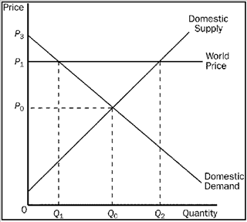
- What is the equilibrium price and the equilibrium quantity of cheese in Wales before trade?
- What is the equilibrium price and the equilibrium quantity of cheese in Wales with trade? What is the amount of import/export?
- What is a valid equation for Welsh consumer and producer surplus, respectively with trade?
- How much is the gains from trade?
- The nation of Aquilonia has decided to end its policy of not trading with the rest of the world. When it ends its trade restrictions, it discovers that it is importing incense, exporting steel, and neither importing nor exporting rugs. We can conclude that Aquilonia’s new free­trade policy has
  - increased consumer surplus and producer surplus in the incense market.
  - increased consumer surplus in the steel market and left producer surplus in the rug market unchanged.
  - decreased consumer surplus in both the steel and rug markets.
  - decreased consumer surplus in the steel market and increased total surplus in the incense market.
- Suppose France imposes a tariff on wine of 3 euros per bottle. If government revenue from the tariff amounts to 30 million euros per year and if the quantity of wine supplied by French wine producers, with the tariff, is 8 million bottles per year, then we can conclude that
  - the quantity of wine demanded by France, with the tariff, is 18 million bottles per year.
  - the quantity of wine demanded by France, without the tariff, would be 24 million bottles per year.
  - the amount of the deadweight loss is 24 million euros per year.
  - the tariff causes French buyers of wine to pay 2 euros more per bottle than they would pay without the tariff.
- If over time the nominal wage rises and the real wage falls, then
- dollar wages rose but the price level rose by a smaller percentage.
- dollar wages rose but the price level rose by a larger percentage.
- dollar wages fell but the price level fell by a smaller percentage.
- dollar wages fell but the price level fell by a larger percentage.
- The inflation tax refers to
- the increase in the price of a product as a result of an increase in the tax on that product.
- the fact that income tax rates rise with the inflation rate.
- the inflationary effect of a decrease in taxes.
- the revenue the government creates by printing money.
- Suppose that the real interest rate is 4%, the inflation rate is 2%, and the tax rate is 25%. According to the Fisher Effect, what is the after-tax real interest rate?
- An increase in the U.S. interest rate
- raises U.S. net capital outflow so the supply of dollars increases.
- raises U.S. net capital outflow so the demand for dollars increases.
- reduces U.S. net capital outflow so the supply of dollars decreases.
- reduces U.S. net capital outflow so the demand for dollars decreases.
- Ceteris paribus, a decrease in US real interest rate will result in
- An increase in the real exchange rate.
- A decrease in the real exchange rate.
- Does not affect the real exchange rate.
- Has an ambiguous effect on the real exchange rate.
- Which of the following statements is incorrect?
- if foreigners want to buy many American products, the demand for dollars will increase.
- if the U.S. runs a large budget deficit that causes domestic interest rates to rise, the demand for dollars will decrease.
- anything that increases the demand for dollars or reduces the supply drives up the dollar’s price.
- anything that lowers the demand for dollars or raises the supply causes the dollar to weaken.
- If you are travelling in China and you purchase a meal that costs 140 yuan and the current exchange rate is 7 yuan to the dollar, then the price of the meal is US currency is
- 200$
- 20$
- 10$
- 2$
- If the price of a car in the US is $26000 and the exchange rate between the dollar and the British pound rised from $1.5 to $2 per pound, then the price of the American car in Britain will
- Fall
- Rise
- Remain the same
- Be irrelevant because the British government will impose restrictions on imports from the US
- Suppose that the US and Georgia both produce wine and shoes. In the US, wine sells for $10 a bottle and shoes sell for $40 a pair. In Georgia, wine sells for 15 GELs a bottle and shoes sell for 20 GELs a pair. If the current exchange rate is 0.8 GEL to the dollar, then
- Georgia will import both shoes and wine from the US
- The US will import both shoes and wine from Georgia
- The US will import shoes from Georgia and Georgia will import wine from the US
- The US will import wine from Georgia and Georgia will import shoes from the US

- In the US a three-pound can of coffee costs about $5. Suppose the exchange rate is about 0.8 Euros per dollar and that three-pound can of coffee in Belgium costs about 3 euros. What is the real exchange rate?
- 5/3 cans of Belgian coffee per can of US coffee
- 4/3 cans of Belgian coffee per can of US coffee
- 3/4 cans of Belgian coffee per can of US coffee
- 3/5 cans of Belgian coffee per can of US coffee

17. The open-economy macroeconomic model includes
A. only the market for loanable funds.
B. only the market for foreign-currency exchange.
C. both the market for loanable funds and the market for foreign-currency exchange.
D. neither the market for loanable funds or the market for foreign-currency exchange

- Which of the following would tend to shift the supply of dollars in foreign-currency exchange market of the open-economy macroeconomic model to the left?
- The exchange rate rises.
- The exchange rate falls.
- The expected rate of return on U.S. assets rises.
- The expected rate of return on U.S. assets falls

