Problem Set 5

***Multiple choice questions:***

1. A relatively mild period of falling incomes and rising unemployment is called a(n)

a. depression.

**b. recession.**

c. expansion.

d. business cycle.

2. Which part of real GDP fluctuates most over the course of the business cycle?

a. consumption expenditures

b. government expenditures

**c. investment expenditures**

d. net exports

3. According to classical macroeconomic theory, changes in the money supply affect

a. nominal variables and real variables.

**b. nominal variables, but not real variables.**

c. real variables, but not nominal variables.

d. neither nominal nor real variables.

4. The aggregate-demand curve shows the

a. quantity of labor and other inputs that firms want to buy at each price level.

b. quantity of labor and other inputs that firms want to buy at each inflation rate.

c. quantity of domestically produced goods and services that households want to buy at each price level.

**d. quantity of domestically produced goods and services that households, firms, the government, and customers abroad want to buy at each price level.**

5. If countries that imported goods and services from the Czech Republic went into recession, we would expect that CR net exports would

1. rise, making aggregate demand shift right.
2. rise, making aggregate demand shift left.
3. fall, making aggregate demand shift right.
4. **fall, making aggregate demand shift left.**

6. The long-run aggregate supply curve shows that by itself a permanent change in aggregate demand would lead to a long-run change

a. in the price level and output.

**b. in the price level, but not output.**

c. in output, but not the price level.

d. in neither the price level nor output.

7. According to the wealth effect, one of the reasons for the slope of the aggregate demand curve is that falling prices

a. **increases the value of money holdings so consumer spending increases.**

b. decreases the value of money holdings so consumer spending increases.

c. increases the value of money holdings so consumer spending decreases.

d. decreases the value of money holdings so consumer spending decreases.

9. Which of the following would NOT cause a shift in AD?

a. a reduction in income tax.

b. a reduction in interest rates.

c. an increase in government spending.

d. **a fall in the cost of production.**

10. Which of the following can explain the upward slope of the short-run aggregate supply curve?

* 1. **nominal wages are slow to adjust to changing economic conditions**
  2. as the price level falls, the exchange rate falls
  3. an increase in the money supply lowers the interest rate
  4. an increase in the interest rate increases investment spending

11. An increase in the expected price level shifts the

a. short-run and long-run aggregate supply curves left.

**b. the short-run but not the long-run aggregate supply curve left.**

c. the long-run but not the short-run aggregate supply curve left.

d. neither the long-run nor the short-run aggregate supply curve left.

12. Suppose the economy is initially in long-run equilibrium. Then suppose there is an increase in military spending. According to the model of aggregate demand and aggregate supply, what happens to prices and employment in the short run?

**a. prices rise, employment rises**

b. prices rise, employment falls

c. prices fall, employment falls

d. prices fall, employment rises

13. An increase in the price level induces people to hold

a. more money, so they lend more, and the interest rate falls.

**b. more money, so they lend less, and the interest rate rises.**

c. less money, so they lend less, and the interest rate rises.

d. less money, so they lend more, and the interest rate falls

14. When taxes increase, consumption decreases

a. as shown by a movement to the left along the aggregate demand curve.

**b. shifting aggregate demand to the left.**

c. shifting aggregate supply the left.

d. which does none of the above.

***True/False questions:***

1. (**F**) The recessions associated with the business cycle come at regular intervals.

2. (**T**) An increase in the money supply causes the interest rate to fall, investment spending to rise, and aggregate demand to shift right.

4. (**T**) Because the price level does not affect the long-run determinants of real GDP, the long-run aggregate-supply is vertical

5. (**F**) Over time technological progress shifts the aggregate supply curve to the right making the inflation rate higher than otherwise.

***Answer the following questions:***

1) Explain why the long-run aggregate-supply curve is vertical. Explain three theories for why the short-run aggregate-supply curve is upward sloping.

***ANSWER***: The long-run aggregate-supply curve is vertical because the price level does not affect the long-run determinants of real GDP, which include supplies of labor, capital, natural resources, and the level of available technology. This is an application of the classical dichotomy and monetary neutrality.

There are three reasons the short-run aggregate-supply curve slopes upward. First, the sticky-wage theory suggests that because nominal wages are slow to adjust, a decline in the price level means real wages are higher, so firms hire fewer workers and produce less, causing the quantity of goods and services supplied to decline. Second, the sticky-price theory suggests that the prices of some goods and services are slow to change. If some economic event causes the overall price level to decline, the relative prices of goods whose prices are sticky will rise and the quantity of those goods sold will decline, leading firms to cut back on production. Thus, a lower price level reduces the quantity of goods and services supplied. Third, the misperceptions theory suggests that changes in the overall price level can temporarily mislead suppliers. When the price level falls below the level that was expected, suppliers think that the relative prices of their products have declined, so they produce less. Thus, a lower price level reduces the quantity of goods and services supplied.

2) What might shift the aggregate-demand curve to the left? Use the model of aggregate demand and aggregate supply to trace through the effects of such a shift?

***ANSWER***: The aggregate-demand curve might shift to the left when something (other than a rise in the price level) causes a reduction in consumption spending (such as a **desire for increased saving**), a reduction in investment spending (such as **increased taxes on the returns to investment**), decreased government spending (such as a **cutback in defense spending**), or reduced net exports (such as when **foreign economies go into recession**).

Figure below traces through the steps of such a shift in aggregate demand. The economy begins in equilibrium, with short-run aggregate supply, AS1, intersecting aggregate demand, AD1, at **point A**. When the **aggregate-demand curve shifts to the left to AD2**, the **economy moves from point A to point B**, reducing the price level and the quantity of output. Over time, people adjust their perceptions, wages, and prices, shifting the short-run aggregate-supply curve to the right to AS2, and **moving the economy from point B to point C**, which is back on the long-run aggregate-supply curve and has a lower price level.

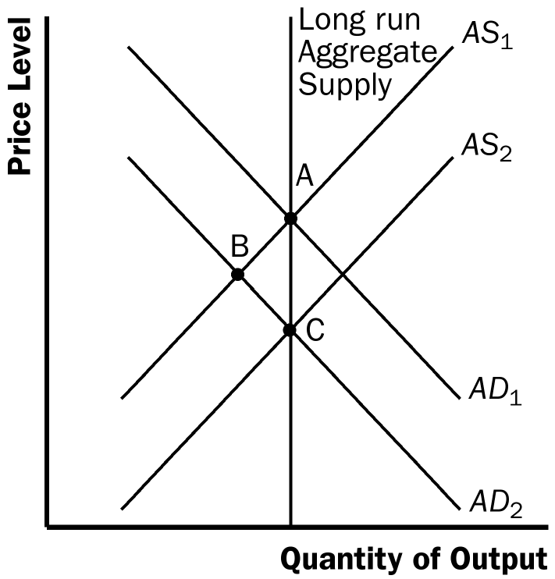

3) For each of the three theories for the upward slope of the short-run aggregate-supply curve, carefully explain the following:

a. how the economy recovers from a recession and returns to its long-run equilibrium without any policy intervention.

***ANSWER***: According to the *sticky-wage theory*, the economy is in a recession because the price level has declined so that **real wages are too high, thus labor demand is too low**. Over time, as nominal wages are adjusted so that real wages decline, the economy returns to full employment.

According to *the sticky-price theory*, the economy is in a recession because not all prices adjust quickly. Over time, firms are able to adjust their prices more fully, and the economy returns to the long-run aggregate-supply curve.

According to the *misperceptions theory*, the economy is in a recession when the price level is below what was expected. Over time, as people observe the lower price level, their expectations adjust, and the economy returns to the long-run aggregate-supply curve.

b. what determines the speed of that recovery?

***ANSWER***: The speed of the recovery in each theory depends on how quickly price expectations, wages, and prices adjust.

4) Suppose that a decrease in the demand for goods and services pushes the economy into recession. What happens to the price level? If the government does nothing, what ensures that the economy still eventually gets back to the natural rate of output?

***ANSWER***: A decrease in aggregate demand causes the price level to fall. If the government takes no action to counter this, then the actual price level will be below the price level that people expected. Individuals will eventually correct their expectations about the price level. As they do so, prices and wages will adjust accordingly, shifting the aggregate supply curve to the right. For example if wages are sticky, in light of the lower price level, firms and workers will eventually make bargains for lower nominal wages. The reduction in wages lowers costs of production, so firms are willing to produce more at any given price level. Consequently, the short-run aggregate supply curve shifts right. The rightward shift in aggregate supply eventually causes output to rise back to the natural rate.

5) Consider the graph below for the following four questions

An increase in the money supply would move the economy from C to

a. B in the short run and the long run.

b. D in the short run and the long run.

c. B in the short run and A in the long run.

d. D in the short run and C in the long run

1. An increase in the money supply would move the economy from C to

a. B in the short run and the long run.

b. D in the short run and the long run.

**c. B in the short run and A in the long run.**

d. D in the short run and C in the long run

1. If the economy starts at A and there is a fall in aggregate demand, the economy moves

a. back to A in the long run.

b. to B in the long run.

**c. to C in the long run.**

d. to D in the long run.

iii) If a change in aggregate demand shifts the economy from A to D, the government might use fiscal policy to move the economy

**a. back to A.**

b. to B.

c. to C.

d. to D

iv) If a change in aggregate supply shifts the economy from C to D, a government concerned about employment might use fiscal policy to move the economy

**a. to A.**

b. to B.

c. back to C.

d. to D.

6. Suppose that consumers anticipate higher future incomes. What does this do to output and the price level? Explain. If the sticky wage theory is right what happens to real wages and how does this lead to the change in output?

**ANSWER:** When consumers anticipate higher future incomes, they spend more now so that aggregate demand shifts right. The increase in aggregate demand increases both output and the price level. If some workers have wages that are fixed in terms of dollars, when the price level increases their wages buy fewer goods, so their real wages have fallen. The decline in real wages induces firms to hire more workers