Exercise Session 5
Multiple choice questions:
Choose the correct answer
1. A macroeconomist is interested in
  - explaining how changes in sellers’ behavior affect prices of a particular good.
  - explaining price changes in a particular market.
  - explaining why the unemployment rate is higher.
  - All of the above are correct.

2. Productivity is defined as the
  - amount of goods and services produced from each unit of labor input.
  - number of workers required to produce a given amount of goods and services.
  - amount of labor that can be saved by replacing workers with machines.
  - actual amount of effort workers put into an hour of working time.

3. A direct or positive relationship exists between a country's
a. productivity and its standard of living.
b. amount of government spending and its productivity.
c. total population and its average citizen’s income.
d. rate of population growth and the extent of its trade with other countries.

4. Estimates of the values of which of the following non-market goods or services are included in GDP?
a. unpaid housework but not the rental value of owner-occupied homes.
b. the rental value of owner-occupied homes but not unpaid housework.
c. unpaid housework and the rental value of owner-occupied homes.
d. Neither unpaid housework nor the rental value of owner-occupied homes.

5. A U.S.-owned automobile factory uses $100,000 worth of parts purchased from foreign countries along with U.S. inputs to produce 30 cars worth $20,000 each. Twenty of these cars are sold and 10 are left in inventory. How much did these actions add to GDP?
a. $300,000
b. $500,000
c. $600,000
d. $700,000

6. Atlas Corporation is in sound financial condition. It sells a long-term bond. Which of the following make the interest rate on this bond lower than otherwise?
a. Both Altas’ sound finances and the long term of the bond.
b. The long term of the bond but not Atlas’ sound finances.
c. Atlas’ sound finances but not the long term of the bond.
d. Neither Atlas’ sound finances nor the long term of the bond.

7. US citizens have better nutrition, better healthcare, and a longer life expectancy than citizens of Ghana. Which of the following conclusions can be drawn from this statement?
a. Average income in the US is higher than the average income in Ghana.
b. The US has a higher standard of living than Ghana.
c. Productivity in the US is higher than productivity in Ghana.
d. All of the above are correct.

8. For an imaginary closed economy, T = $5,000; S = $11,000; C = $48,000; and the government is running a budget surplus of $1,000. Then
a. private saving = $10,000 and GDP = $55,000.
b. private saving = $10,000 and GDP = $63,000.
c. private saving = $12,000 and GDP = $67,000.
d. private saving = $12,000 and GDP = $69,000.
9. People who are unemployed because wages are, for some reason, set above the level that brings labor supply and demand into equilibrium are best classified as
a. cyclically unemployed.
b. frictionally unemployed.
c. discouraged workers.
d. structurally unemployed.

10. Cyclical unemployment is caused by
a. neither frictional nor structural unemployment.
b. frictional and structural unemployment.
c. frictional but not structural unemployment.
d. structural but not frictional unemployment.

11. The value of money varies:
A) inversely with the price level.
B) directly with the price level.
C) directly with the volume of employment.
D) directly with the interest rate.

12. Other things equal, an excessive increase in the money supply will :
A) increase the purchasing power of each dollar.
B) decrease the purchasing power of each dollar.
C) have no impact on the purchasing power of the dollar.
D) reduce the price level.

13.
Year | Price level | Value of dollar
1 | 1.00 | $1:00
2 | 1.25
3 | 0.8
4 | 0.5
Refer to the above table. The value of the dollar in year 2 is:
A) $1.25.
B) $1.33.
C) $.80.
D) $1.00.

14. It is costly to hold money because:
A) deflation may reduce its purchasing power.
B) bond prices are highly variable.
C) in doing so one sacrifices interest income.
D) the velocity of money may decline.

15. If nominal GDP is $600 billion and, on the average, each dollar is spent three times per year, then the
amount of money demanded for transactions purposes will be:
A) $1800 billion.
B) $600 billion.
C) $200 billion.
D) $1200 billion.

True/False questions
State whether statement is true or false, no explanation needed.
- The goal of macroeconomics is to explain the economic changes that affect many households, firms, and markets simultaneously. (T)
- If a good produced this quarter goes into inventory, then it is included in this period’s GDP. If it is sold in the next quarter, it will have no effect on GDP (T)
- The consumer price index is used to monitor changes in an economy’s production of goods and services over time. (F)
- If Congress instituted an investment tax credit, the demand for loanable funds would shift rightward. (T)
- Constant returns to scale is the point on a production function where increasing inputs will no longer increase output. (F)
- Anything other than a change in the interest rate that decreases national saving shifts the supply of loanable funds to the left. (T)
- The adult population must equal the sum of the employed and the unemployed. (F)
- If people who report being unemployed are not, in fact, trying hard to find a job, then the reported unemployment rate will be biased upward. (T)

Answer the following questions:
1) What are the three categories into which the central statistical office divides everyone? How does it compute the labor force, the unemployment rate, and the labor force participation rate?
Answer: The CSO categorizes each adult (16 years of age and older) as employed, unemployed, or not in the labor force. The labor force consists of the sum of the employed and the unemployed. The unemployment rate is the percentage of the labor force that is unemployed. The labor-force participation rate is the percentage of the total adult population that is in the labor force.

2) Why is frictional unemployment inevitable? How might the government reduce the amount of frictional unemployment?
Answer: Frictional unemployment is inevitable because the economy is always changing. Some firms are shrinking while others are expanding. Some regions are experiencing faster growth than in other regions. Transitions of workers between firms and between regions are accompanied by temporary unemployment.
3) What claims do advocates of unions make to argue that unions are good for the economy?
Answer: Advocates of unions claim that unions are good for the economy because they are an antidote to the market power of the firms that hire workers and they are important for helping firms respond efficiently to workers' concerns.
4) Draw the supply curve and the demand curve for a labor market in which the wage is fixed above the equilibrium level. Show the quantity of labor supplied, the quantity demanded, and the amount of unemployment.
Answer: Figure below shows the supply curve (S) and the demand curve (D) for labor. The wage (W) is above the equilibrium wage (W_{E}). The result is unemployment, equal to the amount by which the quantity of labor supplied (L_{S}) exceeds the quantity of labor demanded (L_{D}).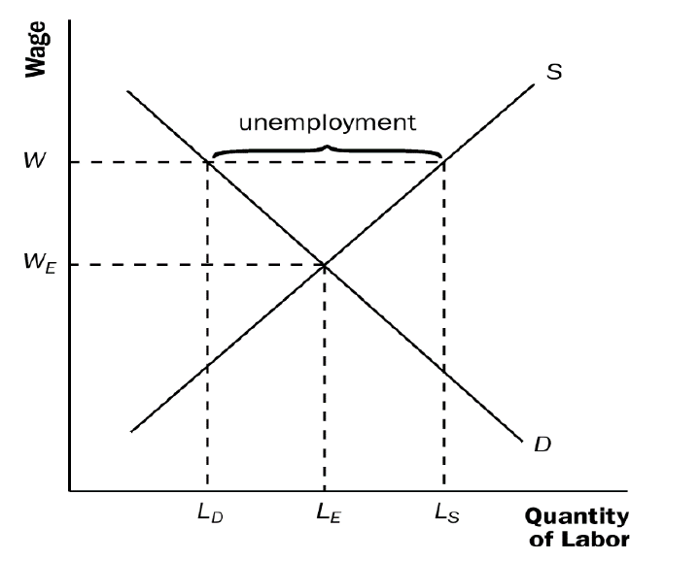
5) Are the following workers more likely to experience short-term or long-term unemployment? Explain.
a. a construction worker laid off because of bad weather.
Answer: A construction worker who is laid off because of bad weather is likely to experience short-term unemployment, because the worker will be back to work as soon as the weather clears up.
b. a manufacturing worker who loses her job at a plant in an isolated area.
Answer: A manufacturing worker who loses his job at a plant in an isolated area is likely to experience long-term unemployment, because there are probably few other employment opportunities in the area. He may need to move somewhere else to find a suitable job, which means he will be out of work for some time.
c. a coach-industry worker laid off because of competition from railroads.
Answer: A worker in the coach industry who was laid off because of the growth of railroads is likely to be unemployed for a long time. The worker will have a lot of trouble finding another job because his entire industry is shrinking. He will probably need to gain additional training or skills to get a job in a different industry. However, it may also take shorter time because joining railroad industry will not require too many new sets of skills
d. a short-order cook who loses his job when a new restaurant opens across the street.
Answer: A short-order cook who loses his job when a new restaurant opens is likely to find another job fairly quickly, perhaps even at the new restaurant, and thus will probably have only a short spell of unemployment.
e. an expert welder with little formal education who loses her job when the company installs automatic welding machinery.
Answer: An expert welder with little education who loses his job when the company installs automatic welding machinery is likely to be without a job for a long time, because he lacks the technological skills to keep up with the latest equipment. To remain in the welding industry, he may need to go back to school and learn the newest techniques.

6) Using a diagram of the labor market, show the effect of an increase in the minimum wage on the wage paid to workers, the number of workers supplied, the number of workers demanded, and the amount of unemployment.
ANSWER: Figure below shows a diagram of the labor market with a binding minimum wage. At the initial minimum wage (w_{M,1}), the quantity of labor supplied L_{S,1} is greater than the quantity of labor demanded L_{D,1}, and unemployment is equal to L_{S,1} – L_{D,1}. An increase in the minimum wage to w_{M,2} leads to an increase in the quantity of labor supplied to L_{S,2} and a decrease in the quantity of labor demanded to L_{D,2}. As a result, unemployment increases as the minimum wage rises.
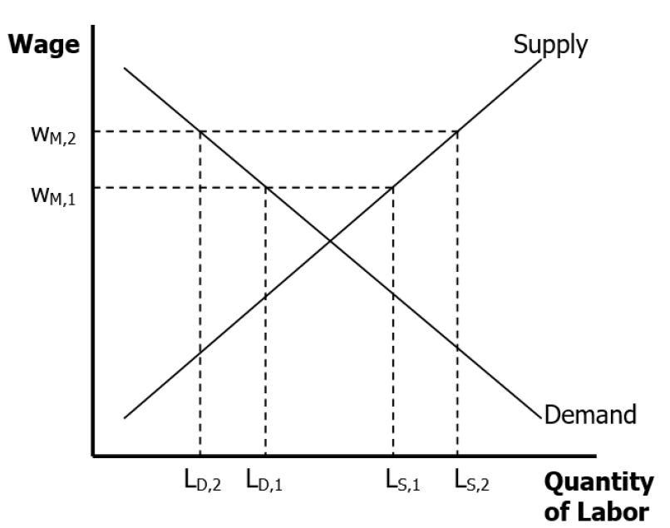
7) Suppose that Congress passes a law requiring employers to provide employees some benefit (such as health care) that raises the cost of an employee by $4 per hour.
a. What effect does this employer mandate have on the demand for labor? (In answering this and the following questions, be quantitative when you can.)
Answer: If a firm was not providing such benefits prior to the legislation, the curve showing the demand for labor would shift to the left by exactly $4 at each quantity of labor, because the firm would not be willing to pay as high a wage given the increased cost of the benefits. If the benefits effectively behave like additional wages, then it will be movement along the demand curve up, again reducing the demand for labor
b. If employees place a value on this benefit exactly equal to its cost, what effect does this employer mandate have on the supply of labor?
Answer: If employees value the benefit by exactly $4 per hour, they would be willing to work the same amount for a wage that is $4 less per hour, so the supply curve of labor shifts to the right by exactly $4. Again, if they perceive this change as changes in wages, then it will be movement along the curve
c. If the wage is free to balance supply and demand, how does this law affect the wage and the level of employment? Are employers better or worse off? Are employees better or worse off?
Answer: Figure below shows the equilibrium in the labor market. Because the demand and supply curves of labor both shift by $4, the equilibrium quantity of labor is unchanged and the wage declines by $4. Both employees and employers are just as well off as before. Here we are not treating the 4$ benefit as actual wages
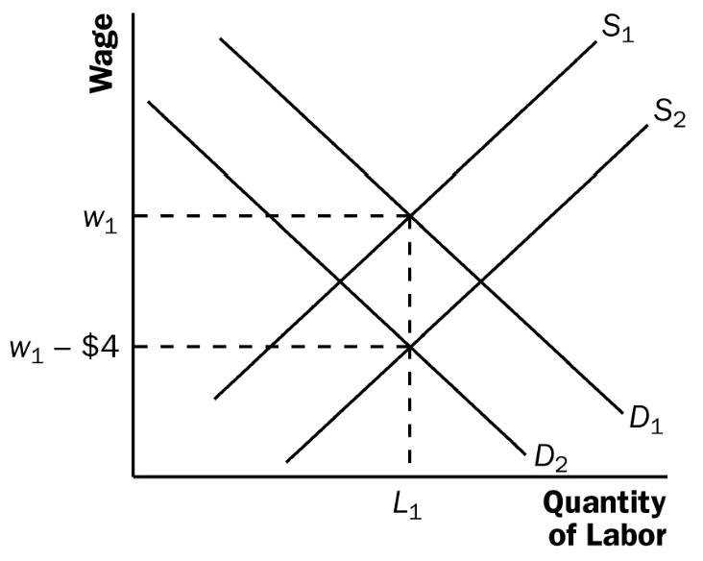
d. Now suppose that workers do not value the mandated benefit at all. How does this alternative assumption change your answers to parts (b) and (c) above?
Answer: If the workers do not value the mandated benefit at all, the supply curve of labor does not shift. As a result, the wage rate will decline by less than $4 and the equilibrium quantity of labor will decline, as shown in the figure below. Employers are worse off, because they now pay a greater total wage plus benefits for fewer workers. Employees are worse off, because they get a lower wage and fewer are employed.

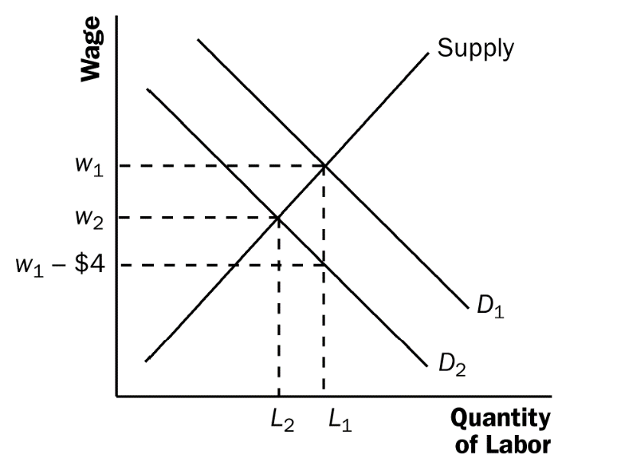
8) Explain why the best educational policies to promote faster growth might be different in the following countries.
a. Mozambique
ANSWER: Mozambique is a very poor country that could benefit from education in the basic skills of reading, writing, and arithmetic as well as skills such as sustainable farming and nutrition.
b. Brazil
ANWER: Brazil is a country with a rapidly growing labor force, a country making the transition from a developing to an industrial country. Education policy here should focus on expanding basic K-12 education to the poor and illiterate. Another goal of education policy should be to expand their universities, providing basic research and development to enhance the development of industrial technology.
c. France
ANWER: France is a highly educated industrial country. Education policy here should focus on the development of new technology.
9) Explain the difference between final goods and intermediate goods. Why is it sometimes difficult to apply this distinction in practice? In this regard, why is the concept of value added useful?
ANSWER: Final goods are goods intended to be used by consumers, or to be used by firms during a period of over a year, while intermediate goods are used up in the production of other goods. But the dividing line is sometimes unclear. For example, an electrician buys a roll of tape, using some of it in his business and some of it on the blade of his hockey stick. When GDP is measured using the value-added method, the distinction between intermediate and final goods is discarded. Instead, GDP is computed as the sum of the values added (revenue minus cost of inputs) in every firm.

10) Give some reasons why the gross domestic product is not a suitable measure of the well-being of the nation. (Have you noticed newspaper accounts in which journalists seem to use GDP for this purpose?)
ANSWER: There are many reasons why the GDP is not an accurate measure of the nation’s well-being. The GDP excludes most goods and services that are not sold in the market, some of which (like childcare in the home) are very valuable. It omits consideration of the value of leisure. While it adds up the money value of “goods,” it makes no subtraction for “bads,” like pollution and natural disasters. It takes no account of the income distribution—and presumably, our assessment of a nation’s well-being would depend in part upon whether the goods and services are concentrated among a few people or are widely distributed.

