Task 2
The following extracts (unfinished sentences) each contain one type of error. . In each case, underline the error and correct it.
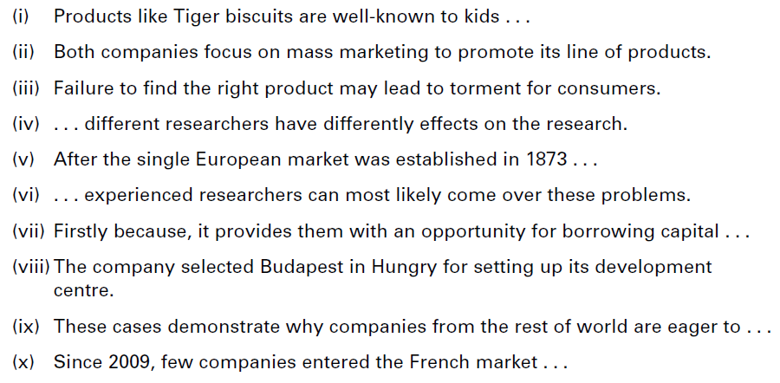

Task 4 Summarise the following text in about 50 words.
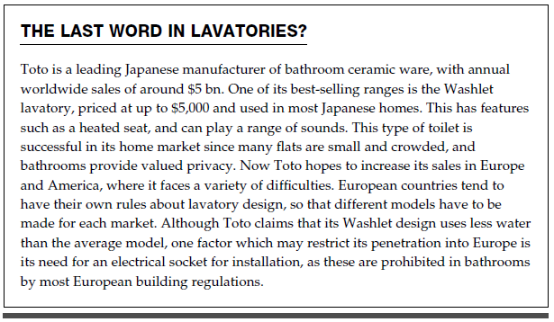

Task 3
Read the following text and the summaries which follow. Rate them from 1 (best) to 3.
