**Write a sentence referring to what the following writers said. (Use the past tense.)**

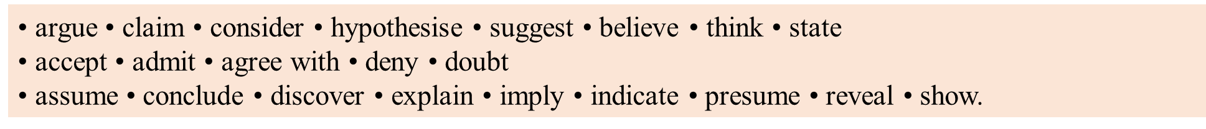

Z: ‘My research shows that biofuels are environmentally neutral’.  
Z claimed/argued that biofuels were environmentally neutral

(a) A: ‘I may have made a mistake in my calculations of the cost of living’.

(b) B: ‘I did not say that women make better economists than men’.

(c) C: ‘Small firms are more dynamic than large ones’.

(d) D: ‘I support C’s views on small firms’.

(e) E: ‘I’m not sure, but most people probably work to earn money’.

(f) F: ‘After much research, I’ve found that growing wheat is more profitable than

growing potatoes’.

(g) G: ‘I think it unlikely that electric cars will replace conventional ones’.

(h) H: ‘There may be a link between age and entrepreneurial ability’.

**Rewrite the following statements using referring verbs from the box.**



Example: K: ‘Guttman’s work is responsible for many of the current social problems’.

K blamed Guttman’s work for many of the current social problems.

(a) L: ‘She was very careless about her research methods’.

(b) M: ‘There are four main types of government bonds’.

(c) N: ‘That company has an excellent record for workplace safety’.

(d) O: ‘Falling unemployment must be a sign of economic recovery’.

(e) P: ‘Wind power and biomass will be the leading green energy sources’.

(f) Q: ‘Adam Smith was the most influential economist of the eighteenth century’.

**Rewrite the following statements using referring verbs from the box.**



Example: K: ‘Guttman’s work is responsible for many of the current social problems’.

K blamed Guttman’s work for many of the current social problems.

(a) L: ‘She was very careless about her research methods’.

(b) M: ‘There are four main types of government bonds’.

(c) N: ‘That company has an excellent record for workplace safety’.

(d) O: ‘Falling unemployment must be a sign of economic recovery’.

(e) P: ‘Wind power and biomass will be the leading green energy sources’.

(f) Q: ‘Adam Smith was the most influential economist of the eighteenth century’.

**Write a sentence referring to what the following writers said. (Use the past tense.)**



Z: ‘My research shows that biofuels are environmentally neutral’.  
Z claimed/argued that biofuels were environmentally neutral

(a) A: ‘I may have made a mistake in my calculations of the cost of living’.

(b) B: ‘I did not say that women make better economists than men’.

(c) C: ‘Small firms are more dynamic than large ones’.

(d) D: ‘I support C’s views on small firms’.

(e) E: ‘I’m not sure, but most people probably work to earn money’.

(f) F: ‘After much research, I’ve found that growing wheat is more profitable than

growing potatoes’.

(g) G: ‘I think it unlikely that electric cars will replace conventional ones’.

(h) H: ‘There may be a link between age and entrepreneurial ability’.