**Undeclared Work Policy Proposal for Central European Countries**

Undeclared work, encompassing various forms of unreported employment, poses a significant challenge to Central European economies and societies. Despite ongoing efforts, informal employment persists due to economic necessity, weak enforcement of labor regulations, and gaps in social protection systems. The computations indicate that 9.3% of the overall labor input within the private sector in the EU remains hidden, with undisclosed activities contributing to 14.3% of GVA in that sector. The discrepancy in the weighted mean in comparison to the unweighted one is affected by nations like Germany, France, and the UK, renowned for their substantial workforce and relatively lower levels of undisclosed labor. Variations in the extent of undisclosed work are remarkable among Member States: - Poland, Romania, and Lithuania are noteworthy for having the highest levels of undisclosed work as a percentage of total labor input, with most nations exceeding the EU average being new EU Member States (NMS). The Czech Republic stands out among NMS, showcasing a smaller undisclosed economy compared to the EU average, while the UK, Germany, and the Netherlands exhibit the least amount of undisclosed work concerning labor input (below 3%). Conversely, countries with undisclosed economies above the EU average are mainly new Member States (Hungary, Latvia, Estonia, Bulgaria, Cyprus, Croatia, and the Czech Republic), in addition to three older EU members: Greece, Spain, and Italy. Slovakia and Slovenia from the NMS countries are the only ones with slightly below-average undisclosed economies. Remarkable distinctions are evident in the prevalence of undisclosed work among different employed categories: - The proportion of undeclared self-employment varies significantly by Member State, from 77.6% in Latvia to as low as 2.5% in Poland; - The proportion of undeclared work in formal employment arrangements ranges from 25.3% in Poland to 1.1% in the Netherlands; and - The proportion of undisclosed family labor varies greatly, with 89.8% in Latvia and 2.1% in Sweden. Examining the composition of the undisclosed labor market within the EU unveils a captivating breakdown: 61.8% of such activities take place within formal employment, 37.3% relates to self-employment, and only 0.3% involves family labor.

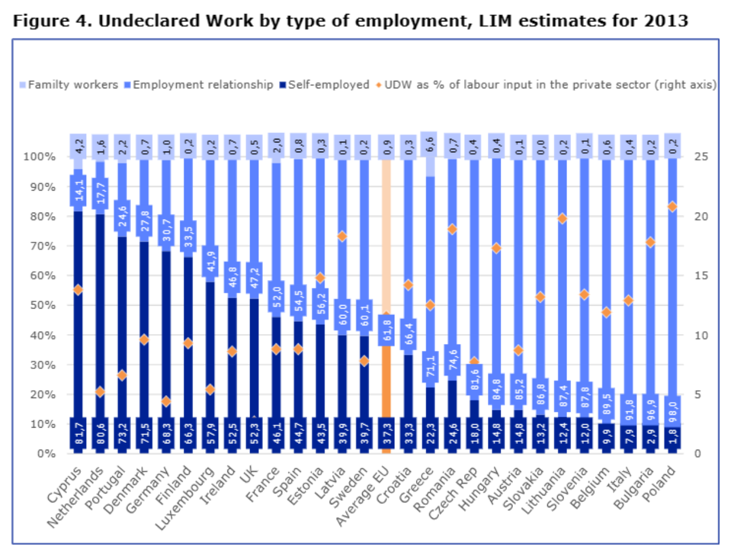

**Problem Statement:**

Undeclared work undermines labor market integrity, deprives workers of legal protections and benefits, reduces government revenues, and distorts competition.

**Policy Objectives:**

- Reduce Incidence of Undeclared Work

- Promote Formal Employment

**Policy Recommendations:**

1. Enhance Enforcement Mechanisms:

- Improve cooperation between relevant authorities.

- Implement targeted controls and sanctions.

- Introduce stricter penalties for offenders.

2. Promote Formalization:

- Create incentives for compliance with labor laws.

- Support initiatives facilitating the transition to formal employment.

3. Improve Data Collection and Analysis:

- Invest in accurate data collection systems.

- Utilize data to inform policy development and evaluation.

4. Strengthen Social Protection Systems:

- Expand coverage of social protection programs.

- Improve outreach and awareness campaigns.

- Establish mechanisms for portable benefits.

5. Foster Collaboration with Informal Economy Actors:

- Engage with informal economy actors to understand needs and challenges.

- Form partnerships to promote formalization and compliance.

**EU Initiatives:**

- Labor inspection agencies conduct regular inspections to detect violations.

- EU programs, like PROGRESS, support national strategies to combat undeclared work.

**Czech Republic Initiatives:**

- Policy reforms aimed at addressing false self-employment, including tax and social contribution reforms, through the impact of tax policies on undeclared work and the effectiveness of special taxation regimes.

**Conclusion:**

Addressing undeclared work demands a comprehensive approach, integrating enforcement, incentives for formalisation, and social protection reforms. Informal employment, while contributing to the economy, exposes workers to vulnerability and precariousness. Effective policy interventions are crucial to mitigate these risks and promote formal employment in Central European countries.

**Resources:**

Horodnic, I. A., & Williams, C. C. (2018, January 24). Do Deterrents Prevent Undeclared Work? *An Evaluation of the Rational Economic Actor Approach.* Retrieved from <http://dx.doi.org/10.2139/ssrn.3108375>

Kovačević, L. (2022). Effectiveness of labour legislation and the role of labour inspection in light of international labour organization standards. *Strani pravni život,* (1), 1-41.

Tarini, M. (2022). Informality on the rise: Dissecting quasi-formal employment in the EU. *Economic and Labour Relations Review,* 33(3), 463-483.

European Commission, Directorate-General for Employment, Social Affairs and Inclusion, Bejakovic, P., Mikulic, D., Horodnic, I. (2017). An evaluation of the scale of undeclared work in the European Union and its structural determinants : *estimates using the labour input method, Publications Office.* <https://data.europa.eu/doi/10.2767/98169>