2. Macroeconomic accounts

Notes for Instructors

  - Overview
[An alphabet soup of products and payments]

The description of what we observe is a necessary first step in trying to understand the macroeconomy. Definitions and distinctions of who pays or receives what from whom provide the building blocks need for an accounting system useful for thinking about households, businesses and governments, their relationships with each other and with the rest of the world.

  - Gross Domestic Product
[Apples and oranges per year grown here]

    - Three Definitions of the Gross Domestic Product (GDP)
[Two sides to each transaction allow cross-checks of totals]

- sum of the final sales
- sum of value added
- sum of factor incomes

Distinctions:
- Stock vs. flow
- Final vs. intermediate sales
- GDP vs. GNP

Two subtle points:
- Imputed owner’s housing rental
- Valuation of public services at cost

    - Real versus Nominal, Deflators versus Price Indices
[We spend € on fruit, but we still consume kg of bananas]

Expenditure totals are what we actually observe, which are sums of value products (price times quantity) of individual items. The problem is one of decomposing a change in an expenditure total into the part due to changes in prices (“on average”) and the part due to changes in quantities (“on average”).

The deflator is a ratio (= nominal GDP/real GDP). The growth of the deflator is a difference (=growth rate of nominal GDP minus growth rate of real GDP).

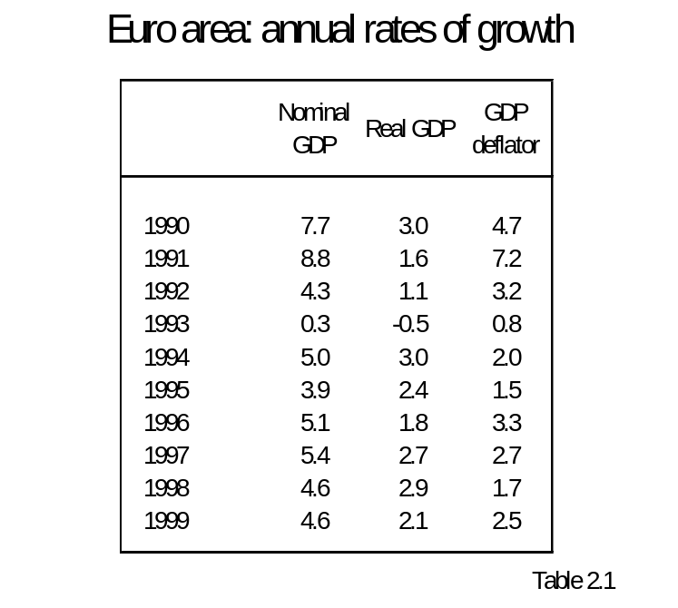
One sees how looking at nominal GDP growth rates gives an “inflated” view of the magnitude of the growth of the rate of annual production. Indeed prices have increased faster than quantities in a majority of the years in the table.

Consumer price index (hold quantities in a “market basket quantity” and value that same market basket in each period’s prices.
As Figure 2.1 shows for Italy, the GDP deflator and CPI do not give exactly the same picture, but they clearly move fairly similarly over longer periods of time.

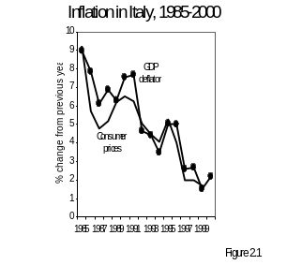
Both the GDP deflator and the consumer price index (CPI) measure the price level, or the price of goods in terms of money. They are used to compute an economy’s inflation rate. The figure shows that both inflation rates tend to move together over time, with occasional exceptions when the difference in the underlying “baskets” makes a difference. In 1986, world oil prices went down sharply. Since gas and heating oil are part of household consumption, inflation measured by the CPI declined. Oil being imported (so it does not create value added in Italy) has only a small impact on the GDP deflator.

Box 2.3 mentions the founding fathers of price index number formulae, Laspeyres (fixed quantity weight as seen in the typical CPI) and Paasche (moving quantity weight as is implicit in the GDP deflator). Both formulae involve the repricing of reference market basket of goods at different sets of prices.

Definitely worth mentioning is the enormous debate about the “new product” problem in constructing a cost of living index (hint: the introduction of cell phones was like going from a situation where the price was so high that the demand for cell phones was zero to the present price situation with positive demand. The point being the theory of price index numbers and the theory of consumer surplus are fraternal twins in the consumer theory learned in microeconomics.)

    - Measuring and Interpreting GDP
[Take three grains of salt with your national income accounts]

- First point is that it is a hard business getting accurate GDP estimates. On the one hand, largely for tax avoidance reasons, there is market production taking place that is unreported (Table 2.2).

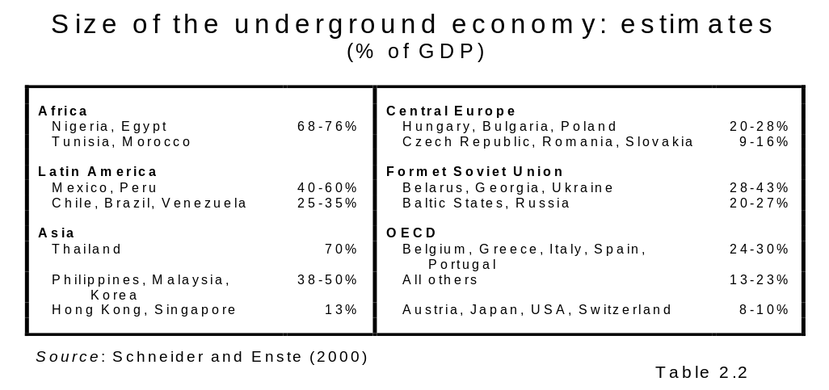
The fact that GDP figures are in part collected through tax returns immediately raises the suspicion that individuals and firms may be less than candid about their finances to the fiscal authorities. Such unreported incomes form what is referred to as the underground economy.

- There is also a lot of economic production that goes unreported not because there is anything illegal or even unusual but because it stays within the household and never even sees the market (Table 2.3)

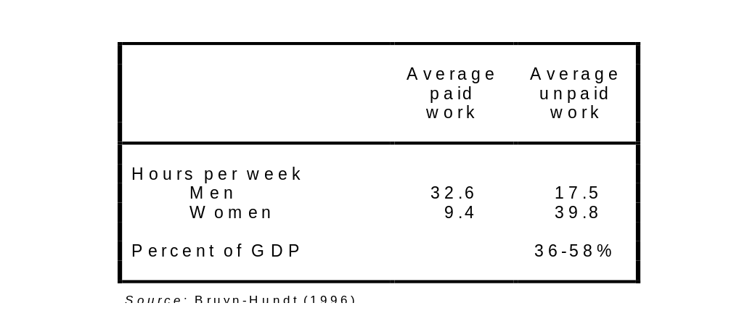
Another serious limit to GDP measures is unpaid work. Fixing the house and caring for the family and cleaning around take up much time and effort. Wealthier people hire help for these chores, in which case it becomes part of GDP (if reported to the tax authorities). Most people do it themselves, and it is unrecorded. Table 2.3 presents estimates for the Netherlands of the size of this “lost output”. The first part shows that women perform much unpaid work. The second part shows that unpaid work represents a sizeable part of official GDP. The estimates depend on which salary we impute to this activity, the lowest figure corresponds to the minimum wage, the highest to the average wage.

- Finally old GDP numbers might make economic historians happy but getting hot and fresh GDP numbers for the immediately preceding past period(s) requires estimates based upon still incomplete returns (not unlike forecasting the winner of an election based upon some fraction of the reporting precincts). Table 2.4 shows how misleading such preliminary returns can be.

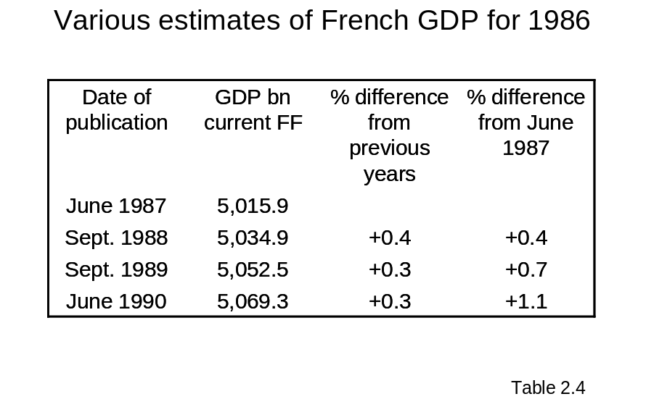
The first estimate, published six months after year end, fell short of the latest figure by more than 1%! This may not seem like much, but it amounts to a full 15% difference for the actual growth rate recorded that year (7.5%).

- For a walk on the statistical wild side, consider the difficulties of GDP comparisons at a point in time across countries at vastly different levels of development.

- The point is not to be completely nihilistic about this business, but to appreciate the subtleties and respect the difficulties of this sort of measurement.

  - Flows of Incomes and Expenditures
[If economists were hydraulic engineers…]

2.3.1. The Circular Flow Diagram
[a.k.a. Wheel of wealth]

Figure 2.2 is a 21st century representation of what Francois Quesnay and the French Physiocrats tried to capture with their Tableau Oeconomique in the middle of the 18th century, the circulation of expenditure and revenue. It is certainly no coincidence that Quesnay was a physician whose medical reputation was based upon investigations of the circulation of blood in the human body.

- The point of national income and product accounting is to gauge the volume of the flow of real goods and services based upon observed flows of spending.

- We collectively earn to collectively spend.

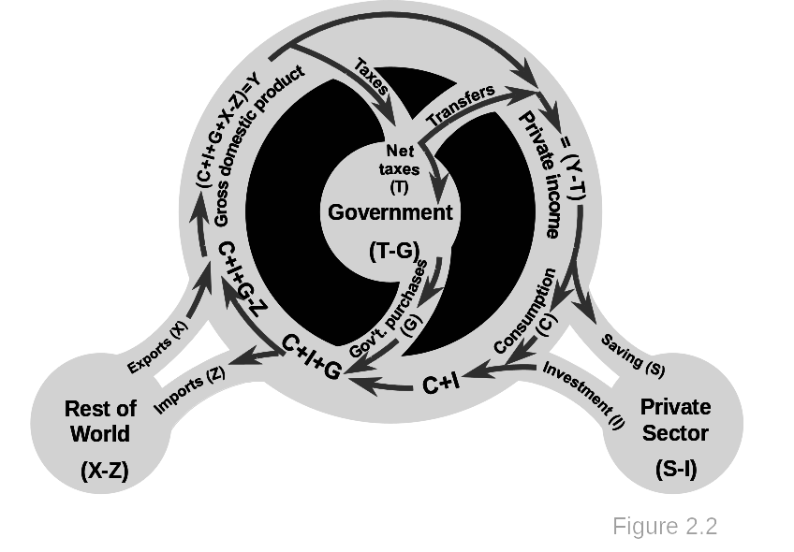
The lower left part of the wheel represents sales of domestically produced goods and services, the sum of consumption spending (C), investment spending (I), government purchases (G), and exports (X) less imports (Z). In the upper left part of the wheel this is interpreted as income to residents. This income is taxed by the government, which also pays out various transfers. What is left, private income, may be saved (S) or spent (C). This circularity is the essence of economic activity: we (collectively) earn to (collectively) spend. The private sector borrows to invest in productive equipment (I). The balance S − I is the private sector’s net saving behaviour. The balance T − G is the public sector borrowing requirement. X − Z represent the country’s net exports.

2.3.2. Summary of the Flow Diagram
[Product uses and income leaks]

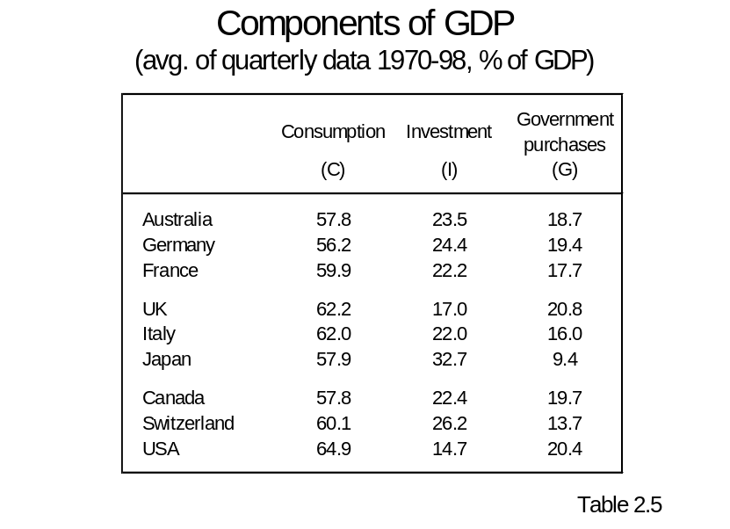
Total national spending or absorption is the sum, C+I+G. Note that investment this period will have an impact on the stock of capital available next period (much of the subject of Chapter 3).

Income leaks: saving, taxes, net imports. These result in changes in the stock of assets and liabilities.

2.3.3. More Detail
[National accounts strip tease]

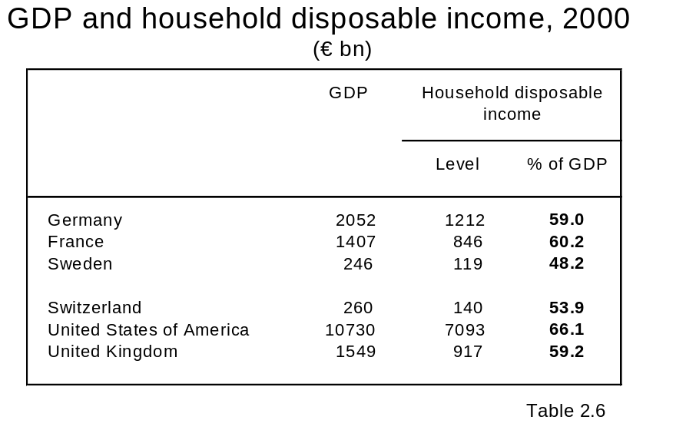
While GDP represents the collective income earned within a nation’s boundaries, not all of it ends up in the hands of individuals. What households actually receive to spend or save is called personal disposable income. Some 30%–40% of GDP does not reach individual households. It either goes to the government (net taxes) or is saved by firms (retained earnings).

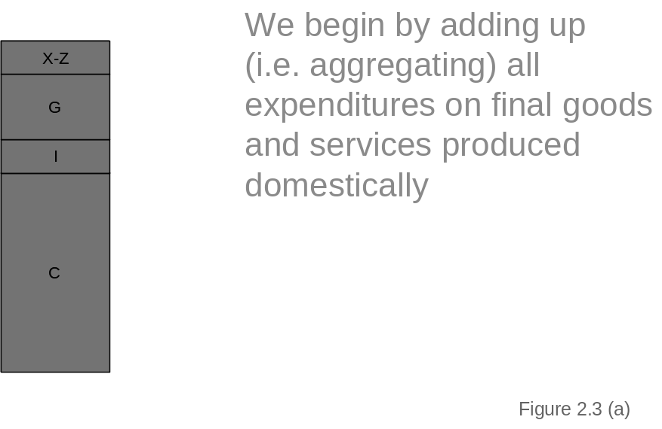
We net out the total sum of imports from exports because we know, e.g. how much households spend on consumption goods, but we really have no clue what percent of what they consume actually originates domestically—much of the stuff is assembled with foreign parts so that what might appear at first glance to be a domestic product probably has some proportion of imports. Same can be said for business investment and government spending on goods and services.
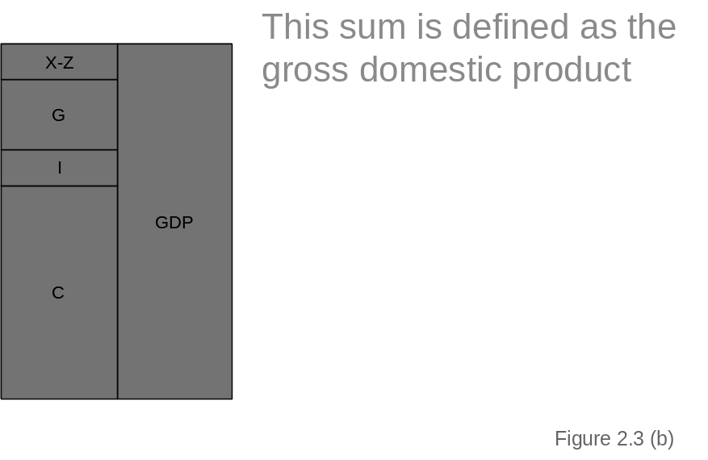
This corresponds to about 10 o’clock on the circular flow diagram.
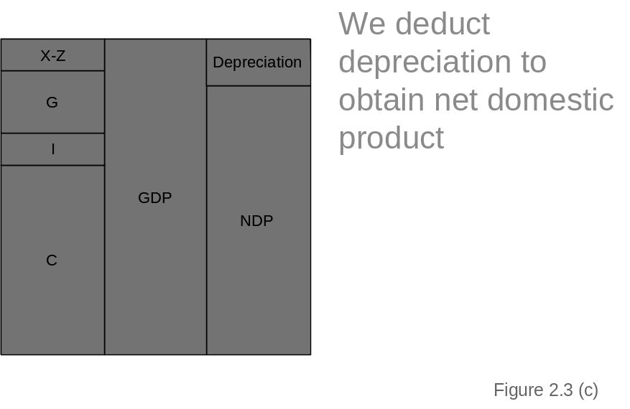
The deduction for depreciation is best understood as analogous to that of a farmer who deducts the seed corn he needs to maintain his current production level and what is left over (here NDP) he can sell in the market which will be his income. The life of capital goods is longer than a year on average, so that the capital consumption allowance is just a proportion of the capital stock in any given year.
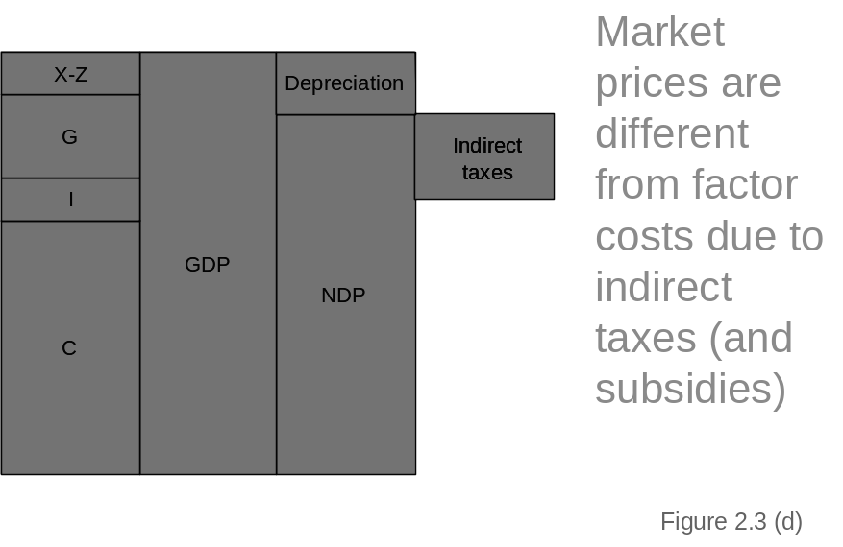
Remember we are going from value of output to the income that is ultimately distributed to the factors of production. The next deduction is the net indirect taxes (essentially sales taxes less the value of subsidies paid by government that permit a company to stay in business with prices that do not fully cover costs).
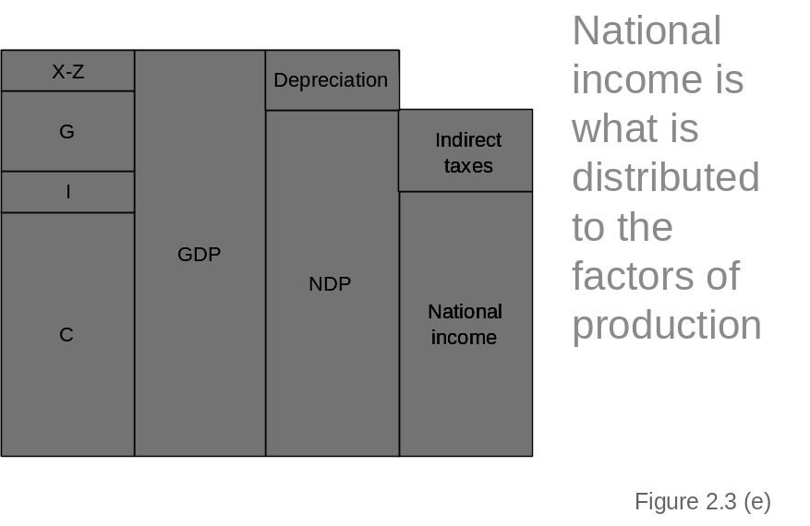
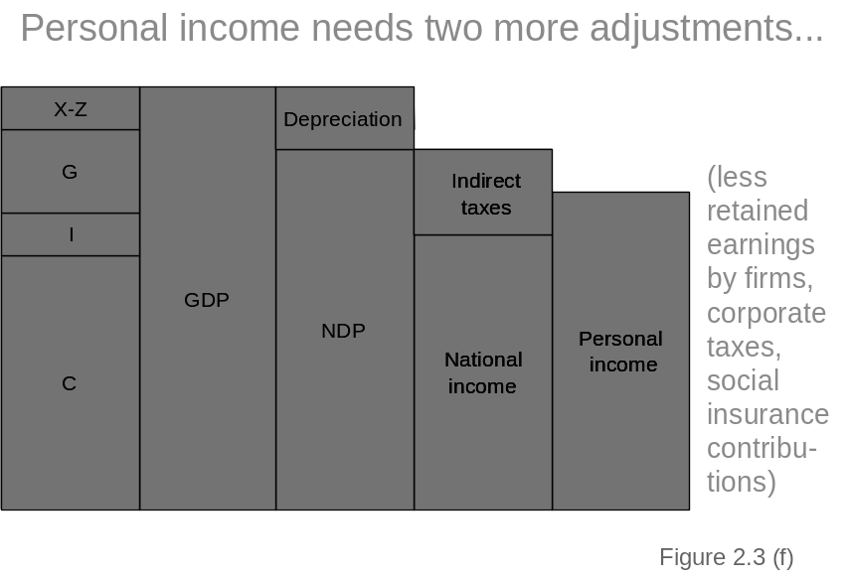
Added in here are the transfer payments to households
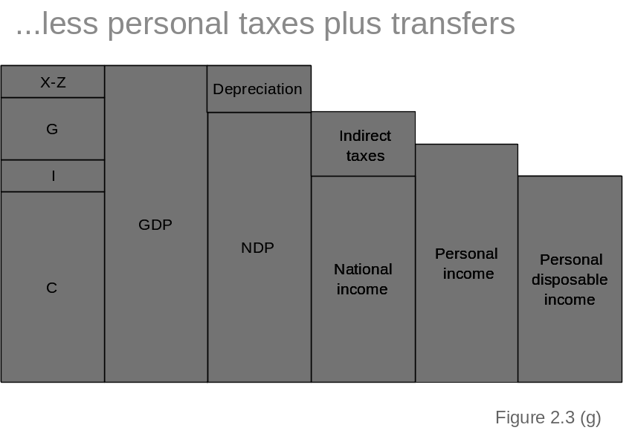
Redistribution through taxes and transfers will be discussed in Chapter 15.
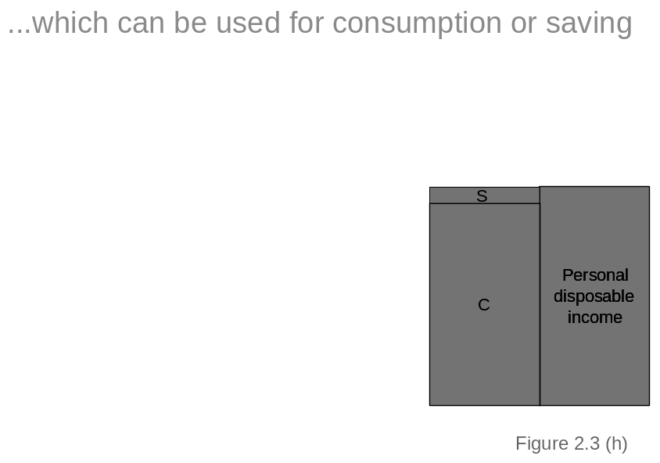
We talk a lot more about this connection in Chapter 6 (consumption function)

2.3.4. A Key Accounting Identity
[Linking Leakages]

Rewrite:
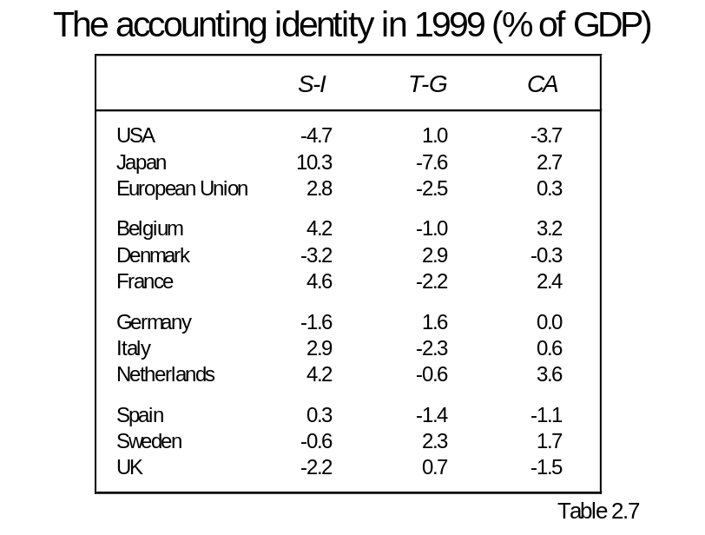
In the USA the private sector is dissaving, spending more than it earns, by a large amount. The public sector’s surplus is too small to compensate, so the country as a whole is running an external deficit. The situation is exactly the opposite in Japan. The private sector’s massive surplus swamps the public sector’s deficit, leaving the country with an external surplus. The European Union as a whole is behaving more like Japan, but the internal imbalances are smaller and about cancel each other to deliver near external balance.

2.3.5. Identities versus Economics
[Accounting is not economics]

(S − I) + (T − G) = (X − Z) or equivalently.
(S − I) = (X − Z) - (T − G)

- Suppose the left hand side is positive. Nothing in the equation tells us how the four items on the right hand side are expected to adjust so that the right hands side turns out to be positive.
- The particular identity is the result of the fact that one economic agent’s payment is another agent’s receipt and that the claims to income produced by the economy necessarily sum to 100%.

  - Balance of Payments
[Dealing with the Rest of the World]

When a transaction involves a payment to us (we sell the rest of the world a good or an asset, or the rest of the world transfers money to us), the item is recorded in the balance of payments with a positive sign.

When we make a payment to the rest of the world (buying a good or an asset, or we send e.g. economic aid or arms to the rest of the world), the item is recorded with a negative sign.

2.4.1. Commercial Transactions

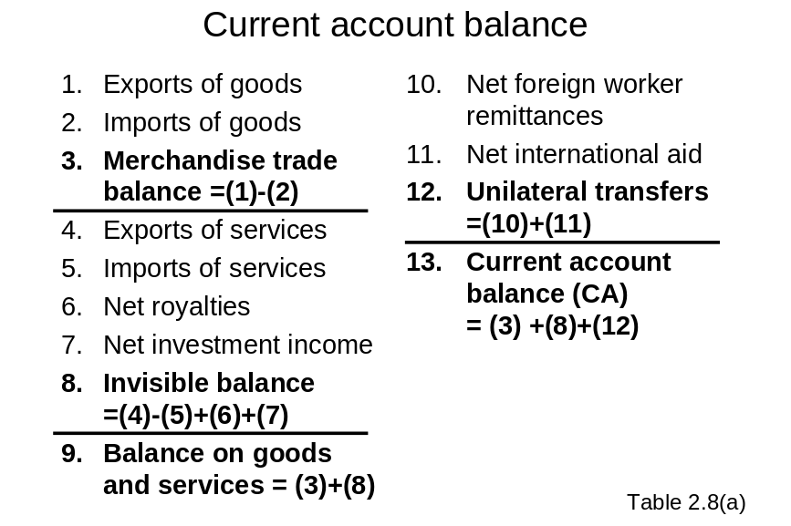
Basic idea: when the country earns more than it spends it accumulates claims on the rest of the world (that are worth something in the future).

2.4.2. Financial Transactions

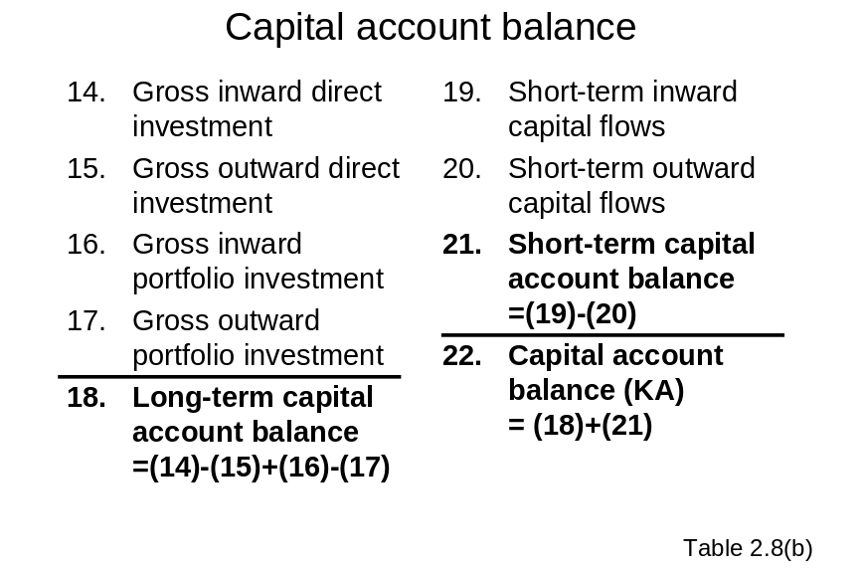
Note these are only the private items of the capital account.

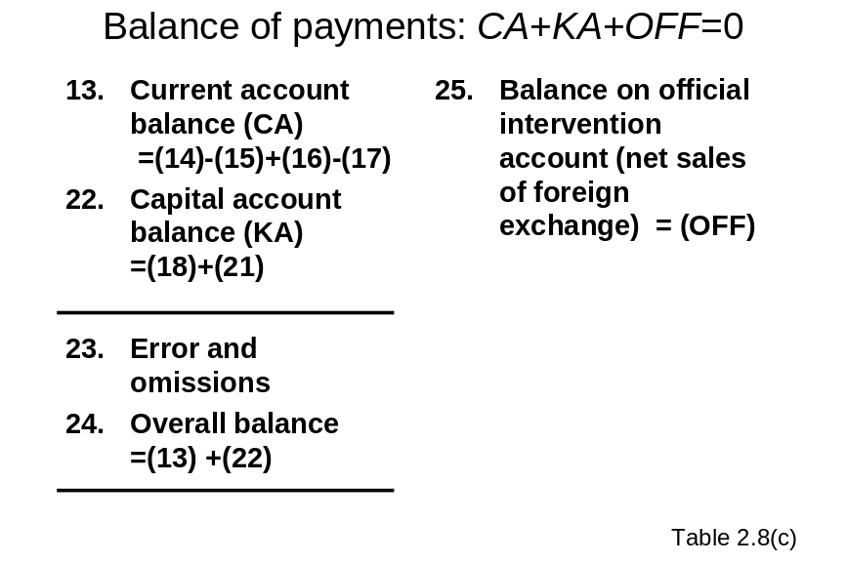
This last item is what distilled the frenzy of the mercantilists. If the current account were positive (e.g. from a trade surplus and there was no offsetting private capital change, then OFF would be negative, a state of affairs that the mercantilists were delighted to have “gold flowing into the realm”) Now the negative OFF would mean foreign exchange from the trade surplus is accumulating.

2.4.3. Errors and Omissions
[Makes GDP and National Income look very accurate]

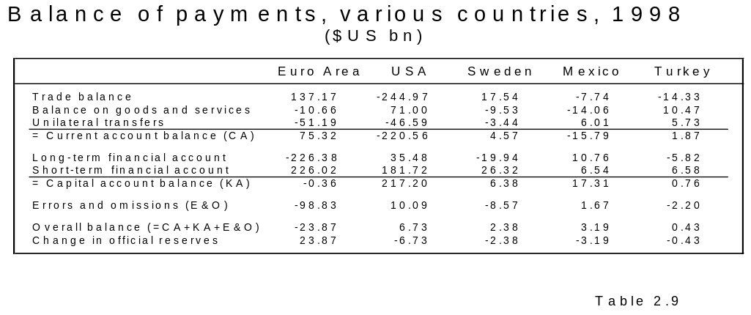

2.4.4. The Meaning of the Accounts

Current account imbalances can be dealt with through OFF or FA. Changes in the official account reveals interventions by the monetary authority. There can be consequences for exchange rates and/or interest rates.

Where we are heading next.
We abstract away from the problem of a changing monetary unit to consider what the economy would look like without a monetary veil.

Links
Countries that subscribe to the IMF's Special Data Dissemination Standard make a commitment to observe the standard and to provide information about their data and data dissemination practices--metadata--for the DSBB. Links to national summary data sites are available for many countries.
http://dsbb.imf.org/country.htm

Everything you wanted to know about national accounts but were afraid to ask:
http://www1.oecd.org/std/nahome.htm

Everything you wanted to know about the balance of payments but were afraid to ask: http://www.ecb.int/stats/mb/ecb_bull_8note.pdf

