What is decision making

Decision making is the cognitive process leading to the selection of a course of action among variations. Every decision making process produces a final choice. It can be an action or an opinion. It begins when we need to do something but know not what. Therefore, decision making is a reasoning process which can be rational or irrational, can be based on explicit assumptions or tacit assumptions.

Why we need decision analysis?

The usage of decision-making methods increase the probability of a right decision in a managerial environment , which is full of uncertainty, where all element that influence the result are given only as numbers of probability or are not given at all.

Decision making in business and management
Several decision making models or practices for business include:
- SWOT Analysis - Evaluation by the decision making individual or organization of Strengths, Weaknesses, Opportunities and Threats with respect to desired end state or objective.
- Buyer decision processes - transaction before, during, and after a purchase
- Corporate finance:
  - The investment decision
  - The financing decision
- Cost-benefit analysis - process of weighing the total expected costs vs. the total expected benefits
- Decision trees
- Grid Analysis - analysis done by comparing the weighted averages of ranked criteria to options. A way of comparing both objective and subjective data.
- Linear programming - optimization problems in which the objective function and the constraints are all linear
- Min-max criterion
- Model (economics)- theoretical construct of economic processes of variables and their relationships
- Monte Carlo method - class of computational algorithms for simulating systems
- Paired Comparison Analysis - paired choice analysis
- Pareto Analysis - selection of a limited of number of tasks that produce significant overall effect
- Strategic planning process - applying the objectives, SWOTs, strategies, programs process
Decision Tree
The most decision-making problems have following feature: the decision made now strongly influences all decisions that will be made in future. This means that when we are deciding about recent problem we need to consider all future decisions that we will have to make. These complex decision-making is called multistage decision-making and it occurs mainly in environment of risk or uncertainty. Decision trees can illustrate these multistage decision-making problems.

Xanadu Traders. Part 1

Xanadu Traders, a privately held U.S. metals broker, has acquired an option to purchase one million kilograms of partially refined molyzirconium ore from the Zeldavian government for $5.00 per kilogram. Molyzirconium can be processed into several different products which are used in semiconductor manufacturing, and George Xanadu, the owner of Xanadu Traders, estimates that he would be able to sell the ore for $8.00 per kilogram after importing it. However, the U.S. government is currently negotiating with Zeldavia over alleged “dumping" of certain manufactured goods which that country exports to the United States. As part of these negotiations, the U.S. government has threatened to ban the import from Zeldavia of a class of materials that includes molyzirconium. If the U.S. government refuses to issue an import license for the molyzirconium after Xanadu has purchased it, then Xanadu will have to pay a penalty of $1.00 per kilogram to the Zeldavian government to annul the purchase of the molyzirconium.
Xanadu has used the services of Daniel A. Analyst, a decision analyst, to help in making decisions of this type in the past, and George Xanadu calls on him to assist with this analysis. From prior analyses, George Xanadu is well-versed in decision analysis terminology, and he is able to use decision analysis terms in his discussion with Analyst.
Analyst: As I understand it, you can buy the one million kilograms of molyzirconium ore for $5.00 a kilogram and sell it for $8.00, which gives a profit of ($8.00 - $5.00) x 1.000.000 = $3.000.000. However, there is some chance that you cannot obtain an import license, in which case you will have to pay $1.00 per kilogram to annul the purchase contract. In that case, you will not have to actually take the molyzirconium and pay Zeldavia for it, but you will lose $1.00 x 1.000.000 = $1.000.000 due to the cost of annulling the contract.
Xanadu: Actually, “some chance" may be an understatement. The internal politics of Zeldavia make it hard for their government to agree to stop selling their manufactured goods at very low prices here in the United States. The chances are only fifty-fifity that I will be able to obtain the import license. As you know, Xanadu Traders is not a very large company. The $1.000.000 loss would be serious, although certainly not fatal. On the other hand, making $3.000.000 would help the balance sheet....

Figure 1Decision tree - basic
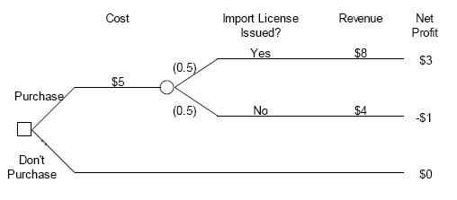

Theory intermission n.1
A diagram of a decision, as illustrated in Figure 1 is called a decision tree. This diagram is read from left to right. The leftmost node in a decision tree is called the root node. In Figure 1, this is a small square called a decision node. The branches emanating to the right from a decision node represent the set of decision alternatives that are available. One, and only one, of these alternatives can be selected. The small circles in the tree are called chance nodes. The number shown in parentheses on each branch of a chance node is the probability that the outcome shown on that branch will occur at the chance node. The right end of each path through the tree is called an endpoint, and each endpoint represents the final outcome of following a path from the root node of the decision tree to that endpoint.

In order to decide which alternative to select in a decision problem, we need a decision criterion; that is, a rule for making a decision. Expected value (EV) is a criterion for making a decision that takes into account both the possible outcomes for each decision alternative and the probability that each outcome will occur. In mathmatics EV is also known as Bayes rule.

Mathemtaical notation:
$${\overline{C}}_{i}=\sum_{j=1}^{n}{C_{\text{ij}}⋅S_{j}}$$
The expected value for an uncertain alternative is calculated by multiplying each possible outcome (Sj) of the uncertain alternative by its probability (Cij), and summing the results. The expected value decision criterion selects the alternative that has the best expected value. In situations involving profits where „more is better," the alternative with the highest expected value is best, and in situations involving costs, where „less is better" the alternative with the lowest expected value is best.

Xanadu traders. Part 2
Let’s add Expected value to Figure 1.
Figure 2 Decision tree – Expected value
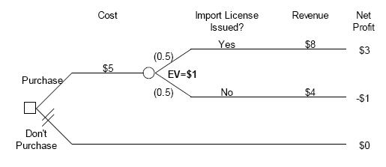
There are two possible alternatives, purchase the molyzirconium or don't purchase it. If the molyzirconium is purchased, then there is uncertainty about whether the import license will be issued or not. The decision tree is shown in Figure 2. Starting from the root node for this tree, it costs $5 million to purchase the molyzirconium, and if the import license is issued, then the molyzirconium will be sold for $8 million, yielding a net profit of $3 million. On the other hand, if the import license is not issued then Xanadu will recover $4 million of the $5 million that it invested, but will lose the other $1 million due to the cost of annulling the contract. The endpoint net profits are shown in millions of dollars, and the expected value for the “purchase" alternative is 0.5 x $3 + 0.5 x(- $1) = $1, in millions of dollars. Therefore, if expected value is used as the decision criterion, then the preferred alternative is to purchase the molyzirconium.

Dependent uncertainties
We continue to follow the discussion between Daniel Analyst and George Xanadu.
Analyst: Maybe there is a way to reduce the risk. As I understand it, the reason you need to make a quick decision is that Zeldavia has also offered this deal to other brokers, and one of them may take it before you do. Is that really very likely? Perhaps you can apply for the import license and wait until you know whether it is approved before closing the deal with Zeldavia.
Xanadu: That's not very likely. Some of those brokers are pretty big operators, and dropping $1,000,000 wouldn't make them lose any sleep. I'd say there is a 0.70 probability that someone else will take Zeldavia's offer if I wait until the import license comes through. Of course, it doesn't cost anything to apply for an import license, so maybe it is worth waiting to see what happens...

Figure 3 Decision tree - Dependent uncertainties
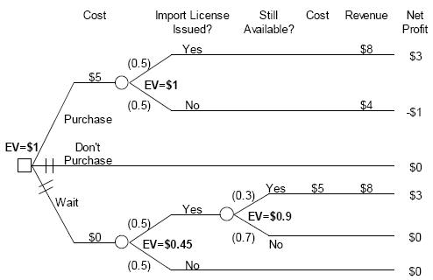

The process of determining the expected value for this alternative involves two stages of calculation. In particular, it is necessary to start at the right side of the decision tree, and carry out successive calculations working toward the root node of the tree. Specifically, first determine the expected value for the alternative assuming that the import license is issued, and then use this result to calculate the expected value for the „wait" alternative prior to learning whether the import license is issued.
Examine Figure 3 to see how this calculation process works. As this figure shows, if the import license is issued, then there is a 0.3 probability that the molyzirconium will still be available. In this case, Xanadu will pay $5 million for the molyzirconium, and sell it for $8 million realizing $3 million in net profit. If the molyzirconium is not still available, then Xanadu will not have to pay anything and will realize no net profit. Thus, the expected value for the situation after the uncertainty about the import license has been resolved is 0.3 x $3+0.7x $0 = $0.9. This expected value is shown next to the lower right chance node on the decision tree in Figure 3. This $0.9 million is the value of the alternative once the result of the import license application is known. Hence, this value should be used in the further expected value calculation needed to determine the overall value of the “wait" alternative. Thus, the expected value for the “wait" alternative is given by 0.5 x $0.9 + 0.5 x $0 = $0.45. This expected value is shown next to the lower left chance node on the decision tree in Figure 3. Since the expected value for the “wait" alternative is less than the $1 million expected value for purchasing the molyzirconium right now, this alternative is less preferred than purchasing the molyzirconium right now. Xanadu should not wait, assuming that expected value is used as the decision criterion.

Theory intermission n.2
Risk attitude

An attitude of decider to risk is very important when deciding in the terms of uncertainty or risky environment. The decider could be risk averse, risk seeking or risk neutral.
Definitions:
Risk averse decider: always prefers not risky alternative to a risky alternative
Risk seeking decider: always prefers risky alternative to not risky alternative
Risk neutral decider: doesn’t give priority neither to risky nor to not risky alternative – they are indifferent for him.

Risk attitude is affected by many factors, for example by personal experience, by history or by the environment in which the decision is taken.

Certainty equivalent
The value of a risky alternative to the decision maker may be different than the expected value of the alternative because of the risk that the alternative poses of serious losses.
An equivalent term for certainty equivalent is selling price.

Suppose that through a previous business deal you have come into possession of an uncertain alternative that has equal chances of yielding a profit of $10,000 or a loss of $5,000. The expected value for this alternative is 0.5 x $10.000 + 0.5 x (-$5.000) = $2.500. However, suppose that you decide that you would be willing to sell this alternative for $500 or more. Then, your certainty equivalent for the alternative is $500.

If your certainty equivalent for alternatives specified in terms of profits is less than the expected profit for an alternative, you are said to be risk averse with respect to this alternative. If your certainty equivalent is equal to the expected profit for the alternative, then you are said to be risk neutral. Finally, if your certainty equivalent is greater than the expected profit for the alternative, you are said to be risk seeking. These definitions are reversed for an uncertain alternative specified in terms of losses. That is, you are risk averse if your certainty equivalent is greater than the expected loss and risk seeking if your certainty equivalent is less than the expected loss.

If you are risk seeking with respect to the various decisions that you make, then over the long run you will probably go broke because on average you will not recover as much from the alternatives as you are willing to pay for them. This is not typical behavior in business, and therefore we will not consider risk seeking behavior further. (Note that there are situations where a risk seeking attitude may make sense in business. For example, suppose your business is in such serious trouble that it is going to go broke anyway unless you get lucky. You might as well “pray for rain" in such a situation and go against the odds. However, this is not a typical business situation.)

Utility functions
Certainty equivalents can be determined using a modification of the procedure that we use to determine expected values. This modification involves introducing a new function, called the utility function.
A utility function translates outcomes into numbers such that the expected value of the utility numbers can be used to calculate certainty equivalents for alternatives in a manner that is consistent with a decision maker's attitude toward risk taking.

0
Utility
1 risk averse
2 risk neutral
3 risk seeking
Criterion

Both theory and practical experience have shown that it is often appropriate to use a particular form of utility function called the exponential. For risk averse decision makers, in decisions involving profits (more of the evaluation measure is better), this function has the form

u(x) = 1 – e^{-x/R}, R>0,
where u(x) represents the utility function, x is the evaluation measure, R is a constant called the risk tolerance, and e represents the exponential function. (The exponential function is often designated by “exp” on a financial calculator or in a spreadsheet program.)

In situations involving costs where less of the evaluation measure is preferred, the exponential utility function has the form
u(x) = 1 – e^{x/R}, R>0.
and in this case larger values of x have lower utilities.

R represents the degree of risk aversion. As R becomes larger, the utility function displays less risk aversion.
The following procedure can be used to determine the approximate value of R for a particular decision maker: Ask the decision maker to consider a hypothetical alternative that has equal chances of yielding a profit of r_{o} or a loss of r_{o}/2. Then ask the decision maker to specify the value of r_{o} for which he or she would be indifferent between receiving or not receiving the alternative. When the decision maker has adjusted r_{o} in this way, then R is approximately equal to r_{o}.

Xanadu Traders, utility funcion
Analyst: I understand from my previous work with you that financial risks of the size involved in this deal would be uncomfortable but would not sink Xanadu Traders. If you could, you would buy some insurance against the potential loss, but you are not going to avoid the deal just because of the possible loss.
Xanadu: That's correct.
Analyst: I recall that you told me in the past that you would be just willing to accept a deal with a fifty-fifty chance of making $2,000,000 or losing $1,000,000. However, if the upside were $2,100,000 and the downside were $1,050,000, you would not take the deal.
Xanadu: That's correct.

First it is necessary to determine Xanadu's utility function. This can be done using the information in the dialog. Using the concept of the risk tolerance, r_{o} = $2 million when an uncertain alternative with equal chances of yielding a profit of r_{o} or a loss of r_{o}/2 has a certainty equivalent of 0. Hence, R is approximately equal to $2 million. Therefore, Xanadu's utility function is
u(x) = 1 – e^{-x/2} ,
where x is in millions of dollars.

Using a spreadsheet or calculator, it is easy to find the utilities for each of the endpoint values in the Figure 3, and these are shown in Figure 4. In this figure, the utility numbers shown at the right side of the tree have been calculated using an exponential utility function with R = $2 million. For example, the topmost utility number is given by u(3) = 1 – e^{-3/2} = 0,777.

Expected utility numbers are calculated in the same manner as expected values. For example, the expected utility for the topmost chance node is given by :
EU = 0,5 x (0,777) + 0,5 x (-0,649) = 0,064. This is the expected utility for the “purchase” alternative, and in a similar manner the expected utilities can be found for the “don't purchase” alternative (EU = - 1,000) and the “wait" alternative (EU = 0.117).

Figure 4 Decision tree -
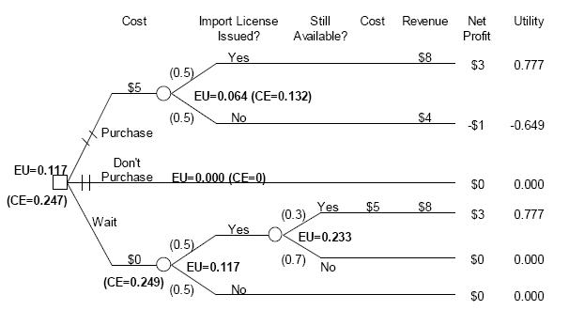

Theory intermission n.3
Certainty equivalent for an Exponential Utility Function
For an exponential utility function involving profits, it can be shown that the certainty equivalent is equal to:
CE = - R x ln(1 - EU),
where CE is the certainty equivalent, EU is the expected utility, R is the risk tolerance, and ln is the natural logarithm. Thus, the certainty equivalent for the “purchase" alternative in Figure 4 is given by CE = -2 x ln[1 – 0.064] = $0.132 million. The certainty equivalents are shown for all three alternatives in Figure 4, and larger certainty equivalents are more preferred.
In situations involving costs, where less of an evaluation measure is preferred to more, then the certainty equivalent is equal to
CE = R x ln(1 - EU),

and alternatives with smaller certainty equivalents are more preferred in this case.

Since a certainty equivalent is the certain amount that is equally preferred to an alternative, the alternative with the greatest certainty equivalent is most preferred for situations where more of an evaluation measure is preferred to less. Therefore, taking Xanadu's risk attitude into account, the “purchase” alternative is no longer the preferred alternative, as it was with the expected value analysis.
The “wait” alternative is now most preferred since it has a certainty equivalent of $0.249 million, and the “purchase” alternative is now the second most preferred alternative with a certainty equivalent of $0.132 million. The “don't purchase” alternative continues to be least preferred with a certainty equivalent of $0

The following table shows EU and CE comparison:
Alternatvie | EV | CE | Difference
Purchase | 1,000 | 0,132 | 0,868
Don’t purchase | 0,000 | 0,000 | 0,000
Wait | 0,450 | 0,249 | 0,201

This demonstrates that the three alternatives have differing risks. There is no difference between the expected value and the certainty equivalent for the “don't purchase” alternative since there is no uncertainty with this alternative. The difference between the expected value and certainty equivalent is greatest for the “purchase” alternative indicating that it has the largest risk. This risk reduces the value of this alternative enough for Xanadu that it is no longer the most preferred alternative. The “wait” alternative also has a lower certainty equivalent than its expected value since this alternative has some risk. However, this risk is substantially lower than the risk for the “purchase" alternative, and hence this becomes the preferred alternative when Xanadu's risk attitude is taken into account.

Theory intermission
The value of information

Perfect information removes all uncertainty about the outcomes for the decision alternatives. While there is rarely an option in real-world business decisions that would actually remove all uncertainty, the value of perfect information provides an easily calculated benchmark about the worth of collecting additional information. If all the available options for collecting information cost more than the value of perfect information, then these options do not need to be analyzed in further detail. This is because imperfect information cannot be worth more than perfect
information.

No source of information can be worth more than the value of perfect information.

Xanadu traders, perfect information
Suppose a source of perfect information existed that would let Xanadu know if the import license would be issued.

How much money would it be worth to obtain perfect information about issuance of the import license?

Figure 5 Decision tree with perfect information
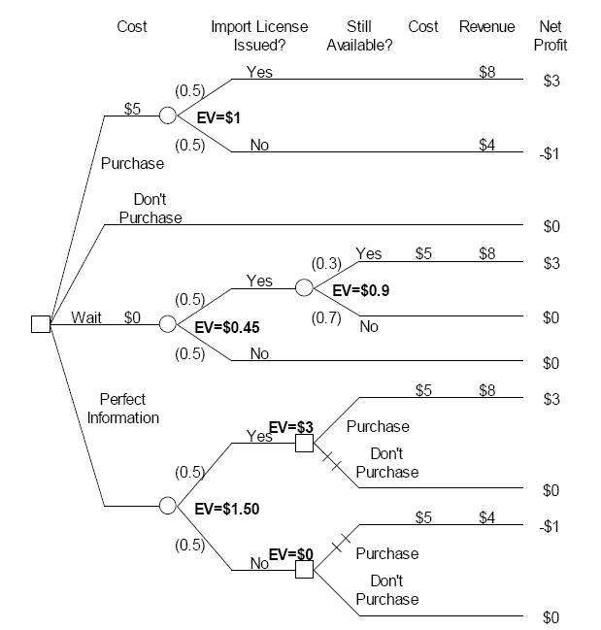
Figure 5 shows a decision tree with this (hypothetical) source of perfect information. The topmost three branches of the root node for this decision tree are the same as the corresponding branches in Figure 3. The lowest branch of the root node is the perfect information alternative. At a quick glance, the perfect information may appear to be similar to the \wait" alternative, since for both of these alternatives George Xanadu learns whether the license will be issued before he purchases the molyzirconium. However, with the perfect information alternative, information is available immediately about whether the license will be issued. Therefore, with the perfect information alternative, Xanadu does not run the risk that a competitor will purchase the molyzirconium before he learns whether the license will be issued.

Since the probability is 0.5 that the license will be issued, this is the probability that the perfect information source will report that the license will be issued. After learning this perfect information, Xanadu then can decide whether or not to purchase the molyzirconium. Of course, if Xanadu learns that the license will be issued, then he purchases the molyzirconium, and if Xanadu learns that the license will not be issued, then he does not purchase the molyzirconium. By the standard calculation procedure, it is determined that the perfect information alternative has an expected value of $1.5 million, and this is shown on the Figure 5 decision tree. Since the best alternative without perfect information (“purchase”) has an expected value of $1 million, the value of perfect information is $1.5 - $1.0 = $0.5 million. Therefore, this places an upper limit on how much it is worth paying for any information about whether the license will be issued. It cannot be worth paying more than $0.5 million for such information, since $0.5 million if the value of perfect information.

The value of imperfect information
The calculation procedure is more complicated for determining the value of imperfect information. This procedure is illustrated by the following example.

Xanadu Traders
Now consider a potential source of imperfect information in the Xanadu Traders case last. We continue with the discussion between Daniel Analyst and George Xanadu.
Analyst: Is there any way of obtaining additional information about the chances of obtaining a license other than waiting and seeing what happens? Perhaps there is something that doesn't take as long as waiting for the import approval.
Xanadu: Well, there's always John S. Lofton. He is a Washington-based business consultant with good connections in the import licensing bureaucracy. For a fee, he will consult his contacts and see if they think the license will be granted. Of course, his assessment that the license will come through is no guarantee. If somebody in Congress starts screaming, they might shut down imports from Zeldavia. They are really upset about this in the Industrial Belt, and Congress is starting to take some heat. On the other hand, even if Lofton thinks the license won't come through, he might be wrong. He has a pretty good record on calling these things, but not perfect. And he charges a lot for making a few telephone calls.
Analyst: How good has he been?
Xanadu: He's done some assessments for me, as well as other people I know. I'd say in cases where the import license was ultimately granted, he called it right 90% of the time. However, he hasn't been so good on the license requests that were turned down. In those cases, he only called it right 60% of the time.
Analyst: You commented earlier that he was expensive. How much would he charge?
Xanadu: This is a pretty standard job for him. His fee for this type of service is $10,000.

Should Xanadu hire Lofton, and if so, what is the maximum amount that he should pay Lofton for his services?

We know from our earlier analysis of the value of perfect information that the maximum amount that it could possibly be worth to purchases Lofton's services is $0.5 million. Since he would only charge $10,000 it is possible that it would be worth purchasing his services. However, it is clear from the discussion above that Lofton often makes mistakes, and perhaps Xanadu would not learn enough to warrant paying Lofton the $10,000.

In order to complete the analysis, we need the probabilities for the two branches labeled “predict import license issued?”. Additionally, we need the probabilities for the two sets of branches under the label “import license issued?” Unfortunately, as often happens in real problems, the information presented about Lofton's accuracy in his predictions is not in a form that directly provides the required probabilities.

Figure 6 decision tree - Accuracy of consultant

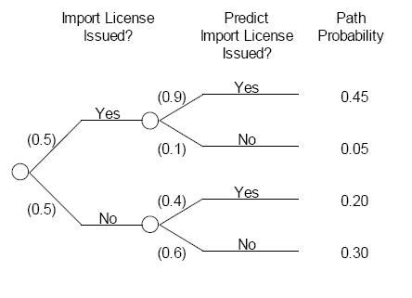
Figure 6 shows in probability tree form the information that is given above about the accuracy of Lofton. The root node on the left side of the tree shows the probabilities for “import license issued?” specified in earlier discussions of this decision problem. The two chance nodes on the right side of the tree show the probabilities that Lofton will call the licensing decision right, based on the conversation between Daniel Analyst and George Xanadu.

Comparing Figure 6 with Figure 7 shows that the probabilities in Figure 6 are “backwards” from what is needed to assign probabilities to the branches of the chance nodes. That is, the probability of license approval is known, as well as the probability of Lofton's different predictions, given the actual situation regarding license approval. However, the decision tree requires the probability of Lofton's different predictions and the probability of license approval given Lofton's predictions. This is shown in Figure 7, where the probabilities marked A, B, C, D, E, and F are required. If these probabilities were known, the expected value could be determined for the alternative of hiring Lofton.
Figure 7 - Decision tree – Probabilities needed
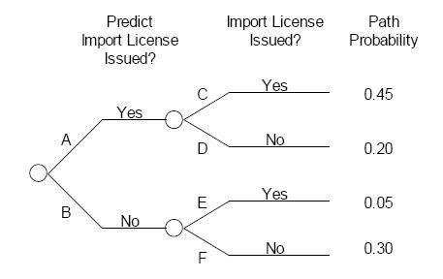
To proceed with the analysis of the alternative of hiring Lofton, we need to „flip“ the probabilities from the tree in Figure 6 to determine the probabilities needed in Figure 7.

Tree flipping is the process of calculating the probabilities for a probability tree with the order of the chance nodes reversed,

The key to doing this is to recognize that the paths from the root node to the endpoints are the same in the Figure 6 and Figure 7 trees, but they are arranged in a different order. The probabilities for these paths can be determined in Figure 3.3 by following the multiplication rule for probabilities. Namely, the probabilities on the branches along a path are multiplied to determine the probability of following that path. For example, the probability of following the topmost path in Figure 3.3 is determined as 0.5 x 0.9 = 0.45.

A path probability is the probability of a particular sequence of branches from the root node to a specified endpoint in a probability tree. A path probability is determined by multiplying the probabilities on the branches included in the path.

Once the probabilities are determined for each path in Figure 6, they can be transferred to Figure 3.4, as shown at the right side of Figure 7. (The topmost and bottommost probabilities are transferred directly from the Figure 6 tree to the Figure 7 tree, and the other two path probabilities need to be reversed when they are transferred.)

Once the path probabilities are known, probabilities A and B can be determined. Probability A is the probability of a „yes“prediction regarding license approval and this occurs only on the two topmost paths in the Figure 7 tree. Therefore, probability A is equal to the sum of the probabilities for the two topmost paths. That is, A = 0.45 + 0.20 = 0.65. Similarly, probability B is equal to the sum of the probabilities for the two bottommost paths. That is, B = 0.05 + 0.30 = 0.35.

Once A and B are known, then C, D, E, and F can be determined using the multiplication rule. Thus, A x C = 0.45, or C = 0.45/A = 0.45/0.65 = 0.69 (rounded). Similarly, D = 0.20/A = 0.20/0.65 = 0.31 (rounded), E = 0:05/B =0.05/0.35 = 0.14 (rounded), and F = 0.30/B = 0.30/0.35 = 0.86 (rounded).
Figure 8 Decision tree probabilities
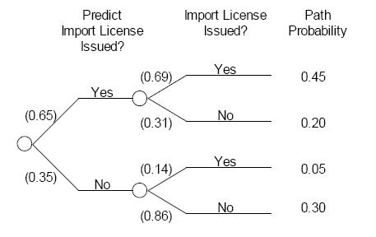

The probabilities can now be transferred to the final tree diagram and the expected value can be calculated for the alternative of hiring Lofton by using the same process as in earlier decision trees. The result is shown in Figure 9, where the expected value for this alternative is $1.13 million. Figure 9 shows that the best alternative without hiring Lofton only has an expected value of $1 million, and so it is worth hiring Lofton. In fact, it is worth considerably more than $10,000 to hire Lofton, since the alternative with hiring him for $10 000 is worth $1.13 million. In fact, it is worth it to hire Lofton as long as he costs less than $130 000 + $10 000 = $140 000.

Figure 9 Hire consultant alternative with Expected Values
