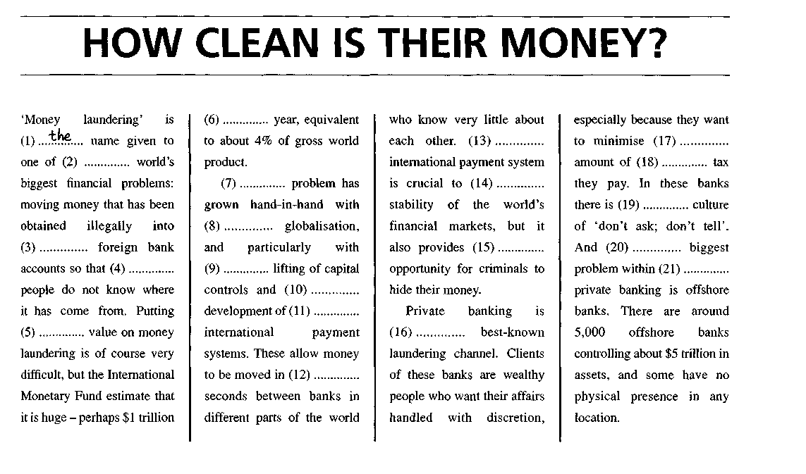
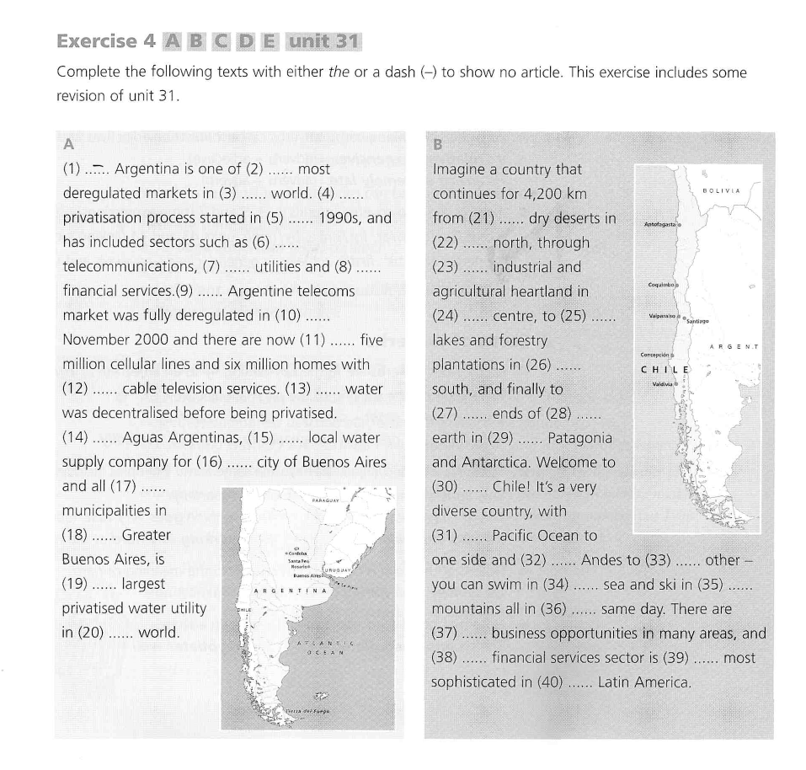

Klíč ke cvičením:
How clean is their money

2 the | 8 - | 14 the | 20 the
3 - | 9 the | 15 an | 21 -
4 - | 10 the | 16 the
5 a | 11- | 17 the
6 a | 12 - | 18 -
7 The | 13 The | 19 a

Unit 35/Ex 4

 | 9 The | 17 the | 25 – (or the) | 33 the
2 the | 10 - | 18 - | 26 the | 34 the
3 the | 11 - | 19 the | 27 the | 35 the
4 The | 12 - | 20 the | 28 the | 36 the
5 the | 13 - | 21 - (or the) | 29 - | 37 -
6 - | 14 - | 22 the | 30 - | 38 the
7 - | 15 the | 23 the | 31 the | 39 the
8 - | 16 the | 24 the | 32 the | 40 -

