MEMO
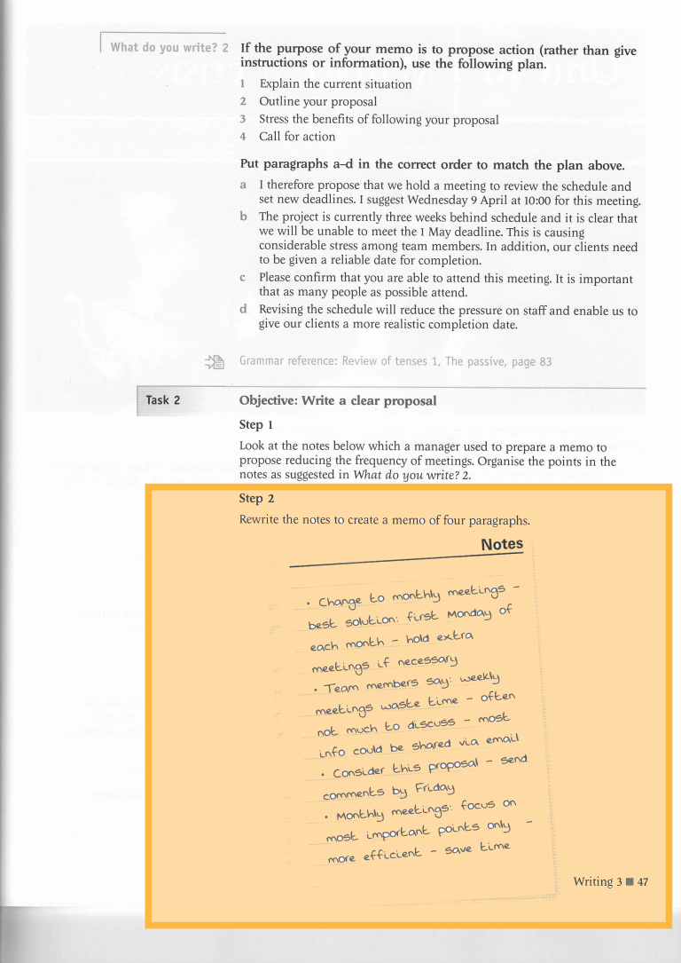

EMAIL
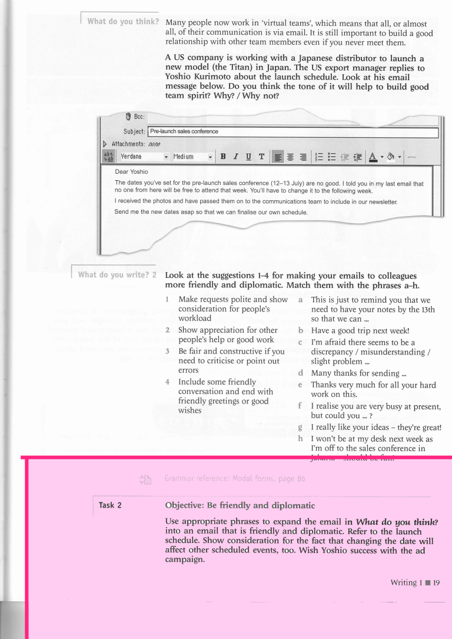

FAX
Follow the rules for writing a fax in Style Guide.

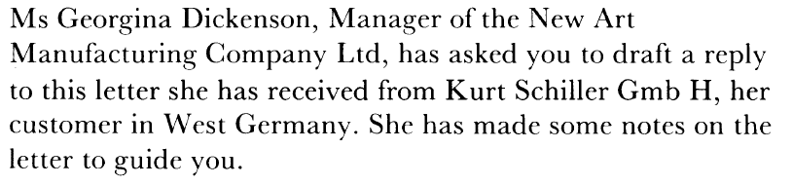
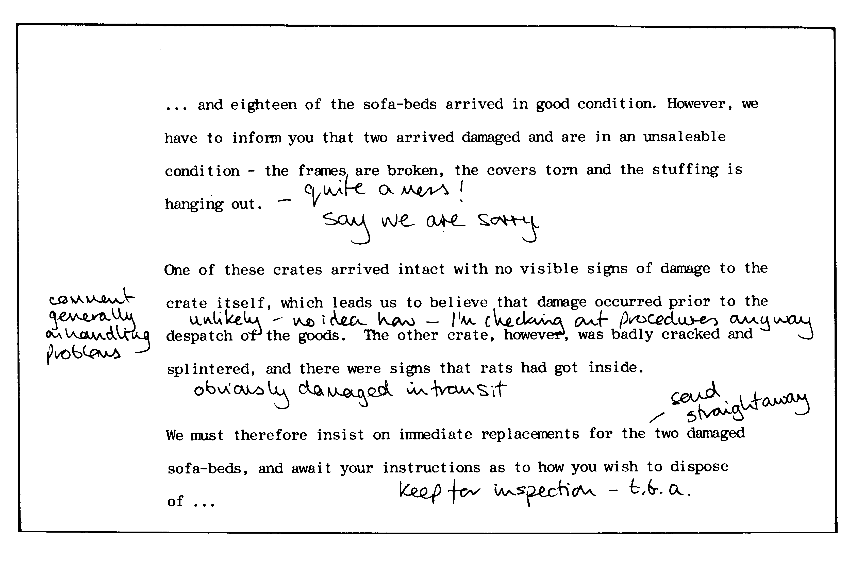

FACTUAL REPORT
You should write a report on your meeting (if you were not in class, you can write it on any other topic).
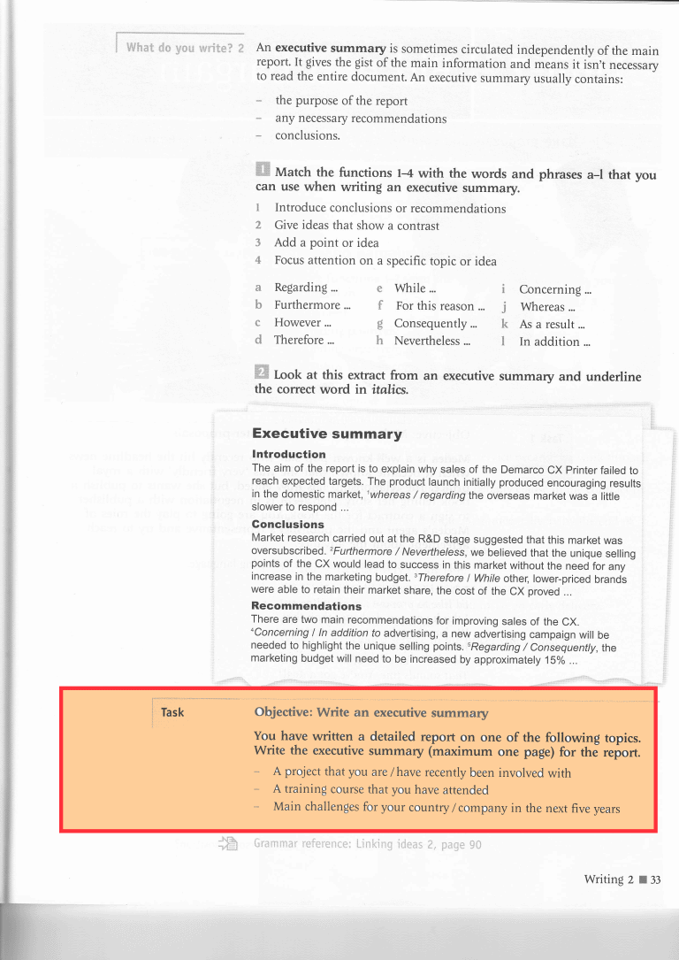
FORMAL CORRESPONDENCE
Choose one of the options.
