TEXT 2 - India's economy

SOURCE: The Economist
http://www.economist.com/research/articlesBySubject/displaystory.cfm?subjectid=6899464&story_id=12060235
Trade

Afta Doha
Sep 4th 2008 | DELHI
From The Economist print edition

Should free traders applaud the rise of preferential trade deals?
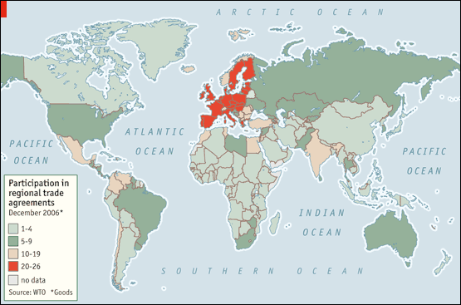
CONTEMPLATING the failure of the Doha round of multilateral trade talks, which collapsed in Geneva in July, Peter Mandelson, trade commissioner of the European Union (EU), predicted that by the time the talks resumed, “the caravans will have moved on elsewhere.” On August 28th they trundled through Singapore. The ten members of the Association of South-East Asian Nations (ASEAN) agreed on a trade deal with India and reached a separate accord with Australia and New Zealand. Together, the agreements cover trade worth about $70 billion in 2006.
After the Geneva disappointment, some free traders find consolation in the success of bilateral and regional deals, such as those agreed on in Singapore. Since the Doha round was launched almost seven years ago, over 100 such deals have come into force, lowering tariffs for some members of the World Trade Organisation (WTO) but not others (see map).
These preferential deals violate the principle of “most-favoured nation” (MFN), which holds that any favour offered to one member must be offered to all. But that principle now has few defenders in the world’s trade ministries. In his new book, “Termites in the Trading System”, Jagdish Bhagwati of Columbia University points out that negotiators see any deal as a “feather in your cap”. But economists know better. By playing favourites with its trading partners, a country can dupe itself into paying more for its imports. Its consumers may switch from a low-cost supplier to a more expensive one, only because the new supplier can sell its goods duty-free and the other cannot. The consumer pays less, but the Treasury is deprived of tariff revenue. Thus discriminatory trade deals do not just hurt those left out.
ASEAN, however, seems a compelling advertisement for regionalism. Its members (which include Indonesia, Malaysia, the Philippines, Thailand and Vietnam) have only 3% of the world’s land area but 11% of its coastline, which extends for 173,000 kilometres around the region’s peninsulas and archipelagos. ASEAN’s prosperity depends on trade: its ratio of exports to GDP is almost 70%.
The group’s economic geography is as spectacular as its topography. Elaborate networks of production span the region and extend to China, Japan and South Korea. Much of the region’s trade is in parts (such as car components) and tasks (such as assembly) rather than finished goods. It has become part of what Richard Baldwin, of the Graduate Institute of International Studies in Geneva, calls “Factory Asia”.
Some of this success may be due to the ASEAN Free-Trade Area (AFTA), which has cut barriers between members and attracted foreign direct investment. But Factory Asia also demonstrates the flaws of such agreements. If a country wants to grant favours to one trading partner but not all, it has to write complex “rules of origin” to establish the nationality of a product.
But in a dense network of production, every product is a mongrel, with an indecipherable pedigree. In recognition of this, AFTA’s rules of origin are quite relaxed: a good qualifies even if only 40% of its value was added in the region, and that 40% can come from more than one member.
Even so, ASEAN’s success owes more to ambitious cuts in its MFN tariffs, which it applies to everybody. Thailand, for example, slashed its average tariff from 41% in 1989 to 18% in 2000; Indonesia cut from 25% to 8%. If the MFN tariff is low enough, exporters will pay up rather than trouble themselves with documenting the origin of their products. Only 5% of ASEAN trade takes advantage of the preferences its officials so painstakingly negotiated.
If multilateral liberalisation were proceeding apace, firms everywhere could bypass the thicket of preferential agreements, just as South-East Asian companies have bypassed AFTA. But do such accords help or hinder the cause of full liberalisation?
Mr Bhagwati insists that they hinder it. One of the stumbling blocks in the Doha round, for example, was “preference erosion”. Some African and Caribbean countries did not want to see the EU open its banana market to all and sundry, because that would erode the value of their privileges. (This issue was reportedly resolved at the Geneva summit in July.)
Sometimes it is the countries granting the privileges that want to preserve their worth. America, for example, offers trade deals to strategic allies as a reward for fighting the war on drugs or stabilising the Middle East. Nuno Limão, of the University of Maryland, has shown that in the last global trade round America was slower to cut MFN tariffs wherever that would remove a plum from its allies’ mouths.
But not all of the evidence is as gloomy. A new study, by Antoni Estevadeordal of the Inter-American Development Bank, Caroline Freund of the World Bank and Emanuel Ornelas of the London School of Economics, reaches a more optimistic conclusion. Looking at ten Latin American countries in the 1990s, they show that preferential cuts in a tariff were often followed by multilateral cuts in the same tariffs.
This may be the result of what Mr Baldwin calls the “juggernaut effect”. A trade deal, even a discriminatory one, should enlarge a country’s export sector and shrink domestic industries vulnerable to foreign competition. This will, in turn, change the country’s politics, strengthening the “mercantilist” lobby, which demands open markets overseas, and weakening the country’s protectionist constituencies. If the export lobby gets its way, freer trade will follow, further strengthening the mercantilists at the expense of the protectionists. The juggernaut, Mr Baldwin writes, is slow to start rolling, but hard to stop.
Will India’s ASEAN deal get the juggernaut rolling in India? Unfortunately, the agreement protected 489 politically sensitive items, mostly agricultural products. The deal thus gives India’s exporters a little of what they want, reducing their incentive to fight for a Doha round. But it still leaves the country’s farmers with every reason to resist a return to Geneva.
The word “juggernaut”, Mr Baldwin notes, has an Indian origin: it is a British mispronunciation of the Hindu deity, Jagannath. Each year, the deity is worshipped in a garlanded chariot, pulled through the streets by pilgrims. The caravans may be moving as Mr Mandelson predicted. Unfortunately, India’s free-trade chariot seems stuck somewhere between Singapore and Switzerland.

