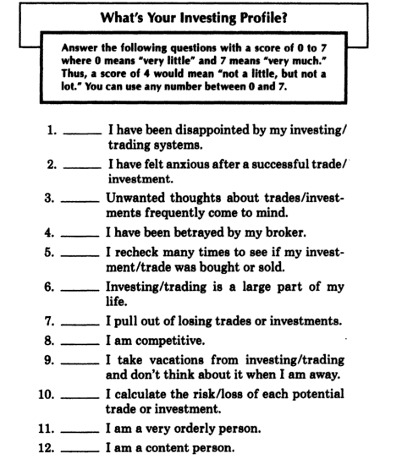
Ira Epstein, David Garfield: The Psychology of Smart Investing

