Unit 2: ARTICLES
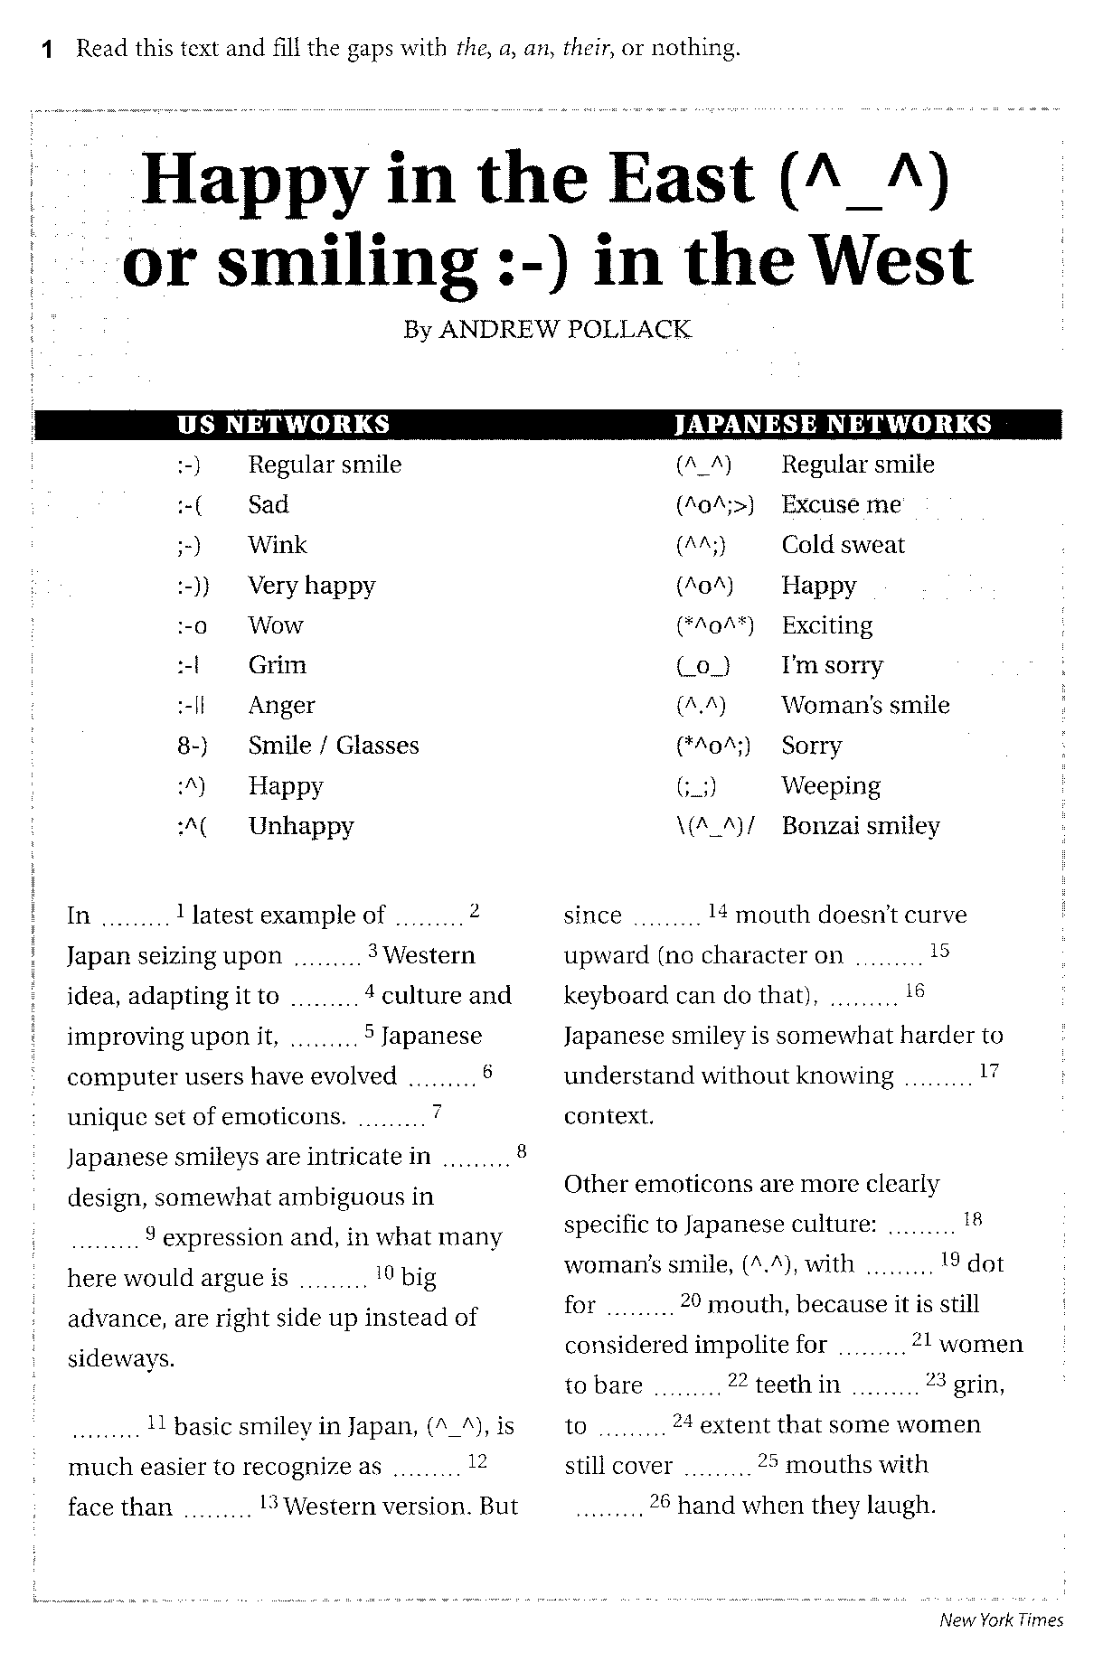

2 Complete the sentences with the, a/an or –.

1 ____ Masaryk University in ____ Brno was established in 1919.
2 ____ Faculty of Economics and Administration was founded on 1 January 1991 as the sixth faculty of ____ Masaryk University.
3 ____ Madagascar is an island nation in ____ Indian Ocean, off the southeastern coast of ____ Africa.
4 ____ Sears Tower is a skyscraper in ____ Chicago, ____ Illinois. It has been the tallest building in ____ United States since 1973.
5 ____ Fifth Avenue is a major thoroughfare in the centre of ____ Manhattan in ____ New York City.
6 ____ Aconcagua is the highest peak of ____ Andes, the longest mountain range of ____ South America.
7 Steve Jobs is the co-founder and CEO of ____ Apple and was the CEO of ____ Pixar until its acquisition by ____ Disney.
8 ____ Lake Victoria is the source of the longest branch of ____ Nile River, ____ White Nile.

----------------------------------------------------------------------------------------------
Complete the sentences with correct expressions in correct forms. Use each word once. (Sometimes you have to change the word.)
CONTRACT, DELIVER, EMPLOY, HAGGLE, LAUNCH, NEGLIGENCE, RESPONSIBLE, SELECT

1 The factory owner was found to have acted ____________ in failing to follow safety procedures.
2 The new drug is scheduled for ____________ next month.
3 The manufacturer ____________ 112 new aircraft last year.
4 They have employed outside ____________ to install the new computer system.
5 The new sales manager will have ____________ for the European market.
6 The firm has over 500 ____________.
7 Lawyers were still ____________ over the terms of the deal.
8 You will have to be ____________ about which information to include in the report.

