Summary C – počet slov 1094
Educating migrant children

Huddled classes
Sep 11th 2008
From The Economist print edition

How migrants fare in school, and what schools can learn from them

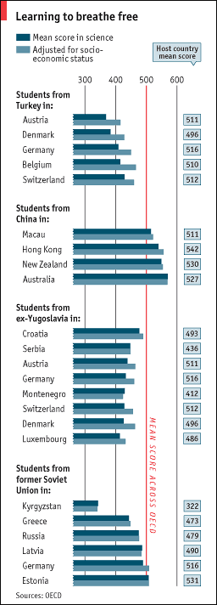
MOST teachers admit that occasionally, when a lesson is going badly, they suspect the problem lies not with the subject or pedagogy, but with the pupils. Some children just seem harder to teach than others. But why? Is it because of, say, cultural factors: parents from some backgrounds place a low value on education and do not push their children? Or is it to do with schools themselves, and their capacity to teach children of different abilities?
It might seem impossible to answer such a question. To do so would require exposing similar sorts of children to many different education systems and see which does best. As it happens, however, an experiment along those lines already exists—as a result of mass migration. Children of migrants from a single country of origin come as near to being a test of the question as you are likely to find.
Every three years, as part of its Programme for International Student Assessment (PISA), the Organisation for Economic Co-operation and Development, a Paris-based think-tank, measures how 15-year-olds in around 50 countries do in their own languages, mathematics and science. The OECD recently sorted the data from its 2006 study of science performance according to the countries of origin of children and their parents. Four places—Turkey, China, the former Soviet Union and ex-Yugoslavia—have each sent enough citizens to enough countries for conclusions to be drawn about the quality of schooling in their host countries.
Almost everywhere immigrant students fare worse than locals—unsurprisingly, as they are often the children of poor, ill-educated parents and do not speak the local language. When data are adjusted to take account of these disadvantages, much but not all of the gap is closed (see chart). More interestingly, children from the same country do very differently, depending on where they end up.
One reason is connected with how much countries “track” pupils (ie, sort them into ability groups and teach them separately). Large numbers of first- and second-generation Turkish children go to school in Austria, Germany, Belgium, Switzerland and Denmark. In the first four countries, pupils are tracked on leaving primary school. But those in Austria and Germany do worse than those in Belgium and Switzerland because, it seems, tracking is earlier and more rigid in the first two, and a child’s socio-economic status has a very large effect on the track he ends up on. Most Turkish kids go to technical schools that don’t fit them for university.
Their poor showing in Denmark’s comprehensive schools, where there is no tracking and all children should in theory have access to equally good education, is a little more puzzling. Andreas Schleicher, the OECD’s head of education research, speculates that their chances are damaged by the way in which poor Danish children are heavily concentrated in some schools, rather than scattered around the place. In general, countries where there is considerable difference in intake between schools tend to do worse in PISA.

Grouping children by ability is not necessarily a bad idea, though, as the experience of mainland Chinese children shows. Those who migrate to Hong Kong do very well despite being poor—and despite the fact that Hong Kong tracks school-children early and often. But there, which track a child ends up on has less to do with the parents’ wealth and education. Moreover, children can move to a different track if they do better than expected. “In general, socio-economic status has less impact in East Asian countries than in western European ones,” says Mr Schleicher.
Among the world’s best performers are Chinese children taught in Australia. The average Chinese first- or second-generation immigrant there outperforms two-thirds of all Australians (themselves no mean performers), and three-quarters of all the children who take the PISA test worldwide. Mr Schleicher praises the Australian school system for its diversity—within schools, not between them—and ability to capture the talents of all students.
The contrasting fates of children from the former Soviet Union and ex-Yugoslavia provide extra proof that the host country makes a difference, over and above the intellectual baggage immigrant children bring with them. Kids who arrive in Kyrgyzstan from other ex-Soviet lands do badly, albeit better than the locals; those who go to successful little Estonia do far better. By contrast, Yugoslav kids do much the same pretty well everywhere—whether they move to another post-Yugoslav state or some richer and more stable place. The difference is timing: the Soviet Union imploded earlier than Yugoslavia, so “ex Soviet” children spent less time in education in their home country; those from Yugoslavia less in the host one.

Wrong sort of migrants or schools?
At least in theory, the new findings should help counter some of the sillier things that policymakers say about the influence of migrants on a country’s overall attainments. “When we started to do the PISA rankings in 2000, many countries were shocked at how badly they did,” says Mr Schleicher. “And excuses we often heard were: ‘We get too many migrants,’ or, ‘we get the wrong sort of migrants.’”
Although immigrant children typically do worse at school than locals, there is no country-wide effect. The OECD’s analyses show an insignificant correlation between the number of immigrant children a country has and the average pupil’s attainment—and it is countries with more immigrant children that do (slightly) better.
As well as testing children on what they know, PISA also asks them how motivated they are: whether they think they will need the subject in question (most recently, science) for their future, and whether they like to study it for its own sake. In most countries, first-generation immigrant students are more motivated than second-generation ones, who are in turn more motivated than the children of the native-born. Germany is a striking exception: new immigrants turn up with the usual ambitions and dreams, but by the age of 15 their children have already given up hope.
That suggests that any country that figures out how to let incomers shine will reap big benefits. Immigrants, however poor, are a self-selected bunch of ambitious, hard-working people, and their children usually know that, lacking the informal networks that let locals get ahead, they must study hard to succeed. Their varying fates—helped to the top in some places, consigned to the scrapheap in others—show that although what happens outside the school gates is important, what happens in classrooms is too.

