Summary E – počet slov 1084
Evangelical voters

The born-again block
Sep 11th 2008 | WASHINGTON, DC
From The Economist print edition

The Democrats are having a lot of trouble wooing evangelical voters

Reuters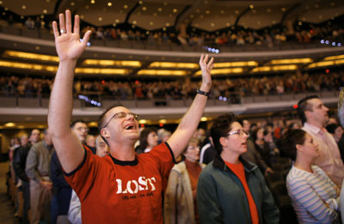
AS BARACK OBAMA and John McCain move into the final two months of this longest of elections, white evangelical or “born again” Christian voters are being fought over more fiercely than at any time in modern history. Both parties employ evangelical outreach specialists. Both are spending a lot of time courting evangelical leaders. And both are holding meetings with “values voters” to try to reassure them.
The Democrats have at last realised that it is foolish to write off a group that makes up an astonishing 23% of the population. In 1988 Michael Dukakis could hardly bring himself to speak to evangelicals. This year all the major Democratic candidates have cuddled up to them. Mr Obama says that he is “somebody who really has insisted that the Democratic Party reach out to people of faith”. His staff has already conducted more than 200 “American values forums” or faith-themed town-hall meetings. The aim, of course, is not to win the evangelical vote: merely chipping away at such a monolith could be hugely useful.

The Democrats have had good reasons for thinking that they may be able to make inroads. Many evangelicals are disillusioned with George Bush: polling by the Pew Research Centre shows that less than half of white evangelicals (47%) approve of his performance compared with 48% who disapprove. (All polls quoted in this article are by Pew unless otherwise stated.) The 2006 mid-term election was terrible for the evangelical right. Its heroes, like Rick Santorum in Pennsylvania and Kenneth Blackwell in Ohio, went down in flames. The Democrats have recruited muscular Christians of their own, including Tim Kaine and Ted Strickland, governors of Virginia and Ohio respectively.
Many evangelicals have also long been uncomfortable with Mr McCain, a man who cannot decide whether he is an Episcopalian or a Baptist. Mr McCain denounced Pat Robertson and Jerry Falwell, two veteran evangelical leaders, as “agents of intolerance” in 2000. This time round, he first courted and then rejected the support of two prominent evangelicals, John Hagee and Rod Parsley. The only thing that the evangelical leadership could agree on during the Republican primaries was that they wanted anyone but Mr McCain. Just 28% of white evangelicals described themselves as “strong” backers of him in August, compared with 57% who said the same thing about Mr Bush four years ago.
Yet even with all this going for them, the Democrats are operating in hostile territory. White evangelicals are the most Republican religious group in the country, with 62% of them leaning Republican, compared with 38% of all voters. Their support for the Republicans is higher than it was in 2000, and also higher among the under-30s than the over-30s: 64% of young evangelicals lean Republican compared with 29% who lean Democratic.
This general preference for the Republicans over the Democrats has also translated into a preference for Mr McCain (for all his faults) over Mr Obama (for all his religion-friendly rhetoric). White evangelicals in general prefer Mr McCain to Mr Obama by a margin of 44 points (the figure for Bush versus Gore in the summer of 2000 was only 30 points). Among white evangelicals who go to church more than once a week, the gap is 54 points. Much of this is driven by suspicion of Mr Obama. Only 27% of this group believe that the deeply religious senator from Illinois shares their values—a figure shaped partly by revulsion for his preacher, Jeremiah Wright, partly by the mistaken belief that Mr Obama is a Muslim, but mostly by his uncompromising support of abortion choice.
Mr McCain’s biggest problem among evangelicals has been one of intensity rather than broad preference. The big question haunting the Republican Party has been whether the evangelical foot-soldiers could be bothered to do the grunt work or even turn out to vote (Karl Rove blamed Mr Bush’s election squeaker in 2000 on the fact that 4m evangelicals stayed at home when they heard of young George’s drunk-driving conviction). But over the past month or so Mr McCain has dramatically revved up the evangelical base.
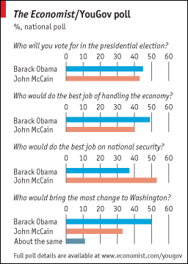
Mr McCain has been laying the groundwork for this for some time. He appointed Marlys Popma, the former head of Iowa Right to Life, to run “religious outreach” in late 2006. He visited Billy and Franklin Graham in North Carolina, and Mr Falwell at Liberty University in Virginia. But three events supercharged his support among evangelicals.
The first was his appearance at Saddleback, a church run by the most popular evangelical in the country, Rick Warren. Mr McCain impressed the audience with his snappy answers and engaging anecdotes. Equally, Mr Obama disappointed them by being evasive about when he thinks life begins. Then came the publication of the Republican platform, a document that is considerably more conservative than it was four years ago, and which is notably uncompromising in its hostility not just to abortion and gay rights but also to stem-cell research.
But Mr McCain’s biggest coup by far was picking Sarah Palin as his running-mate. Mrs Palin is an evangelical convert—she was born a Catholic—who is deeply-rooted in the evangelical subculture. Her eldest son, Track, has a tattoo of the “Jesus fish” on his calf. She has pronounced opinions on abortion, gay marriage and creationism. The news of her selection was greeted with standing ovations from leaders of the religious right and near-hysteria on Christian radio stations.
Can Mr McCain ride an energised evangelical base into the White House? He is certainly much better off now than he was a month ago, before the evangelical surge. But he nevertheless confronts two big problems. The first is that evangelical issues have less resonance with the general public than they did in 2004. There has been a decline in support for traditional morality, an uptick in hostility to the involvement of the church in politics, and an increase in support for social welfare. Catholics in particular are shifting back into the Democratic camp. The second is that Mrs Palin and her supporters may energise America’s secularists while also putting off swing voters (who are likely to be troubled by Mrs Palin’s hostility to abortion even in cases of rape and incest). The big problems now facing Mr McCain may not be too little enthusiasm among evangelicals, but too much.

Back to top ^^

Readers' comments

