Grammar seminar handout 1

EXERCISE 1
Underline the correct words.
- That looks like Carlos over, there, but it can’t / mustn’t be. He’s in Germany.
- Marie isn’t at her office, so she can / must be on her way here.
- I think you need to / need get some advice from your colleagues.
- It’s getting very late. I think we’d better / ought pay the bill and leave.
- You don’t need / needn’t come to the meeting if you are busy.
- I’m sorry, you mustn’t / may not smoke in this area. It’s forbidden here.
- They have had to / have to wait for hours.
- We haven’t been allowed to take / mustn’t take a rest for hours.
- You shouldn’t / oughtn’t to spend so much on clothes.
- The company has to / must pay the invoice by the end of the month.

EXERCISE 2
Complete each sentence with a word or phrase from the list below. Each can be used only ONCE.
have to had to don’t have to must mustn’t
should could didn’t have to needn’t doesn’t need to

- We’re trying a new dress code. We _________ wear formal clothes on Fridays.
- You _________ touch that button! The whole production line will stop.
- Before we agree, we’ll _________ study the contract in more detail.
- Sorry I can’t stay any longer. I really _________ go now or I’ll miss my train.
- If you needed the goods urgently, we _________ speed up the order.
- Sorry I’m late, but I _________ go to the doctor’s.
- I think we _________ accept their offer. It’s the best we’ll get.
- Luckily, I _________ attend the meeting yesterday, so I managed to finish all my paperwork.
- You _________ wait for me – I’ll come along later.
- Mark _________ finish the report today. He can do it at the weekend.

EXERCISE 3 – HOMEWORK 1

Complete the second sentence so that it has a similar meaning as the first sentence.

- It would be a good idea to bring in a firm of consultants.
We _______________________________ in a firm of consultants.

- It’s not necessary for you to leave a deposit.
You _______________________________ a deposit.

- I’m sure that isn’t John, because he’s in Paris.
That _______________________________ John, because he’s in Paris.

- Ann is almost certainly with a customer.
Ann _______________________________ with a customer.

- I expect the meeting will be finished by ten.
The meeting _______________________________ finished by ten.

- It’s possible that I’ll be late.
I _______________________________ late.

- We are not allowed to dispose of waste in that way.
We _______________________________ of waste in that way.

- Perhaps I’ll see you on Thursday evening.
I _______________________________ you on Thursday evening.

- It’s the rule that we check all bank references.
We _______________________________ all bank references.

- You’d better speak to her as soon as possible.
You _______________________________ to her as soon as possible

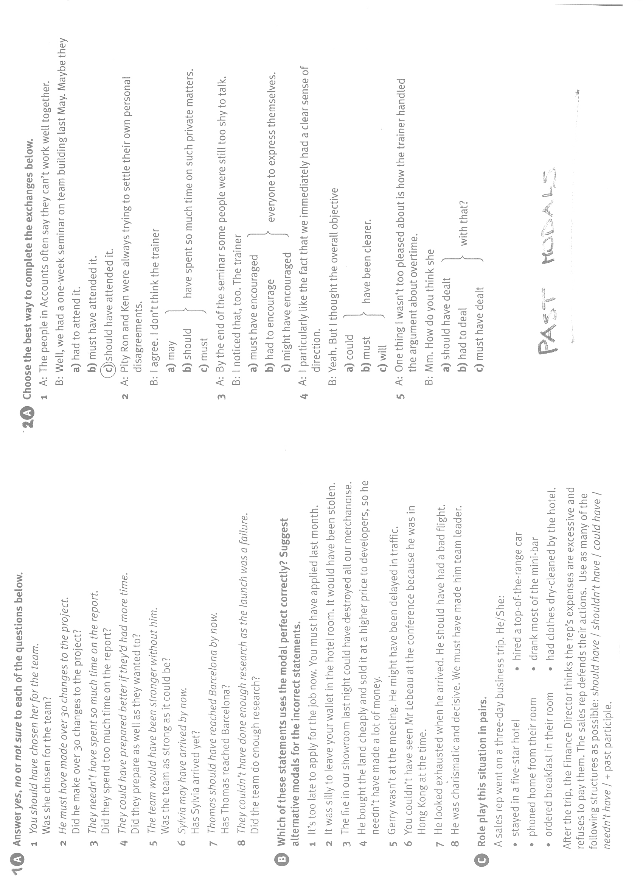
EXERCISE 4 – HOMEWORK 2
Complete the second sentence so that it has a similar meaning as the first sentence.

- Perhaps David made a mistake.
David _________________________ made a mistake.

- I’m sure that she worked very hard on this project.
She _________________________ worked very hard on this project.

- I’m sure the warranty hasn’t expired already.
The warranty _________________________ expired already.

- It would have been a good idea for you to tell me
You _________________________ told me.

- Perhaps you didn’t see the line we launched at the Munich Fair
You _________________________ seen the line we launched at the Munich Fair.

- I was expecting them to call by now.
They _________________________ called by now.

- It was a bad idea for us to drop our prices so much.
We _________________________ our prices so much.

- It was possible for us to see this problem coming.
We _________________________ this problem coming.

